Student Number: 1226909816  
Name: Wei Hng Yeo   
CSE450 Assignment 4

1. Let activity i which starts at si and finishes at fi.

Consider activities in increasing order of start time and we assign activity to any compatible lecture hall.

Firstly, sort intervals by starting time so that s1 <= s2 <= s3…<=𝑠𝑛.

Then assign, hall_number ← 0 // Number of lecture hall used so far

for (i ← 1 to 𝑛) {

if (activity i is compatible with some lecture hall 𝑘 then) {

schedule activity i in lecture hall 𝑘

} else {

allocate a new lecture hall of hall_number +1

schedule activity i in lecture hall hall_number + 1

hall_number ← hall_number +1

}

}

1. (a) A minimum-bottleneck tree may not be a minimum spanning tree.

For example, see the graph as shown below with 4 nodes and 6 edges

A graph with 4 nodes and 6 edges

The minimum spanning tree is as shown below where the edges are outlined in red. The total weight of all the edges are 8 + 7 + 6 = 21.

Minimum spanning tree

On the other hand, a minimum-bottleneck tree could be the one as shown below according to the definition with the edges outlined in red (shown below). However, the total weights is 8 + 8 + 6 = 22 which is 1 more than the minimum spanning tree we have computed.

Minimum-bottleneck tree

(b) A minimum spanning tree must be minimum-bottleneck tree. Consider a prove by contradiction, if we were to have a minimum spanning tree with the maximum edge weight not the cheapest possible, then that is not a minimum spanning tree since there exist another spanning tree that has even smaller total edge weight. So, a minimum spanning tree’s maximum edge must be the cheapest possible and by definition, that must be a minimum-bottleneck tree.

1. Maximum flow from Vancouver to Winnipeg is 19.
2. We first initialize flow f (all edges) to 0
3. While there exists an augmenting path p in the residual network
4. Augment flow f along p.
5. Return f

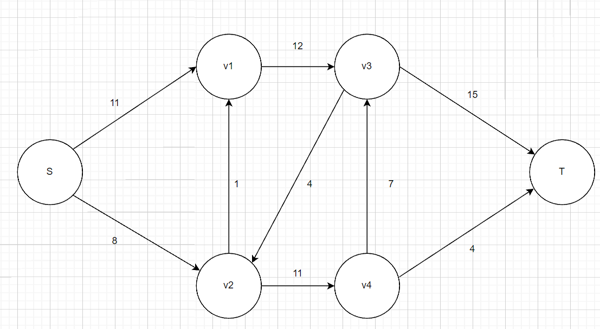

Maximum Flow Working

Where each edge indicates the maximum flow, and each flow does not exceed the capacity stated in the question.

1. (a) No. Because if we take the example at the bottom, the maximum flow is clearly not the sum of the flow from RHS to LHS and LHS to RHS.

(b) Yes, I agree. Since the capacity of the cut on one side of the cut is used as the upper limit for the flow from S to S’. So, in order to get the max flow, it must be equal to the capacity of the cut on the other side. Thus, it shows that the maximum flow is indeed equivalent to the capacity of the minimum cut.