CSE 460

Programming Assignment Report

Posting ID: [9816-379]

[26 November 2022]

Fall 2022

1. Description and Assumptions

The software system producer-supplier system that lets producer create add new car models and lets buyers subscribe to notification of car models of certain categories that the buyers selected. Only the car models that matches the car categories selected by the buyers will be notified to the buyers.

There are 3 basic operations – subscribe and unsubscribe which are operations that buyers can perform and publish which is the operation that the producer can perform.

For subscribe, the command is strictly “subscribe, <name of buyer>, <category type>”. The spaces between the comma is optional. On the otherhand, for unsubscribe the command is strictly “unsubscribe, <name of buyer>, <category type>”. And once again, spaces between the comma is optional.

For publish, the command is strictly “publish, <producer name>, <category type>, < model name>, <fuel type>”. The spaces between the comma is optional.

The order of the parameter passed to the 3 operations must strictly follow the description above, otherwise the notification will be printed incorrectly.

1. Use Case Diagrams

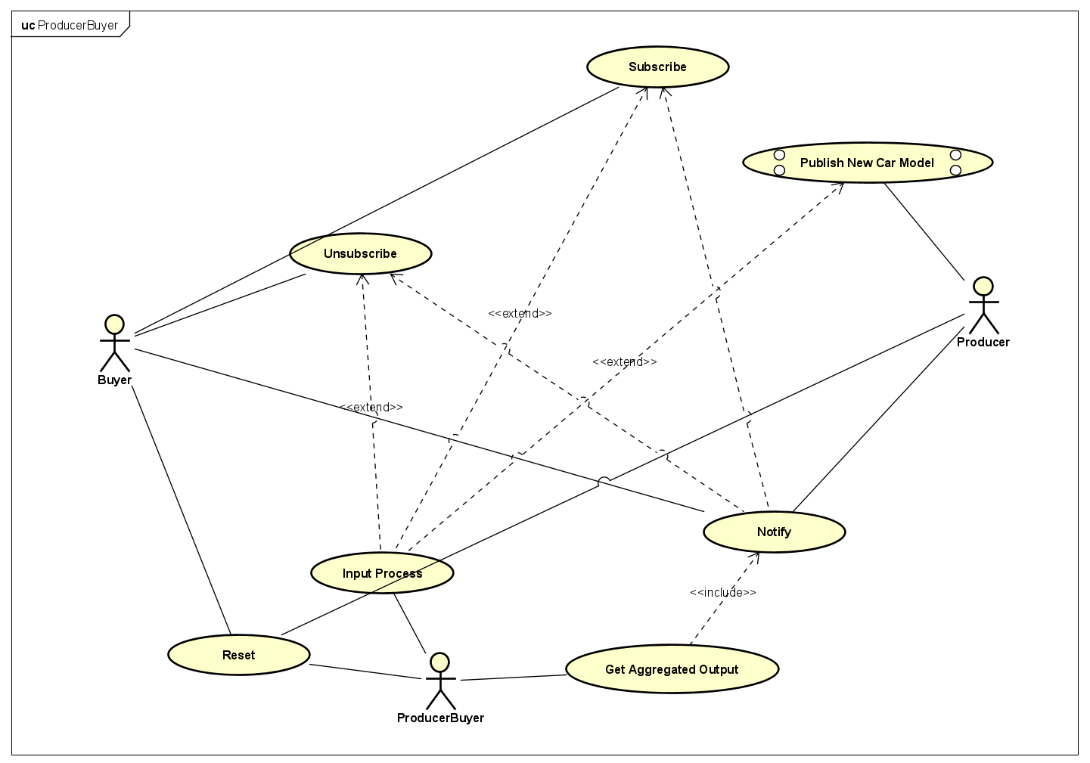

Use Case Diagram

ProducerBuyer has some use case which is to Get Aggregated Output from the notification computed from the buyer and producer. Input Process of ProducerBuyer can process command by buyers and perform subscribe, unsubscribe and publish operations. The reset operation of ProducerBuyer can remove all the published car models and remove all the categories that have been subscribed.

The buyer can perform subscribe or unsubscribe to the categories of car they want to receive notification of. Depending on what is subscribe, the notification will show categories of what is subscribed only.

The producer can publish new car models that will add to the list of car models that they already have.

1. Class Diagrams

Producer Class Diagram

Buyer Class Diagram

ProducerBuyer Class Diagram

1. Sequence Diagrams

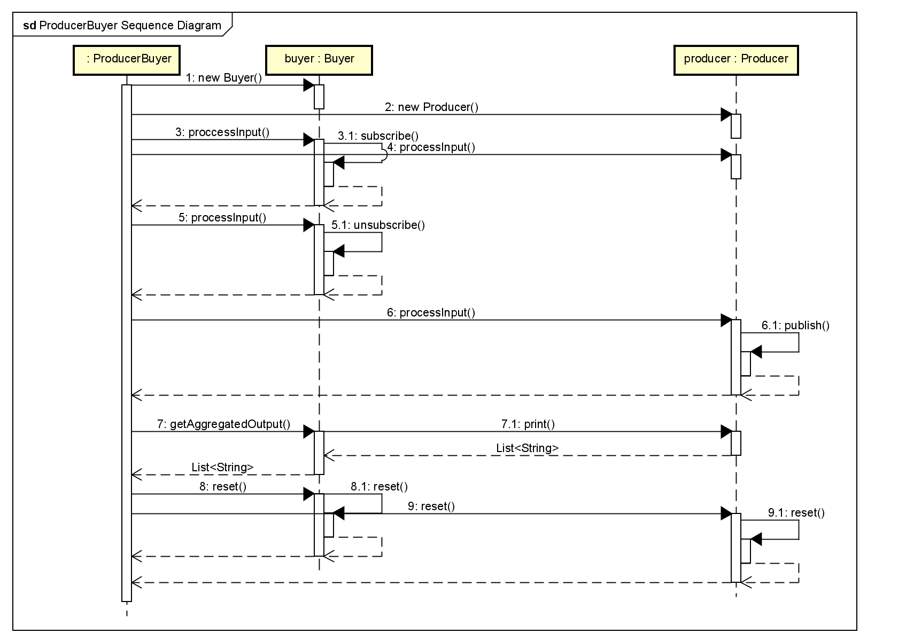

ProducerBuyer Sequence Diagram

The above sequence diagram depicts how the ProducerBuyer interact with the Buyer and Producer class.

1. State Machine Diagrams

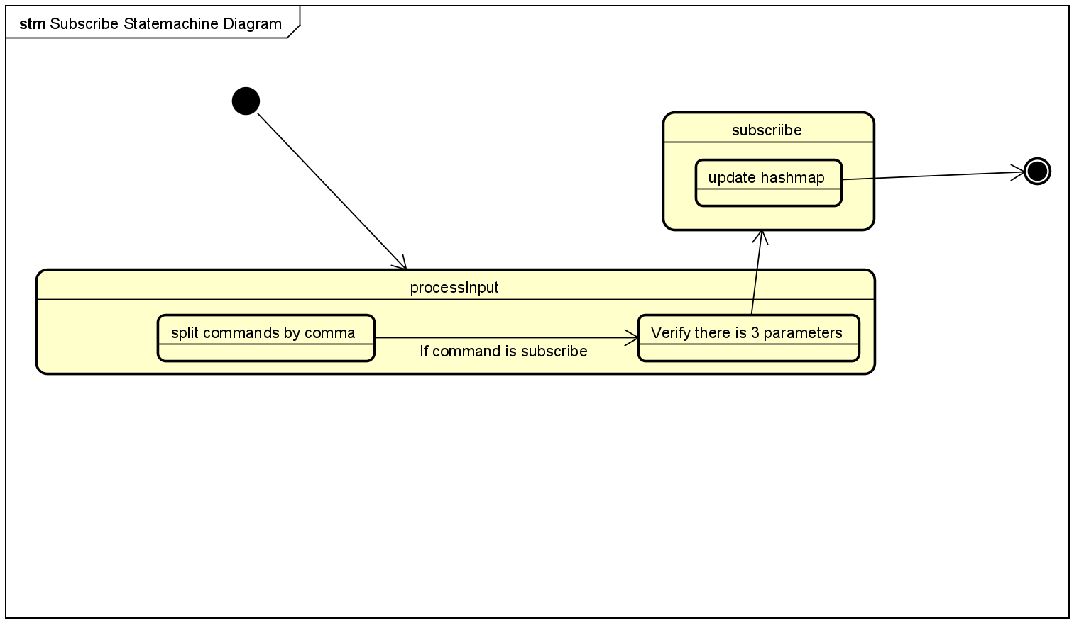

State Machine Diagram for Subscribing

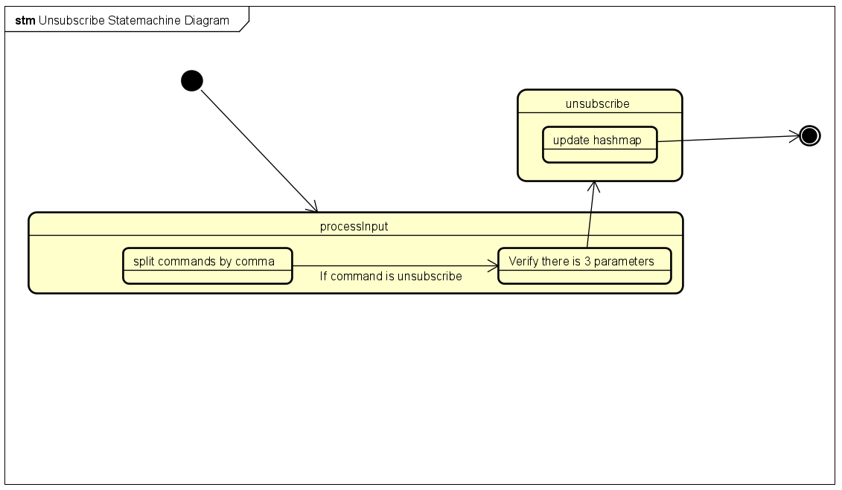

State Machine Diagram for Unsubscribing

The subscribing or unsubscribing process starts by first processing the input command given by the users. Then it splits the command delimited by a comma, if the command is indeed subscribe or unsubscribe, then we verify that there is indeed 3 parameters first. Then we proceed with the subscribing or unsubscribing process if there is indeed 3 parameters present, and then we update the hashmap data for the categories subscribed for the particular user.

State Machine Diagram for Publishing

We first process the command given by the user by splitting it delimited by a comma and then verify that there is indeed 5 parameters. Then if it checks out, we will continue and perform the adding of the newly published model by adding to the ArrayList.