*k*

**A MINI PROJECT REPORT**

*for*

**Mini Project using Python (20CSE59)**

*on*

**CRAFTY COMMERCE**

*Submitted by*

**S.YERRINATHA REDDY**

**USN: 1NH19CS233, Sem-Sec: 5-D**

*In partial fulfillment for the award of the degree of*

**BACHELOR OF ENGINEERING**

*in*

**COMPUTER SCIENCE AND ENGINEERING**



**CERTIFICATE**

This is to certify that the mini project work titled

**CRAFTY COMMERCE**

submitted in partial fulfillment of the degree of Bachelor of Engineering in Computer Science and Engineering by

**S.YERRINATHA REDDY**

**USN:1NH19CS233**

*DURING*

*ODD SEMESTER 2021-2022*

*for*

*Course: Mini Project using Python-20CSE59*

Signature of Reviewer Signature of HOD

**SEMESTER END EXAMINATION**

*Name of the Examiner Signature with date*

|  |  |
| --- | --- |
| 1. |  |
| 2. |  |

**ABSTRACT**

The main aim of this project is to create an online shopping application which provides a user-friendly interface to the customers performing shopping. The application is developed to save the time of customer as well as the shop. It also provides a safe environment to the customers.

In this project the user can perform operations such as creating account, login, shopping, and admin can check previous transaction and payment. The user can perform these operations just by sitting in house in a few clicks instead of physically going to the Shop. This saves a lot of time and more safety.

By using this application, the drawbacks from the existing system can be overcome. Hence the new proposed system brings lot of advantages

The entire program has been developed in Python and uses the PyCharm Community Edition 2021.2.3 for running the python application.

The mini-project is completely based on the high-level language, Python and the DBMS language, SQL and uses HTML programming to provide a simple and easy to understand platform for the users.

# ACKNOWLEDGEMENT

The satisfaction and euphoria that accompany the successful completion of any task would be impossible without the mention of the people who made it possible, whose constant guidance and encouragement crowned our efforts with success.

I have great pleasure in expressing gratitude to **Dr. Mohan Manghnani**, Chairman, New Horizon Educational Institutions, for providing necessary infrastructure and creating good environment.

I take this opportunity to express my profound gratitude to **Dr. Manjunatha,** Principal, New Horizon College of Engineering, for his constant support and encouragement.

I would also like to thank **Dr. B. Rajalakshmi**, Professor and HOD, Department of Computer Science and Engineering, for her constant support.

I also express my gratitude to **Ms. Pramilarani K**, Senior Assistant Professor Department of Computer Science and Engineering, my project guide, for constantly monitoring the development of the project and setting up precise deadlines. Her valuable suggestions were the motivating factors in completing the work.

**S.YERRINATHA REDDY**

**USN: 1NH19CS233**

**CONTENTS**

**ABSTRACT I**

**ACKNOWLEDGEMENT II**

**LIST OF FIGURES VI**

**LIST OF TABLES VII**

1. **INTRODUCTION** 
   1. PROBLEM DEFINITION **1**
   2. OBJECTIVES **1**
   3. EXPECTED OUTCOMES **2**
   4. HARDWARE AND SOFTWARE REQUIREMENTS **2**
2. **FUNDAMENTALS OF PYTHON**
   1. INTRODUCTION TO PYTHON **3**
   2. ADVANTAGES OF PYTHON **4**
   3. DATA TYPES **6**

1. **FUNDAMENTALS OF DBMS**
   1. INTRODUCTION **27**
   2. CHARACTERISTICS OF A DBMS **27**
   3. DATA MODEL **29**
   4. THREE - SCHEMA ARCHITECTURE **30**
   5. DBMS COMPONENT MODULES **30**
   6. ENTITY-RELATIONSHIP (ER) MODEL **33**
2. **FUNDAMENTALS OF SQL** 
   1. INTRODUCTION **35**
   2. SQL COMMANDS **35**
   3. DATA DEFINITION LANGUAGE **36**
   4. DATA MANIPULATION LANGUAGE **36**
   5. DATA CONTROL LANGUAGE **37**
   6. TRANSACTION CONTROL LANGUAGE **37**

**CHAPTER 1**

**INTRODUCTION**

* 1. **PROBLEM DEFINITION**

We are living in 21st century everything became online. And people are saving their time by doing shopping online. And this a pandemic situation it is too difficult and danger to go out. And time is very important in life. So why not we buy or sell Products online and give employment to many, also best and safety products to the customers. It saves a lot of time and less risky.

**1.2 OBJECTIVES**

This CRAFTY COMMERCE Project is created based on python, Django, and SQL Database. The True Times that will assist online store or store in providing an online ordering system for their customers. The system has two user interfaces: one for the admin user and the other for the client, or the system’s website.

The main purpose of this project is to build a platform where the buyers and sellers can connect with each other online. These kinds of projects or websites are used to sell products and gain some money out of it.

**1.3 EXPECTED OUTCOME**

* User Authentication (register and login)
* Session of each user is saved using cookies.
* All Products with their view, key features and reviews by other users.
* Cart Functionality.
* Proper Order Summary Before Placing Order.
* Change Password Facility.
* Contact Us.

**1.4 HARDWARE AND SOFTWARE REQUIREMENTS**

SOFTWARE :

1.VSCodeUserSetup-x64-1.62.0/PyCharm Community Edition 2021.2.3

HARDWARE :

1.Operating system : Windows 10

2.Processor :Intel (r) core i5

3.Hard disk :1TB

4.Ram :8GB

**CHAPTER 2**

**FUNDAMENTALS OF PYTHON**

**2.1 INTRODUCTION TO PYTHON**

[Python](https://www.geeksforgeeks.org/python-programming-language/) is a commonly and extensively used general-purpose, high-level programming language. Guido van Rossum in 1991 was the founder of Python and was later developed by Python Software Foundation. It was primarily designed to emphasize on code readability, and its syntax allows programmers to express ideas in few lines of code. Python can be used for things like:

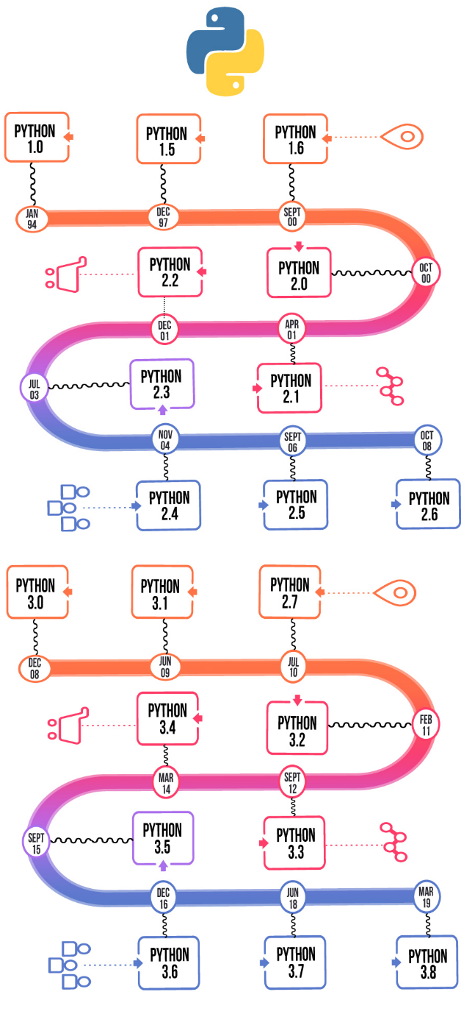

Figure 2.1: Different versions of Python over the years

**2.2 ADVANTAGES OF PYTHON**

* **Easy-to-learn and Easy-to-use**

Python programming language has a syntax similar to the English language, making it extremely easy and simple for anyone to read and understand its codes. You can pick up this language without much trouble and learn it easily.

This is one of the reasons why Python is better compared to other programming languages such as C, C++, or Java. Besides, Python requires relatively fewer numbers of lines of code to perform the same operations and tasks done in other programming languages with larger code blocks.

* **Improves Productivity**

Another one of Python benefits is that it is an extremely productive language, and because of its simplicity, Python Programmers can easily focus on solving issues.

* **Interpreted Language**

Python, being an interpreted language, can execute the code directly, one line after the other. Moreover, if there is any error, then rather than continuing with further execution, it instead reports back the error that occurred.

* **Open-source**

Python has an open-source license and is available for users for free, allowing you to easily distribute it. With Python, you can download any source code and further modify and distribute your version of the code in Python. This feature can come in handy especially when you wish to reuse the code and save time to build innovative applications. Besides, you can change its behavior and use the older version of code for development.

* **Easily Portable**

In most languages, including the ones you have learned to read, write, and use such as C, C++, etc., you need to make changes in the code to run a given program on distinct platforms. However, that is not the case with Python programming. In Python, you need to write the code only once, and you can run it on any platform, adapting the ‘write once, run anywhere’ feature. Although, you need to make sure that you do not involve any features that are system-dependent.

* **Massive Libraries**

Python’s standard library is vast, and herein, you can find all the necessary functions you require for any given task. This makes Python independent of external libraries. Although, if you do wish to use some external libraries, then with the Python package manage (pip), you can easily import several packages from the massive Python Package Index (PyPi), containing more than 200,000 packages.

* **Easy-to-integrate with Other Programming Languages**

Python has another unique feature that allows it to integrate not only with libraries, such as Jython and Cython, but also with other programming languages, including Java, C, and C++ for cross-platform development. Therefore, Python is comparatively more powerful. No programming language is complete, and it is not generally advisable to use one language for all applications and developments. Besides, similar to every other language, Python’s forte is to provide you a massive library so that you can enjoy strong and powerful features of other languages as well

**2.3 DATA TYPES**

## ****Standard Data Types in Python****

A variable is used to hold different types of values. For example, a person’s name must be stored as a string whereas an employee ID must be stored as an integer.

Python provides various standard data types that define the storage method on each of them. The standard data types in Python include:

* **Numbers**
* [String](https://www.edureka.co/blog/what-is-string-in-python/)
* [List](https://www.edureka.co/blog/lists-in-python/)
* **Tuple**
* **Dictionary**

Now that you know about the standard python data types, let’s move on and understand each of these in detail.

### ****Numbers****

Number is used to store numeric values. Python creates Number [objects](https://www.edureka.co/blog/python-class/) when a number is assigned to a variable. There are 4 types of numeric data:

* **int** – It is used for signed integers like 12, 2, 7, etc.
* **long** – This integer is used for a higher range of values like 908090800L, -0x1929292L, etc.
* **float** – It is used to store floating-point numbers like 1.5, 701.89, 15.2, etc.
* **complex** – This is used for complex numbers like 2.14j, 2.0 + 2.3j, etc.

### ****String****

A [string](https://www.edureka.co/blog/what-is-string-in-python/) is defined as a sequence of characters represented in the quotation marks. In python, you can use single, double, or triple quotes to define a string.

String handling in python can be done using various inbuilt functions and [operators](https://www.edureka.co/blog/operators-in-python/). In the case of string handling, the operator + is used to concatenate two strings.

### ****List****

Lists are similar to [arrays in C](https://www.edureka.co/blog/arrays-in-c/) but it can contain different types of data in Python. The items stored in the list are separated with a comma (,) and enclosed within square brackets [].You can use slice [:] operators to access the data of the list. The concatenation operator (+) is similar to the one in strings.

### ****Tuple****

A tuple is similar to lists in many ways. Like lists, [tuples](https://www.edureka.co/blog/tuple-in-python/) also contain the collection of the items of different data types. The items of the tuple are separated with a comma (,) and enclosed in parentheses ().

A tuple is a read-only data structure and you cannot modify the size and value of the items of a tuple.

### ****Dictionary****

Dictionary is an ordered set of a key-value pair of items. It is like an associative array or a hash table where each key stores a specific value. Key can hold any primitive data type whereas value is an arbitrary Python object.

The items in the dictionary are separated with the comma and enclosed in the curly braces {}.

**2.4 FUNCTIONS IN PYTHON**

Functions are the most important aspect of an application. A function can be defined as the organized block of reusable code, which can be called whenever required.

Python allows us to divide a large program into the basic building blocks known as a function. The function contains the set of programming statements enclosed by {}. A function can be called multiple times to provide reusability and modularity to the Python program.

There are mainly two types of functions.

* **User-define functions** - The user-defined functions are those define by the **user** to perform the specific task.
* **Built-in functions** - The built-in functions are those functions that are **pre-defined** in Python.

### Creating a Function

Python provides the **def** keyword to define the function. The syntax of the define function is given below.

**Syntax:**

Let's understand the syntax of functions definition.

* The **def** keyword, along with the function name is used to define the function.
* The identifier rule must follow the function name.
* A function accepts the parameter (argument), and they can be optional.
* The function block is started with the colon (:), and block statements must be at the same indentation

## The return statement

The return statement is used at the end of the function and returns the result of the function. It terminates the function execution and transfers the result where the function is called. The return statement cannot be used outside of the function.

**CHAPTER 3**

**FUNDAMENTALS OF DBMS**

**3.1 INTRODUCTION**

The database is a collection of inter-related data which is used to retrieve, insert and delete the data efficiently. It is also used to organize the data in the form of a table, schema, views, and reports, etc.

## Database Management System

* Database management system is a software which is used to manage the database. For example: [MySQL](https://www.javatpoint.com/mysql-tutorial), [Oracle](https://www.javatpoint.com/oracle-tutorial), etc are a very popular commercial database which is used in different applications.
* DBMS provides an interface to perform various operations like database creation, storing data in it, updating data, creating a table in the database and a lot more.
* It provides protection and security to the database. In the case of multiple users, it also maintains data consistency.

## 4.2 Characteristics of DBMS

* It uses a digital repository established on a server to store and manage the information.
* It can provide a clear and logical view of the process that manipulates data.
* DBMS contains automatic backup and recovery procedures.
* It contains ACID properties which maintain data in a healthy state in case of failure.
* It can reduce the complex relationship between data.
* It is used to support manipulation and processing of data.
* It is used to provide security of data.
* It can view the database from different viewpoints according to the requirements of the user.

## Advantages of DBMS

* **Controls database redundancy:** It can control data redundancy because it stores all the data in one single database file and that recorded data is placed in the database.
* **Data sharing:** In DBMS, the authorized users of an organization can share the data among multiple users.
* **Easily Maintenance:** It can be easily maintainable due to the centralized nature of the database system.
* **Reduce time:** It reduces development time and maintenance need.
* **Backup:** It provides backup and recovery subsystems which create automatic backup of data from [hardware](https://www.javatpoint.com/hardware) and [software](https://www.javatpoint.com/software) failures and restores the data if required.
* **multiple user interface:** It provides different types of user interfaces like graphical user interfaces, application program interface

Data Models

Data Model is the modeling of the data description, data semantics, and consistency constraints of the data. It provides the conceptual tools for describing the design of a database at each level of data abstraction. Therefore, there are following four data models used for understanding the structure of the database

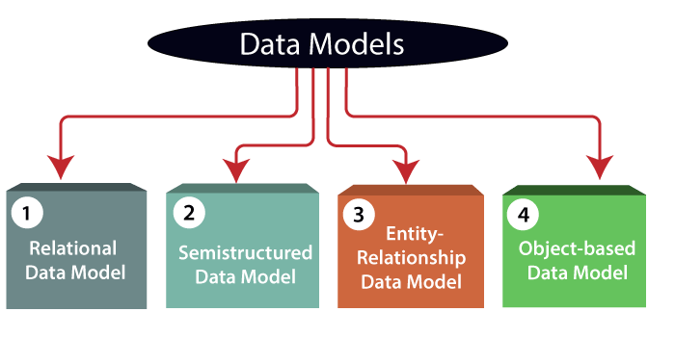

1. **Relational Data Model:** This type of model designs the data in the form of rows and columns within a table. Thus, a relational model uses tables for representing data and in-between relationships. Tables are also called relations.

**2) Entity-Relationship Data Model:** An ER model is the logical representation of data as objects and relationships among them. These objects are known as entities, and relationship is an association among these entities.For example, student_name, student_id describes the 'student' entity. A set of the same type of entities is known as an 'Entity set', and the set of the same type of relationships is known as 'relationship set'.

**3) Object-based Data Model:** An extension of the ER model with notions of functions, encapsulation, and object identity, as well. This model supports a rich type system that includes structured and collection types.Here, the objects are nothing but the data carrying its properties.

**4) Semi-structured Data Model:** This type of data model is different from the other three data models (explained above). The semi-structured data model allows the data specifications at places where the individual data items of the same type may have different attributes sets. The Extensible Markup Language, also known as XML, is widely used for representing the semi-structured data.

# 4.4 Three schema Architecture

* The three schema architecture is also called ANSI/SPARC architecture or three-level architecture.
* This framework is used to describe the structure of a specific database system.
* The three schema architecture is also used to separate the user applications and physical database.
* The three schema architecture contains three-levels. It breaks the database down into three different categories.

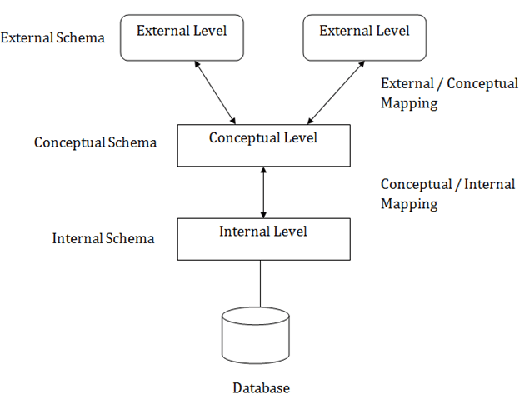

### 1. Internal Level

* The internal level has an internal schema which describes the physical storage structure of the database.
* The internal schema is also known as a physical schema.
* The physical level is used to describe complex low-level data structures in detail.

### 2. Conceptual Level

* The conceptual schema describes the design of a database at the conceptual level. Conceptual level is also known as logical level.
* The conceptual schema describes the structure of the whole database.
* Programmers and database administrators work at this level.

### 3. External Level

* At the external level, a database contains several schemas that sometimes called as subschema. The subschema is used to describe the different view of the database.
* An external schema is also known as view schema.
* The view schema describes the end user interaction with database systems

# 4.5 Data model Schema and Instance

* The data which is stored in the database at a particular moment of time is called an instance of the database.
* The overall design of a database is called schema.
* A database schema is the skeleton structure of the database. It represents the logical view of the entire database.
* A schema contains schema objects like table, foreign key, primary key, views, columns, data types, stored procedure, etc.
* A database schema can be represented by using the visual diagram. That diagram shows the database objects and relationship with each other.
* A database schema is designed by the database designers to help programmers whose software will interact with the database. The process of database creation is called data modeling.

A schema diagram can display only some aspects of a schema like the name of record type, data type, and constraints. Other aspects can't be specified through the schema diagram. For example, the given figure neither show the data type of each data item nor the relationship among various files.

In the database, actual data changes quite frequently. For example, in the given figure, the database changes whenever we add a new grade or add a student. The data at a particular moment of time is called the instance of the database.

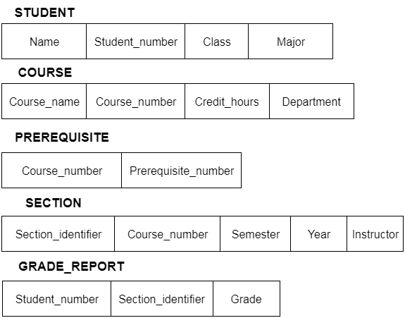

**4.6 ENTITY-RELATIONSHIP (ER) MODEL**

The Entity-Relationship (ER) Model is an attractive high level conceptual data model. It has an entity which may be an object with a physical existence like a particular car, house, person or employee or it may be an object with a conceptual existence like an organization, a profession, or a university course. Each entity has attributes—the definite properties that characterize it. For example, a student entity may be described by the student’s name, age, address, USN etc.

The Entity-Relationship (ER) Model is an attractive high level conceptual data model. It has an entity which may be an object with a physical existence like a particular car, house, person or employee or it may be an object with a conceptual existence like an organization, a profession, or a university course. Each entity has attributes—the definite properties that characterize it. For example, a student entity may be described by the student’s name, age, address, USN etc.

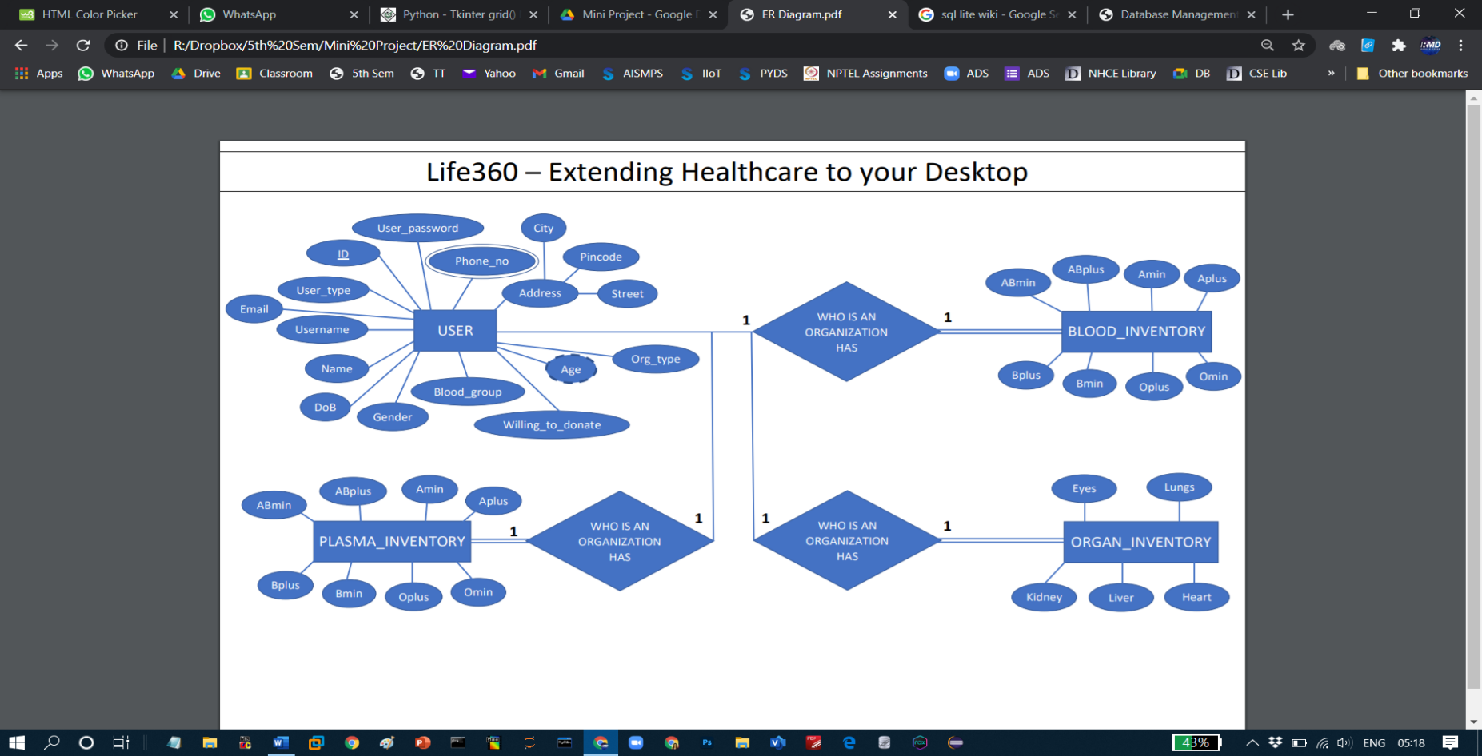

**CHAPTER 4**

**FUNDAMENTALS OF SQL**

**4.1 INTRODUCTION**

Nowadays, SQL is widely used in data science and analytic. Following are the reasons which explain why it is widely used:

* The basic use of SQL for data professionals and SQL users is to insert, update, and delete the data from the relational database.
* SQL allows the data professionals and users to retrieve the data from the relational database management systems.
* It also helps them to describe the structured data.
* It allows SQL users to create, drop, and manipulate the database and its tables.
* It also helps in creating the view, stored procedure, and functions in the relational database.
* It allows you to define the data and modify that stored data in the relational database.
* It also allows SQL users to set the permissions or constraints on table columns, views, and stored procedures.

## 4.2 SQL Commands

The SQL commands help in creating and managing the database. The most common SQL commands which are highly used are mentioned below:

1. CREATE command
2. UPDATE command
3. DELETE command
4. SELECT command
5. DROP command
6. INSERT command

### CREATE Command

This command helps in creating the new database, new table, table view, and other objects of the database.

### UPDATE Command

This command helps in updating or changing the stored data in the database.

### DELETE Command

This command helps in removing or erasing the saved records from the database tables. It erases single or multiple tuples from the tables of the database.

### SELECT Command

This command helps in accessing the single or multiple rows from one or multiple tables of the database. We can also use this command with the WHERE clause.

### DROP Command

This command helps in deleting the entire table, table view, and other objects from the database.

### INSERT Command

This command helps in inserting the data or records into the database tables. We can easily insert the records in single as well as multiple rows of the table.

## Advantages of SQL

SQL provides various advantages which make it more popular in the field of data science. It is a perfect query language which allows data professionals and users to communicate with the database. Following are the best advantages or benefits of Structured Query Language:

**1. No programming needed**

SQL does not require a large number of coding lines for managing the database systems. We can easily access and maintain the database by using simple SQL syntactical rules. These simple rules make the SQL user-friendly.

**2. High-Speed Query Processing**

A large amount of data is accessed quickly and efficiently from the database by using SQL queries. Insertion, deletion, and updation operations on data are also performed in less time.

**3. Standardized Language**

SQL follows the long-established standards of ISO and ANSI, which offer a uniform platform across the globe to all its users.

**4. Portability**

The structured query language can be easily used in desktop computers, laptops, tablets, and even smartphones. It can also be used with other applications according to the user's requirements.

**5. Interactive language**

We can easily learn and understand the SQL language. We can also use this language for communicating with the database because it is a simple query language. This language is also used for receiving the answers to complex queries in a few seconds.

**6. More than one Data View**

The SQL language also helps in making the multiple views of the database structure for the different database users.

**4.3** **Data Definition Language**.

The DDL Commands in Structured Query Language are used to create and modify the schema of the database and its objects. The syntax of DDL commands is predefined for describing the data. The commands of Data Definition Language deal with how the data should exist in the database.

**Following are the five DDL commands in SQL:**

1. CREATE Command
2. DROP Command
3. ALTER Command
4. TRUNCATE Command
5. RENAME Command

**4.4 Data Manipulation Language**.

The DML commands in Structured Query Language change the data present in the SQL database. We can easily access, store, modify, update and delete the existing records from the database using DML commands.

**Following are the four main DML commands in SQL:**

1. SELECT Command
2. INSERT Command
3. UPDATE Command
4. DELETE Command

**4.5 Transaction control language**.

* A single unit of work in a database is formed after the consecutive execution of commands is known as a transaction.
* There are certain commands present in SQL known as TCL commands that help the user manage the transactions that take place in a database.
* **COMMIT. ROLLBACK** and **SAVEPOINT** are the most commonly used TCL commands in SQL.