Assignment 2: API
Zhexenov Dauren
SE-2404
Objective: The objective of this assignment is to learn how to work with APIs to retrieve, process, and display data. Enhance your project by integrating multiple APIs and presenting the information effectively. Develop clean, responsive, and user-friendly applications using best practices in coding and project design.
System Architecture
The project follows the MVC (Model-View-Controller) pattern, specifically focusing on the separation of Routes and Controllers.
- Backend: Node.js with Express.js framework.
- Routing: Dedicated route files to handle endpoint mapping.
- Business Logic: Controllers handle the asynchronous "chaining" of four different APIs.
- Frontend: Vanilla JavaScript, HTML5, and CSS3 Grid/Flexbox.

Implementation Details
Server-Side Logic (Node.js)
The core logic resides in the userController.js. It performs a sequence of requests where the output of one API serves as the input for the next.
- RandomUser API provides the country.
- REST Countries API uses that country to find the currency.
- ExchangeRate API uses the currency to fetch rates.
- News API uses the country to fetch headlines.
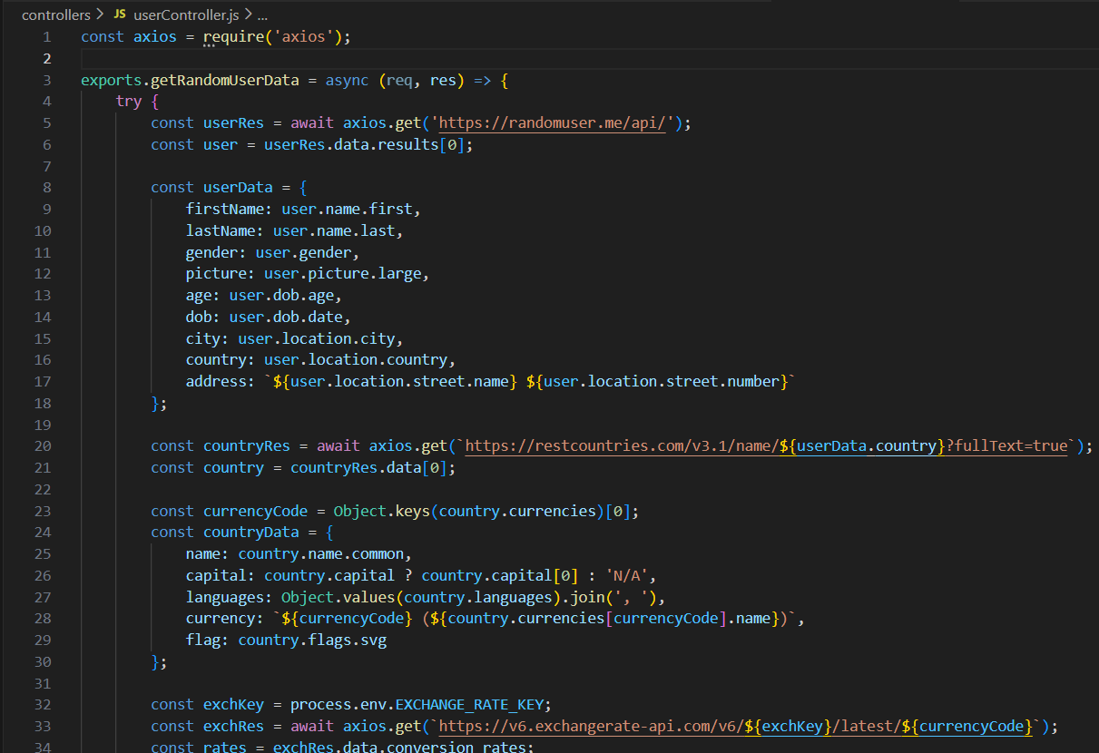
Environment Variables & Security
Sensitive information, such as API keys for NewsAPI and ExchangeRate-API, are stored securely in a .env file and accessed via process.env.
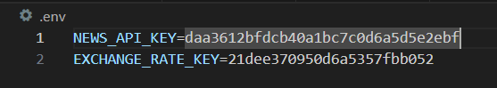
User Interface Design
The UI is designed to be intuitive and modular. Information is grouped into three main visual blocks:
- Identity Card: Personal details and profile picture.
- Geographic Info: National data, flag, and currency conversion.
- News Feed: A grid of the latest articles related to the user's country.
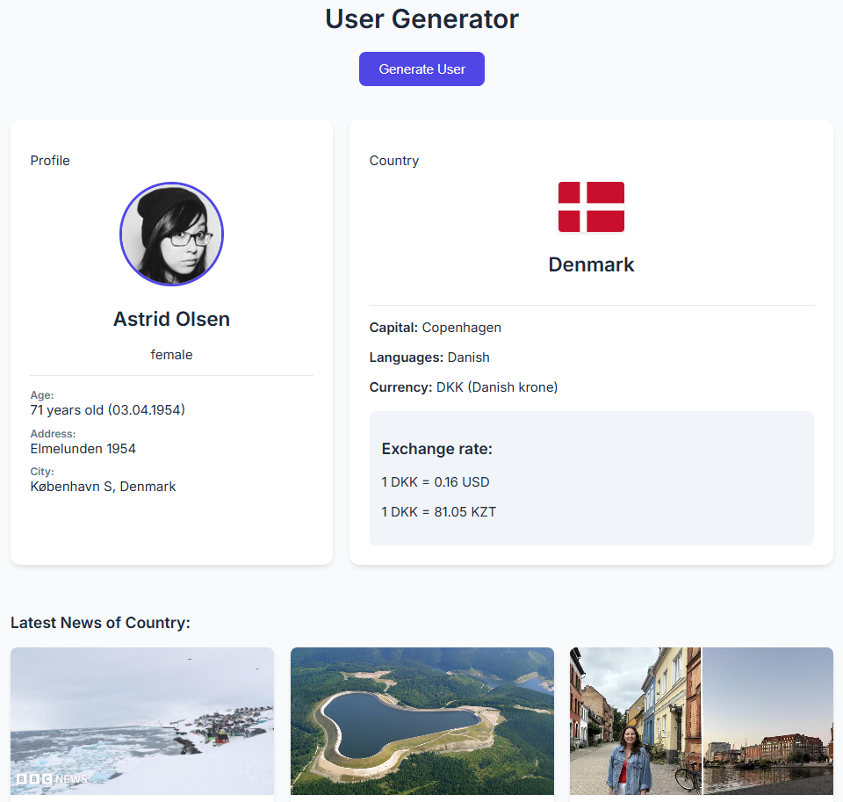
API Integration Results
Random User & Country Data
The application successfully extracts specific fields: First/Last name, Gender, Age, DOB, and Full Address.
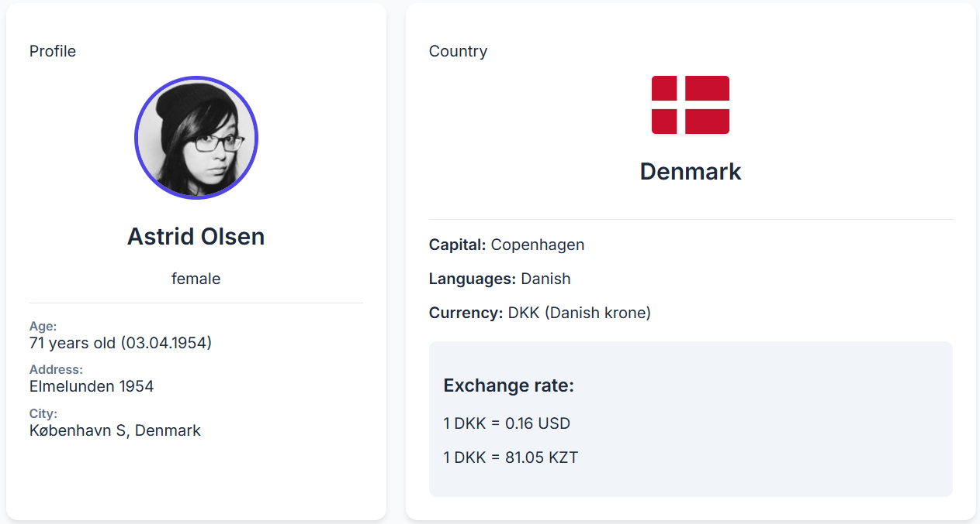
Currency Exchange Rates
The app dynamically calculates the value of the user's local currency against the USD and KZT.
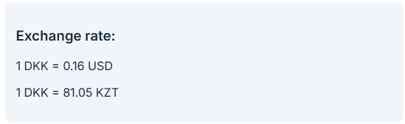
News Headlines
The News API fetches 5 articles in English. Each card includes a title, image, description, and a functional link to the source.

Conclusion
This project provided hands-on experience in building a modular Full-Stack application using the MVC (Routes/Controllers) architecture. I practiced the logic of API Chaining and server-side data processing, which significantly improved my understanding of backend security and efficient data management.

