Detailed steps to deploy Istio in Docker Desktop

Here is the complete process to run a Kubernetes cluster in Docker Desktop and complete the Istio starter tutorial. The steps have been optimized for the Docker Desktop environment to address issues such as entry gateway access and environment variable configuration.

1. Enable Kubernetes cluster on Docker Desktop

Open the Docker Desktop Settings and go to the Kubernetes TAB.

Enable Kubernetes and click Apply & Restart.

Wait for Kubernetes to finish startup (the status bar says "Kubernetes is running" in green).

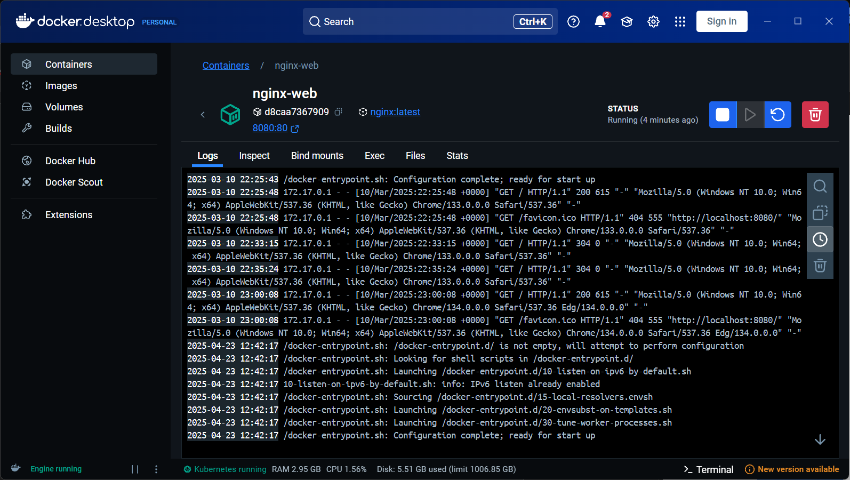

2. Download and install Istio

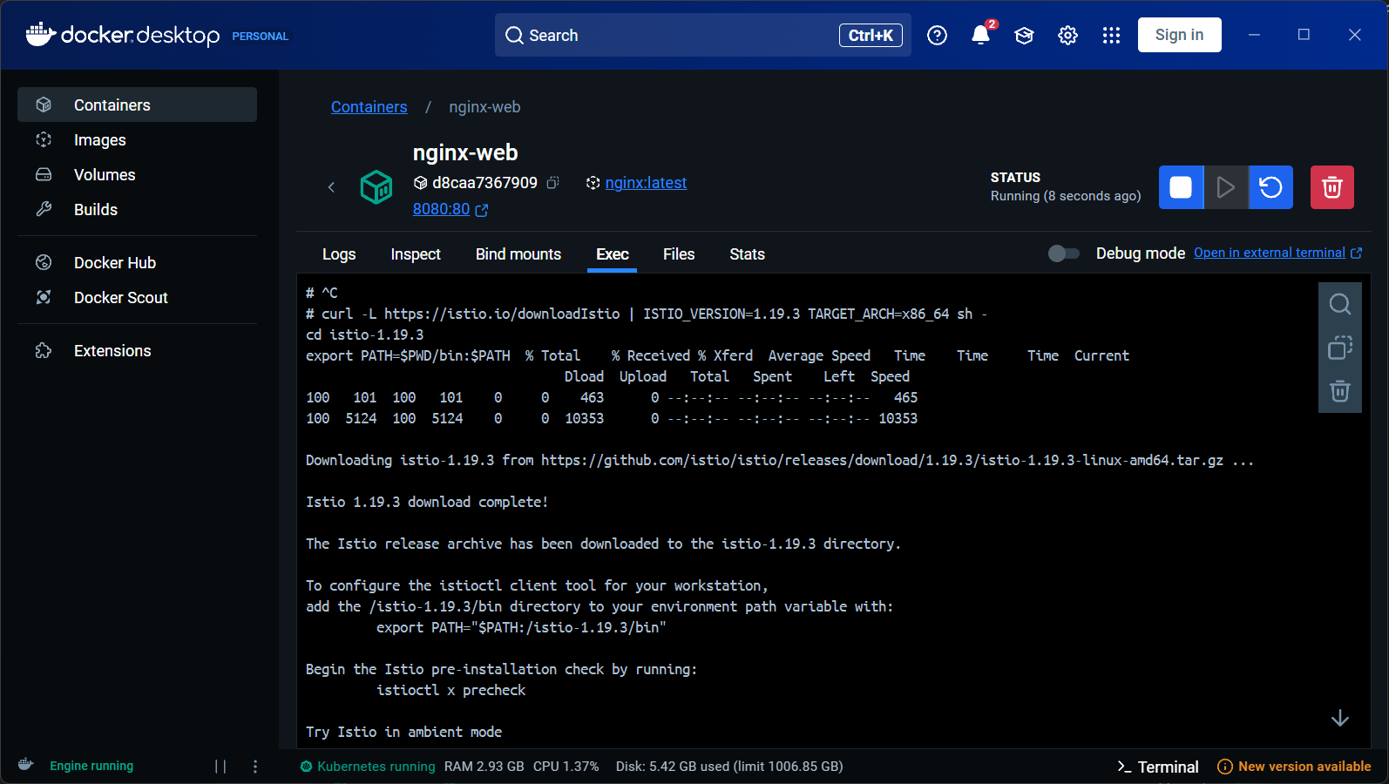

1. Environment preparation

Enable WSL2 (make sure Docker Desktop uses a WSL2 backend).

Install Chocolatey (Windows package manager, optional but recommended) :

powershell

replication

Set-ExecutionPolicy Bypass -Scope Process -Force; [System.Net.ServicePointManager]::SecurityProtocol = [System.Net.ServicePointManager]::SecurityProtocol -bor 3072; iex ((New-Object System.Net.WebClient).DownloadString('https://community.chocolatey.org/install.ps1'))

2. Install istioctl (Windows-specific step)

powershell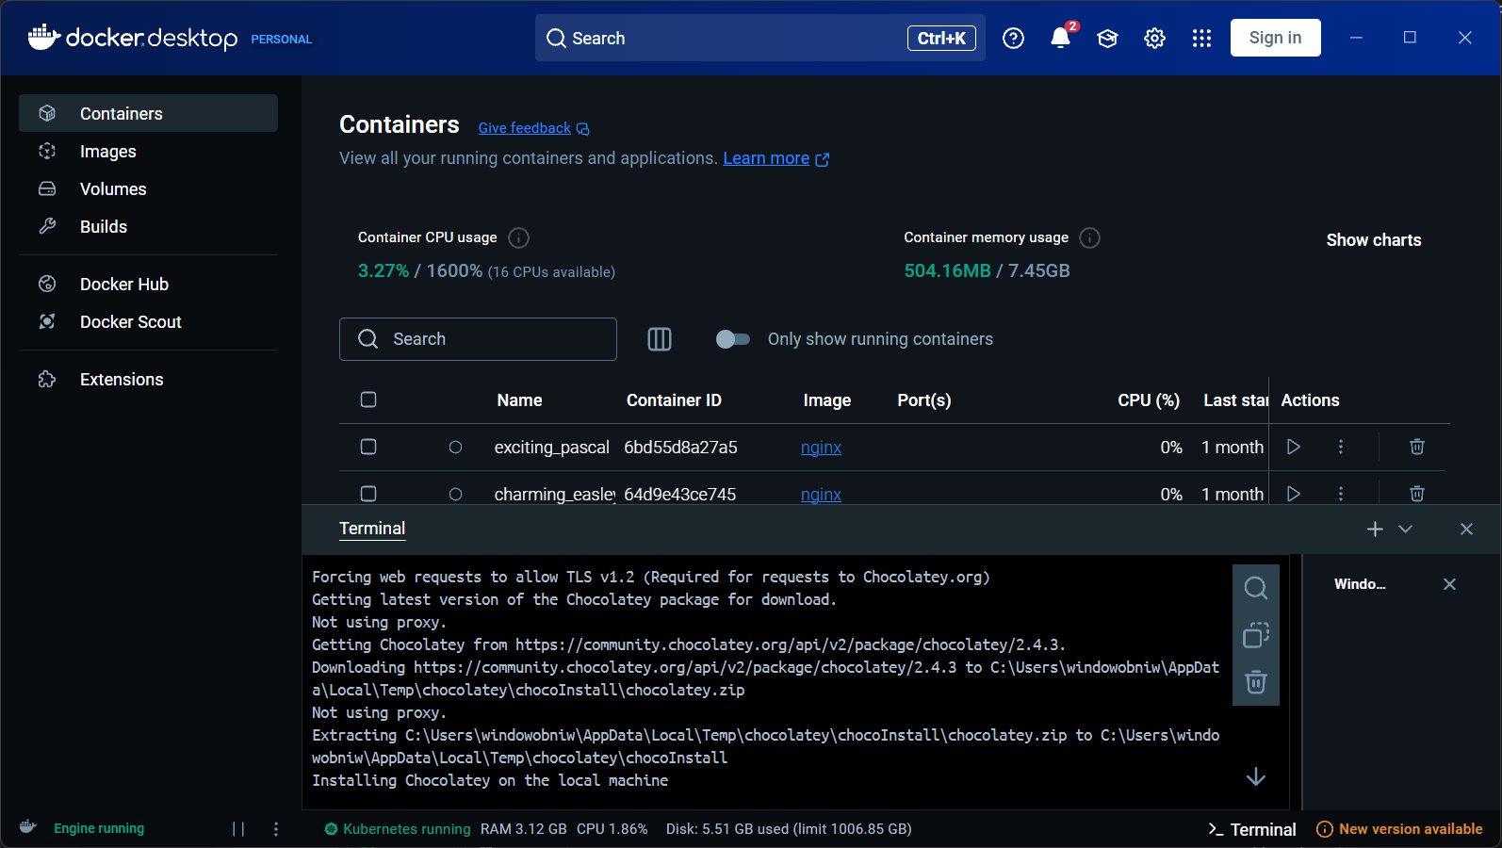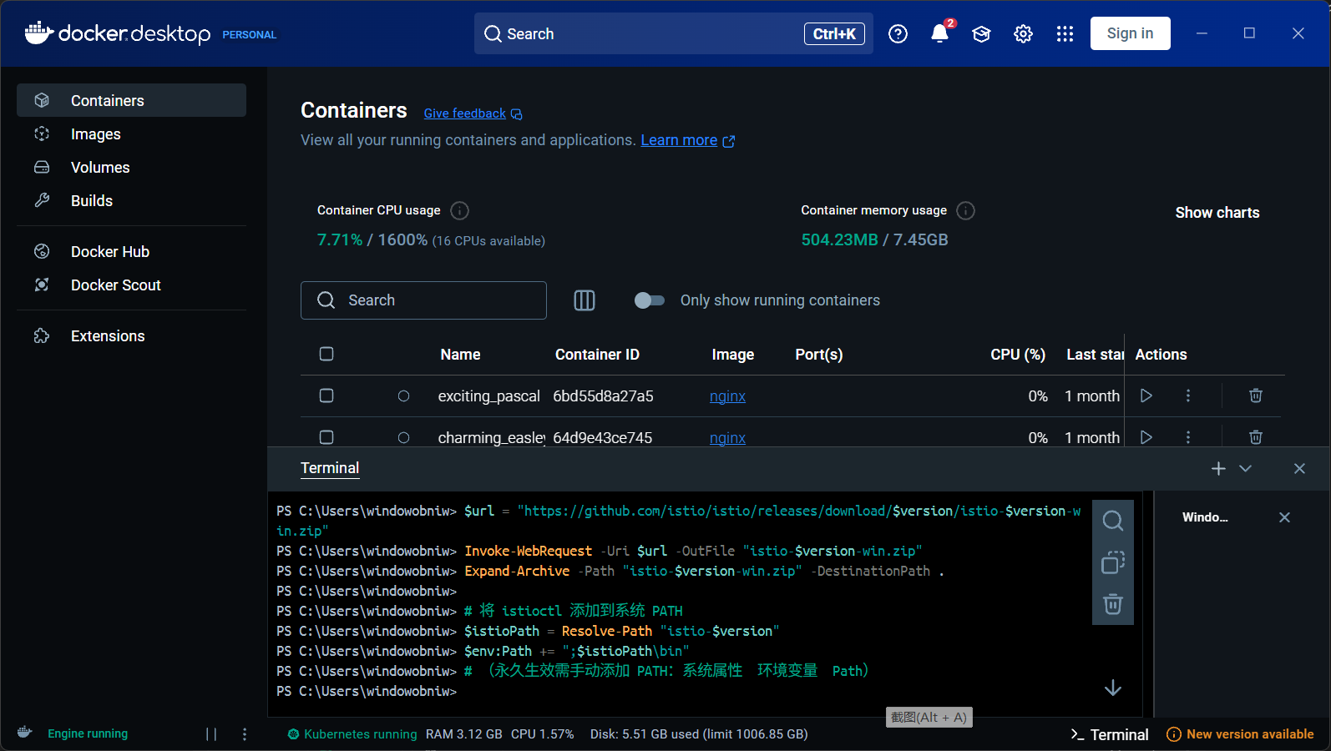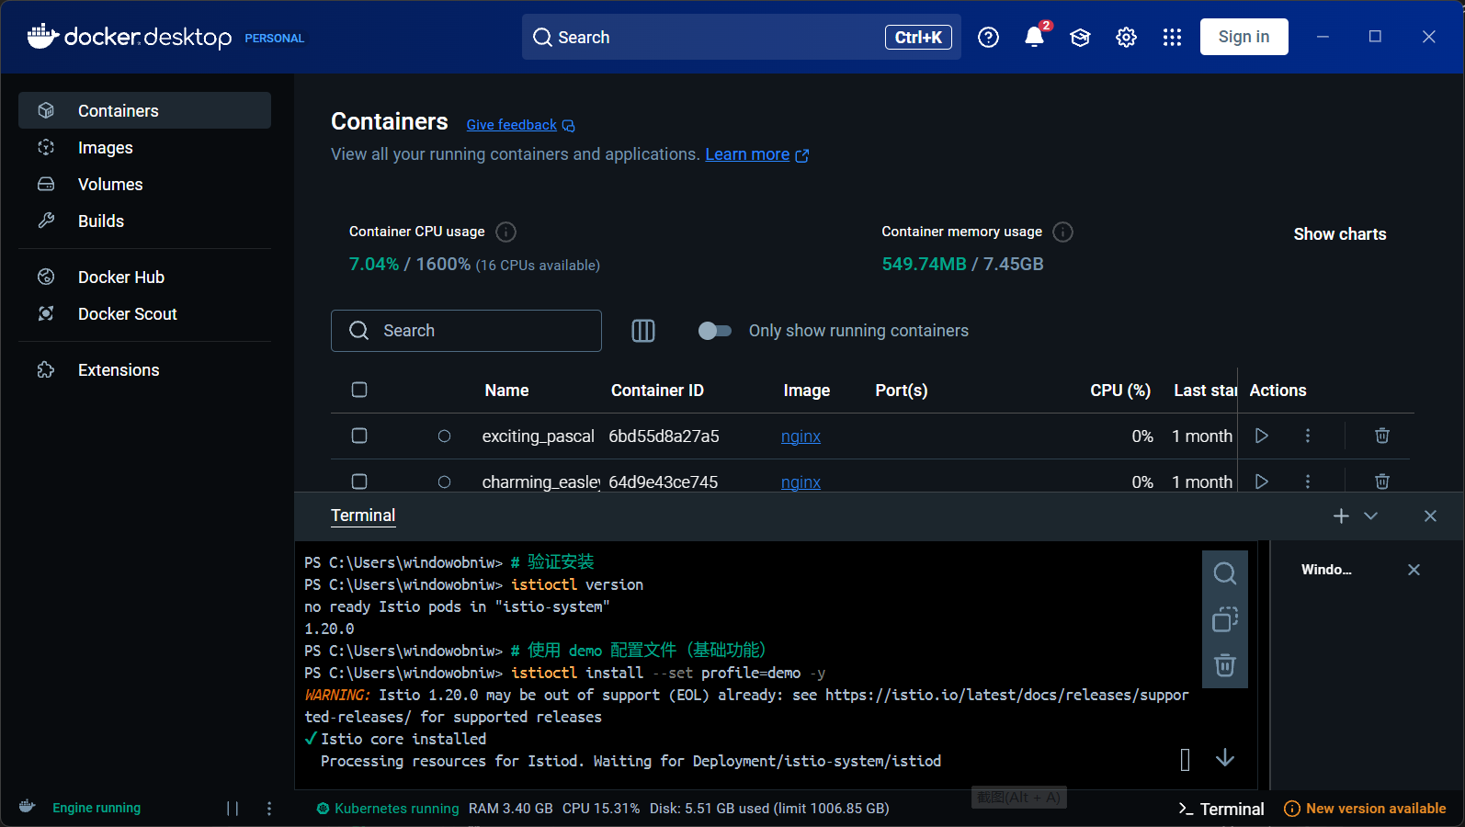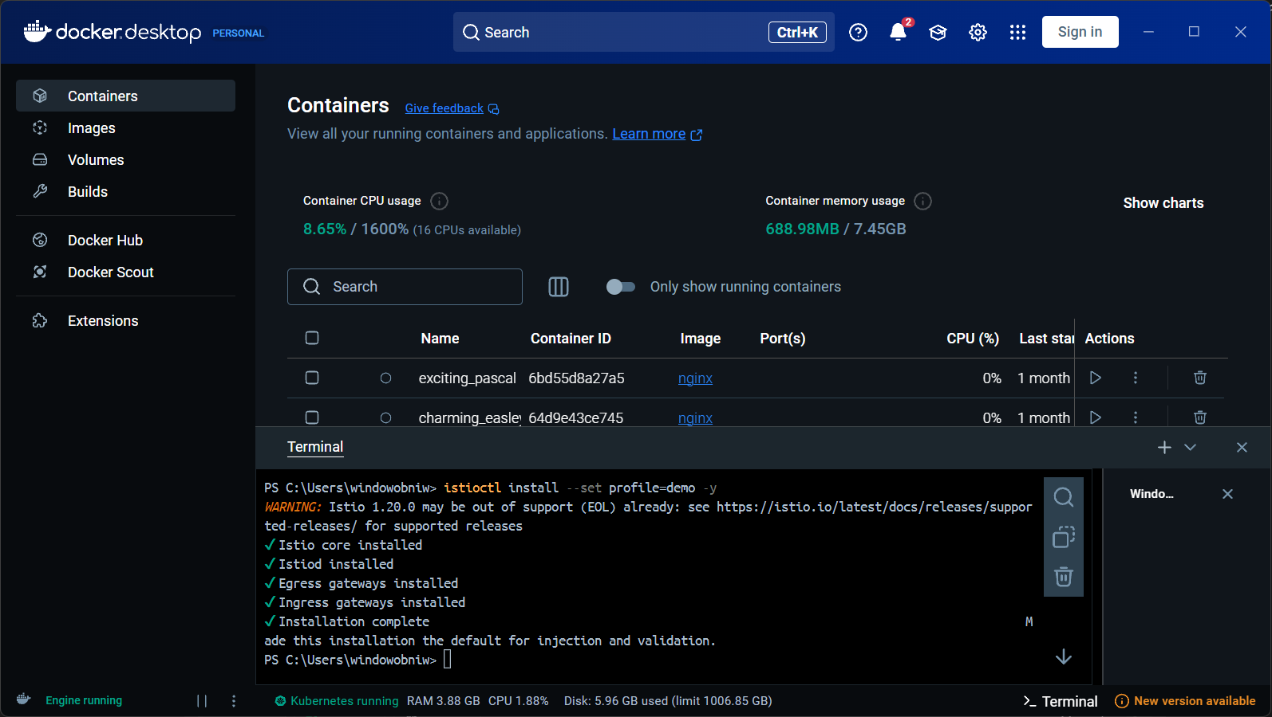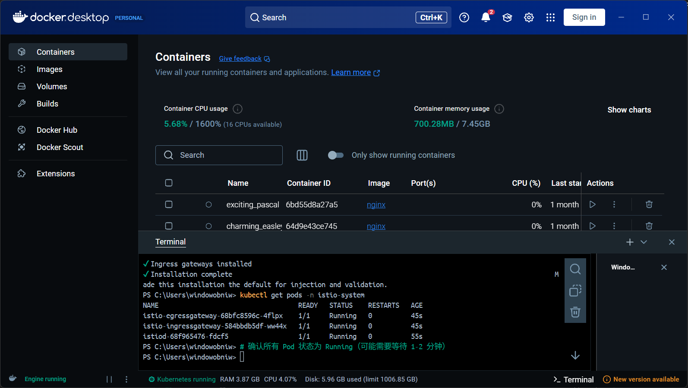

replication

Download Istio (e.g. 1.20.0)

$version = "1.20.0"

$url = "https://github.com/istio/istio/releases/download/$version/istio-$version-win.zip"

Invoke-WebRequest -Uri $url -OutFile "istio-$version-win.zip"

Expand-Archive -Path "istio-$version-win.zip" -DestinationPath .

Add istioctl to the system PATH

$istioPath = Resolve-Path "istio-$version"

$env:Path += "; $istioPath\bin"

# (manually add PATH: system properties → environment variables → Path)

Verify installation

istioctl version

电脑屏幕的手机截图

AI 生成的内容可能不正确。3. Install Istio to Kubernetes

powershell

replication

Using the demo configuration file (basic functionality)

istioctl install --set profile=demo -y

Verify the control plane state

powershell

replication

kubectl get pods -n istio-system

Verify that all pods are Running (may take 1-2 minutes)

截图里有图片

AI 生成的内容可能不正确。5. Enable automatic Sidecar injection (for the default namespace)

powershell

replication

kubectl label namespace default istio-injection=enabled

电脑屏幕截图

AI 生成的内容可能不正确。6. Deploying the sample App (Bookinfo)

powershell

replication

Go to the Istio directory

cd istio-$version

Deploy the Bookinfo application

kubectl apply -f samples/bookinfo/platform/kube/bookinfo.yaml

Wait for all pods to run (2/2 of each Pod should be Running)

kubectl get pods -w电脑屏幕的手机截图

AI 生成的内容可能不正确。

图形用户界面, 文本, 应用程序, 电子邮件

AI 生成的内容可能不正确。7. Configure gateways and routes

powershell

replication

kubectl apply -f samples/bookinfo/networking/bookinfo-gateway.yaml