Since I was not able to directly manipulate Docker Desktop or generate screenshots, I will provide you with a detailed step-by-step guide for completing these 4 Istio experiments in Docker Desktop for Windows China. You can follow these steps and take screenshots of the key steps yourself.

Experiment 1: Traffic Shifting

Steps:

Start Docker Desktop and make sure Kubernetes is enabled

Install Istio to the cluster (install using istioctl)

Deploy the Bookinfo example app:

markdown

replication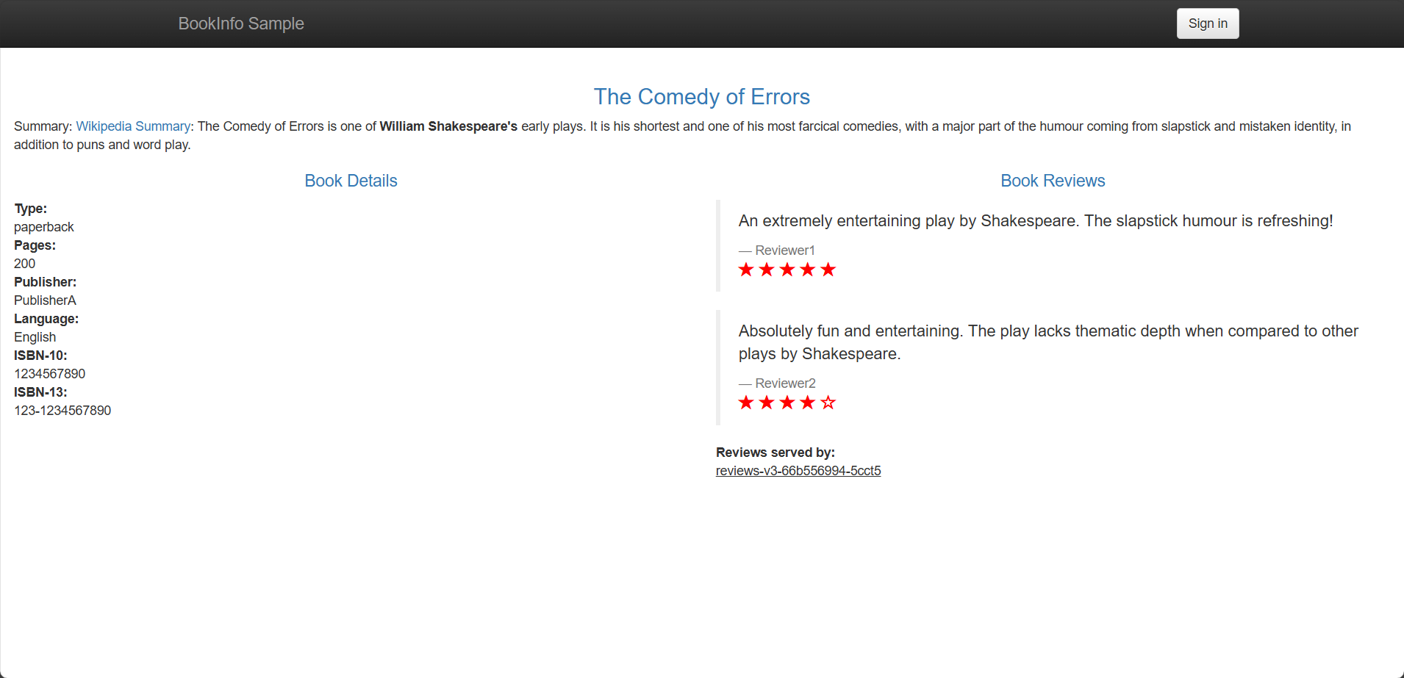

kubectl apply -f samples/bookinfo/platform/kube/bookinfo.yaml

Create a default gateway:

markdown

replication

kubectl apply -f samples/bookinfo/networking/bookinfo-gateway.yaml

Apply the rule for all traffic to v1:

markdown

replication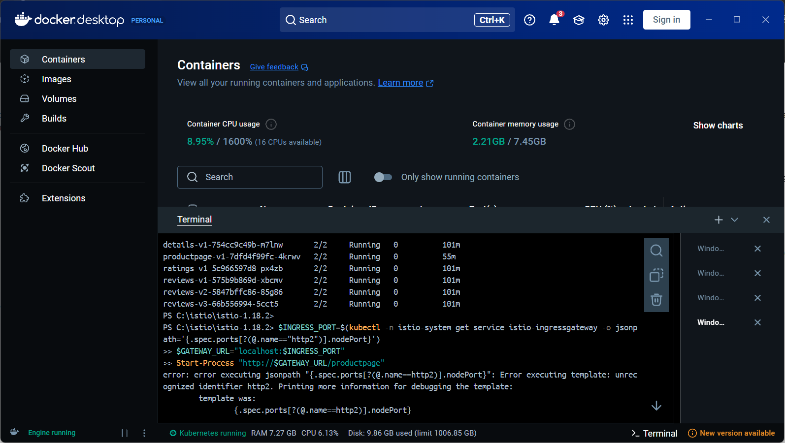

kubectl apply -f samples/bookinfo/networking/virtual-service-all-v1.yaml

Get the gateway URL and open /productpage in a browser

Apply the rule of 50% traffic to v3:

markdown

replication电脑屏幕的手机截图

AI 生成的内容可能不正确。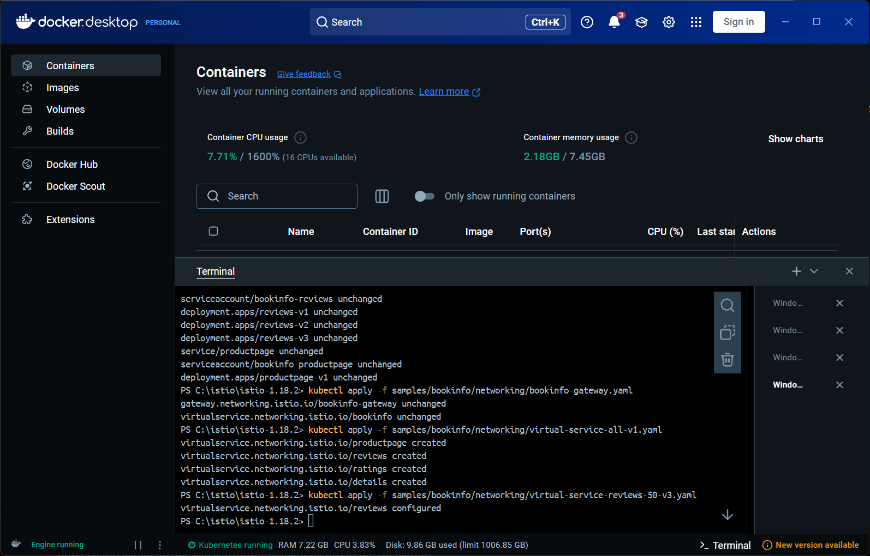

kubectl apply -f samples/bookinfo/networking/virtual-service-reviews-50-v3.yaml

Refresh the page to see how often red stars appear

Finally apply the rule with 100% traffic to v3 version

Experiment 2: Request Routing

Steps:

电脑屏幕的手机截图

AI 生成的内容可能不正确。

Make sure the Bookinfo application is deployed

Apply the rule of full traffic to v1 version

图形用户界面, 文本, 应用程序

AI 生成的内容可能不正确。Apply user-based routing rules:

markdown

replication

kubectl apply -f samples/bookinfo/networking/virtual-service-reviews-test-v2.yaml

Log in as user "jason" to observe the rating display

Log in as another user to observe no stars

Experiment 3: Fault Injection

Steps:

Make sure Bookinfo is deployed and apply v1 and test v2 rules

Inject a 7-second delay fault:

markdown

replication电脑截图

AI 生成的内容可能不正确。

kubectl apply -f samples/bookinfo/networking/virtual-service-ratings-test-delay.yaml

Log in as jason to observe page load latency and errors

Inject HTTP abort faults:

markdown

replication图形用户界面, 文本, 应用程序

AI 生成的内容可能不正确。

kubectl apply -f samples/bookinfo/networking/virtual-service-ratings-test-abort.yaml

Log in as user jason and observe the error messages

Experiment 4: Circuit Breaking

Steps:

Deploy the httpbin service:

markdown

replication

kubectl apply -f samples/httpbin/httpbin.yaml

Apply the circuit breaker rule:

markdown

replication

kubectl apply -f samples/httpbin/networking/destination-rule-all.yaml

Deploying the fortio load test Client

Different concurrency numbers are used to test the fuse effect