

SYMBIOSIS UNIVERSITY OF APPLIED SCIENCES (SUAS)

**India’s 1st Skill Development University**

**PRACTICAL JOURNAL**

Enrollment Number – 2019BTCS088 Year of Enrollment – 2019-2023

Name of the Student – YASH GUPTA

School of COMPUTER SCIENCE & INFORMATION TECHNOLOGY

Program – B. TECH

Specialization/ Branch – CS&IT

Semester - 3rd Section – B2 Branch – CS&IT

Paper Code – BTCS03CCB5 Name of Paper – ADAA

Faculty-In-Charge - DR. P. MANIKANANDAN SIR

CERTIFICATE

THE PRACTICAL EXPERIMENTS

ENTERED IN THIS JOURNAL HAVE BEEN SATISFACTORY PERFORMED BY

ENROLLMENT NO - 2019BTCS088 MR/MS­­­­­­­­­­­­­­­­­­­­ YASH GUPTA

STUDYING IN PROGRAM B. TECH BRANCH CS&IT IN

SCHOOL OF COMPUTER SCIENCE & INFORMATION TECHNOLOGY

DURING SEMESTER 3RD OF ACADEMIC YEAR 2020-2021

_______________________

( )

Date: 16/04/2021

INDEX

|  |  |  |  |  |
| --- | --- | --- | --- | --- |
| S.NO | Title of Skill Activity | Date of Allocation | Date of Submission | Sign of Faculty |
| 1 | Practical-06 | 16/12/2021 | 16/12/2021 |  |
| 2 | Practical-07 | 16/12/2021 | 16/12/2021 |  |
| 3 | Practical-08 | 16/12/2021 | 16/12/2021 |  |
|  |  |  |  |  |
|  |  |  |  |  |
|  |  |  |  |  |
|  |  |  |  |  |
|  |  |  |  |  |
|  |  |  |  |  |
|  |  |  |  |  |
|  |  |  |  |  |
|  |  |  |  |  |
|  |  |  |  |  |
|  |  |  |  |  |
|  |  |  |  |  |
|  |  |  |  |  |
|  |  |  |  |  |
|  |  |  |  |  |
|  |  |  |  |  |
|  |  |  |  |  |
|  |  |  |  |  |
|  |  |  |  |  |
|  |  |  |  |  |
|  |  |  |  |  |
|  |  |  |  |  |
|  |  |  |  |  |

PRACTICAL-06

**Write a Program to Implement Prim's Algorithm in C++.**

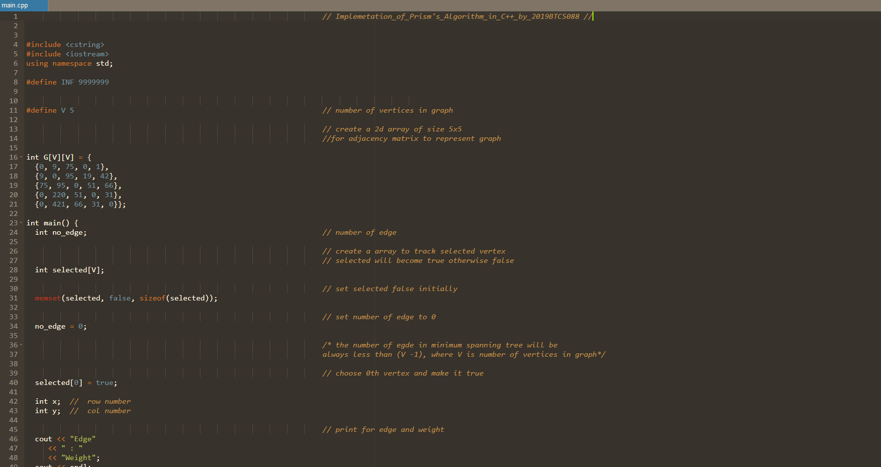

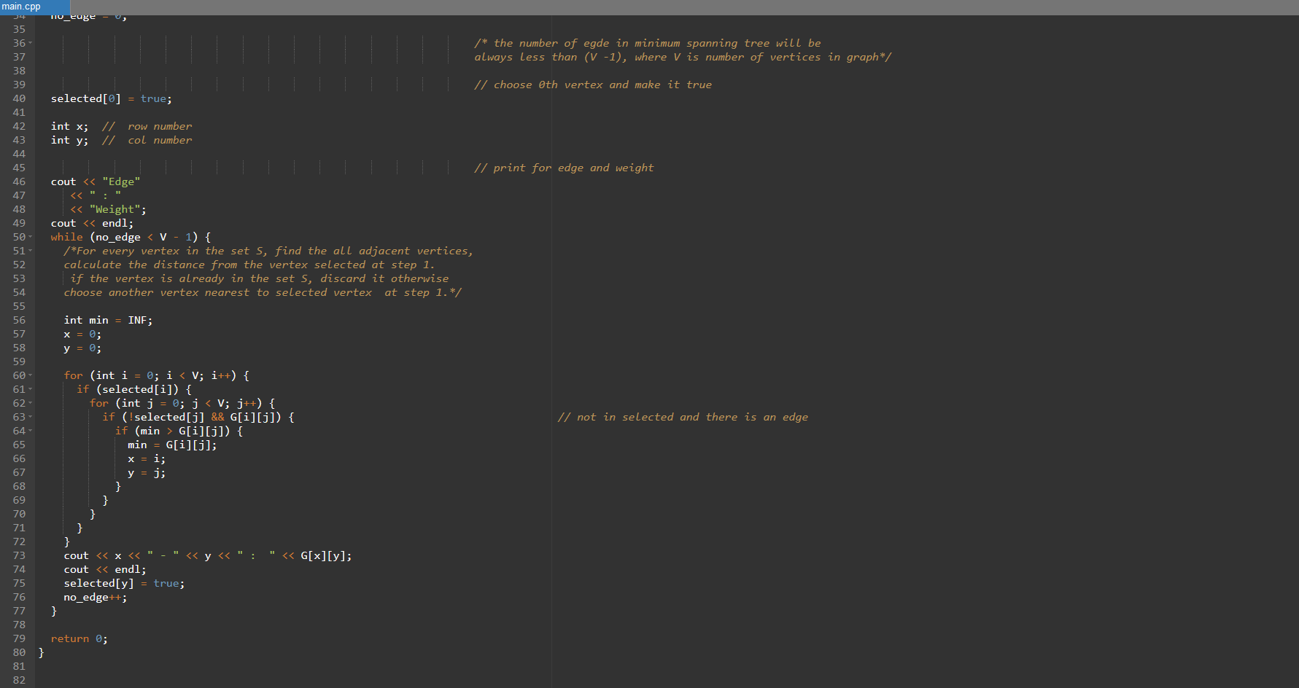

# Output

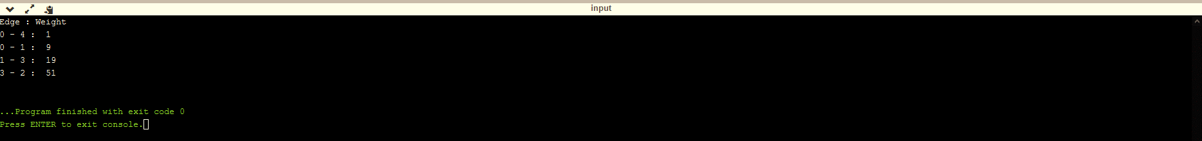

**--------<<<THE END>>>------**

PRACTICAL-07

**Write a Program to implement Kruskal's Algorithm.**

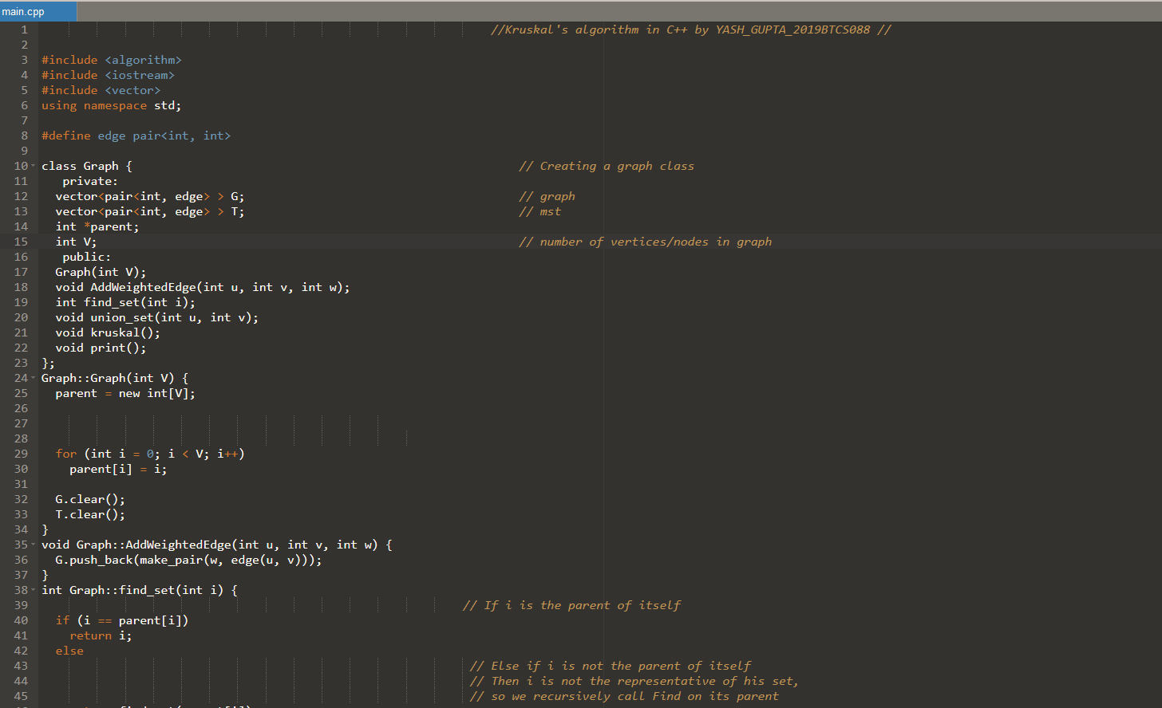

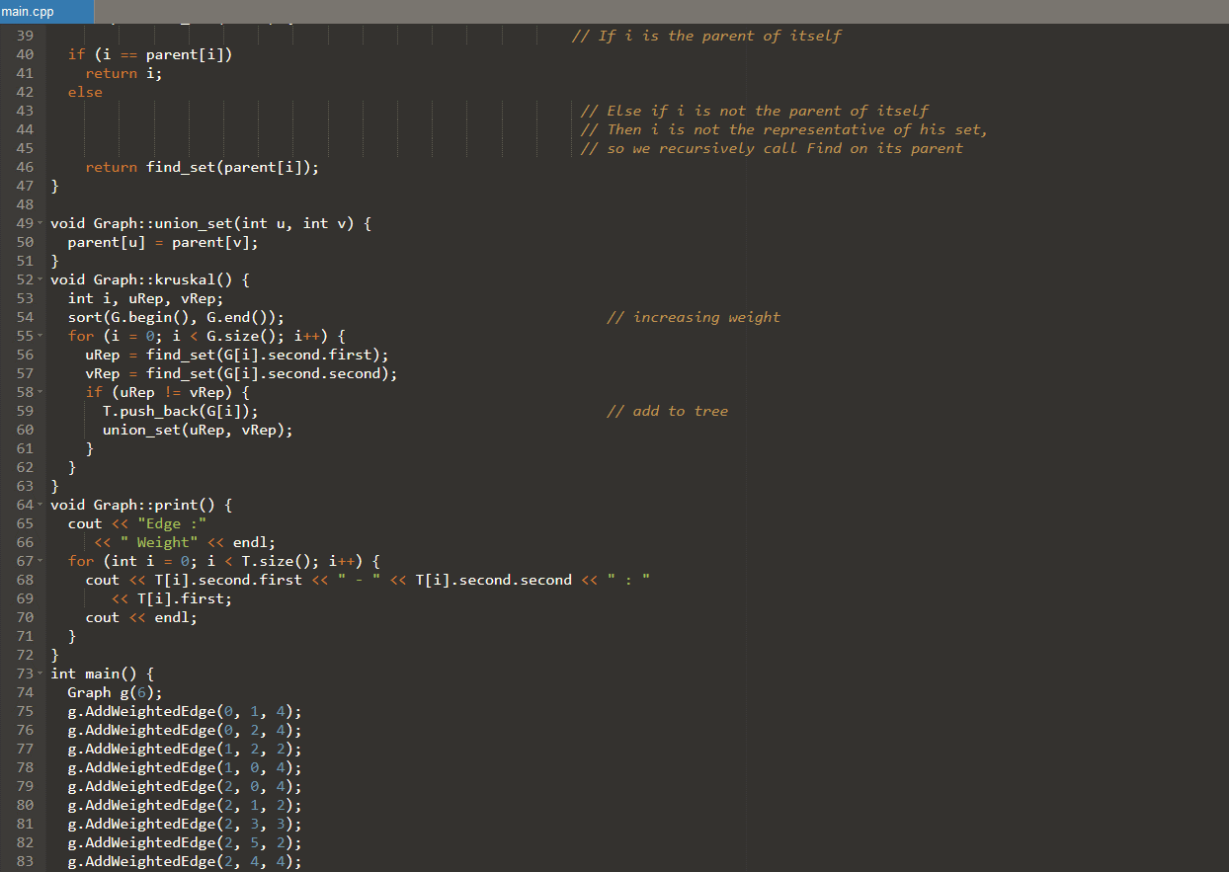

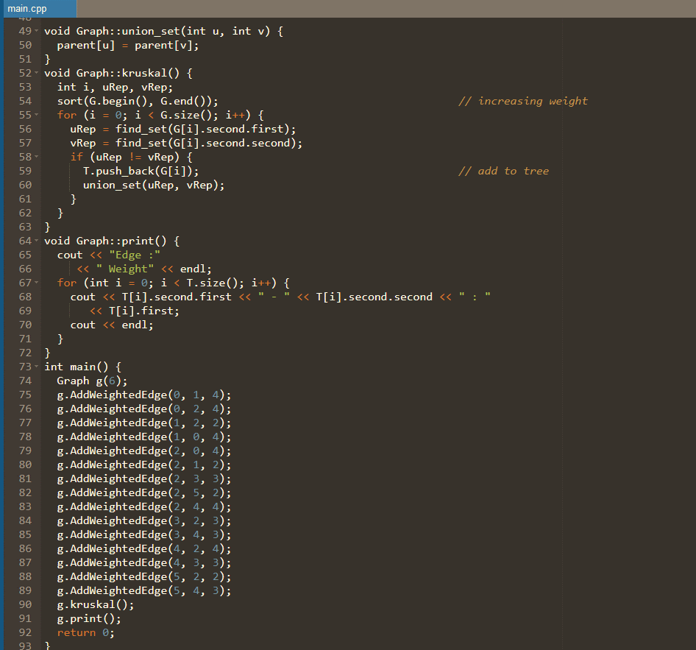

# Output

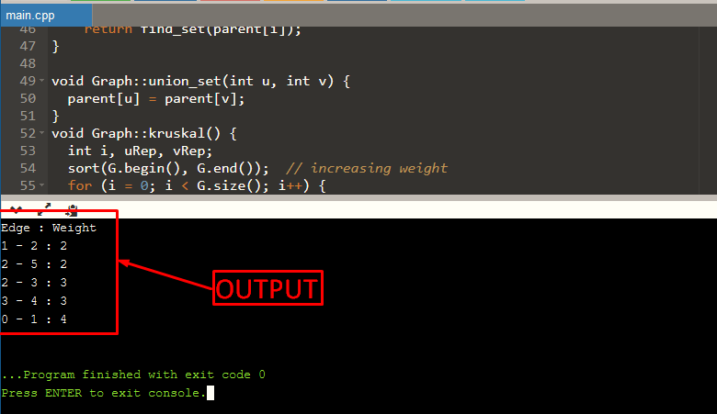

------<<<THE END>>>-------

PRACTICAL-08

**Write a Program of Fibonacci Series using Dynamic Programming.**

**INPUT CODE**

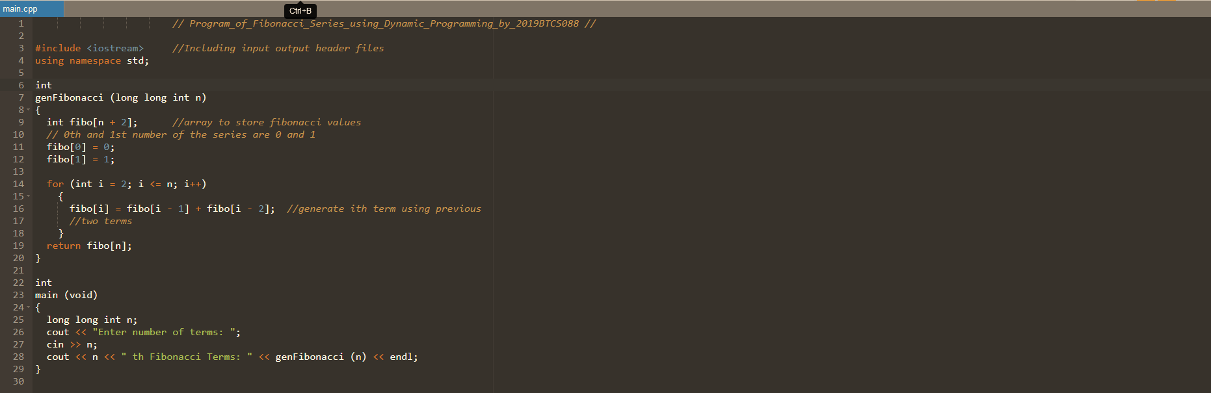

**OUTPUT CODE**

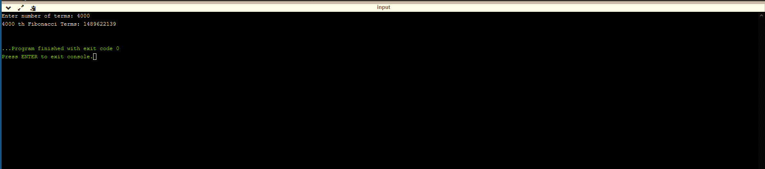  
-------<<<THE END>>>-------

INTENTIONALLY LEFT BLANK FOR DIVERSION BETWEEN SKILL AND PRACTICAL JOURNAL



SYMBIOSIS UNIVERSITY OF APPLIED SCIENCES (SUAS)

**India’s 1st Skill Development University**

**SKILL JOURNAL**

Enrollment Number – 2019BTCS088 Year of Enrollment – 2019-2023

Name of the Student – YASH GUPTA

School of COMPUTER SCIENCE & INFORMATION TECHNOLOGY

Program – B. TECH

Specialization/ Branch – CS&IT

Semester - 3rd Section – B2 Branch – CS&IT

Paper Code – BTCS03CCB5 Name of Paper – ADAA

Faculty-In-Charge - DR. P. MANIKANANDAN SIR

CERTIFICATE

THE SKILL EXPERIMENTS

ENTERED IN THIS JOURNAL HAVE BEEN SATISFACTORY PERFORMED BY

ENROLLMENT NO - 2019BTCS088 MR/MS­­­­­­­­­­­­­­­­­­­­ YASH GUPTA

STUDYING IN PROGRAM B. TECH BRANCH CS&IT IN

SCHOOL OF COMPUTER SCIENCE & INFORMATION TECHNOLOGY

DURING SEMESTER 3RD OF ACADEMIC YEAR 2020-2021

_______________________

( )

Date: 16/04/2021

INDEX

|  |  |  |  |  |
| --- | --- | --- | --- | --- |
| S.NO | Title of Skill Activity | Date of Allocation | Date of Submission | Sign of Faculty |
| 1 | Skill-01 | 16/12/2021 | 16/12/2021 |  |
| 2 | Skill-02 | 16/12/2021 | 16/12/2021 |  |
| 3 | Skilll-03 | 16/12/2021 | 16/12/2021 |  |
|  |  |  |  |  |
|  |  |  |  |  |
|  |  |  |  |  |
|  |  |  |  |  |
|  |  |  |  |  |
|  |  |  |  |  |
|  |  |  |  |  |
|  |  |  |  |  |
|  |  |  |  |  |
|  |  |  |  |  |
|  |  |  |  |  |
|  |  |  |  |  |
|  |  |  |  |  |
|  |  |  |  |  |
|  |  |  |  |  |
|  |  |  |  |  |
|  |  |  |  |  |
|  |  |  |  |  |
|  |  |  |  |  |
|  |  |  |  |  |

**SKILL-01**

**Coin change Problem -   
You are given coins of different denominations and a total sum. Coins are – (1, 2, 5, 10) and Sum = 18.  Find the number of ways we get the sum using coins. Number of coins are unlimited and any denomination of coin can be used any number of times. Write a program to find the number of possible ways we get the sum using the above given coin denomination.**

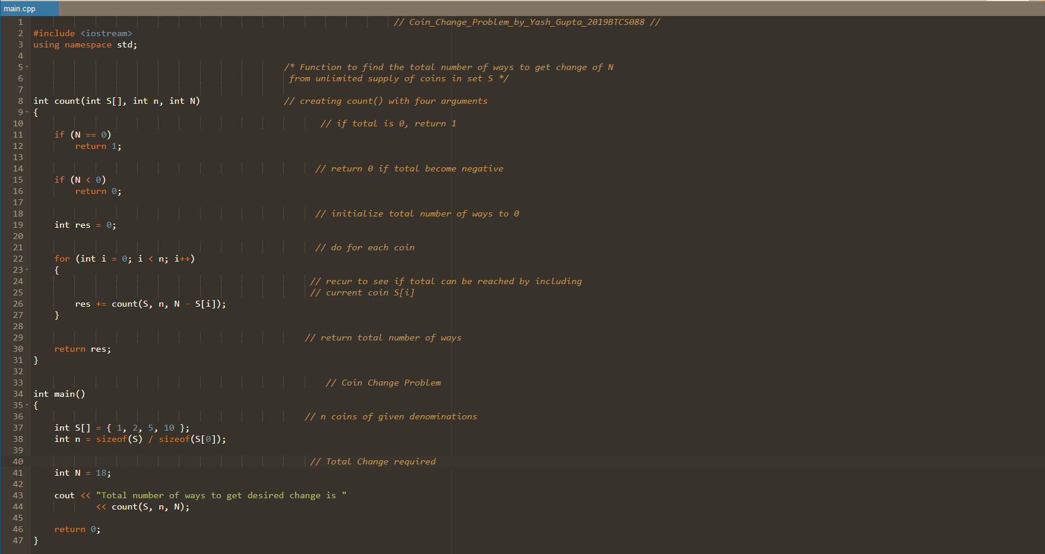

# Output

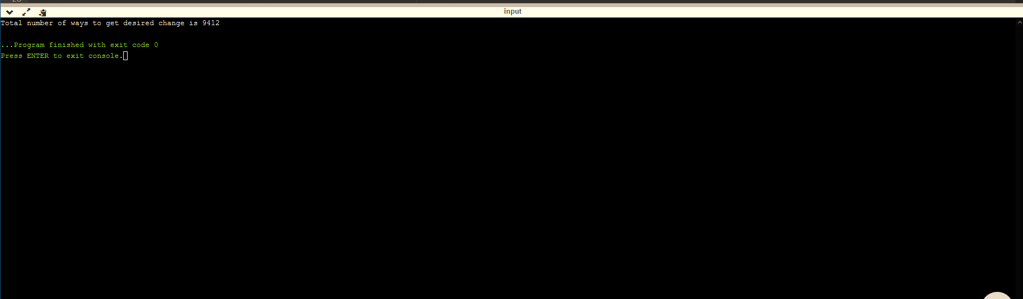

-------<<<THE END>>>--------

**SKILL-02**

**Rod cutting Problem - Given a rod of length n, and an array that contains the prices of all the pieces smaller than n, determine the maximum profit you could obtain from cutting up the rod and selling its pieces. Write a program to find the maximum profit for the values given below - Suppose that we have a rod of length 5, and an array containing the length(1,2,3 and 4 ) and price(2,5,7 and 8 ) of the pieces.**

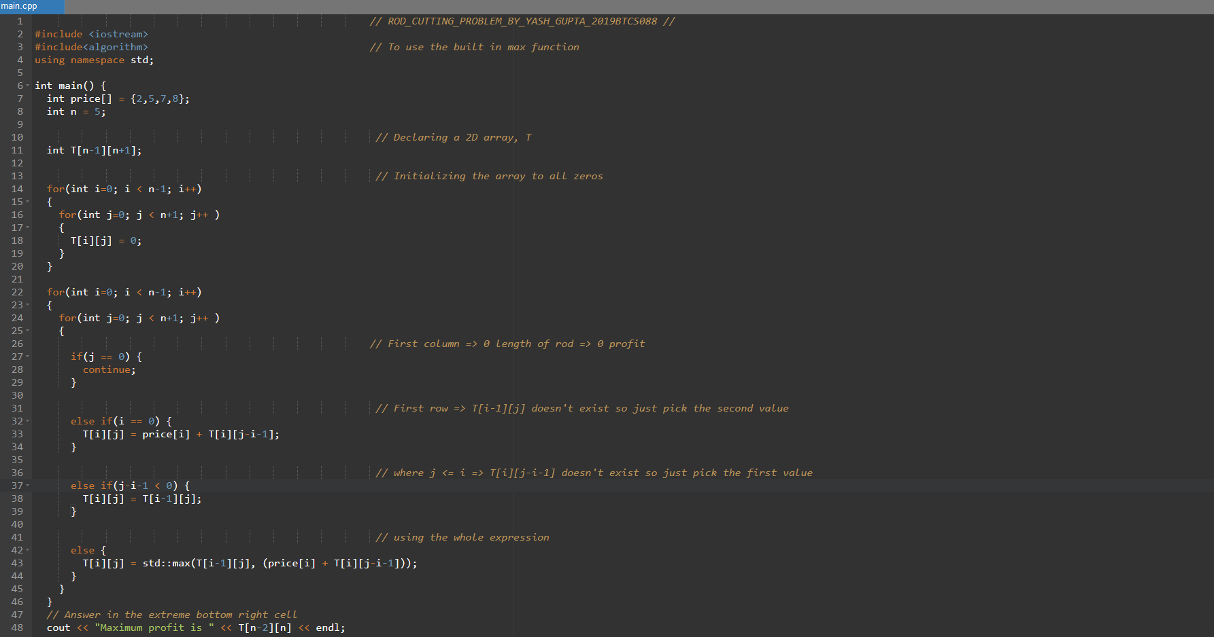

# Output

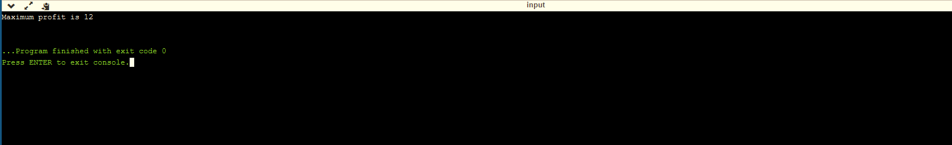

-------<<<THE END>>>--------

**SKILL-03**

**Equal Sum Partition problem – A set has been given and you have to find that can the given set can be divided into two subsets such that sum of both subsets are equal. Write a program to find if it is possible to divide a given set into two subsets with equal sum.**

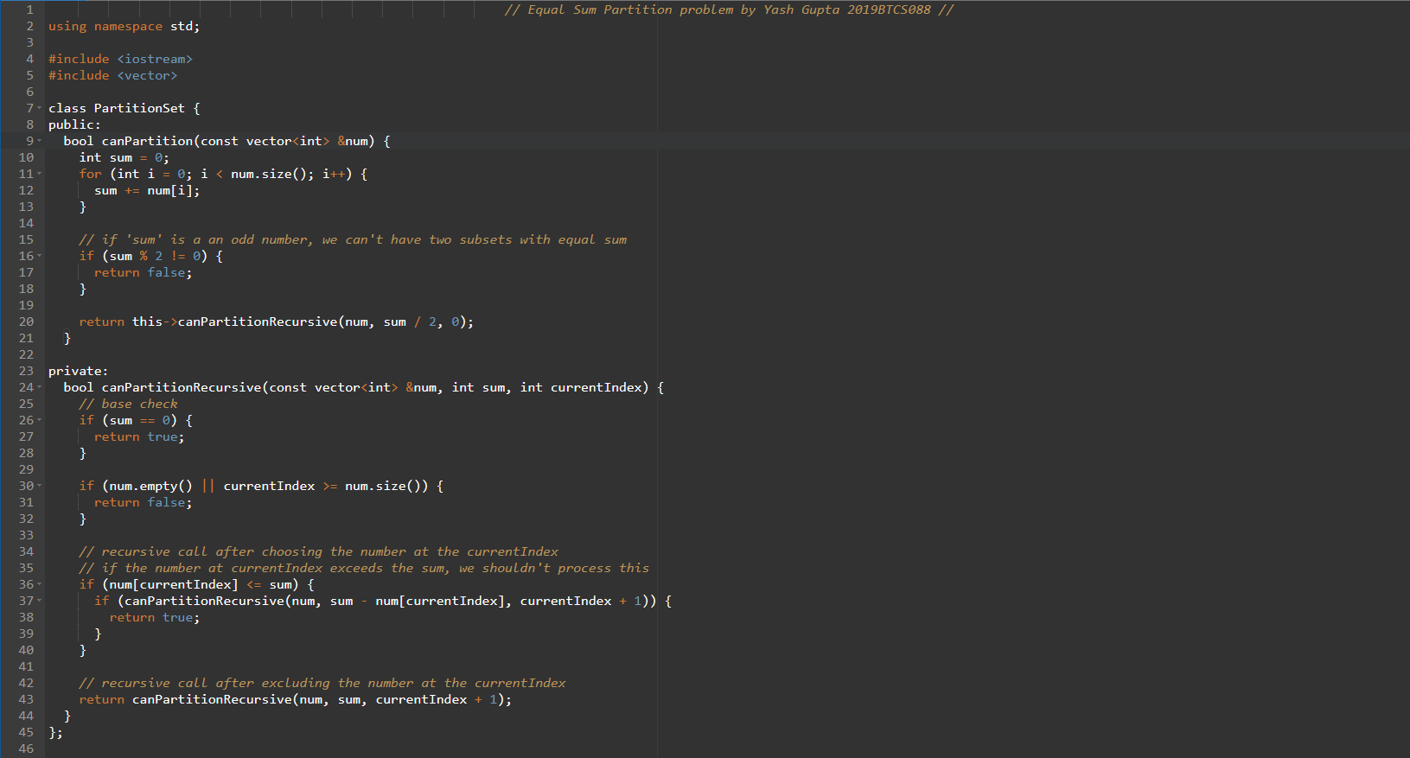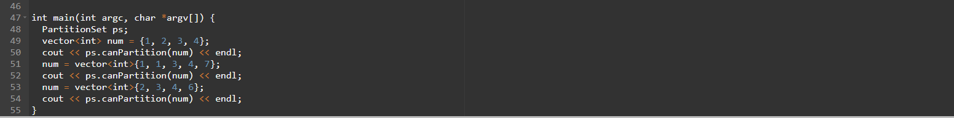

# Output

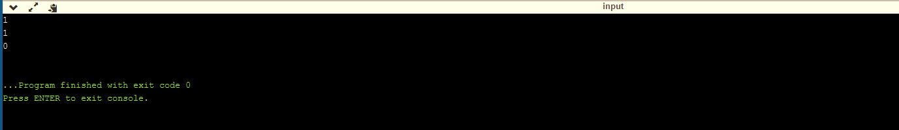

--------<<<THE END>>>--------