

SYMBIOSIS UNIVERSITY OF APPLIED SCIENCES (SUAS)

**India’s 1st Skill Development University**

**PRACTICAL JOURNAL**

Enrollment Number – 2019BTCS088 Year of Enrollment – 2019-2023

Name of the Student – YASH GUPTA

School of COMPUTER SCIENCE & INFORMATION TECHNOLOGY

Program – B. TECH

Specialization/ Branch – CS&IT

Semester - 3rd Section – B2 Branch – CS&IT

Paper Code – BTCS03CCB5 Name of Paper – ADAA

Faculty-In-Charge - DR. P. MANIKANANDAN SIR

CERTIFICATE

THE PRACTICAL EXPERIMENTS

ENTERED IN THIS JOURNAL HAVE BEEN SATISFACTORY PERFORMED BY

ENROLLMENT NO - 2019BTCS088 MR/MS­­­­­­­­­­­­­­­­­­­­ YASH GUPTA

STUDYING IN PROGRAM B. TECH BRANCH CS&IT IN

SCHOOL OF COMPUTER SCIENCE & INFORMATION TECHNOLOGY

DURING SEMESTER 3RD OF ACADEMIC YEAR 2020-2021

_______________________

( )

Date: 14/04/2021

INDEX

|  |  |  |  |  |
| --- | --- | --- | --- | --- |
| S.NO | Title of Skill Activity | Date of Allocation | Date of Submission | Sign of Faculty |
| 1 | Practical-01 | 12/04/2021 | 14/04/2021 |  |
| 2 | Practical-02 | 12/04/2021 | 14/04/2021 |  |
|  |  |  |  |  |
|  |  |  |  |  |
|  |  |  |  |  |
|  |  |  |  |  |
|  |  |  |  |  |
|  |  |  |  |  |
|  |  |  |  |  |
|  |  |  |  |  |
|  |  |  |  |  |
|  |  |  |  |  |
|  |  |  |  |  |
|  |  |  |  |  |
|  |  |  |  |  |
|  |  |  |  |  |
|  |  |  |  |  |
|  |  |  |  |  |
|  |  |  |  |  |
|  |  |  |  |  |
|  |  |  |  |  |
|  |  |  |  |  |

PRACTICAL-03

**Write a Program to implement Integer Multiplication using Divide and Conquer.**

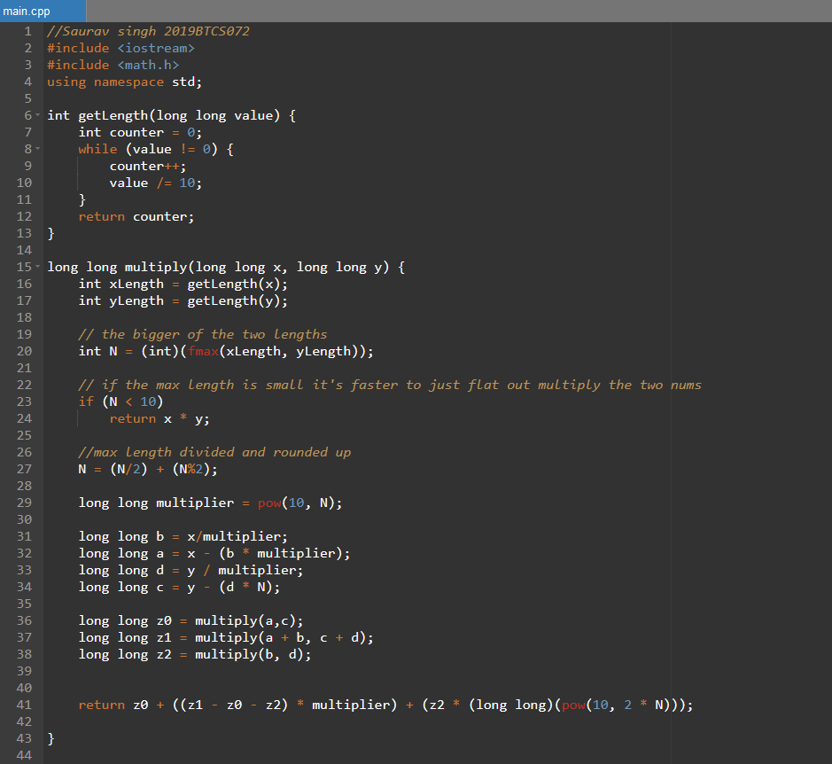

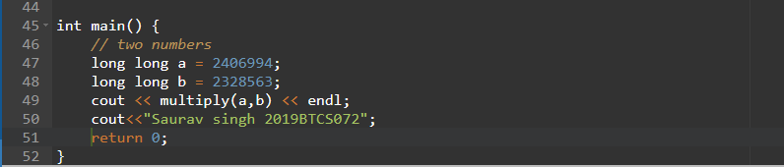

------<<<THE END>>>-----

PRACTICAL-04

**Write a Program using greedy algorithm to find the minimum number of notes that could makeup to the given sum. Take denomination {10, 20, 50, 100, 500, 2000} If input is 5000, Then output of the program should me the number of minimum notes.**

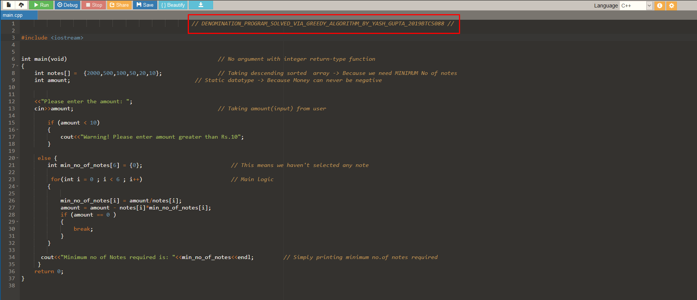  
------<<<THE END>>>------

PRACTICAL-05

**Write a Program to implement Knapsack Problem using Greedy Method.**

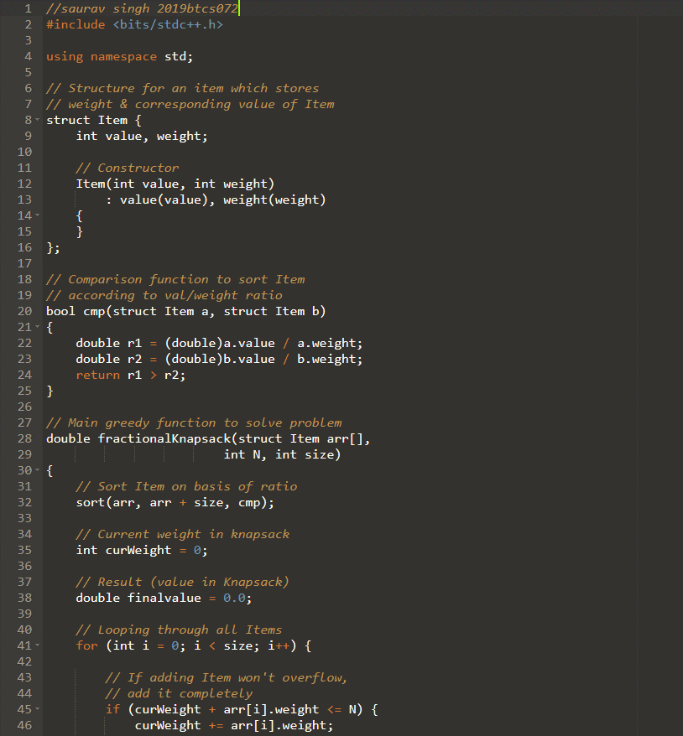

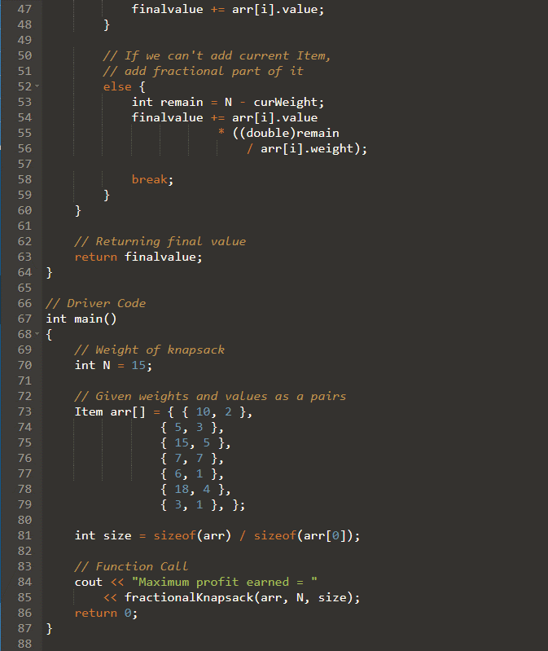

# Output

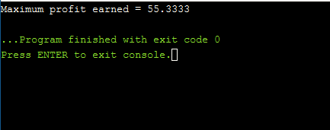

------<<<THE END>>>-----