

SYMBIOSIS UNIVERSITY OF APPLIED SCIENCES (SUAS)

**India’s 1st Skill Development University**

**PRACTICAL JOURNAL**

Enrollment Number – 2019BTCS088 Year of Enrollment – 2019-2023

Name of the Student – YASH GUPTA

School of COMPUTER SCIENCE & INFORMATION TECHNOLOGY

Program – B. TECH

Specialization/ Branch – CS&IT

Semester - 3rd Section – B2 Branch – CS&IT

Paper Code _____________________________________ Name of Paper – JAVA 2 EE(J2EE)

Faculty-In-Charge - MR. MANISH KHULE SIR

CERTIFICATE

THE PRACTICAL EXPERIMENTS

ENTERED IN THIS JOURNAL HAVE BEEN SATISFACTORY PERFORMED BY

ENROLLMENT NO - 2019BTCS088 MR/MS­­­­­­­­­­­­­­­­­­­­ YASH GUPTA

STUDYING IN PROGRAM B. TECH BRANCH CS&IT IN

SCHOOL OF COMPUTER SCIENCE & INFORMATION TECHNOLOGY

DURING SEMESTER 3RD OF ACADEMIC YEAR 2020-2021

_______________________

( )

Date: 27/04/2021

INDEX

|  |  |  |  |  |
| --- | --- | --- | --- | --- |
| **S.NO** | **Title of Skill Activity** | **Date of Allocation** | **Date of Submission** | **Sign of Faculty** |
| 1 | Practical-02 | 27/04/2021 | 27/04/2021 |  |
|  |  |  |  |  |
|  |  |  |  |  |
|  |  |  |  |  |
|  |  |  |  |  |
|  |  |  |  |  |
|  |  |  |  |  |
|  |  |  |  |  |
|  |  |  |  |  |
|  |  |  |  |  |
|  |  |  |  |  |
|  |  |  |  |  |
|  |  |  |  |  |
|  |  |  |  |  |
|  |  |  |  |  |
|  |  |  |  |  |
|  |  |  |  |  |
|  |  |  |  |  |
|  |  |  |  |  |
|  |  |  |  |  |
|  |  |  |  |  |

**Write a program to create Sender and Receiver for connectionless communication**

|  |
| --- |
| **// Program for Receiver-Side communication using UDP BY YASH_GUPTA 2019BTCS088 //**  **// Importing standard libraries**  **import java.io.*; // for standard input output operation**  **import java.net.*; //**  **import java.util.Scanner;**    **public class udpBaseClient_2**  **{**  **public static void main(String args[]) throws IOException**  **{**  **Scanner sc = new Scanner(System.in);**    **DatagramSocket ds = new DatagramSocket();**  **// Step 1: Create the socket object for carrying the data.**    **InetAddress ip = InetAddress.getLocalHost();**  **byte buf[] = null;**      **while (true) // loop while user not enters "bye"**  **{**  **String inp = sc.nextLine();**    **// convert the String input into the byte array.**  **buf = inp.getBytes();**    **// Step 2 : Create the datagramPacket for sending the data.**  **DatagramPacket DpSend =**  **new DatagramPacket(buf, buf.length, ip, 1234);**    **// Step 3 : invoke the send call to actually send**  **// the data.**  **ds.send(DpSend);**    **// break the loop if user enters "bye"**  **if (inp.equals("bye"))**  **break;**  **}**  **}**  **}** |

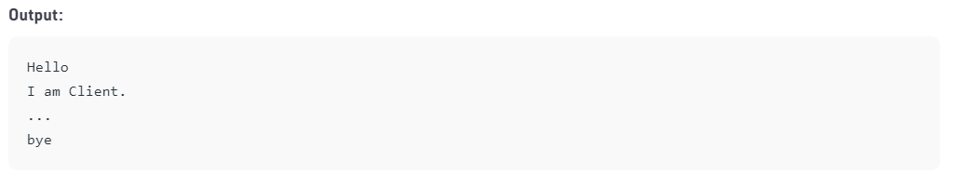

|  |
| --- |
| **// Program for Server-Side communication using UDP BY YASH_GUPTA 2019BTCS088 //**  **import java.io.*;**  **import java.net.*;**  **import java.net.SocketException;**    **public class udpBaseServer_2**  **{**  **public static void main(String[] args) throws IOException**  **{**  **// Step 1 : Create a socket to listen at port 1234**  **DatagramSocket ds = new DatagramSocket(1234);**  **byte[] receive = new byte[65535];**    **DatagramPacket DpReceive = null;**  **while (true)**  **{**    **// Step 2 : create a DatgramPacket to receive the data.**  **DpReceive = new DatagramPacket(receive, receive.length);**    **// Step 3 : revieve the data in byte buffer.**  **ds.receive(DpReceive);**    **System.out.println("Client:-" + data(receive));**    **// Exit the server if the client sends "bye"**  **if (data(receive).toString().equals("bye"))**  **{**  **System.out.println("Client sent bye.....EXITING");**  **break;**  **}**    **// Clear the buffer after every message.**  **receive = new byte[65535];**  **}**  **}**    **// A utility method to convert the byte array data into a string representation.**  **public static StringBuilder data(byte[] a)**  **{**  **if (a == null)**  **return null;**  **StringBuilder ret = new StringBuilder();**  **int i = 0;**  **while (a[i] != 0)**  **{**  **ret.append((char) a[i]);**  **i++;**  **}**  **return ret;**  **}**  **}** |

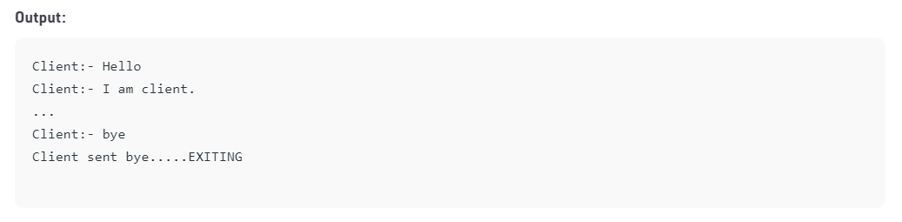

**----------<<<THE END>>>----------**