

SYMBIOSIS UNIVERSITY OF APPLIED SCIENCES (SUAS)

**India’s 1st Skill Development University**

**PRACTICAL JOURNAL**

Enrollment Number – 2019BTCS088 Year of Enrollment – 2019-2023

Name of the Student – YASH GUPTA

School of COMPUTER SCIENCE & INFORMATION TECHNOLOGY

Program – B. TECH

Specialization/ Branch – CS&IT

Semester - 3rd Section – B2 Branch – CS&IT

Paper Code _____________________________________ Name of Paper – JAVA 2 EE(J2EE)

Faculty-In-Charge - MR. MANISH KHULE SIR

CERTIFICATE

THE PRACTICAL EXPERIMENTS

ENTERED IN THIS JOURNAL HAVE BEEN SATISFACTORY PERFORMED BY

ENROLLMENT NO - 2019BTCS088 MR/MS­­­­­­­­­­­­­­­­­­­­ YASH GUPTA

STUDYING IN PROGRAM B. TECH BRANCH CS&IT IN

SCHOOL OF COMPUTER SCIENCE & INFORMATION TECHNOLOGY

DURING SEMESTER 3RD OF ACADEMIC YEAR 2020-2021

_______________________

( )

Date: 27/04/2021

INDEX

|  |  |  |  |  |
| --- | --- | --- | --- | --- |
| **S.NO** | **Title of Skill Activity** | **Date of Allocation** | **Date of Submission** | **Sign of Faculty** |
| 1 | Practical-05 | 27/04/2021 | 27/04/2021 |  |
|  |  |  |  |  |
|  |  |  |  |  |
|  |  |  |  |  |
|  |  |  |  |  |
|  |  |  |  |  |
|  |  |  |  |  |
|  |  |  |  |  |
|  |  |  |  |  |
|  |  |  |  |  |
|  |  |  |  |  |
|  |  |  |  |  |
|  |  |  |  |  |
|  |  |  |  |  |
|  |  |  |  |  |
|  |  |  |  |  |
|  |  |  |  |  |
|  |  |  |  |  |
|  |  |  |  |  |
|  |  |  |  |  |
|  |  |  |  |  |

WRITE A PROGRAM TO INSERT RECORD IN DATABASE.

|  |
| --- |
| **// Program to insert records to a table using JDBC BY YASH_GUPTA 2019BTCS088 //**  **// Importing standard libraries**  **import java.io.*;**  **import java.sql.*;**  **public class Database {**  **// url that points to mysql database, 'db' is database name**  **static final String url**  **= "jdbc:mysql://localhost:3306/db";**  **public static void main(String[] args)**  **throws ClassNotFoundException**  **{**  **try {**  **// this Class.forName() method is user for**  **// driver registration with name of the driver**  **// as argument**  **// we have used MySQL driver**  **Class.forName("com.mysql.jdbc.Driver");**  **// getConnection() establishes a connection. It**  **// takes url that points to your database,**  **// username and password of MySQL connections as**  **// arguments**  **Connection conn = DriverManager.getConnection(**  **url, "root", "1234");**  **// create.Statement() creates statement object**  **// which is responsible for executing queries on**  **// table**  **Statement stmt = conn.createStatement();**  **// executeUpdate() is used for INSERT, UPDATE,**  **// DELETE statements.It returns number of rows**  **// affected by the execution of the statement**  **int result = stmt.executeUpdate(**  **"insert into student(Id,name,number) values('1','rachel','45')");**  **// if result is greater than 0, it means values**  **// has been added**  **if (result > 0)**  **System.out.println("successfully inserted");**  **else**  **System.out.println(**  **"unsucessful insertion ");**  **// closing connection**  **conn.close();**  **}**  **catch (SQLException e) {**  **System.out.println(e);**  **}**  **}**  **}** |

**OUTPUT:**

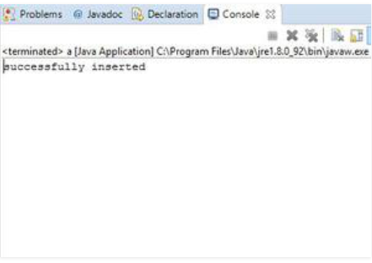

**----------<<<THE END>>>----------**