

SYMBIOSIS UNIVERSITY OF APPLIED SCIENCES (SUAS)

**India’s 1st Skill Development University**

**PRACTICAL JOURNAL**

Enrollment Number – 2019BTCS088 Year of Enrollment – 2019-2023

Name of the Student – YASH GUPTA

School of COMPUTER SCIENCE & INFORMATION TECHNOLOGY

Program – B. TECH

Specialization/ Branch – CS&IT

Semester - 3rd Section – B2 Branch – CS&IT

Paper Code _____________________________________ Name of Paper – JAVA 2 EE(J2EE)

Faculty-In-Charge - MR. MANISH KHULE SIR

CERTIFICATE

THE PRACTICAL EXPERIMENTS

ENTERED IN THIS JOURNAL HAVE BEEN SATISFACTORY PERFORMED BY

ENROLLMENT NO - 2019BTCS088 MR/MS­­­­­­­­­­­­­­­­­­­­ YASH GUPTA

STUDYING IN PROGRAM B. TECH BRANCH CS&IT IN

SCHOOL OF COMPUTER SCIENCE & INFORMATION TECHNOLOGY

DURING SEMESTER 3RD OF ACADEMIC YEAR 2020-2021

_______________________

( )

Date: 27/04/2021

INDEX

|  |  |  |  |  |
| --- | --- | --- | --- | --- |
| **S.NO** | **Title of Skill Activity** | **Date of Allocation** | **Date of Submission** | **Sign of Faculty** |
| 1 | Practical-06 | 27/04/2021 | 27/04/2021 |  |
|  |  |  |  |  |
|  |  |  |  |  |
|  |  |  |  |  |
|  |  |  |  |  |
|  |  |  |  |  |
|  |  |  |  |  |
|  |  |  |  |  |
|  |  |  |  |  |
|  |  |  |  |  |
|  |  |  |  |  |
|  |  |  |  |  |
|  |  |  |  |  |
|  |  |  |  |  |
|  |  |  |  |  |
|  |  |  |  |  |
|  |  |  |  |  |
|  |  |  |  |  |
|  |  |  |  |  |
|  |  |  |  |  |
|  |  |  |  |  |

Write a program to store the txt file in the Database.

|  |
| --- |
| **// Program for storing the txt file in the Database BY YASH_GUPTA 2019BTCS088 //**  **import java.io.*; // library for standard input output operation**  **import java.sql.*; // library for interfacing SQL connection**    **public class StoreFile {**    **public static void main(String[] args) {**  **try{**  **Class.forName("oracle.jdbc.driver.OracleDriver");**    **Connection con = DriverManager.getConnection( "jdbc:oracle:thin:@localhost:1521:xe","system","oracle");**    **PreparedStatement ps = con.prepareStatement("insert into filetable values(?,?)");**    **File f = new File("d:\\myfile.txt");**  **FileReader fr = new FileReader(f);**    **ps.setInt(1,101);**  **ps.setCharacterStream(2,fr,(int)f.length());**    **int I = ps.executeUpdate();**  **System.out.println(i+" records affected");**  **con.close();**  **}catch (Exception e) {e.printStackTrace();}**  **}**  **}** |

**OUTPUT:**

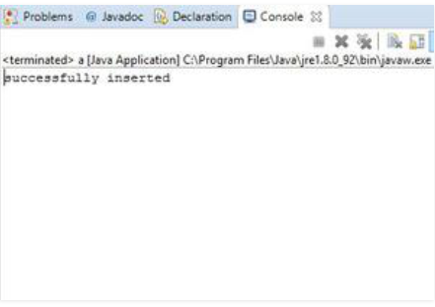

**----------<<<THE END>>>----------**