

SYMBIOSIS UNIVERSITY OF APPLIED SCIENCES (SUAS)

**India’s 1st Skill Development University**

**SKILL JOURNAL**

Enrollment Number – 2019BTCS088 Year of Enrollment – 2019-2023

Name of the Student – YASH GUPTA

School of COMPUTER SCIENCE & INFORMATION TECHNOLOGY

Program – B. TECH

Specialization/ Branch – CS&IT

Semester - 3rd Section – B2 Branch – CS&IT

Paper Code – BTCS03CCB3 Name of Paper – JAVA 2 EE(J2EE)

Faculty-In-Charge - MR. MANISH KHULE SIR

CERTIFICATE

THE SKILL EXPERIMENTS

ENTERED IN THIS JOURNAL HAVE BEEN SATISFACTORY PERFORMED BY

ENROLLMENT NO - 2019BTCS088 MR/MS­­­­­­­­­­­­­­­­­­­­ YASH GUPTA

STUDYING IN PROGRAM B. TECH BRANCH CS&IT IN

SCHOOL OF COMPUTER SCIENCE & INFORMATION TECHNOLOGY

DURING SEMESTER 3RD OF ACADEMIC YEAR 2020-2021

_______________________

( )

Date: 10/12/2020

INDEX

|  |  |  |  |  |
| --- | --- | --- | --- | --- |
| S.NO | Title of Skill Activity | Date of Allocation | Date of Submission | Sign of Faculty |
| 1 | Skill-01 | 05/12/2020 | 10/12/2020 |  |
| 2 | Skill-02 | 06/12/2020 | 10/12/2020 |  |
| 3 | Skill-03 | 07/12/2020 | 10/12/2020 |  |
| 4 | Skill-04 | 08/12/2020 | 10/12/2020 |  |
| 5 | Skill-05 | 09/12/2020 | 10/12/2020 |  |
|  |  |  |  |  |
|  |  |  |  |  |
|  |  |  |  |  |
|  |  |  |  |  |
|  |  |  |  |  |
|  |  |  |  |  |
|  |  |  |  |  |
|  |  |  |  |  |
|  |  |  |  |  |
|  |  |  |  |  |
|  |  |  |  |  |
|  |  |  |  |  |
|  |  |  |  |  |
|  |  |  |  |  |
|  |  |  |  |  |
|  |  |  |  |  |
|  |  |  |  |  |
|  |  |  |  |  |
|  |  |  |  |  |
|  |  |  |  |  |
|  |  |  |  |  |
|  |  |  |  |  |
|  |  |  |  |  |
|  |  |  |  |  |
|  |  |  |  |  |
|  |  |  |  |  |
|  |  |  |  |  |
|  |  |  |  |  |
|  |  |  |  |  |
|  |  |  |  |  |
|  |  |  |  |  |
|  |  |  |  |  |
|  |  |  |  |  |
|  |  |  |  |  |
|  |  |  |  |  |

SKILL-01

**Create a java application code to display no of records from**

* **table name (student)**
* **database name(information)**

**Ans:**

|  |  |  |
| --- | --- | --- |
| |  |  | | --- | --- | | 1  2  3  4  5  6  7  8  9  10  11  12  13  14  15  16  17  18  19  20  21  22 | **import** **java.sql.\***;  **import** **java.sql.Connection**;  **import** **java.sql.DriverManager**;  **import** **java.sql.ResultSet**;  **import** **java.sql.Statement**;  **public** **class** **Example1** {  **public** **static** **void** **main**(String[] args) {  **try** {  Class.forName("com.mysql.jdbc.Driver");  Connection conn= DriverManager.getConnection("jdbc:mysql://localhost/informationn","root","");  Statement stmt=conn.createStatement();  ResultSet rs= stmt.executeQuery("select * from studentt");  **while**(rs.next())  System.out.println(rs.getString(**1**)+" "+rs.getInt(**2**)+" "+rs.getInt(**3**)+" "+rs.getString(**4**));  conn.close();  }  **catch** (Exception e) {  System.out.println(e);  }  }  } | |

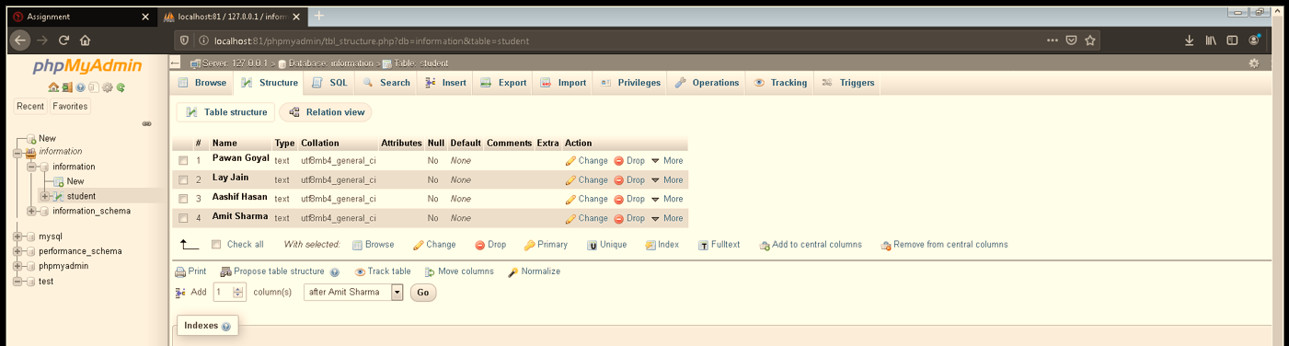



**----------<<<THE END>>>---------**

SKILL-02

**Write a program using servlet to print details like**

* **name**
* **city**
* **phone number**
* **address.**

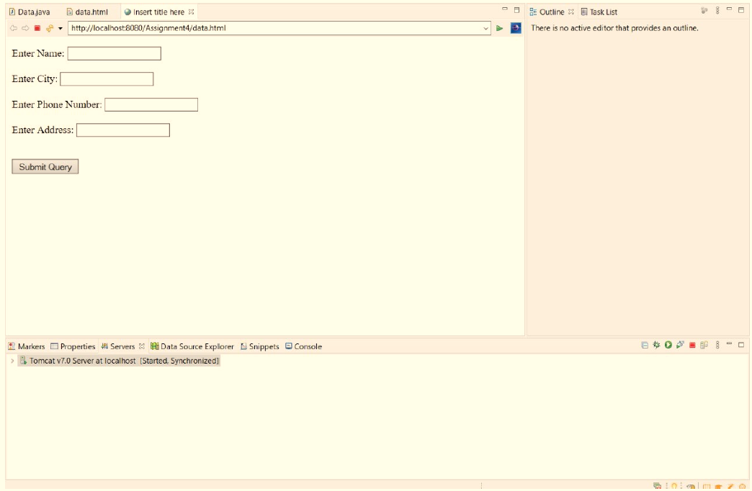

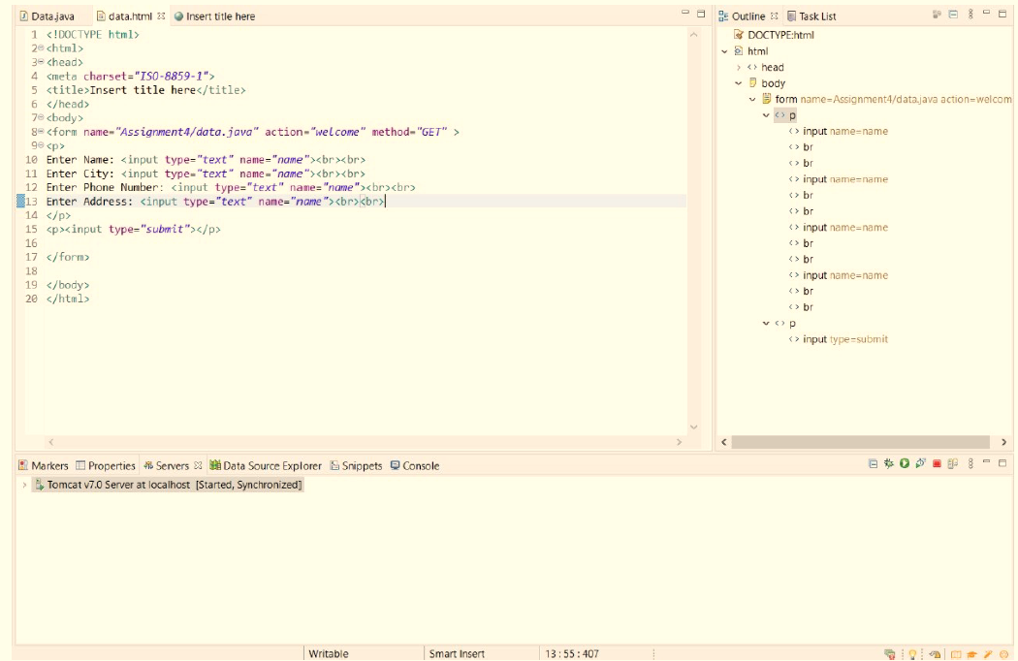

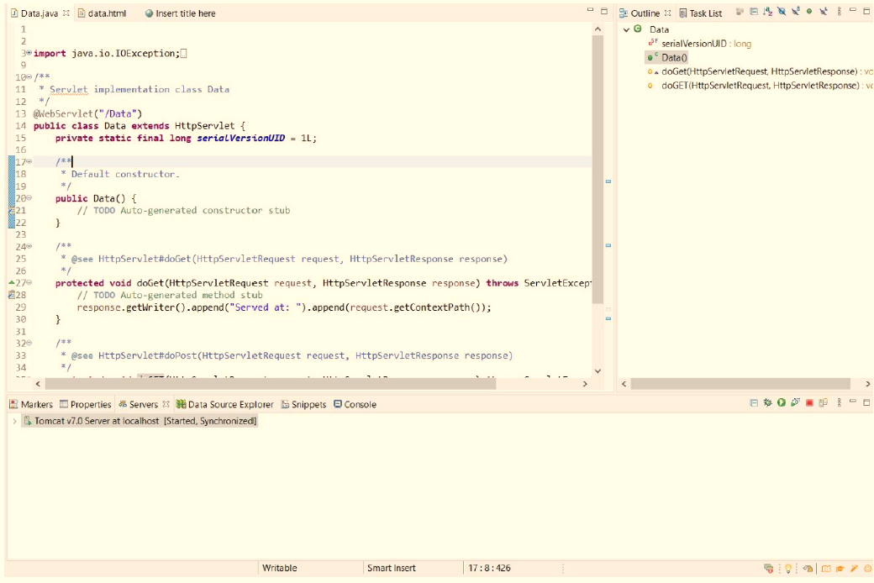

---------<<<THE END>>>--------

**SKILL-04**

**Create a hibernate application to insert record in Database.  
Ans:** To create hibernate application we require **2** most important files i.e.,

* hibernate.cfg
* StudentDetails.hbm

***hibernate.cfg***

|  |  |  |
| --- | --- | --- |
| |  |  | | --- | --- | | 1  2  3  4  5  6  7  8  9  10  11  12  13  14  15 | <?xml version="1.0" encoding="UTF-8"?>  <!DOCTYPE hibernate-configuration PUBLIC  "-//Hibernate/Hibernate Configuration DTD 3.0//EN"  "http://www.hibernate.org/dtd/hibernate-configuration-3.0.dtd">    <hibernate-configuration>  <session-factory>  <property name = "hibernate.dialect">org.hibernate.dialect.MySQLDialect </property>  <property name = "hibernate.connection.url">**jdbc:mysql:**//localhost/test </property>  <property name="connection.username">root</property>  <property name="connection.password"></property>  <property name = "hibernate.connection.driver_class">com.mysql.jdbc.Driver</property>  <mapping resource="StudentDeatils.hbm.xml"/>  </session-factory>  </hibernate-configuration> | |

***StudentDetails.hbm***

|  |  |  |
| --- | --- | --- |
| |  |  | | --- | --- | | 1  2  3  4  5  6  7  8  9  10  11  12  13  14  15 | <?xml version = "1.0" encoding = "utf-8"?>  <!DOCTYPE hibernate-mapping PUBLIC  "-//Hibernate/Hibernate Mapping DTD//EN"  "http://www.hibernate.org/dtd/hibernate-mapping-3.0.dtd">    <hibernate-mapping>  <**class** **name**="com.hibernate.StudentDeatils" table="detail">  <id name="city">  <generator class="assigned"></generator>  </id>  <property name="name"></property>    </class>  </hibernate-mapping> | |

***StudentDetails.java***

|  |  |  |
| --- | --- | --- |
| |  |  | | --- | --- | | 1  2  3  4  5  6  7  8  9  10  11  12  13  14  15  16  17  18  19  20 | **package** com.hibernate;  **public** **class** **StudentDeatils** {  **private** String name;  **public** String **getName**() {  **return** name;  }  **public** **void** **setName**(String name) {  **this**.name = name;  }  **public** String **getCity**() {  **return** city;  }  **public** **void** **setCity**(String city) {  **this**.city = city;  }  **private** String city;    } | |

***Data.java***

|  |
| --- |
|  |
| 1  2  3  4  5  6  7  8  9  10  11  12  13  14  15  16  17  18  19  20  21  22  23  24  25  26  27  28  29 | **package** com.hibernate;  **import** **org.hibernate.Session**;  **import** **org.hibernate.SessionFactory**;  **public** **class** **Data** {  **public** **static** **void** **main**(String[] args) {    SessionFactory factory = **new** org.hibernate.cfg.Configuration().configure("hibernate.cfg.xml").buildSessionFactory();  Session session=factory.openSession();    org.hibernate.Transaction tx=session.beginTransaction();  StudentDeatils ob = **new** StudentDeatils();  ob.setCity("Gwalior");  ob.setName("Manish");        session.save(ob);  tx.commit();  System.out.print("saved");    factory.close();  session.close();  }  } |

**------<<<THE END>>>------**

SKILL-05

**Write a program using spring mvc to print name and rollno.**

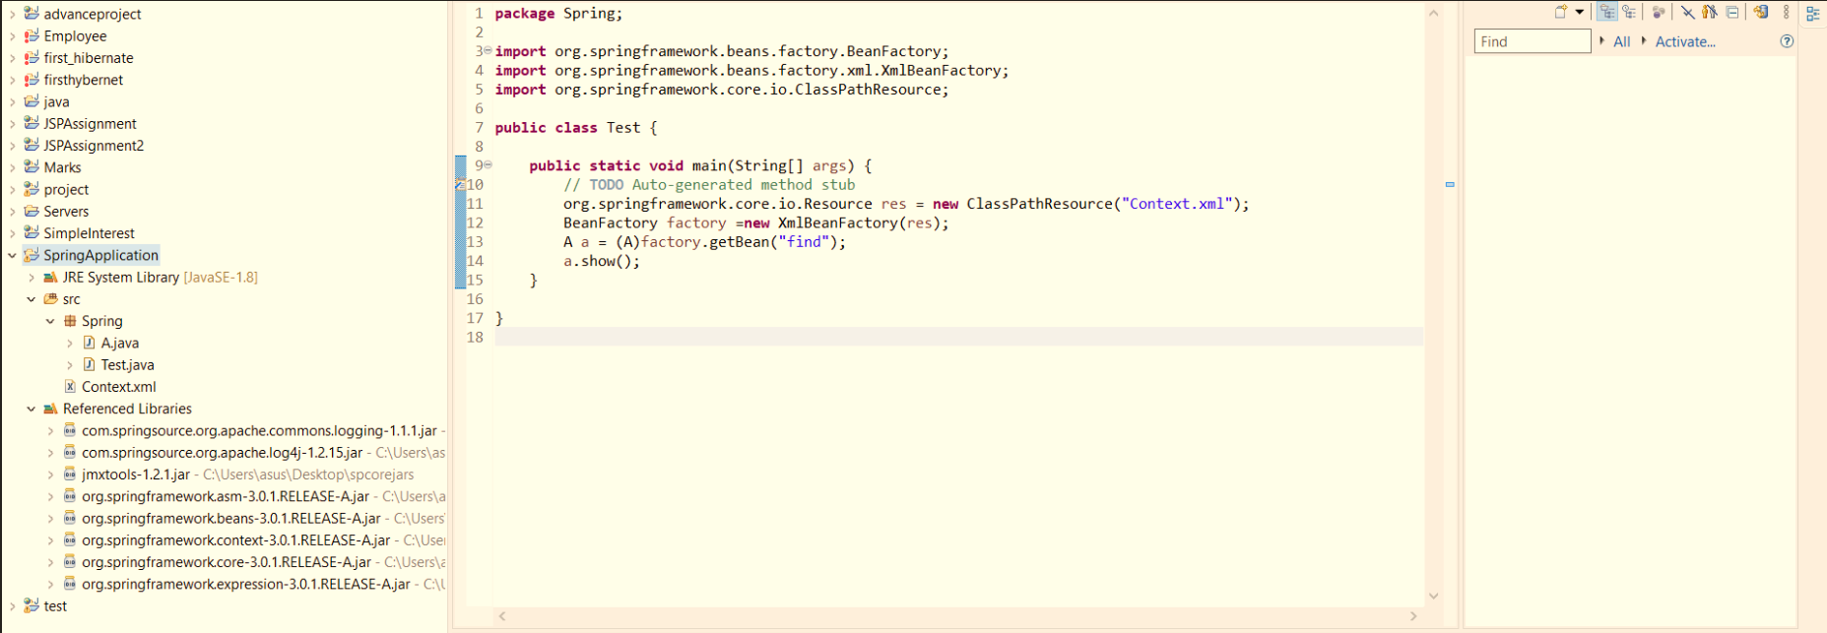

|  |  |  |
| --- | --- | --- |
| |  |  | | --- | --- | | 1  2  3  4  5  6  7  8  9  10  11  12  13  14  15  16  17  18  19  20  21  22  23  24  25  26  27  28  29 | **package** Spring;  **public** **class** **A**{  **private** **int** rollno;  **private** String name;  **public** String **getName**() {  **return** name;  }  **public** **void** **setName**(String name) {  **this**.name = name;  }  **public** **int** **getRollno**() {  **return** rollno;  }  **public** **void** **setRollno**(**int** rollno) {  **this**.rollno = rollno;  }  **public** **void** **show**(){    System.out.println("My Name is"+" "+name);  System.out.println("My Roll No. is"+" "+rollno);  }  } | |

|  |  |  |
| --- | --- | --- |
| |  |  | | --- | --- | | 1  2  3  4  5  6  7  8  9  10  11  12  13  14  15  16  17 | **package** Spring;  **import** **org.springframework.beans.factory.BeanFactory**;  **import** **org.springframework.beans.factory.xml.XmlBeanFactory**;  **import** **org.springframework.core.io.ClassPathResource**;  **public** **class** **Test** {  **public** **static** **void** **main**(String[] args) {  // TODO Auto-generated method stub  org.springframework.core.io.Resource res = **new** ClassPathResource("Context.xml");  BeanFactory factory =**new** XmlBeanFactory(res);  A a = (A)factory.getBean("find");  a.show();  } | |

**------<<<THE END>>>------**