

**PRACTICAL JOURNAL**

Enrollment Number – 2019BTCS088 Year of Enrollment – 2019-2023

Name of the Student – YASH GUPTA

School of COMPUTER SCIENCE & INFORMATION TECHNOLOGY

Program – B. TECH

Specialization/ Branch – CS&IT

Semester – 3RD  Section – B2 Branch – CS&IT

Paper Code – BTCS03CCB1 Name of Paper – Microprocessors & Microcontrollers

Faculty-In-Charge – MR. ISHWAR LAL RATHOD SIR

CERTIFICATE

THE PRACTICAL EXPERIMENTS

ENTERED IN THIS JOURNAL HAVE BEEN SATISFACTORY PERFORMED BY

ENROLLMENT NO - 2019BTCS088 MR/MS­­­­­­­­­­­­­­­­­­­­ YASH GUPTA

STUDYING IN PROGRAM B. TECH BRANCH CS&IT IN

SCHOOL OF COMPUTER SCIENCE & INFORMATION TECHNOLOGY

DURING SEMESTER 3RD OF ACADEMIC YEAR 2020-2021

_______________________

( )

Date: _________________

INDEX

|  |  |  |  |  |
| --- | --- | --- | --- | --- |
| S.NO | Title of Skill Activity | Date of Allocation | Date of Submission | Sign of Faculty |
| 1. | Assembly Program for Adding two Hexa-Decimal Numbers | 17/08/2020 | 02/09/2020 |  |
|  |  |  |  |  |
| 2. | Assembly Program for Finding Greatest between two Hexa-Decimal Numbers | 17/08/2020 | 02/09/2020 |  |
|  |  | 17/08/2020 | 02/09/2020 |  |
| 3. | Assembly Program for Multiplying a Hexa-Decimal Number by 16 | 17/08/2020 | 02/09/2020 |  |
|  |  | 17/08/2020 | 02/09/2020 |  |
| 4. | Assembly Program for Subtracting two Hexa-Decimal Numbers | 17/08/2020 | 02/09/2020 |  |
|  |  | 17/08/2020 | 02/09/2020 |  |
| 5. | Assembly Program for Division between two Hexa-Decimal Numbers | 17/08/2020 | 02/09/2020 |  |
|  |  |  |  |  |
|  |  |  |  |  |
|  |  |  |  |  |
|  |  |  |  |  |
|  |  |  |  |  |
|  |  |  |  |  |
|  |  |  |  |  |
|  |  |  |  |  |
|  |  |  |  |  |
|  |  |  |  |  |
|  |  |  |  |  |
|  |  |  |  |  |
|  |  |  |  |  |
|  |  |  |  |  |
|  |  |  |  |  |
|  |  |  |  |  |
|  |  |  |  |  |

Practical No: 01  
(Assembly Program for Adding two Hexa-Decimal Numbers)  
 Date: 17th August 2020  
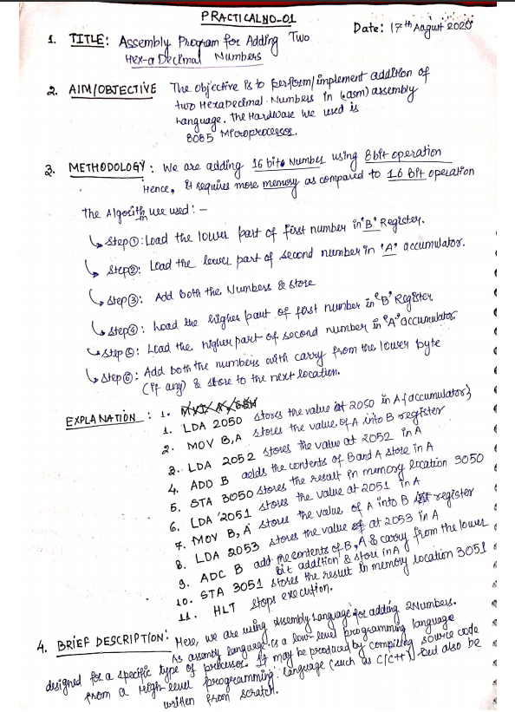

**Assessment Parameters (To be filled by faculty)**

1. **Successful completion of Practical (Y/N)**
2. **Time taken (hours/ minutes)**
3. **List other Parameters & Outcomes:**

|  |  |  |
| --- | --- | --- |
| **S.No.** | **Parameters** | **Outcomes**  **(Achieved / Not Achieved)** |
|  |  |  |
|  |  |  |
|  |  |  |
|  |  |  |
|  |  |  |
|  |  |  |
|  |  |  |
|  |  |  |
|  |  |  |
|  |  |  |

**Remarks:**

# source code:



# output:

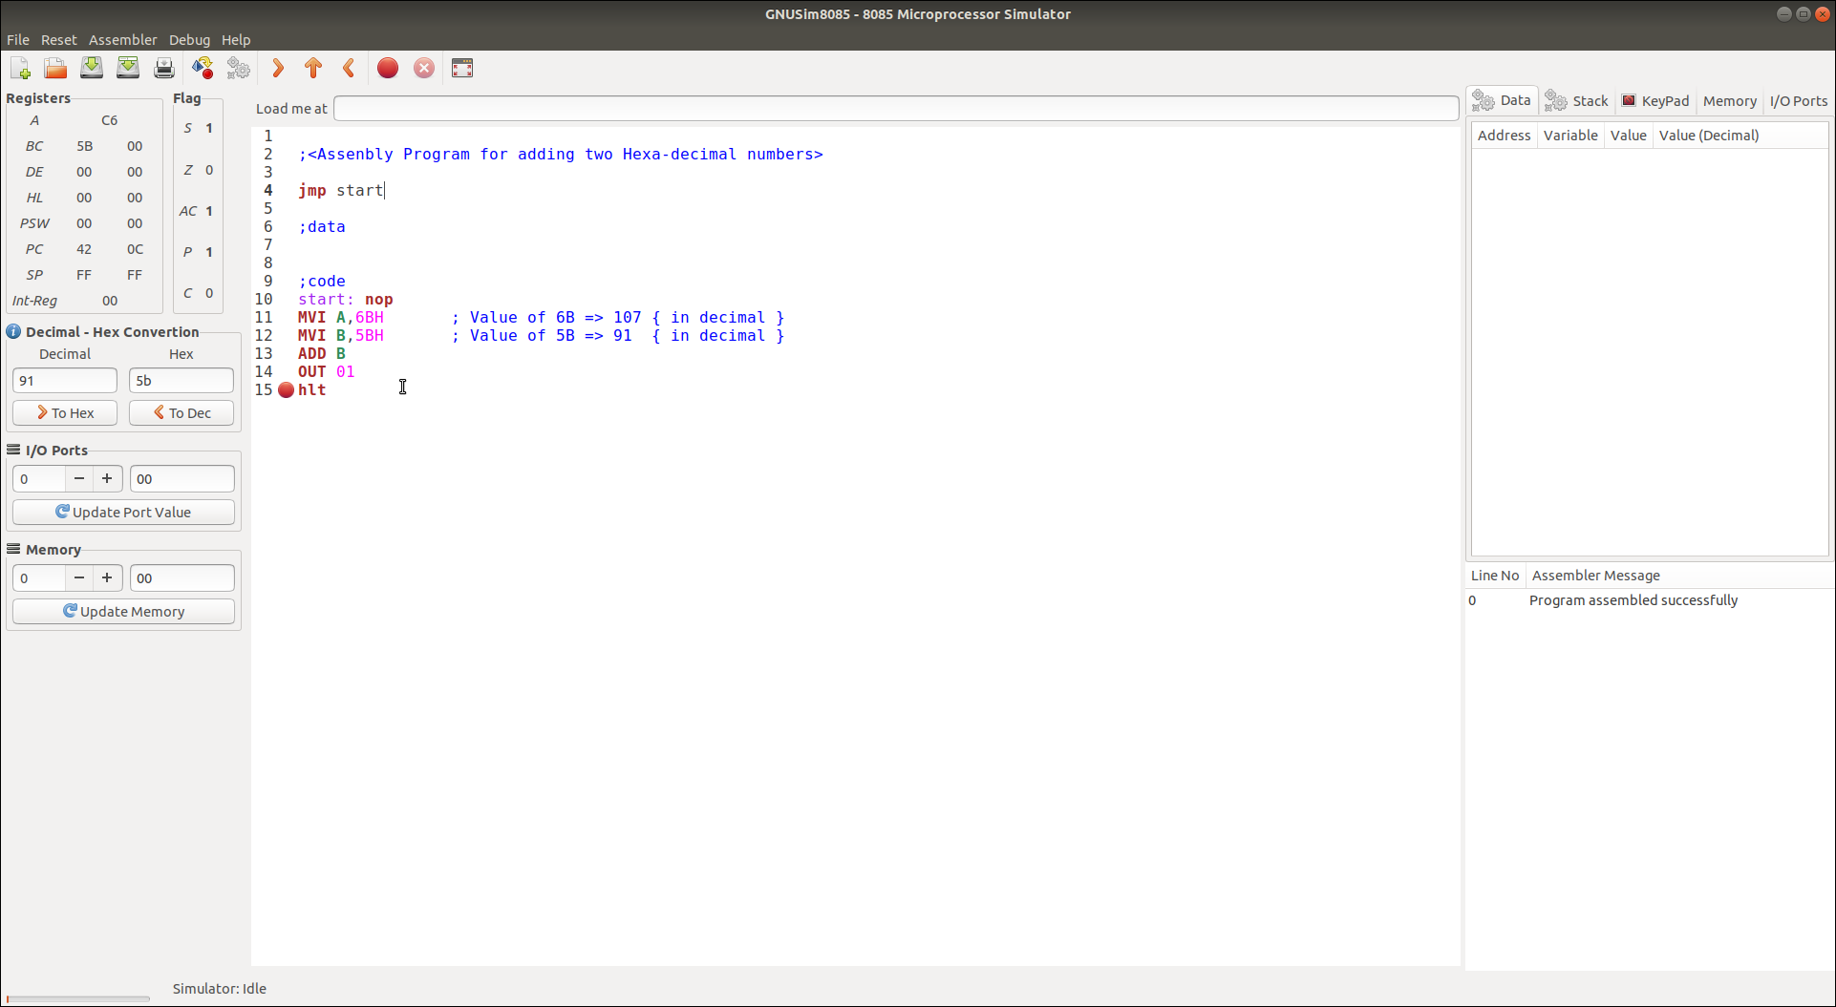---------------------------------------------------------------------------

Practical No: 02  
(Assembly Program for Finding Greatest between two Hexa-Decimal Numbers)

Date: 17th August 2020

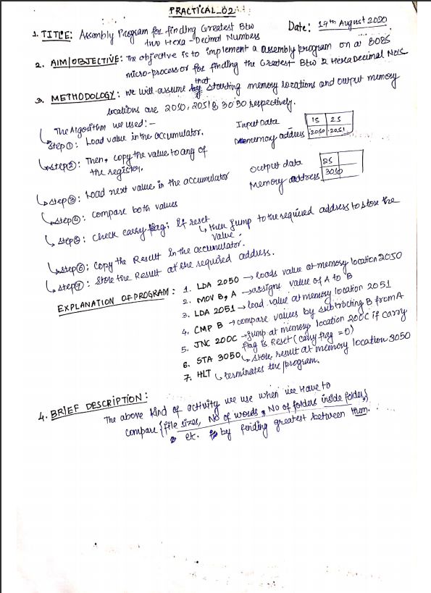

**Assessment Parameters (To be filled by faculty)**

1. **Successful completion of Practical (Y/N)**
2. **Time taken (hours/ minutes)**
3. **List other Parameters & Outcomes:**

|  |  |  |
| --- | --- | --- |
| **S.No.** | **Parameters** | **Outcomes**  **(Achieved / Not Achieved)** |
|  |  |  |
|  |  |  |
|  |  |  |
|  |  |  |
|  |  |  |
|  |  |  |
|  |  |  |
|  |  |  |
|  |  |  |
|  |  |  |

**Remarks:**

**Total marks __________ out of 10. Sign of Faculty**

# source code:



# output:

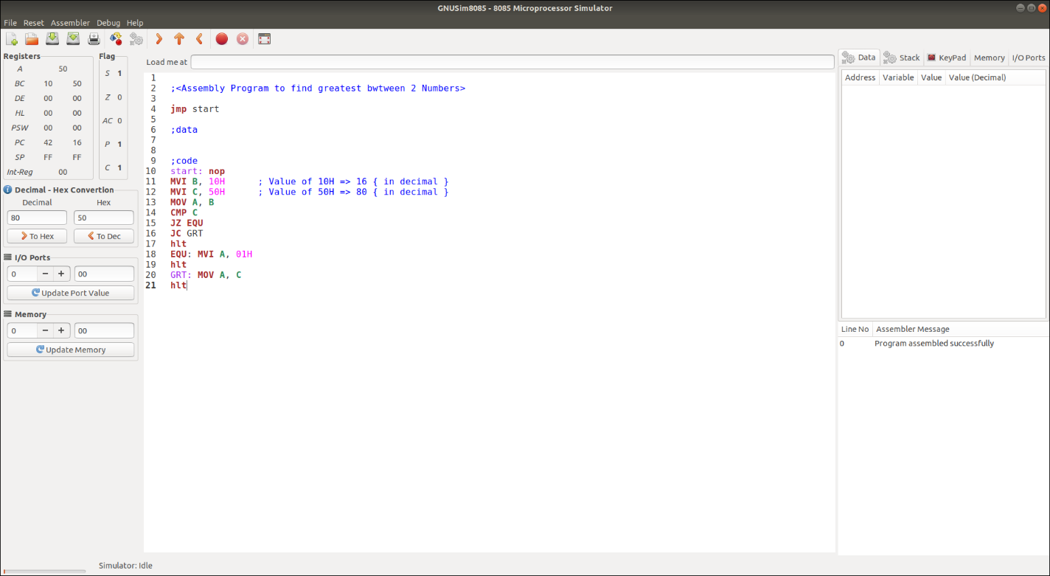  
  
-------------------------------------------------------------------------------------

Practical No: 03  
(Assembly Program for Multiplying a Hexa-Decimal Number by 16)

Date: 17th August 2020

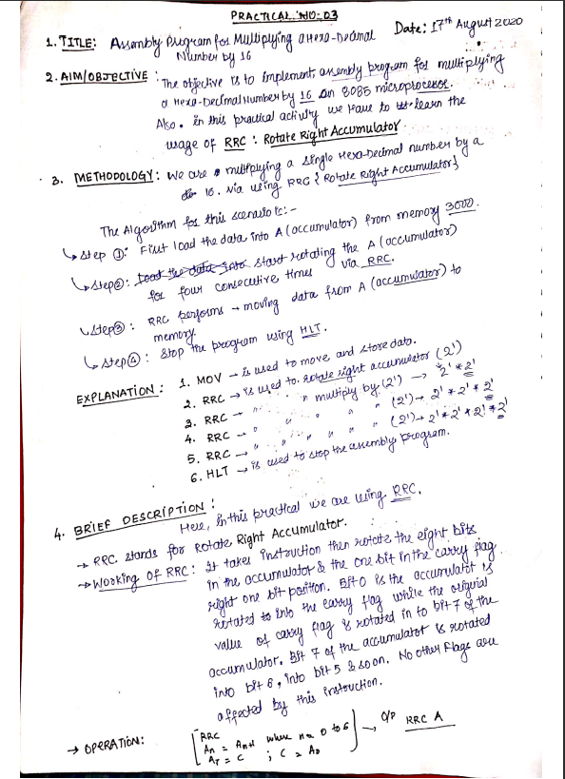

**Assessment Parameters (To be filled by faculty)**

1. **Successful completion of Practical (Y/N)**
2. **Time taken (hours/ minutes)**
3. **List other Parameters & Outcomes:**

|  |  |  |
| --- | --- | --- |
| **S.No.** | **Parameters** | **Outcomes**  **(Achieved / Not Achieved)** |
|  |  |  |
|  |  |  |
|  |  |  |
|  |  |  |
|  |  |  |
|  |  |  |
|  |  |  |
|  |  |  |
|  |  |  |
|  |  |  |

**Remarks:**

**Total marks __________ out of 10. Sign of Faculty**

# source code:



# output:

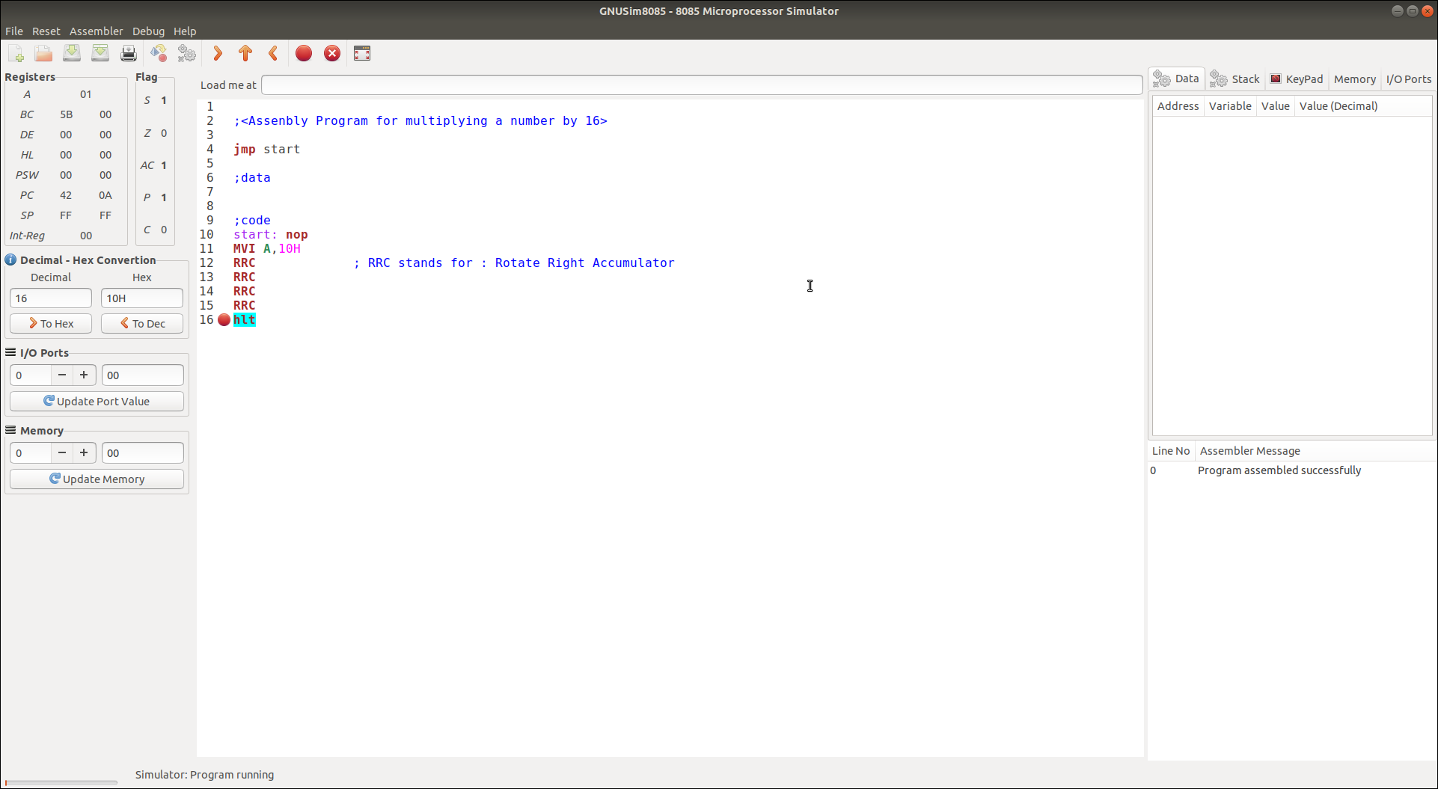

------------------------------------------------------------------------------------

Practical No: 04  
(Assembly Program for Subtracting two Hexa-Decimal Numbers)

Date: 17th August 2020

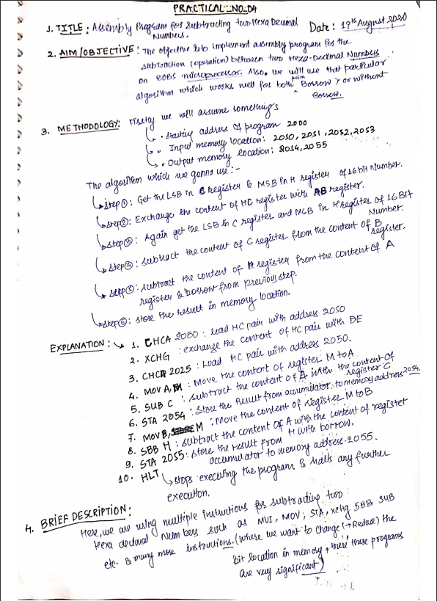

**Assessment Parameters (To be filled by faculty)**

1. **Successful completion of Practical (Y/N)**
2. **Time taken (hours/ minutes)**
3. **List other Parameters & Outcomes:**

|  |  |  |
| --- | --- | --- |
| **S.No.** | **Parameters** | **Outcomes**  **(Achieved / Not Achieved)** |
|  |  |  |
|  |  |  |
|  |  |  |
|  |  |  |
|  |  |  |
|  |  |  |
|  |  |  |
|  |  |  |
|  |  |  |
|  |  |  |

**Remarks:**

**Total marks __________ out of 10. Sign of Faculty**

# source code:



# OUTPUT:

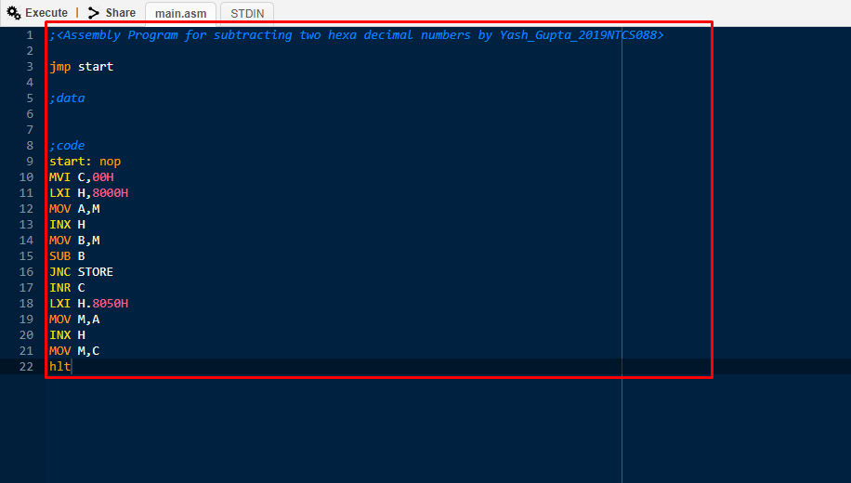

------------------------------------------------------------------------------------

Practical No: 05  
(Assembly Program for Division between two Hexa-Decimal Numbers)

Date: 17th August 2020

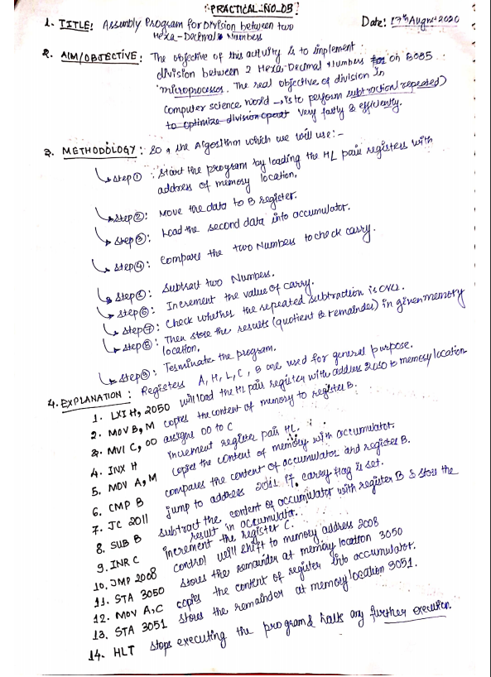

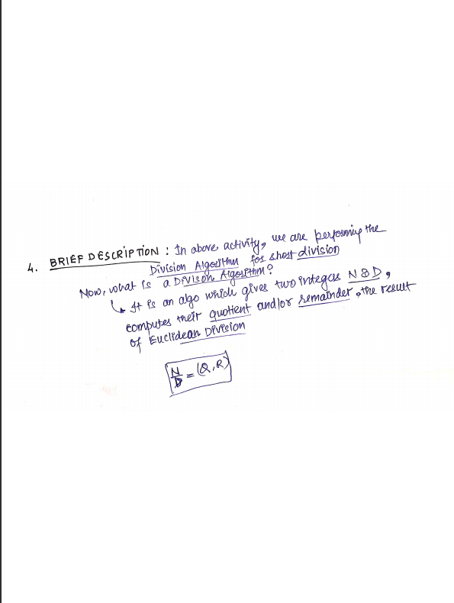

**Assessment Parameters (To be filled by faculty)**

1. **Successful completion of Practical (Y/N)**
2. **Time taken (hours/ minutes)**
3. **List other Parameters & Outcomes:**

|  |  |  |
| --- | --- | --- |
| **S.No.** | **Parameters** | **Outcomes**  **(Achieved / Not Achieved)** |
|  |  |  |
|  |  |  |
|  |  |  |
|  |  |  |
|  |  |  |
|  |  |  |
|  |  |  |
|  |  |  |
|  |  |  |
|  |  |  |

**Remarks:**

**Total marks __________ out of 10. Sign of Faculty**

# source code:



# OUTPUT:



