

**PRACTICAL JOURNAL**

Enrollment Number – 2019BTCS088 Year of Enrollment – 2019-2023

Name of the Student – YASH GUPTA

School of COMPUTER SCIENCE & INFORMATION TECHNOLOGY

Program – B. TECH

Specialization/ Branch – CS&IT

Semester – 4TH Section – B2 Branch – CS&IT

Paper Code – BTCS04CCB4 Name of Paper – Application Development using .NET

Faculty-In-Charge – MR. MANISH KHULE SIR

CERTIFICATE

THE PRACTICAL EXPERIMENTS

ENTERED IN THIS JOURNAL HAVE BEEN SATISFACTORY PERFORMED BY

ENROLLMENT NO - 2019BTCS088 MR/MS­­­­­­­­­­­­­­­­­­­­ YASH GUPTA

STUDYING IN PROGRAM B. TECH BRANCH CS&IT IN

SCHOOL OF COMPUTER SCIENCE & INFORMATION TECHNOLOGY

DURING SEMESTER 4TH OF ACADEMIC YEAR 2020-2021

_______________________

( )

Date: _________________

INDEX

|  |  |  |  |  |
| --- | --- | --- | --- | --- |
| S.NO | Title of Skill Activity | Date of Allocation | Date of Submission | Sign of Faculty |
| 1 | Assignment_14 (Use of update & Delete in Web Forms) | 02/06/2021 | 08/06/2021 |  |
|  |  |  |  |  |
|  |  |  |  |  |
|  |  |  |  |  |
|  |  |  |  |  |
|  |  |  |  |  |
|  |  |  |  |  |
|  |  |  |  |  |
|  |  |  |  |  |
|  |  |  |  |  |
|  |  |  |  |  |
|  |  |  |  |  |
|  |  |  |  |  |
|  |  |  |  |  |
|  |  |  |  |  |
|  |  |  |  |  |
|  |  |  |  |  |
|  |  |  |  |  |
|  |  |  |  |  |
|  |  |  |  |  |
|  |  |  |  |  |
|  |  |  |  |  |
|  |  |  |  |  |
|  |  |  |  |  |
|  |  |  |  |  |
|  |  |  |  |  |
|  |  |  |  |  |
|  |  |  |  |  |
|  |  |  |  |  |
|  |  |  |  |  |
|  |  |  |  |  |
|  |  |  |  |  |
|  |  |  |  |  |
|  |  |  |  |  |
|  |  |  |  |  |
|  |  |  |  |  |
|  |  |  |  |  |
|  |  |  |  |  |
|  |  |  |  |  |
|  |  |  |  |  |
|  |  |  |  |  |
|  |  |  |  |  |
|  |  |  |  |  |

# source code for update & delete functionality in web forms

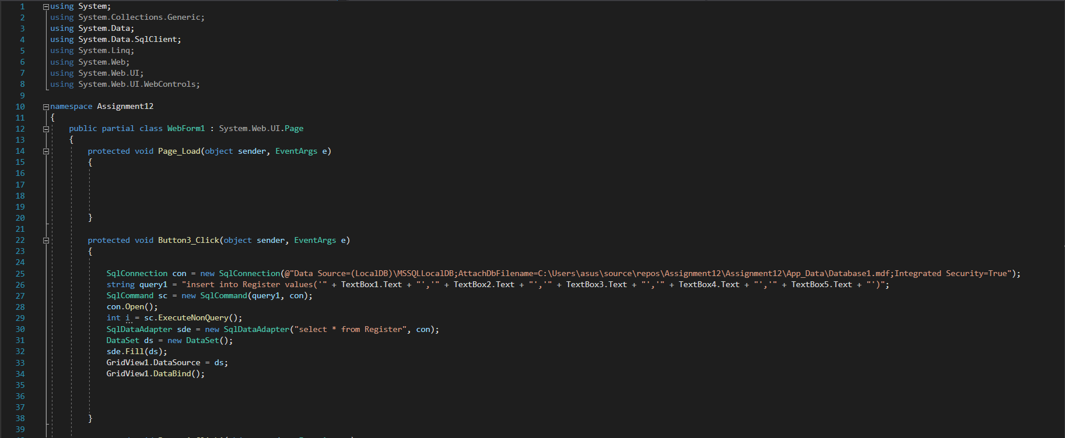

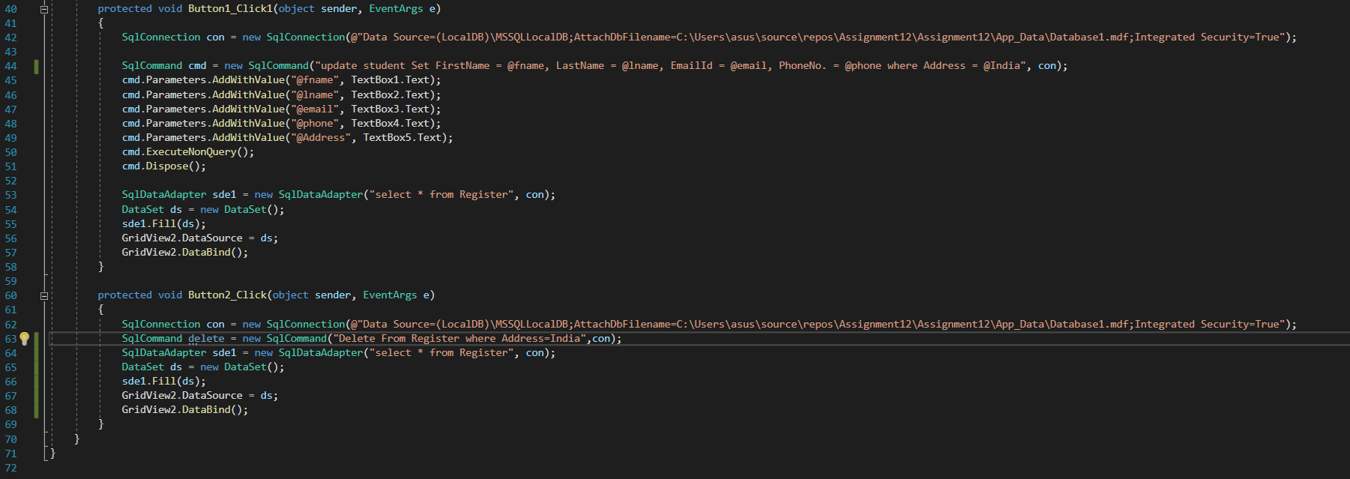

# output of insert record operation:

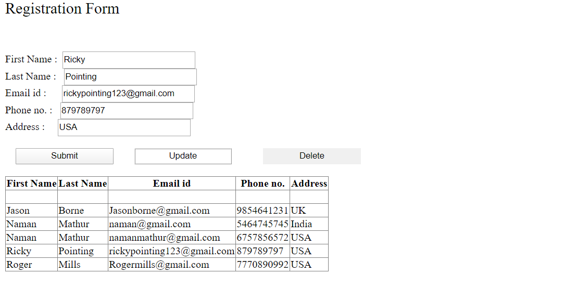

# output of update record operation:

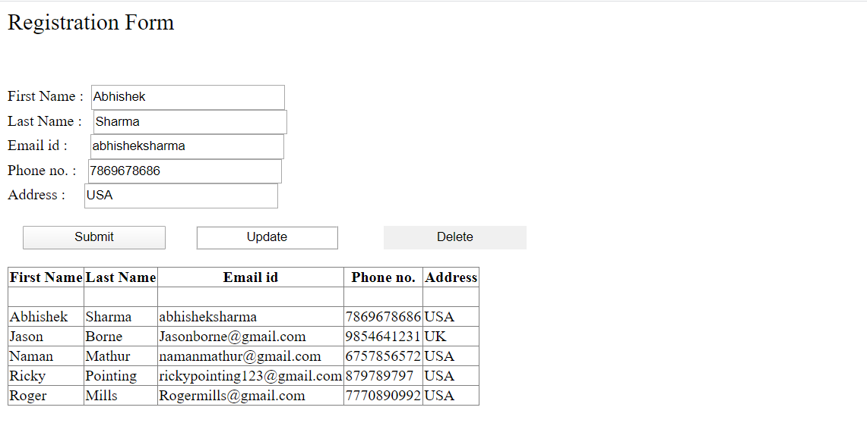

# output of DELETION RECORD operation:

# BEFORE DELETION:

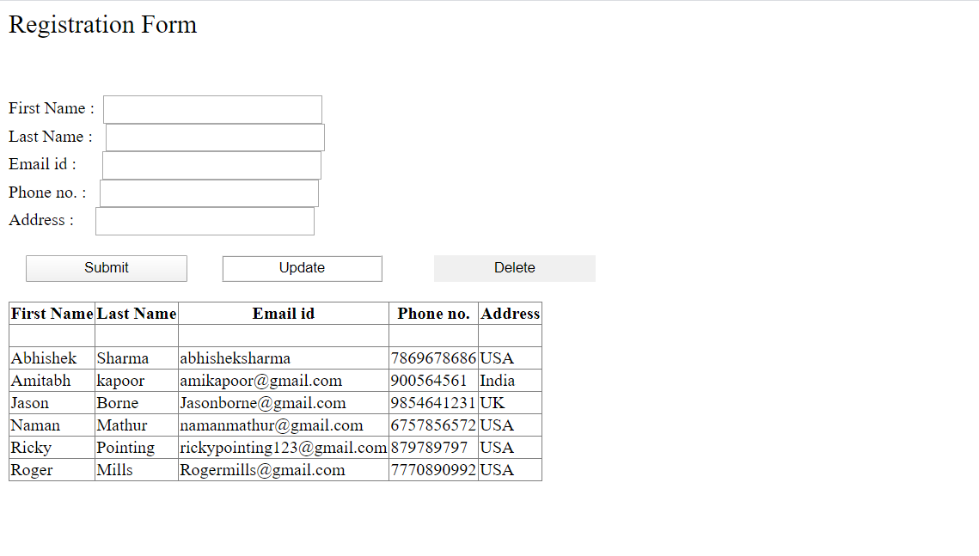

# After DELETION:

