**Application Development Framework using .NET  
PRACTICAL LAB_01**

**NAME: - YASH GUPTA**

**ENROLLMENT NO: - 2019BTCS088**

**BRANCH: - B. TECH CS&IT**

**SECTION: - B 2nd YEAR (4TH SEMESTER)**

**SUBMITTED TO: - MANISH KHULE**

## Write a Program in C# Sharp to store elements in an array and print

|  |
| --- |
| using System;  public class Array  {  public static void Main()  {  int[] array = new int[5]; // declaring 1d array  int i;  Console.Write("\n\nRead and Print elements of an array:\n");  Console.Write("-----------------------------------------\n");    Console.Write("Input 10 elements in the array :\n");  for(i=0; i<5; i++) // taking input from user  {  Console.Write("element - {0} : ",i);  array[i] = Convert.ToInt32(Console.ReadLine());  }    Console.Write("\nElements in array are: "); // Printing the input provided by user  for(i=0; i<5; i++)  {  Console.Write("{0} ", array[i]); // Printing the 1d array  }  Console.Write("\n");  }  } |

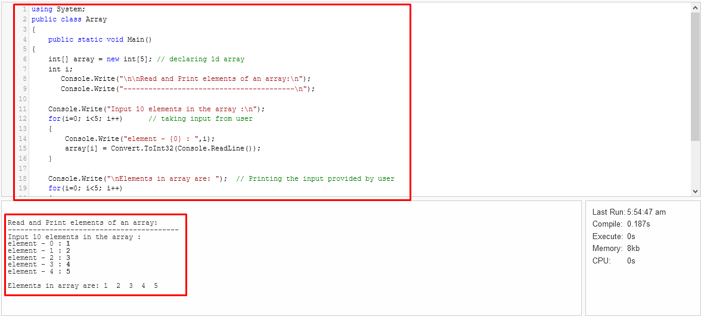

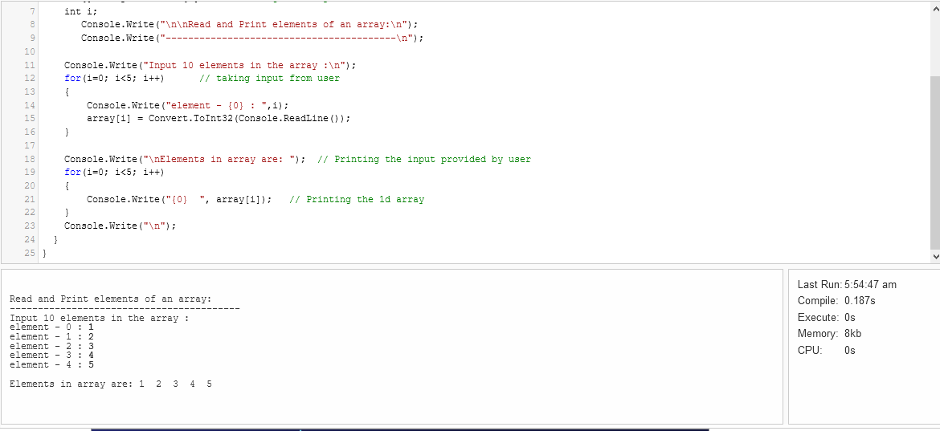

## Write a program in C# Sharp to find the sum of all elements of the array.

|  |
| --- |
| **using System;**  **public class SumArray**  **{**  **public static void Main()**  **{**  **int[] a= new int[100];**  **int i, n, sum=0;**      **Console.Write("\n\nFind sum of all elements of array:\n");**  **Console.Write("--------------------------------------\n");**  **Console.Write("Input the number of elements to be stored in the array :");**  **n = Convert.ToInt32(Console.ReadLine());**    **Console.Write("Input {0} elements in the array :\n",n);**  **for(i=0;i<n;i++)**  **{**  **Console.Write("element - {0} : ",i);**  **a[i] = Convert.ToInt32(Console.ReadLine());**  **}**  **for(i=0; i<n; i++)**  **{**  **sum += a[i];**  **}**  **Console.Write("Sum of all elements stored in the array is : {0}\n\n", sum);**  **}**  **}** |

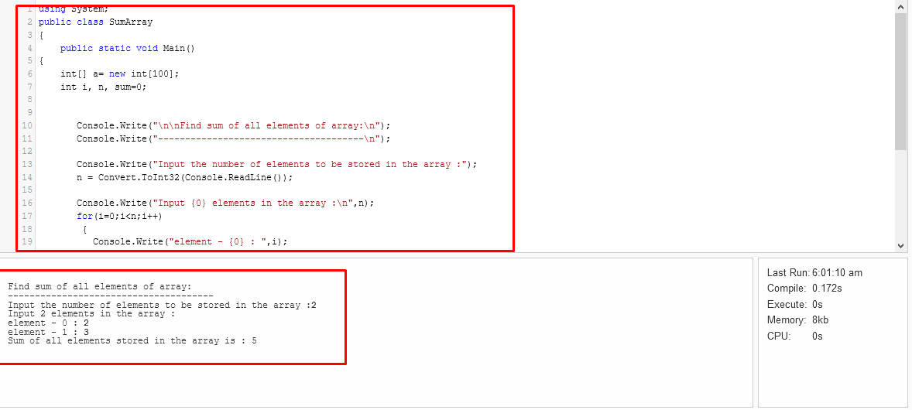

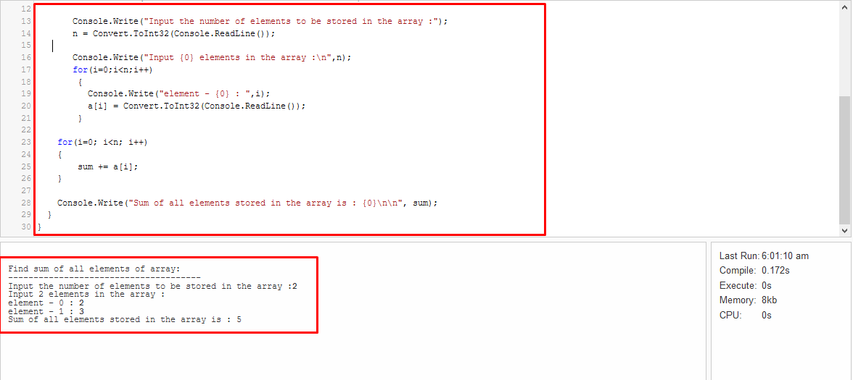

## Write a program in C# Sharp to count a total number of duplicate elements in an array.

|  |
| --- |
| **using System;**  **public class Program**  **{**  **public static void Main()**  **{**  **int[] arr = new int[100];**  **int i, j, num, count = 0;**    **//Reads size of the array**  **Console.WriteLine("Enter size of the array: ");**  **num = Convert.ToInt32(Console.ReadLine());**    **//Reads elements in array**  **Console.WriteLine("Enter elements in the array: ");**  **for (i = 0; i < num; i++)**  **{**  **arr[i] = Convert.ToInt32(Console.ReadLine());**  **}**    **//Find all duplicate elements in array**  **for (i = 0; i < num; i++)**  **{**  **for (j = i + 1; j < num; j++)**  **{**  **// If duplicate element found then increment count by 1**  **if (arr[i] == arr[j])**  **{**  **count++;**  **break;**  **}**  **}**  **}**  **Console.WriteLine("\n Total number of duplicate elements found in array is/are: " + count);**  **Console.ReadLine();**  **}**    **}** |

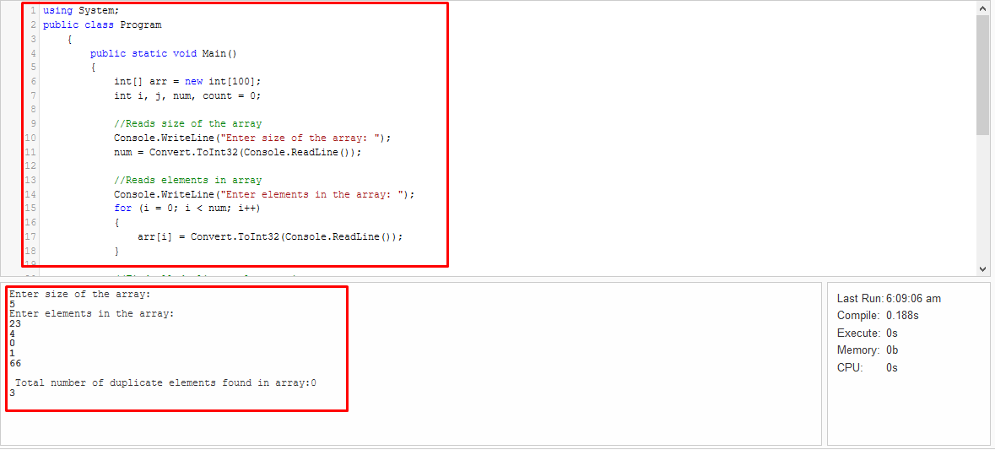

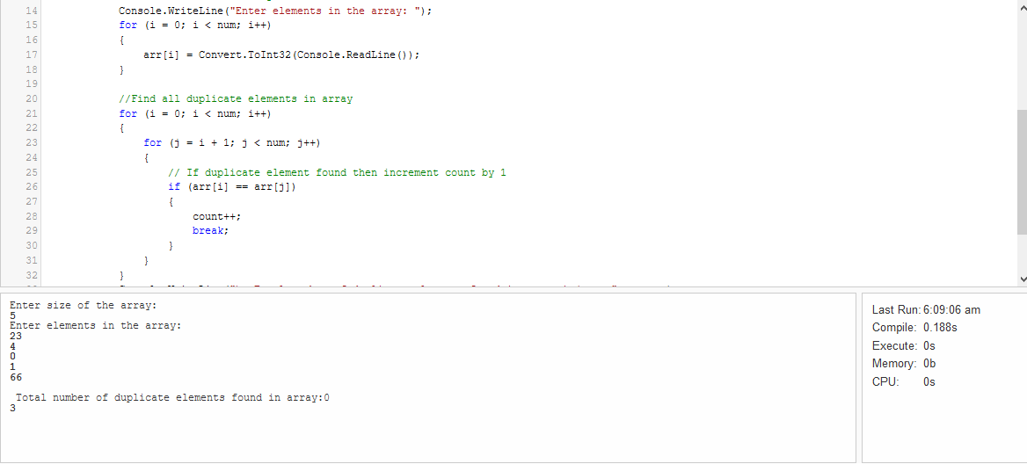

## Write a program to property contain roll no and name use object student to access them

|  |
| --- |
| **using System;**  **namespace ConsoleApp**  **{**  **public class Rollnumber**  **{**  **public string studentname;//variable**  **public string RollNo {//property name**  **get {**  **return studentname; // access the value**  **}**  **set { // use to store the value**  **studentname = value;// value is a keyword**  **}**  **}**  **public static void Main(string[] args)**  **{**  **Rollnumber student = new Rollnumber();**    **student.RollNo = "2019BTCS088";**  **Console.WriteLine(student.RollNo);**  **Console.ReadLine();**  **}**  **}**  **}** |

