**Application Development Framework using .NET  
PRACTICAL LAB_02**

**NAME: - YASH GUPTA**

**ENROLLMENT NO: - 2019BTCS088**

**BRANCH: - B. TECH CS&IT**

**SECTION: - B 2nd YEAR (4TH SEMESTER)**

**SUBMITTED TO: - MANISH KHULE\**

## 1. Write a program in C# Sharp to Remove Items from List using remove function bypassing the object

## Sample:

## Char: a Char: b Char: c Char: d Char: e

|  |
| --- |
| // Program_to_Remove_Elements_by_YASH_GUPTA_2019BTCS088 //  using System;  using System.Collections.Generic;  using System.Linq;  public class RemoveElements  {  public static void Main()  {    List<string> listOfStrings = new List<string>();  listOfStrings.Add("a");  listOfStrings.Add("b");  listOfStrings.Add("c");  listOfStrings.Add("d");  listOfStrings.Add("e");      Console.Write("\nLINQ : Remove Items from List by passing item index : ");  Console.Write("\n--------------------------------------------------\n");    var _result1 = from y in listOfStrings  select y;  Console.Write("Here is the list of items : \n");  foreach(var tchar in _result1)  {  Console.WriteLine("Char: {0} ", tchar);  }  listOfStrings.RemoveAt(3);    Console.ReadLine();  }  } |

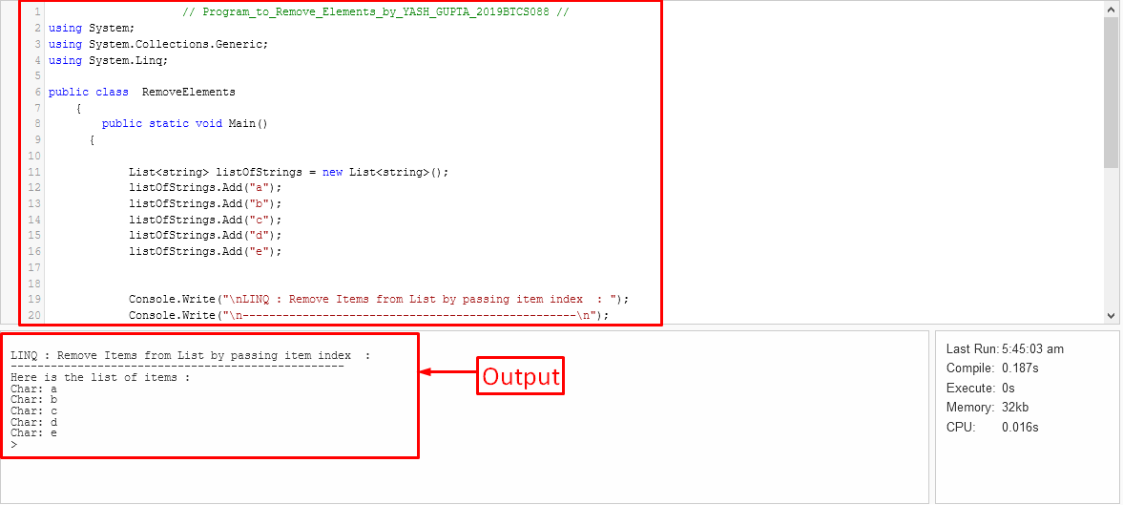

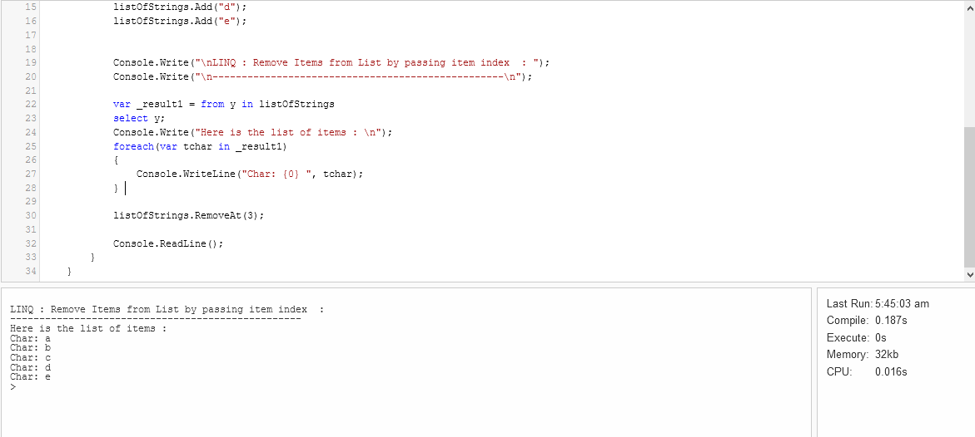

---------<<<>>>>---------

## 2.Write a program in C# Sharp to remove a range of items from a list bypassing the start index and the number of elements to remove. Test Data : Here is the list of items : Char: a Char: c Char: d Char: e Char: b Expected Output: Here is the list after removing the three items starting from the item index 1 from the list : Char: a Char: b

|  |
| --- |
| **// Program_to_Remove_Range_Of_Elements_by_YASH_GUPTA_2019BTCS088 //**  **using System;**  **using System.Collections.Generic;**  **using System.Linq;**  **public class RemoveRangeOfElements**  **{**  **public static void Main()**  **{**  **List<string> listOfString = new List<string>();**  **listOfString.Add("a");**  **listOfString.Add("c");**  **listOfString.Add("d");**  **listOfString.Add("e");**  **listOfString.Add("b");**  **Console.Write("\nLINQ : Remove range of items from list by passing start index and number of elements to delete : ");**  **Console.Write("\n------------------------------------------------------------------------------------------------\n");**  **var _result1 = from y in listOfString**  **select y;**  **Console.Write("Here is the list of items : \n");**  **foreach(var tchar in _result1)**  **{**  **Console.WriteLine("Char: {0} ", tchar);**  **}**  **listOfString.RemoveRange(1, 3);**  **var _result = from z in listOfString**  **select z;**  **Console.Write("\nHere is the list after removing the three items starting from the item index 1 from the list : \n");**  **foreach(var rChar in _result)**  **{**  **Console.WriteLine("Char: {0} ", rChar);**  **}**  **Console.ReadLine();**  **}**  **}** |

--------<<<>>>-------

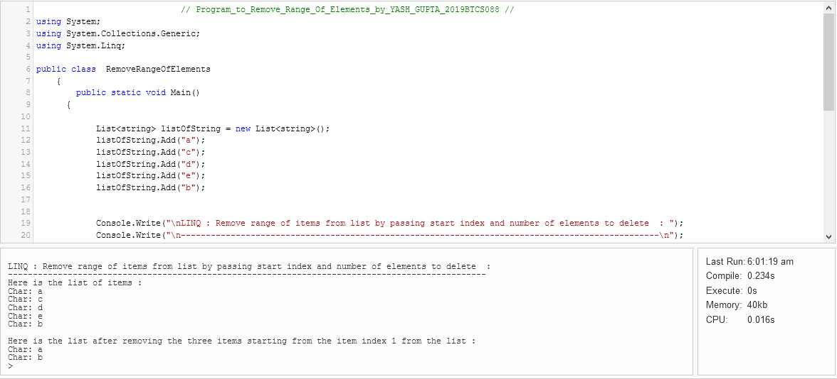

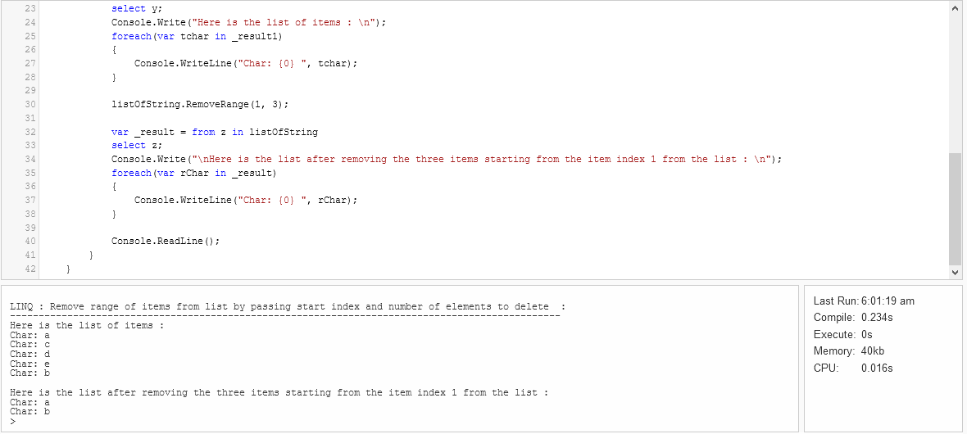

-------<<<>>>------

## 3. Write a program to create a delegate and print the area of squares and the area of circle.

|  |
| --- |
| **// Program_to_find_create a delegate and print the area of squares and the area of circle_BY_YASH_GUPTA_2019BTCS088 //**  **using System;**    **public class AreaOfCircle**  **{**    **// Function to return the required area**  **public static float getArea(int radius)**  **{**    **// Calculate the area**  **float area = (float)(Math.PI * radius * radius) / 4;**  **return area;**  **}**    **// Driver code**  **public static void Main()**  **{**  **int radius = 3;**  **Console.Write("Delegated Area is: \n");**  **Console.Write(getArea(radius));**  **}**  **}** |

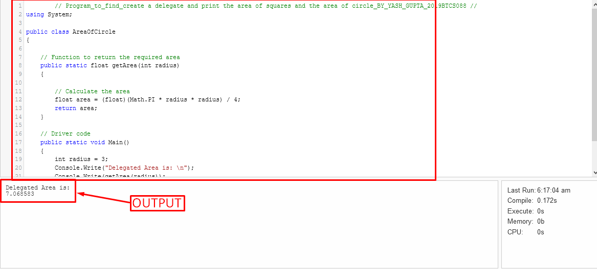

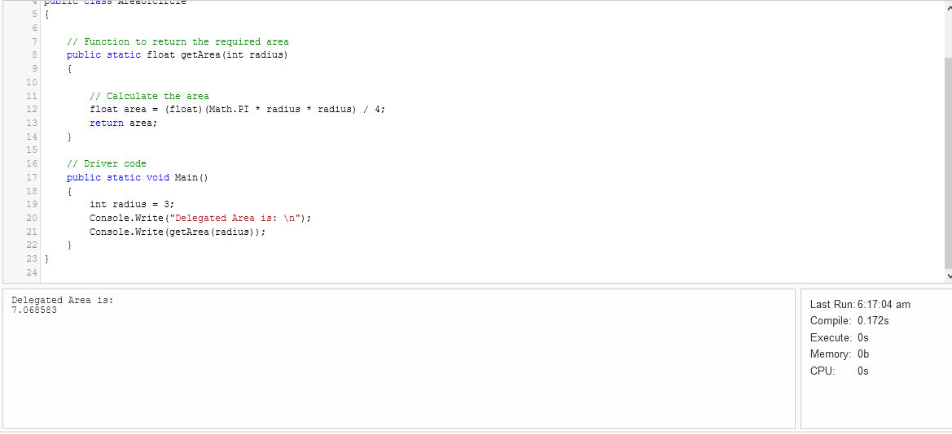

## 4. write a program to create an index in C#

## Display

## Name

## Semester

## Year

|  |
| --- |
| **// Program_for_using_Indexer_in C#_BY_YASH_GUTA_2019BTCS088 //**  **using System;**    **// class declaration**  **public class IndexerCreation**  **{**    **// class members**  **public string[] val = new string[3];**    **// Indexer declaration**  **// public - access modifier**  **// string - the return type of the Indexer**  **// this - is the keyword having a parameters list**  **public string this[int index]**  **{**    **// get Accessor**  **// retrieving the values**  **// stored in val[] array**  **// of strings**  **get**  **{**    **return val[index];**  **}**    **// set Accessor**  **// setting the value at**  **// passed index of val**  **set**  **{**    **// value keyword is used**  **// to define the value**  **// being assigned by the**  **// set indexer.**  **val[index] = value;**  **}**  **}**  **}**    **// Driver Class**  **public class main {**    **// Main Method**  **public static void Main() {**    **// creating an object of parent class which**  **// acts as primary address for using Indexer**  **IndexerCreation ic = new IndexerCreation();**    **// Inserting values in ic[]**  **// Here we are using the object**  **// of class as an array**  **ic[0] = "YASH GUPTA";**  **ic[1] = "4th";**  **ic[2] = "2nd";**    **Console.Write("Printing values stored in objects used as arrays\n");**    **// printing values**  **Console.WriteLine("Name : {0}", ic[0]);**  **Console.WriteLine("Semester : {0}", ic[1]);**  **Console.WriteLine("Year : {0}", ic[2]);**    **}**  **}** |

