**SYMBIOSIS UNIVERSITY OF APPLIED SCIENCES, INDORE**



**B-TECH CSIT B (4th Semester)**

**ASSIGNMENT**

**DOTNET Assignment**

**SUBMITTED TO:**

**Mr. Manish Khule**

**SUBMITTED BY:**

**Saurav Singh**

**2019BTCS072**

1. Write a program in C# sharp to create a blank file in the disk newly

Code->

using System;

using System.Collections.Generic;

using System.Linq;

using System.Text;

using System.Threading.Tasks;

using System.IO;

using System.Text;

namespace ConsoleApp1Assignment6

{

class Program

{

static void Main(string[] args)

{

FileStream fileStr = File.Create(@" C:\Users\2001a\source\repos\4th Sem Assignment\Assignment 6\Files Folder\Sample.txt");

Console.WriteLine("File Created Successfully");

Console.ReadLine();

}

}

}

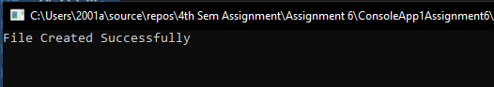

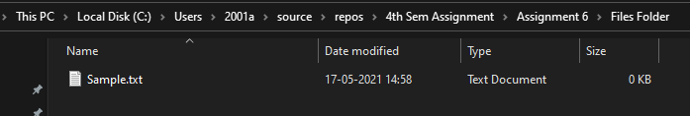

1. Write a program in C# sharp to remove a file from the disk.

Code->

using System;

using System.Collections.Generic;

using System.Linq;

using System.Text;

using System.Threading.Tasks;

using System.IO;

using System.Text;

namespace ConsoleApp2Assignment6

{

class Program

{

static void Main(string[] args)

{

File.Delete(@"C:\Users\2001a\source\repos\4th Sem Assignment\Assignment 6\Files Folder\sample.txt");

Console.WriteLine("File Deleted Successfully");

Console.ReadLine();

}

}

}

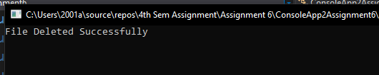

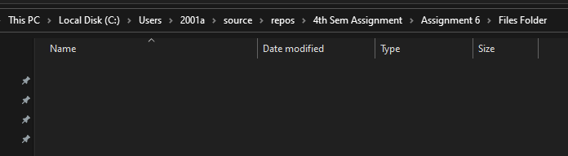

1. Write a program in C# sharp to create a file and add some text.

Code->

using System;

using System.Collections.Generic;

using System.Linq;

using System.Text;

using System.Threading.Tasks;

using System.IO;

using System.Text;

namespace ConsoleApp3Assignment6

{

class Program

{

static void Main(string[] args)

{

FileStream fileStr = new FileStream(@" C:\Users\2001a\source\repos\4th Sem Assignment\Assignment 6\Files Folder\Sample.txt",

FileMode.Create, FileAccess.Write, FileShare.None);

var text = "This is some text written to the textfile";

byte[] writeArr = Encoding.UTF8.GetBytes(text);

fileStr.Write(writeArr, 0, text.Length);

fileStr.Close();

Console.WriteLine("File Created and Data Entered Successfully");

Console.ReadLine();

}

}

}



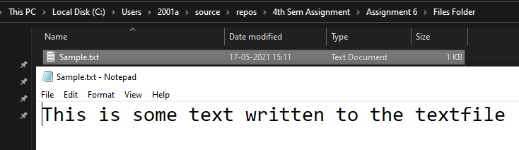

1. Write a program in C# sharp to append some text to an existing file .

Code->

using System;

using System.Collections.Generic;

using System.Linq;

using System.Text;

using System.Threading.Tasks;

using System.IO;

using System.Text;

namespace ConsoleApp4Assignment6

{

class Program

{

static void Main(string[] args)

{

String path = @" C:\Users\2001a\source\repos\4th Sem Assignment\Assignment 6\Files Folder\Sample.txt";

using (StreamWriter sw = File.AppendText(path))

{

sw.WriteLine("\nThis is the use of append in file stream of c#");

sw.WriteLine("This is another line of append using file stream in c#");

}

Console.WriteLine("File Successfully Appended");

Console.ReadLine();

}

}

}

