**SYMBIOSIS UNIVERSITY OF APPLIED SCIENCES, INDORE**



**B-TECH CSIT B (4th Semester)**

**ASSIGNMENT**

**DOT NET Assignment - 12**

**SUBMITTED TO:**

**Mr. Manish Khule**

**SUBMITTED BY:**

**Saurav Singh**

**2019BTCS072**

Q) Use Of Gridview to display data.

Code :

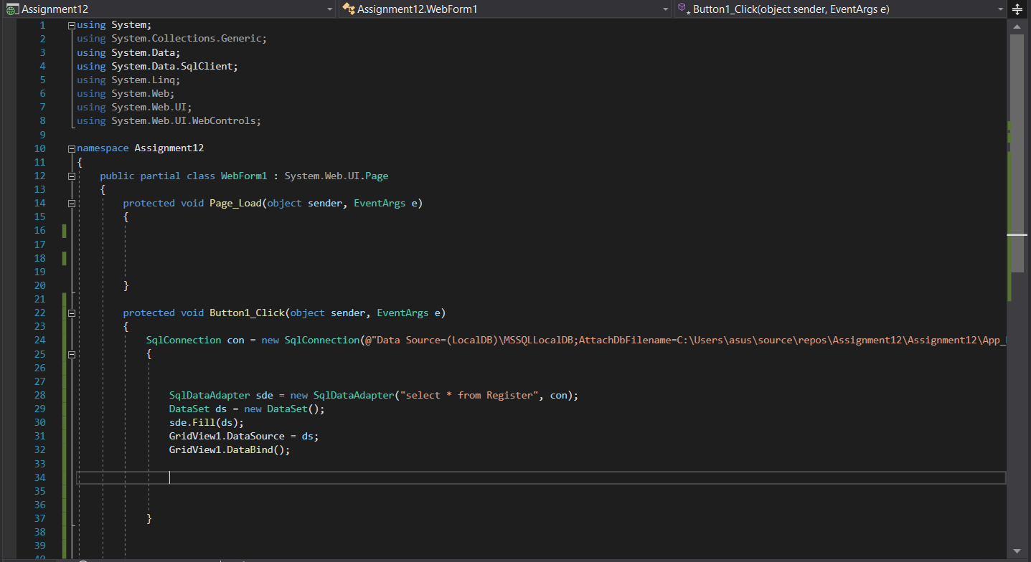

HTML FILE :

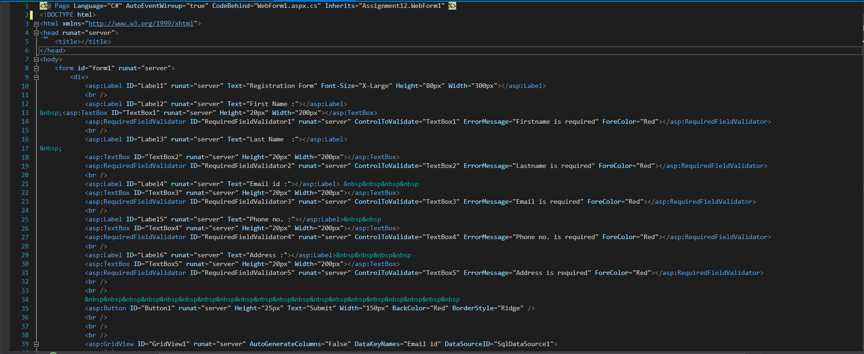

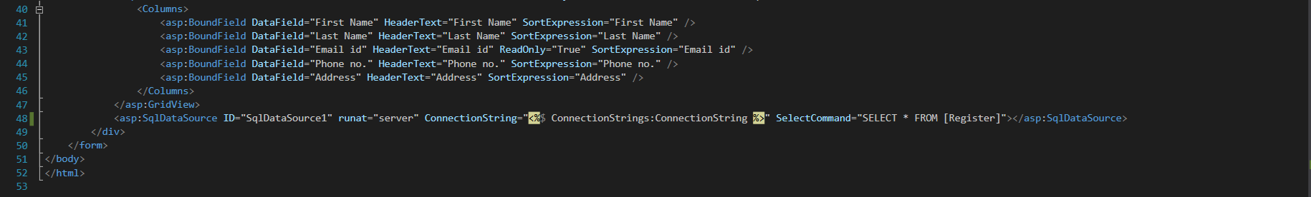

Output :

