**SYMBIOSIS UNIVERSITY OF APPLIED SCIENCES, INDORE**



**B-TECH CSIT B (4th Semester)**

**ASSIGNMENT**

**DOT NET Assignment - 7**

**SUBMITTED TO:**

**Mr. Manish Khule**

**SUBMITTED BY:**

**Saurav Singh**

**2019BTCS072**

Question 1: Write a C# Sharp program to extract the Date property and display the Date Time value in the formatted output.

CODE –

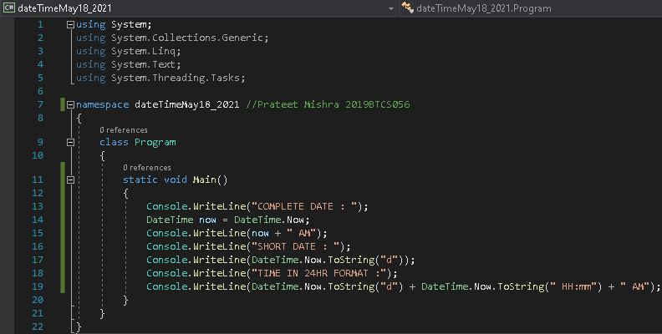

OUTPUT –

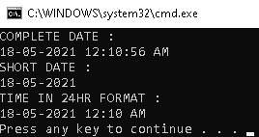

Question 2: Write a C# Sharp program to display the Day properties (year, month, day, hour, minute, second, millisecond etc.).

CODE –

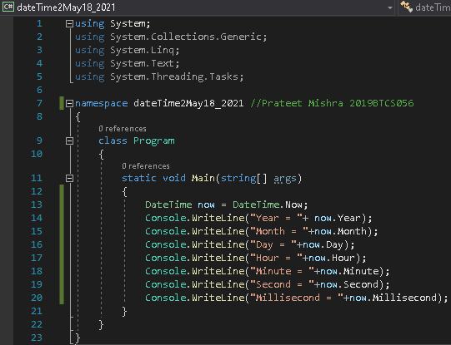

OUTPUT –

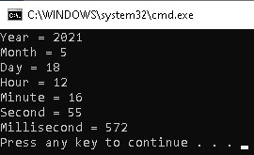

Question 3: Write a C# Sharp program to get the day of the week for a specified date.

CODE –

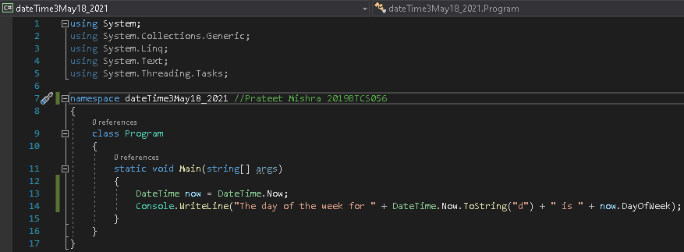

OUTPUT –

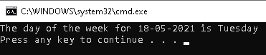

Question 4: Write a C# Sharp program to get a Date Time value that represents the current date and time on the local computer.

CODE –

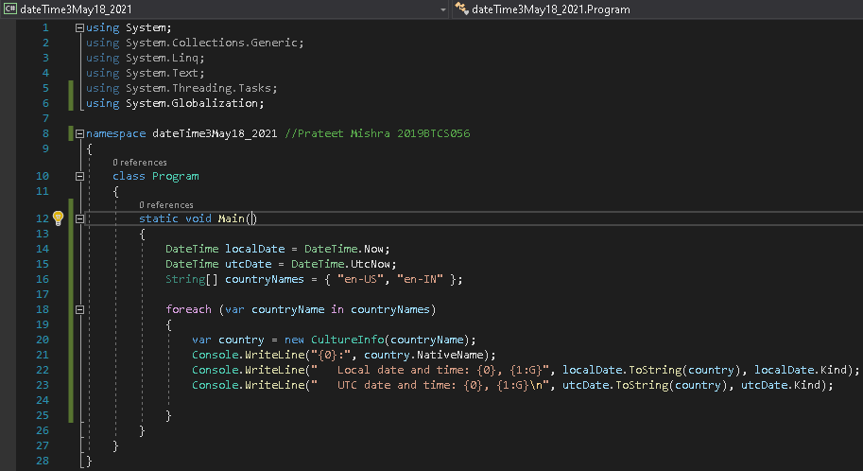

OUTPUT –

