

**SKILL JOURNAL**

Enrollment Number – 2019BTCS088 Year of Enrollment – 2019-2023

Name of the Student – YASH GUPTA

School of COMPUTER SCIENCE & INFORMATION TECHNOLOGY

Program – B. TECH

Specialization/ Branch – CS&IT

Semester – 4TH Section – B2 Branch – CS&IT

Paper Code – BTCS04CCB4 Name of Paper – Application Development using .NET

Faculty-In-Charge – MR. MANISH KHULE SIR

CERTIFICATE

THE SKILL EXPERIMENTS

ENTERED IN THIS JOURNAL HAVE BEEN SATISFACTORY PERFORMED BY

ENROLLMENT NO - 2019BTCS088 MR/MS­­­­­­­­­­­­­­­­­­­­ YASH GUPTA

STUDYING IN PROGRAM B. TECH BRANCH CS&IT IN

SCHOOL OF COMPUTER SCIENCE & INFORMATION TECHNOLOGY

DURING SEMESTER 4TH OF ACADEMIC YEAR 2020-2021

_______________________

( )

Date: _________________

INDEX

|  |  |  |  |  |
| --- | --- | --- | --- | --- |
| S.NO | Title of Skill Activity | Date of Allocation | Date of Submission | Sign of Faculty |
| 1 | Application of CRUD operations | 02/06/2021 | 08/06/2021 |  |
|  |  |  |  |  |
| 2. | Use of Grid View to Display Data | 17/06/2021 | 18/06/2021 |  |
|  |  |  |  |  |
| 3. | Displaying Date & Time using C# | 26/05/2021 | 31/05/2021 |  |
|  |  |  |  |  |
| 4. | File Handling using C# | 28/05/2021 | 31/05/2021 |  |
|  |  |  |  |  |
| 5. | Program to count Total No. of Alphabets, digits & Special Characters in a String | 17/06/2021 | 28/06/2021 |  |
|  |  |  |  |  |
|  |  |  |  |  |
|  |  |  |  |  |
|  |  |  |  |  |
|  |  |  |  |  |
|  |  |  |  |  |
|  |  |  |  |  |
|  |  |  |  |  |
|  |  |  |  |  |
|  |  |  |  |  |
|  |  |  |  |  |
|  |  |  |  |  |
|  |  |  |  |  |
|  |  |  |  |  |
|  |  |  |  |  |
|  |  |  |  |  |
|  |  |  |  |  |
|  |  |  |  |  |
|  |  |  |  |  |
|  |  |  |  |  |
|  |  |  |  |  |
|  |  |  |  |  |
|  |  |  |  |  |
|  |  |  |  |  |
|  |  |  |  |  |
|  |  |  |  |  |

SKILL ACTIVITIY NO: 1  
(Application of CRUD Operations)

Date: 08th June 2021

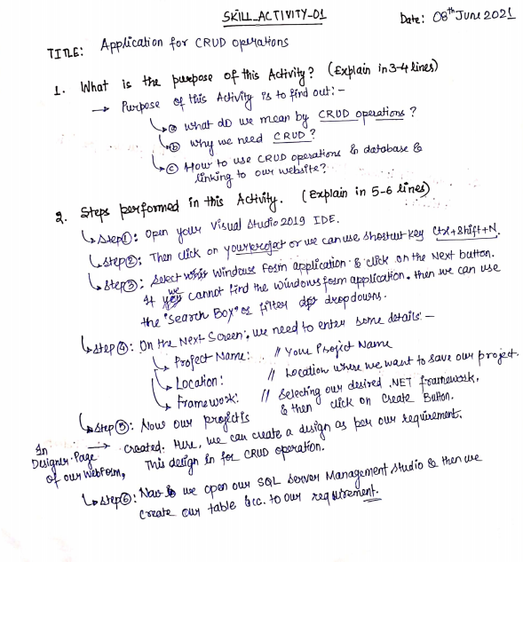

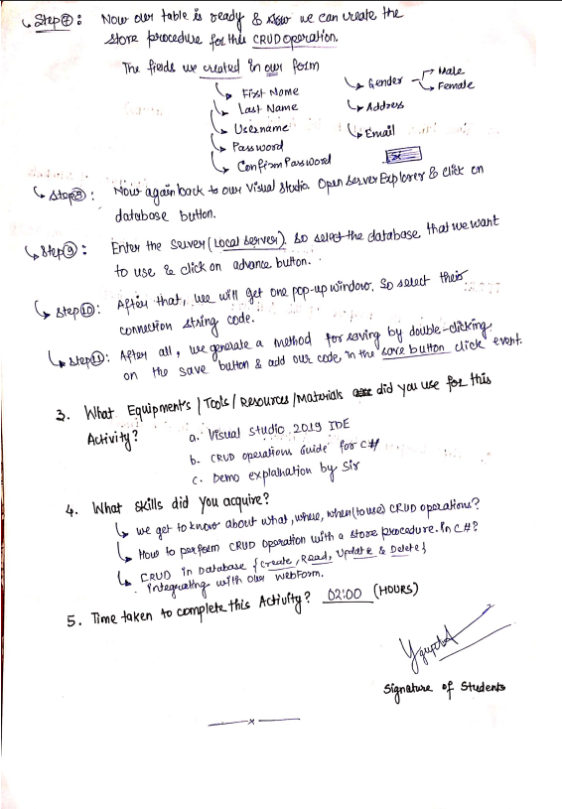

**(To be filled by Faculty)**

|  |  |  |
| --- | --- | --- |
| Sr. No. | Skill /Competencies | (Achieved / Not Achieved)  (Yes / No) |
|  |  |  |
|  |  |  |
|  |  |  |
|  |  |  |

Remarks :

Total mark ___________________________out of 10.

Signature of Faculty

Date: _________________

**Details of Activity:**

# source code: QUestion 1

**File Name: WebFormFirst.aspx******

**File Name: WebFormFirst.aspx.cs******

**  
File Name: WebFormSecond.aspx**

**File Name: WebFormSecond.aspx.cs**



**File Name: WebFormThird.aspx********  
File Name: WebFormThird.aspx.cs**



********

# output’s: user registratio form ui

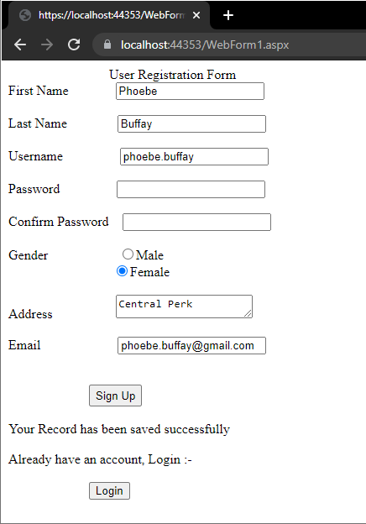

# on unscuccessful login UI:

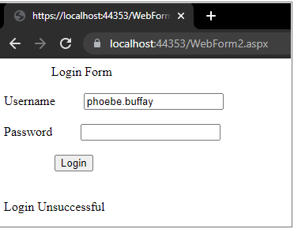

# UPDATING USER REGISTARTION FORM UI:

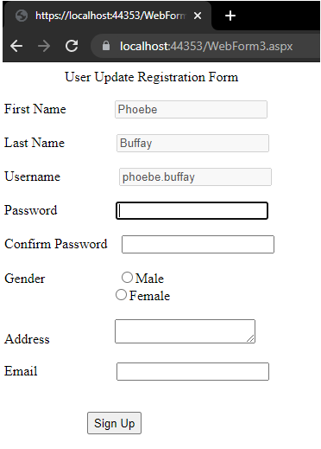

---------------------------------------------------------------------------------------------------------------------------------------------------------------

SKILL ACTIVITIY NO: 2  
(Use of Grid View to Display Data)

Date: 17th June 2021

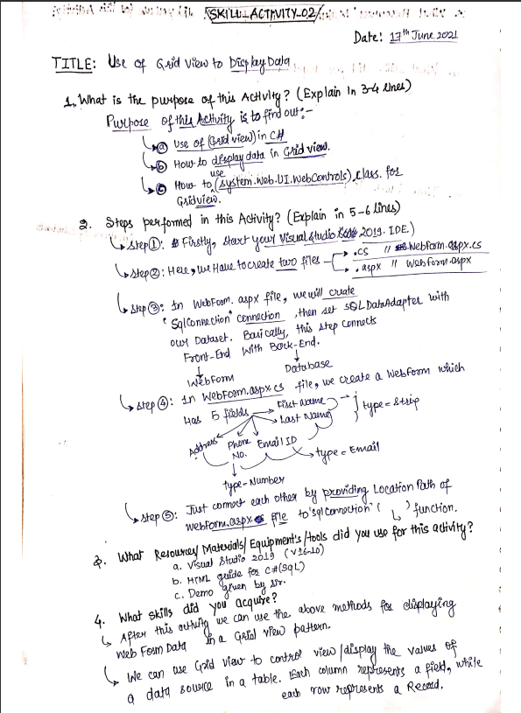

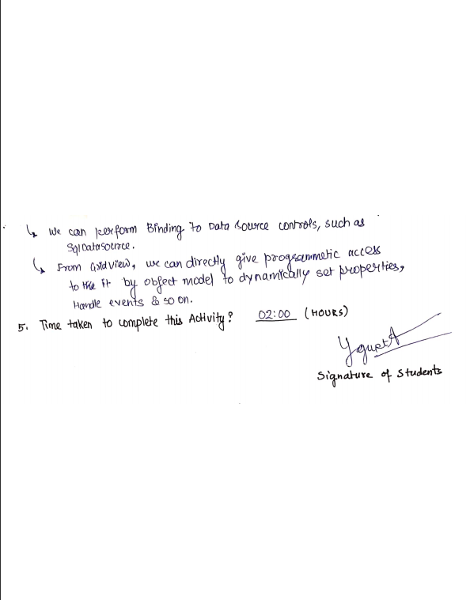

**(To be filled by Faculty)**

|  |  |  |
| --- | --- | --- |
| Sr. No. | Skill /Competencies | (Achieved / Not Achieved)  (Yes / No) |
|  |  |  |
|  |  |  |
|  |  |  |
|  |  |  |

Remarks :

Total mark ___________________________out of 10.

Signature of Faculty

Date: _________________

# source code question 1:

**File Name: WebForm.aspx**



**File Name: WebForm.aspx.cs**



# output:

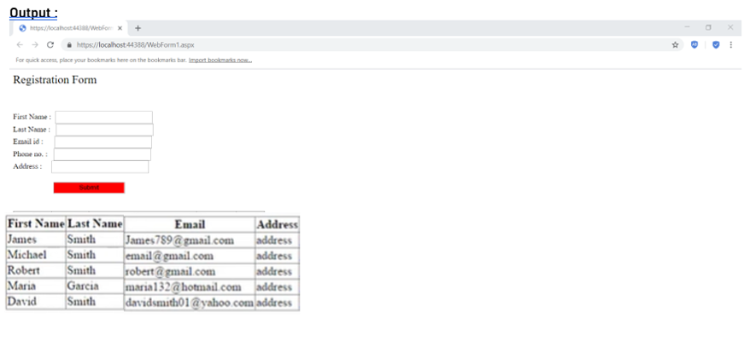  
**-------------------------------------------------------------------------------------------------------------------------------------**

SKILL ACTIVITIY NO: 3  
(Displaying Date & Time using C#)

Date: 17-June-2021

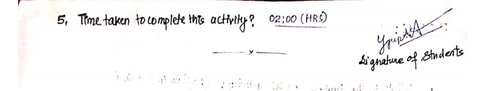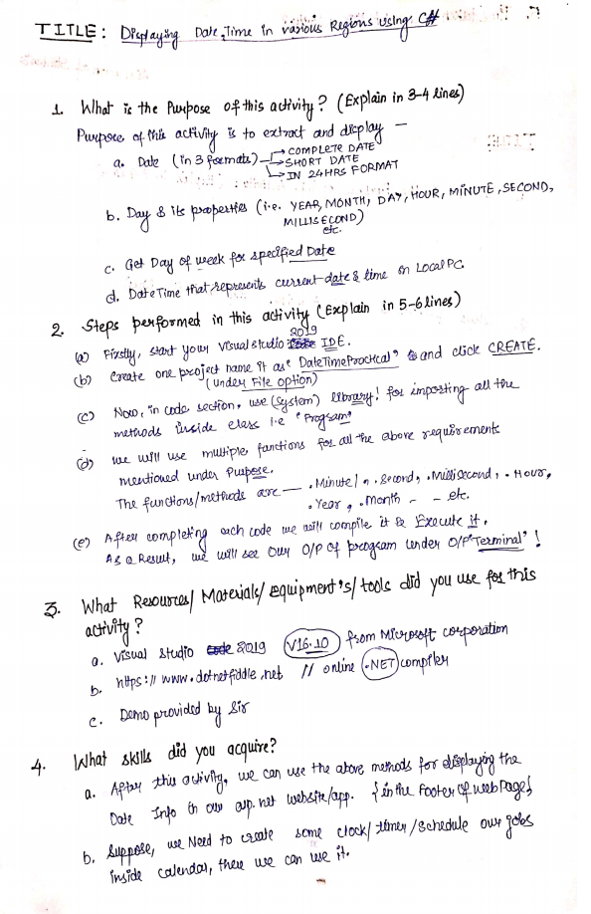

**(To be filled by Faculty)**

|  |  |  |
| --- | --- | --- |
| Sr. No. | Skill /Competencies | (Achieved / Not Achieved)  (Yes / No) |
|  |  |  |
|  |  |  |
|  |  |  |
|  |  |  |

Remarks :

Total mark ___________________________out of 10.

Signature of Faculty

Date: _________________

**Details of the Activity**

# SOURCE CODE: question 1

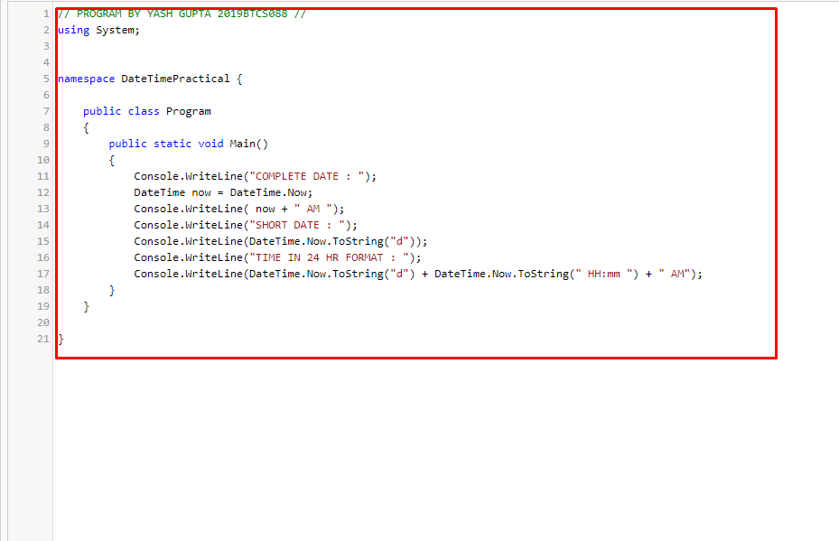

# OUTPUT:

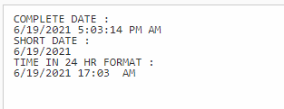

# source code: question 2

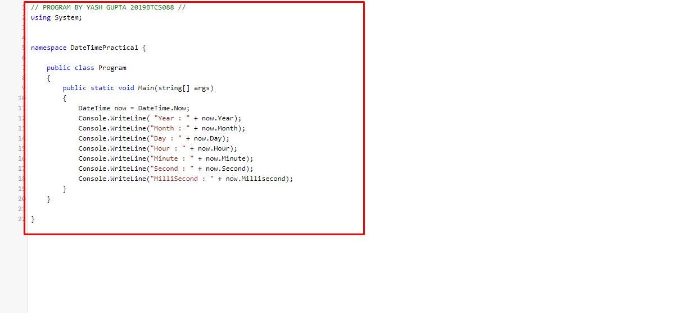

# OUTPUT:

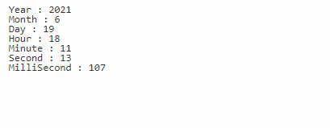

# SOURCE CODE: QUESTION 3

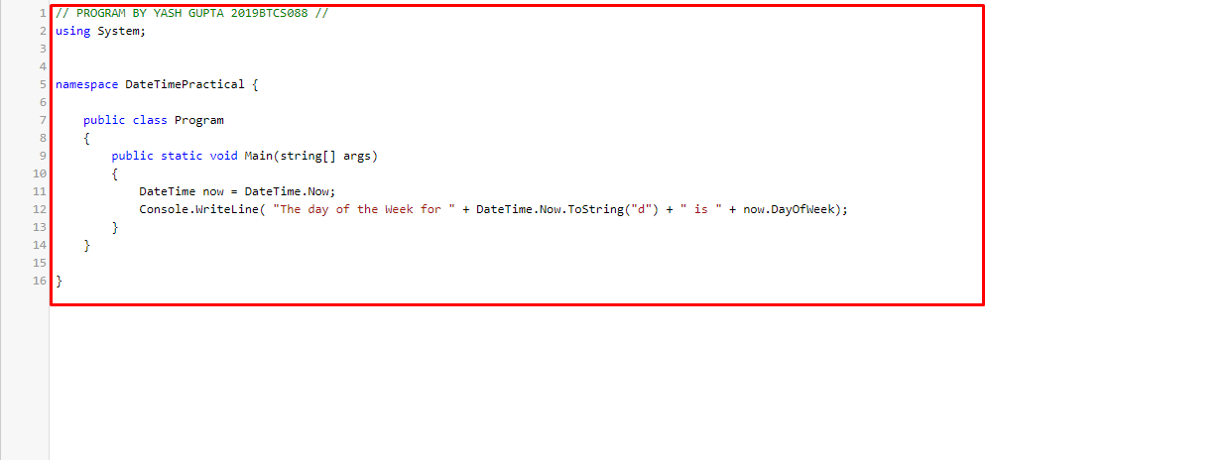  
UTPUT:

# OUTPUT:

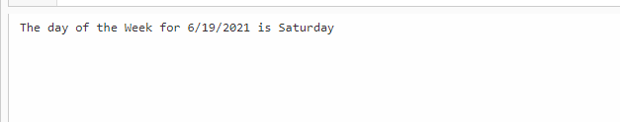

# source code: question 4

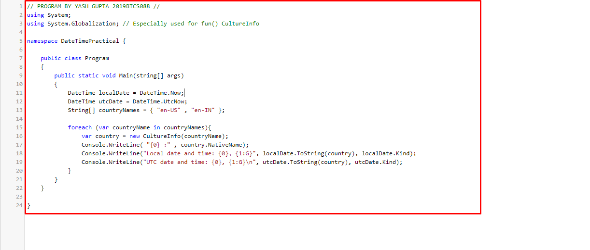

# OUTPUT:

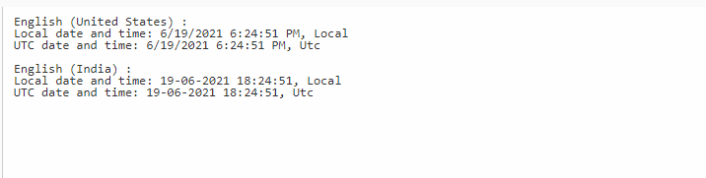

**--------------------------------------------------------------------------------------------------------------------------------------**

SKILL ACTIVITIY NO: 4  
(File Handling by using C#)

Date: 17-June-2021

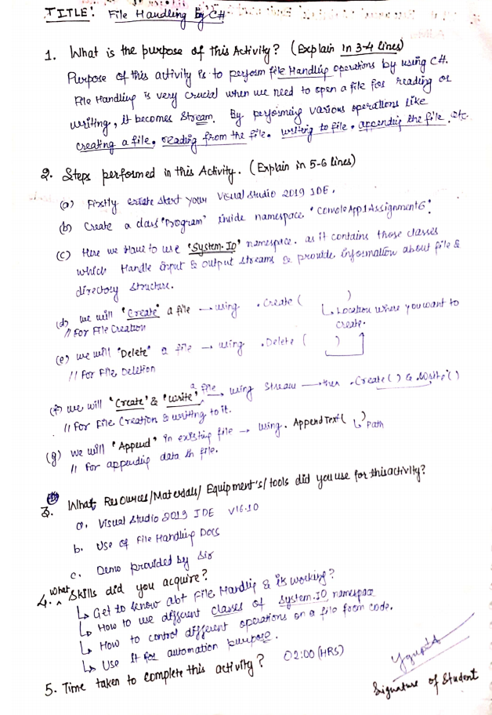

**(To be filled by Faculty)**

|  |  |  |
| --- | --- | --- |
| Sr. No. | Skill /Competencies | (Achieved / Not Achieved)  (Yes / No) |
|  |  |  |
|  |  |  |
|  |  |  |
|  |  |  |

Remarks :

Total mark ___________________________out of 10.

Signature of Faculty

Date: _________________

**Details of Activity:**

# source code: question 1



# output:

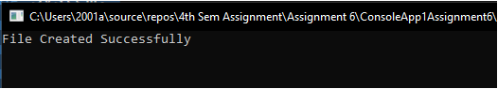  
  
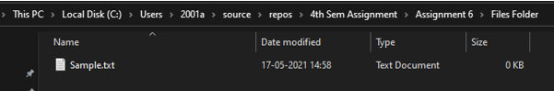

**--------------------------------------------------------------------------------------------------------------------------------------**

# SOURCE CODE: question 2



# output

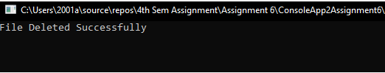  
  
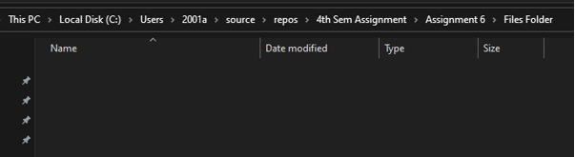  
  
**--------------------------------------------------------------------------------------------------------------------------------------**

# SOURCE CODE: question 3



# output

  
  
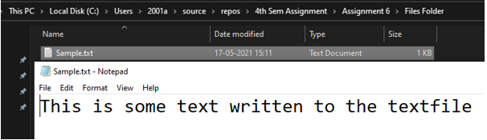  
  
**--------------------------------------------------------------------------------------------------------------------------------------**

# source code: question 4



# output

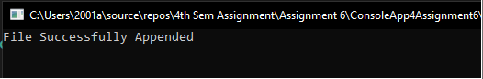

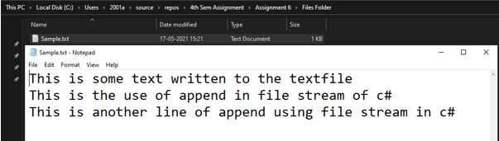  
**--------------------------------------------------------------------------------------------------------------------------------------**  
SKILL ACTIVITIY NO: 5  
(Program to count Total No. of Alphabets, digits & Special Characters in a String)

Date: 17-June-2021

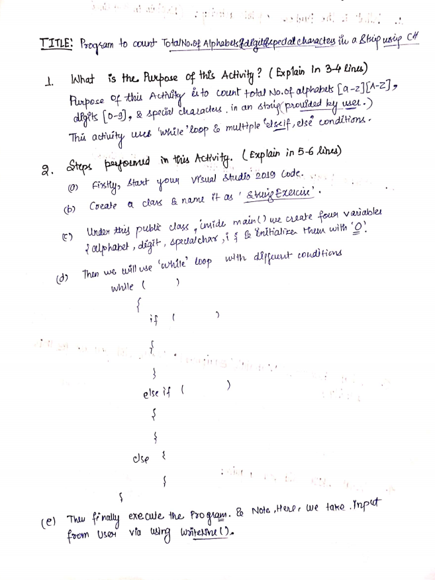

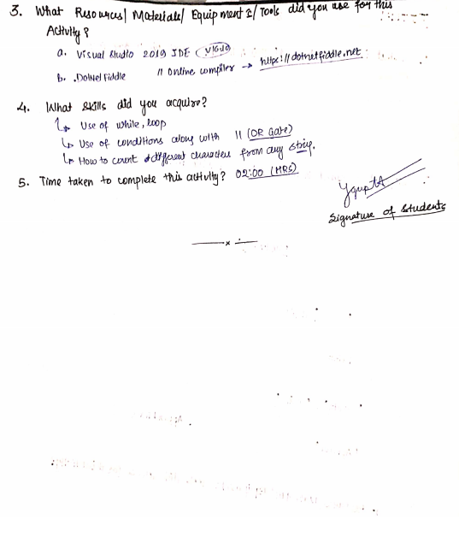

**(To be filled by Faculty)**

|  |  |  |
| --- | --- | --- |
| Sr. No. | Skill /Competencies | (Achieved / Not Achieved)  (Yes / No) |
|  |  |  |
|  |  |  |
|  |  |  |
|  |  |  |

Remarks:

Total mark ___________________________out of 10.

Signature of Faculty

Date: _________________

# source code:



# output:

  
  
