**COMPUTER NETWORKS  
PRACTICAL LAB_01**

**NAME: - YASH GUPTA**

**ENROLLMENT NO: - 2019BTCS088**

**BRANCH: - B. TECH CS&IT**

**SECTION: - B 2nd YEAR (4TH SEMESTER)**

**SUBMITTED TO: - DR. NEHA GUPTA MAM**

## Perform the following experiments using Cisco Packet Tracer

## Configure the following topologies:

## Bus

## Star

## Ring

## Mesh

## Hybrid

# Ans:

# Ans:

# Brief about the working of ATM Machine?

The term **ATM stands** for automated teller machine. It is an electronic device that is used by only bank customers to process account transactions. The users access their accounts through a special type of plastic card that is encoded with user information on a magnetic strip. The strip contains an identification code that is transmitted to the bank’s central computer by modem. The users insert the card into ATMs to access the account and process their account transactions. The automated teller machine was invented by John Shepherd-Barron in the year 1960.

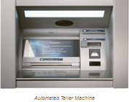

## Block Diagram of Automated Teller Machine

The **block diagram of the automated teller machine** consists of mainly two input devices and four output devices. The input devices like card reader and keypad whereas output devices are speaker, display screen, receipt printer, and cash depositor.

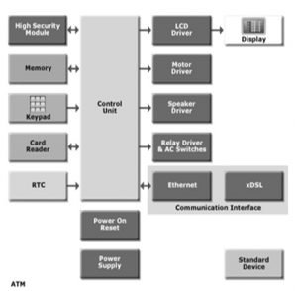  
Automated Teller Machine Block Diagram

## Input Devices

The input devices like card reader and keypad.

### Card Reader

The card reader is an input device that reads data from a card. The card reader is part of the identification of your particular account number and the magnetic strip on the backside of the ATM card is used for connection with the card reader. The card is swiped or pressed on the card reader which captures your account information i.e. the data from the card is passed on to the host processor (server). The host processor thus uses this data to get the information from the cardholders.

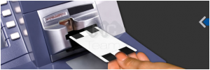  
ATM Card Reader

## Keypad

The card is recognized after the machine asks for further details like your identification number, withdrawal, and your balance inquiry Each card has a unique PIN so that there is little chance for some else to withdraw money from your account. There are separate laws to protect the PIN code while sending it to the host processor. The PIN is mostly sent in encrypted form. The keyboard contains 48 keys and is interfaced to the processor.

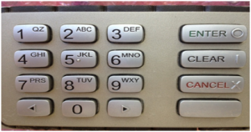  
ATM Keyboard

## Output Devices

The output devices are speaker, display screen, receipt printer, and cash depositor.

#### Speaker

The speaker provides audio feedback when a particular key is pressed.

#### Display Screen

The display screen displays the transaction information. Each step of withdrawal is shown by the display screen. A CRT screen or LCD screen is used by most of the ATMs.

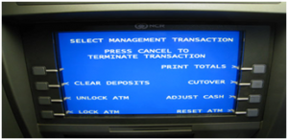  
ATM Display

#### Receipt Printer

The receipt printer prints all the details recording your withdrawal, date and time, and the amount of withdrawal and also shows the balance of your account in the receipt.

#### Cash Dispenser

The cash dispenser is the heart of the ATM. This is a central system of the ATM from where the required money is obtained. From this portion, the user can collect the money. The cash dispenser must count each bill and give the required amount. If in some cases the money is folded, it will be moved to another section and becomes the reject bit. All these actions are carried out by high precision sensors. A complete record of each transaction is kept by the ATM with the help of an RTC device.

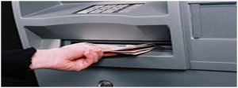  
ATM Cash Dispenser

## ATM Networking

The internet service provider (ISP) also plays an important role in the ATMs. This provides communication between ATM and host processors. When the transaction is made, the details are input by the cardholder. This information is passed on to the host processor by the ATM. The host processor checks these details with an authorized bank. If the details are matched, the host processor sends the approval code to the machine so that the cash can be transferred.

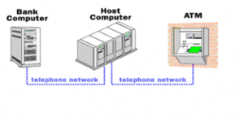  
Automated Teller Machine Networking

### Types of ATM Machines

There are different types of ATMs in the market which include the following. Most of the host processors can support either leased-line or dial-up machines

#### Leased Line ATM Machines

The leased line machines connect directly to the host processor through a four-wire point to point dedicated telephone line. These types of machines are preferred in place. The operating cost of these machines is very high.

#### Dial-Up ATM Machines

The dial-up ATMs connect to the host processor through a normal phone line using a modem. These require a normal connection their and their initial installation cost is very less. The operating cost of these machines is low compared with leased line machines.

#### White Label ATM

These ATMs are arranged, operated & owned through non-bank entities. These ATMs were launched by RBI (Reserve Bank of India) for assisting financial insertion as well as drive ATM access within the country. These types of ATMs will not show any bank’s logo. The first white logo ATM was launched by TATA in India beneath the brand name like Indicash.

#### Brown Label ATM

Brown label ATMs were maintained & owned through a service provider where a supporter bank whose brand can be employed on ATM to take care of network connectivity as well as cash organization.

#### Onsite ATM

These ATM machines are arranged in locations wherever a bank branch is located. So, both the bank as well as ATM can be used physically for several purposes by being on-site. Many customers can utilize this to keep away from the queue lines at the branch of the bank so that time taken to finish their bank transactions can be reduced.

#### Offsite ATM

These machines are arranged on a separate basis, which means that the bank has a place where there is only an ATM machine then this becomes an offsite ATM. This can be done to make sure that the bank reaches out to more geographical locations to utilize its services by the people even when there is no branch of the bank within the region. So these machines will operate outside of the bank locations.

#### Cash Dispenser

These machines allow simply balance inquiry, mini statement & cash withdrawals.

#### Mobile ATM

These machines move in the locations for the users because COVID 19 has led to the rush within the several Mobile ATMs.

#### Green Label

These types of ATMs are used especially for agricultural transactions.

#### Orange Label

These are mainly used for share transactions.

#### Yellow Label

These ATMs are used for an online purchase by providing an E-Commerce facility

#### Pink Label

These ATMs are used especially for women. These ATMs are observed by protectors to make sure that only women are accessing or not so that women waiting in long queues can be reduced.

### ATM Security:

The ATM card is secured with a PIN which is kept secret. There is no way to get the PIN from your card. It is encrypted by strong software like Triple data Encryption Slandered.

### Automated Teller Machine Working Principle

The automated teller machine is simply a data terminal with two inputs and four output devices. These devices are interfaced with the processor. The processor is the heart of the ATM. All the ATMs working around the world are based on a centralized [database system](https://www.elprocus.com/rfid-based-attendance-management-system/). The ATM has to connect and communicate with the host processor (server).

 The host processor is communicating with the internet service provider (ISP). It is the gateway through all the ATM networks available to the cardholder. When a cardholder wants to do an ATM transaction, the user provides necessary information through a card reader and keypad. The ATM forwards this information to the host processor. The host processor enters the transaction request to the cardholder bank.

 If the cardholder requests the cash, the host processor takes the cash from the cardholder’s account. Once the funds are transferred from the customer account to the host processor bank account, the processor sends the approval code to the ATM and the authorized machine to dispense the cash. This is the way to get the amount on ATMs. The ATM network is fully based on a centralized database environment. This will make life easier and secure cash.

<<<<<>>>>>

Describe about the ATM card in detail:-

* An **ATM card** is a [payment card](https://en.wikipedia.org/wiki/Payment_card) or dedicated payment card issued by a [financial institution](https://en.wikipedia.org/wiki/Financial_institution) (i.e. a bank) which enables a customer to access their financial accounts via its and others’ [automated teller machines](https://en.wikipedia.org/wiki/Automated_teller_machine) (ATMs) and to make approved point of purchase retail transactions (i.e. gas stations, grocery, hardware, department stores, etc.)
* ATM cards are not [credit cards](https://en.wikipedia.org/wiki/Credit_cards) or [debit cards](https://en.wikipedia.org/wiki/Debit_cards). ATM cards are payment card size and style plastic cards with a [magnetic stripe](https://en.wikipedia.org/wiki/Magnetic_stripe) and/or a plastic [smart card](https://en.wikipedia.org/wiki/Smart_card) with a [chip](https://en.wikipedia.org/wiki/Integrated_circuit) that contains a unique card number and some security information such as an expiration date or [CVVC](https://en.wikipedia.org/wiki/Card_Verification_Value_Code) (CVV).
* ATM cards are known by a variety of names such as **bank card**, **MAC** (money access card), **client card**, **key card** or **cash card**, among others. Other payment cards, such as [debit cards](https://en.wikipedia.org/wiki/Debit_card) and [credit cards](https://en.wikipedia.org/wiki/Credit_card) can also function as ATM cards.
* Charge and proprietary cards cannot be used as ATM cards. The use of a credit card to withdraw cash at an ATM is treated differently to a [POS](https://en.wikipedia.org/wiki/Point_of_sale) transaction, usually attracting interest charges from the date of the cash withdrawal. [Interbank networks](https://en.wikipedia.org/wiki/Interbank_network) allow the use of ATM cards at ATMs of private operators and financial institutions other than those of the institution that issued the cards.
* ATM cards can also be used on improvised ATMs such as "mini ATMs", merchants' card terminals that deliver ATM features without any [cash drawer](https://en.wikipedia.org/wiki/Cash_drawer).[[1]](https://en.wikipedia.org/wiki/ATM_card#cite_note-1)[[2]](https://en.wikipedia.org/wiki/ATM_card#cite_note-2) These terminals can also be used as cashless [scrip](https://en.wikipedia.org/wiki/Scrip) ATMs by cashing the receipts they issue at the merchant's [point of sale](https://en.wikipedia.org/wiki/Point_of_sale).[[3]](https://en.wikipedia.org/wiki/ATM_card#cite_note-3)

The first ATM cards were issued in **1967** by [**Barclays**](https://en.wikipedia.org/wiki/Barclays)in [**London**](https://en.wikipedia.org/wiki/London)**.**