Step1: Go to [***http://www.cloudbus.org/cloudsim/***](http://www.cloudbus.org/cloudsim/) for downloading **CloudSim 3.0.**

Step2: Then go to [***https://github.com/Cloudslab/cloudsim/releases***](https://github.com/Cloudslab/cloudsim/releases) for downloading cloudsim3.0  
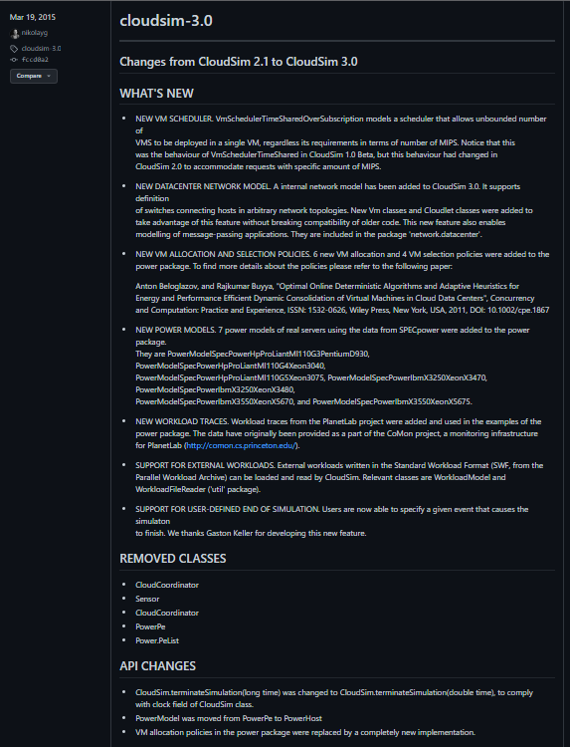  
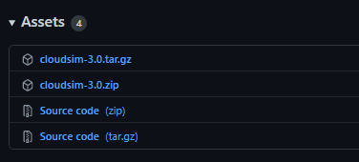

Step3: Now extract the **.zip** into our desired folder.  
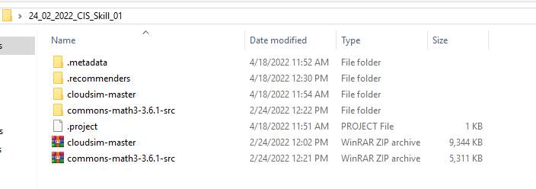

Step4: Now download **Eclipse IDE for Java Developers Version: Oxygen.3a Release (4.7.3a)** from ***https://www.eclipse.org/downloads/packages/release/oxygen***.  
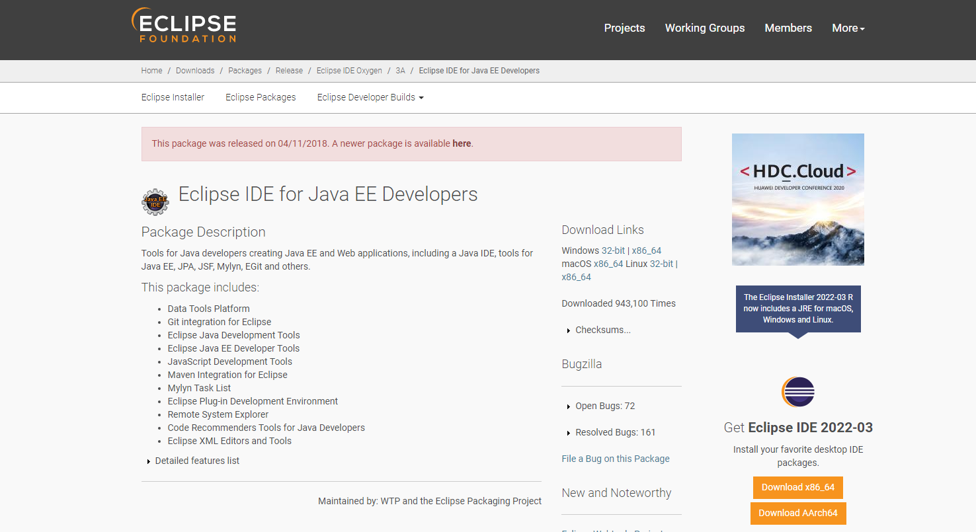  
Step5: For Java dependency of **cloudsim 3.0** we need **Apache Commons Math 3.6.1.** Download it from [***https://commons.apache.org/proper/commons-math/download_math.cgi***](https://commons.apache.org/proper/commons-math/download_math.cgi)***.***