Step1: Select your directory as workspace (where **cloudsim 3.0** & common_math is extracted) & launch it.  
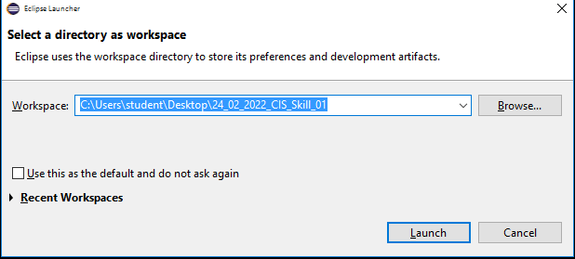  
Step2: Go to File & click on **Open Projects from file System.**   
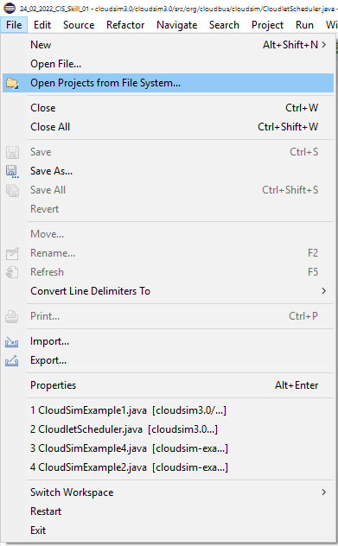  
Step3: Select **cloudsim3.0**.   
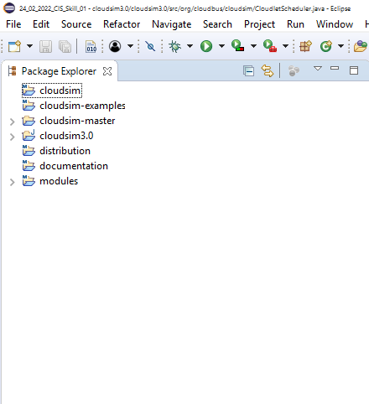

Step4: Select any example under   
**-> cloudsim3.0/src  
 -> org.cloudbus.cloudsim**

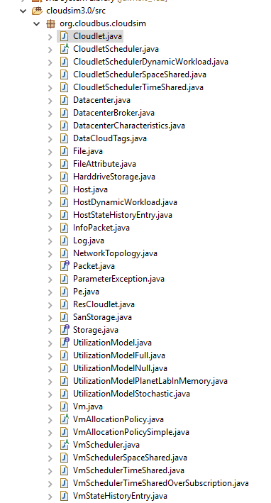  
Step5: Use the java code provided as example.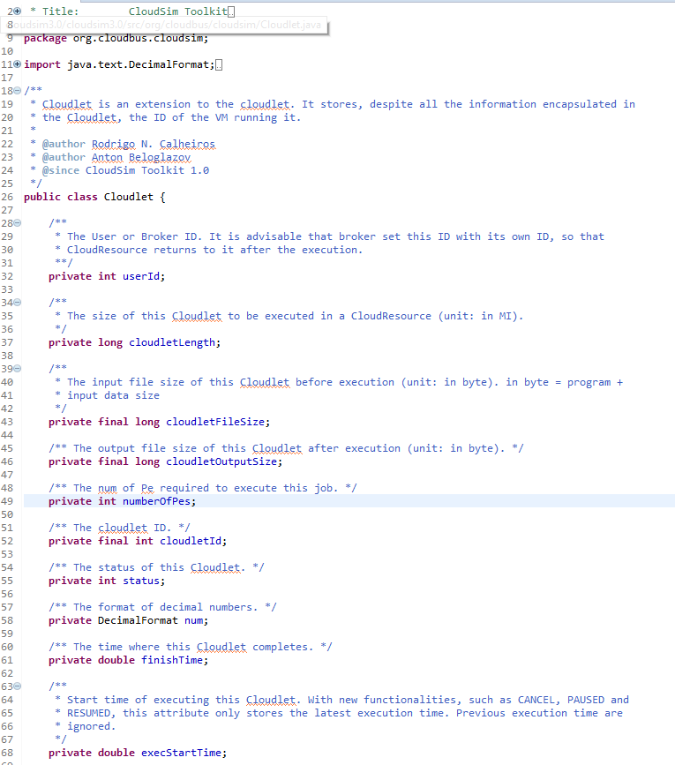 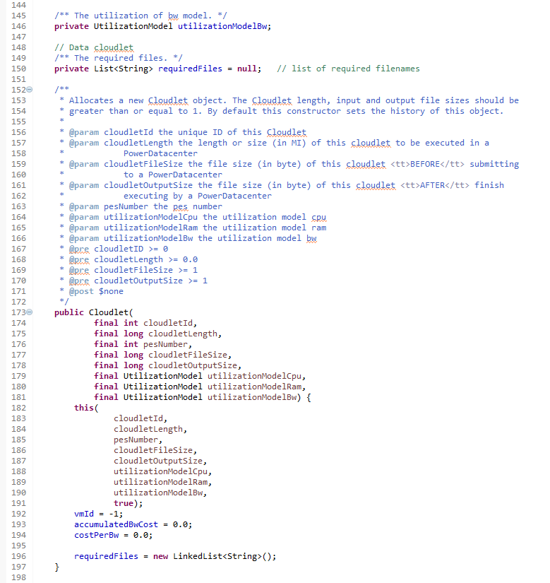  
  
  
Step6: Click on **Run** or press **Ctrl+F11** to execute the program. Foloowing **output** will be shown for **Cloudlet.java.**

