**Using Ubuntu_20.04**

Step 1: - Click on Ubuntu_20.04_Provision.cmd

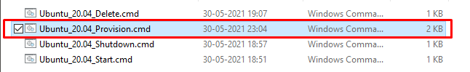

Step2: - After clicking, script automatically starts executing

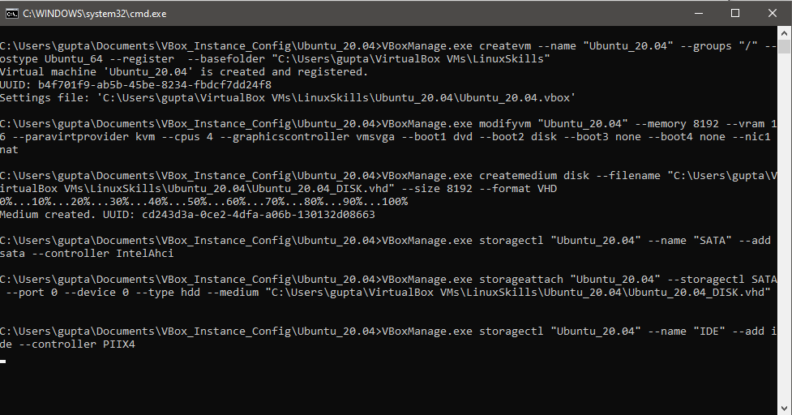  
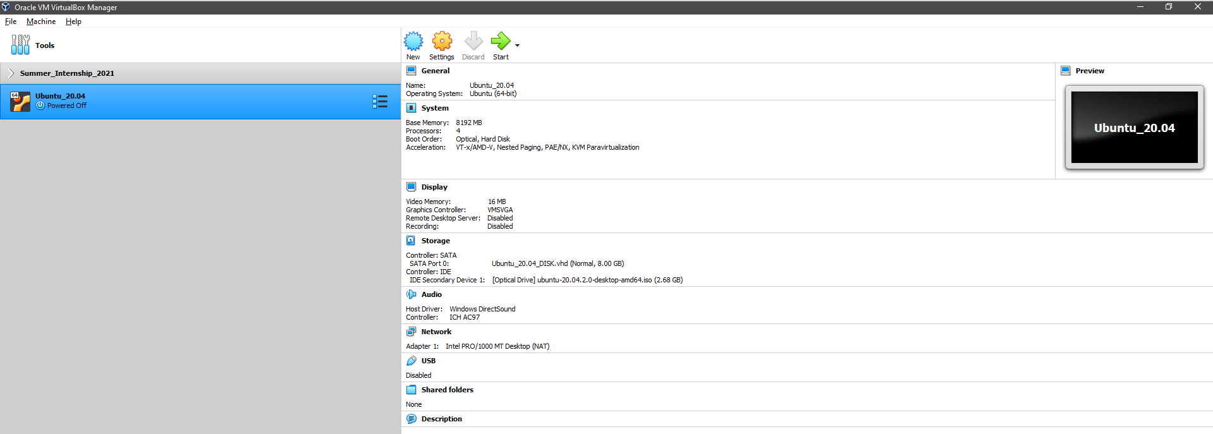  
Confirm from Oracle VirtualBox also

Step3: - Click on Ubuntu_20.04_Start.cmd  
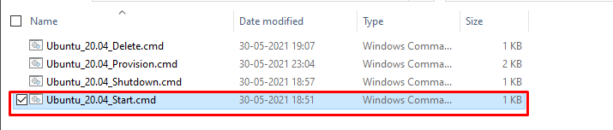Step4: - After clicking, script automatically starts executing

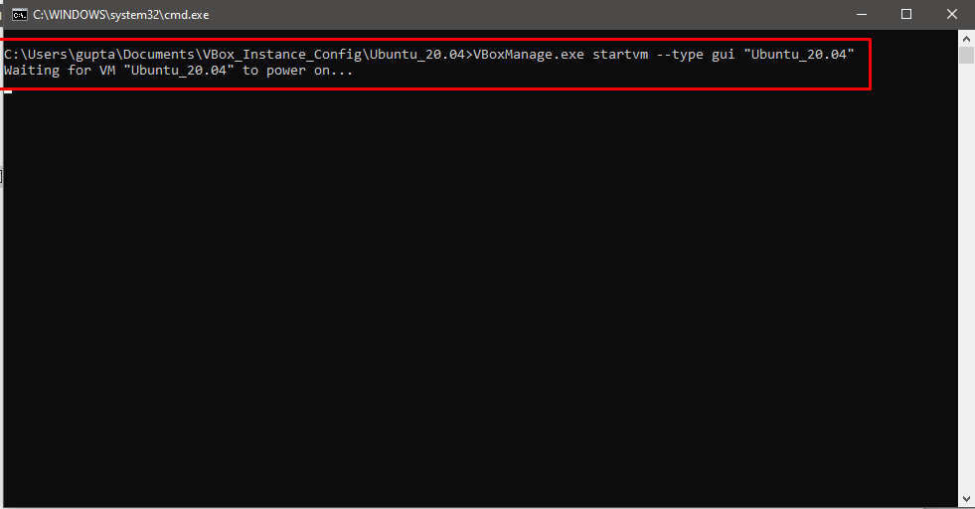  
Step5: - Ubuntu 20.04 Starts running

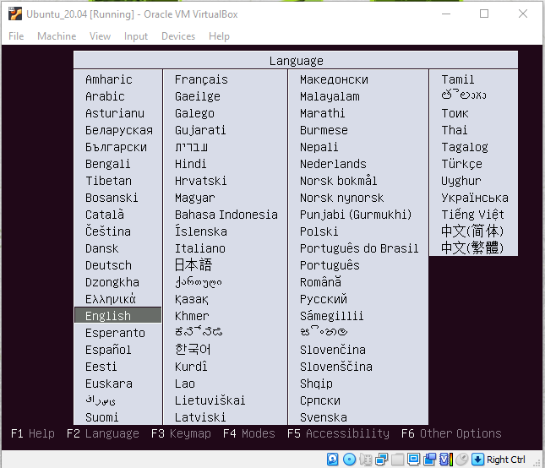  
Select **ENGLISH** language,   
  
Step6 :- Select Install Ubuntu option. Then Press **ENTER**  
**NOTE**:(Use arrow KEYS for using)  
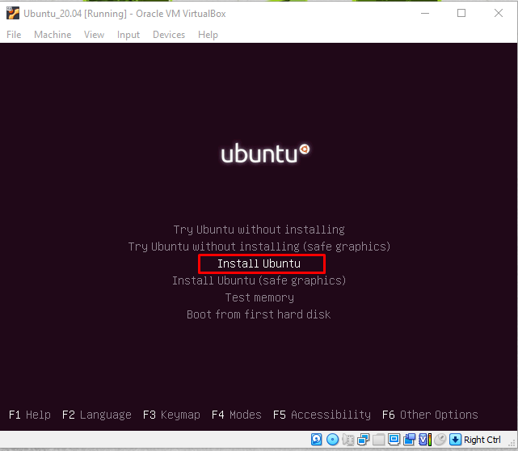  
Step7: - Ubuntu Bootloader starts checking disks. You can Cancel by pressing **CTRL+C.** 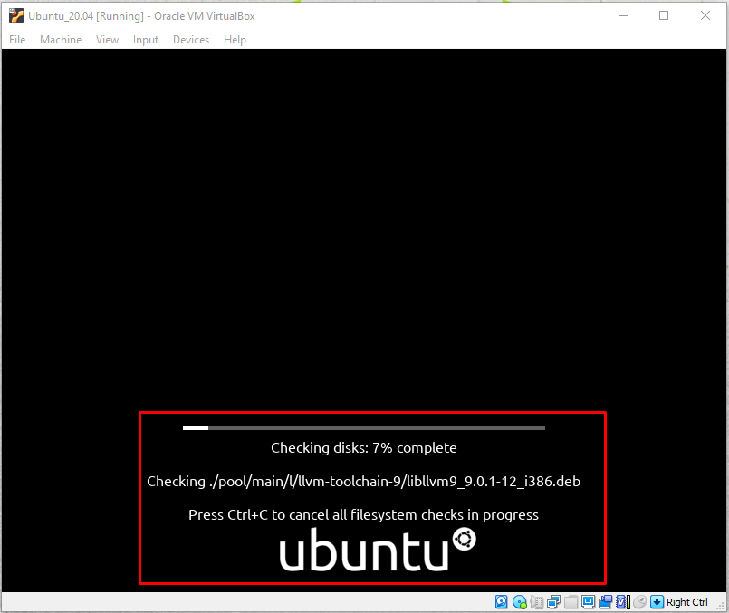  
Step8: - Select ’Continue’ and your desired Language.  
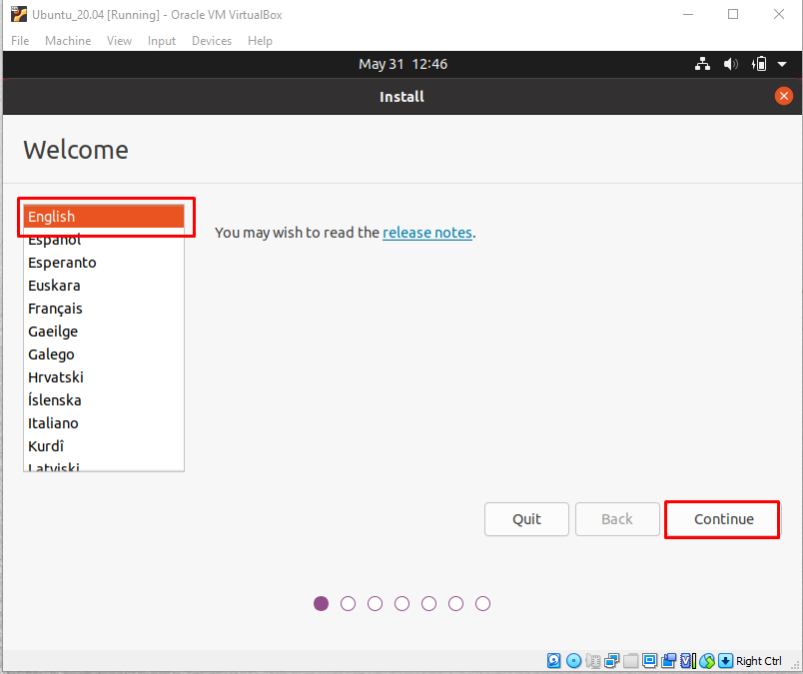

------------------------------------------------------------------------------------------------------------------------------------------

**Installation of Ubuntu_20.04**

Step 1: - Click on Ubuntu_20.04_Provision.cmd



Step2: - After clicking, script automatically starts executing

  
  
Confirm from Oracle VirtualBox also

Step3: - Click on Ubuntu_20.04_Start.cmd  
Step4: - After clicking, script automatically starts executing

  
Step5: - Ubuntu Bootloader starts checking disks. You can Cancel by pressing **CTRL+C.**   
Step6: - Select ’**Install Ubuntu’** & desired language.  
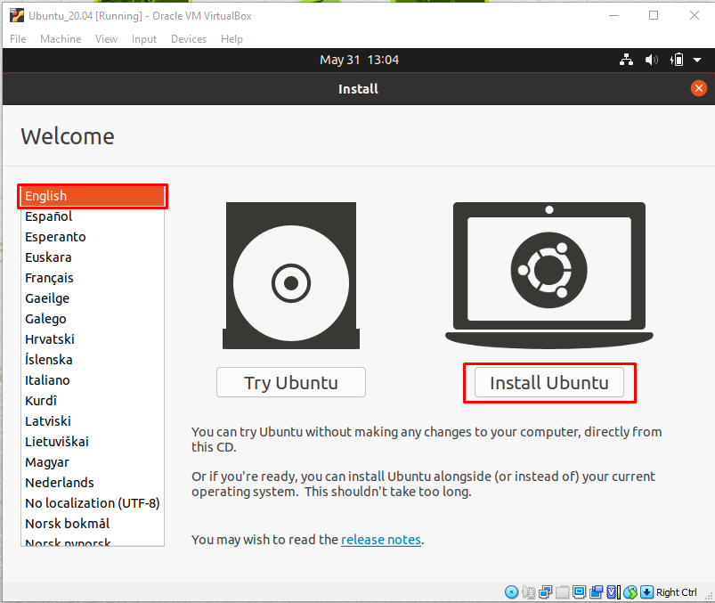

Step7: - Select your **Desired Keyboard** & press **Continue.**  
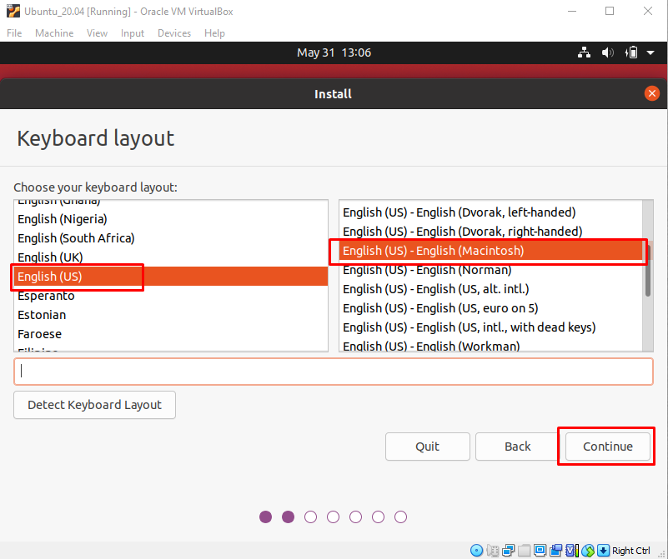

Step8: - Select **Normal Installation** (FOR most users)  
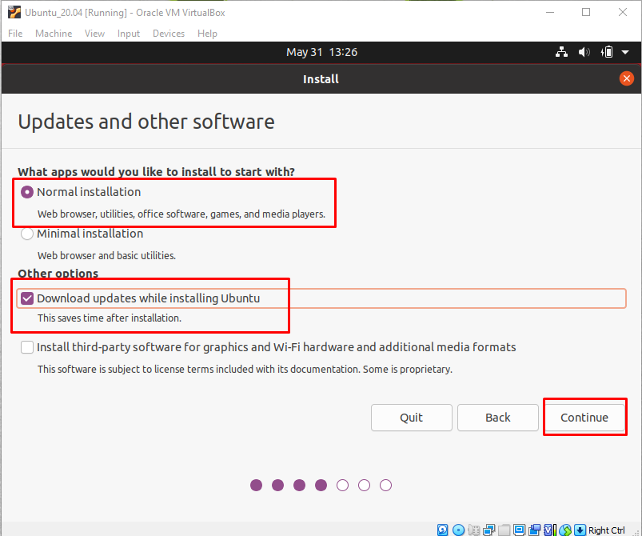

My own setup because of GPU support.  
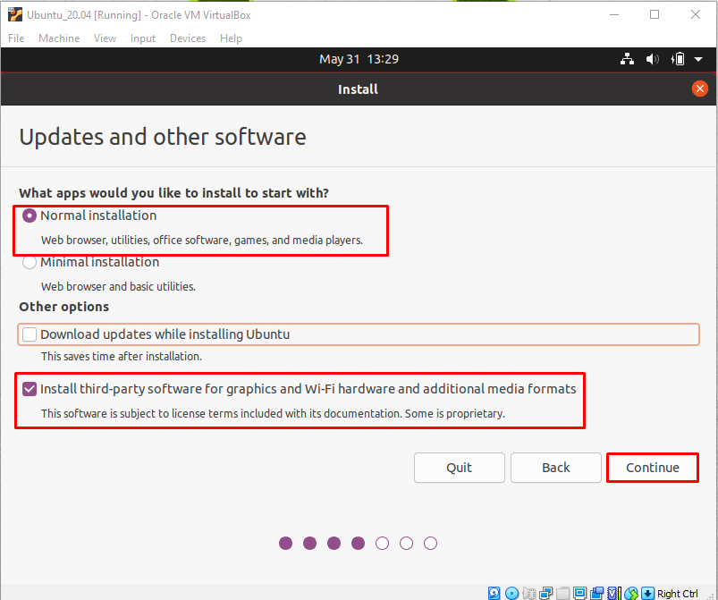

Step9: - For New Users: Go with this option.  
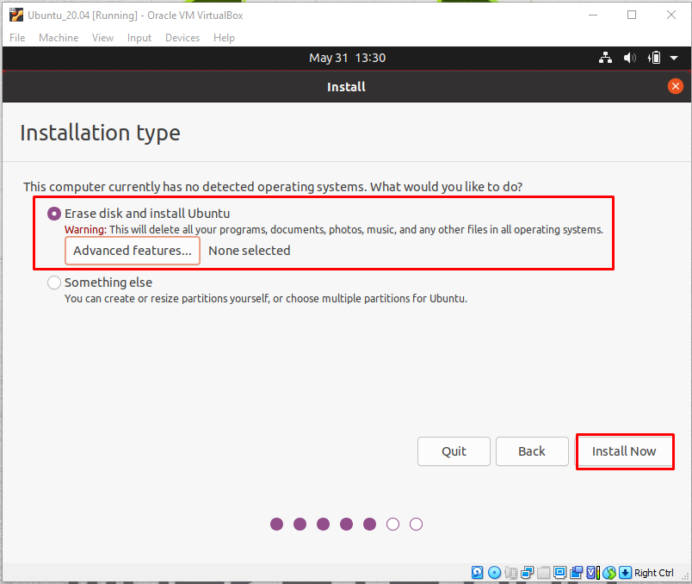  
Additionally, if you want to create LVM then click on ’**Advanced Features”** or **ZFS**  
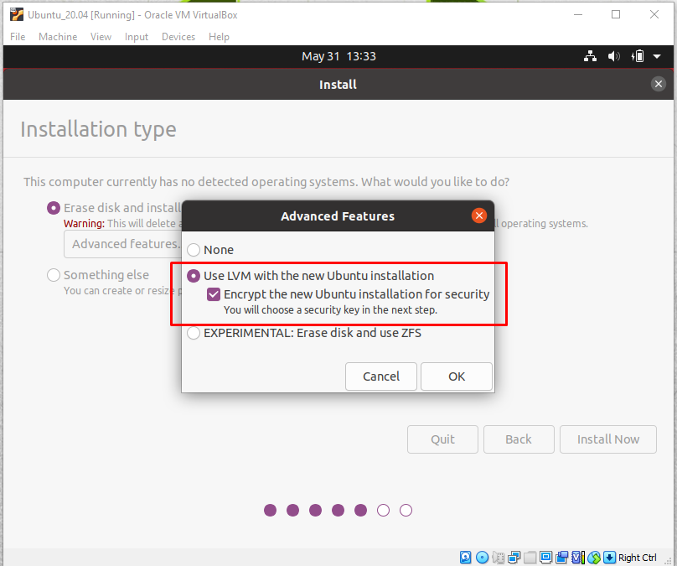  
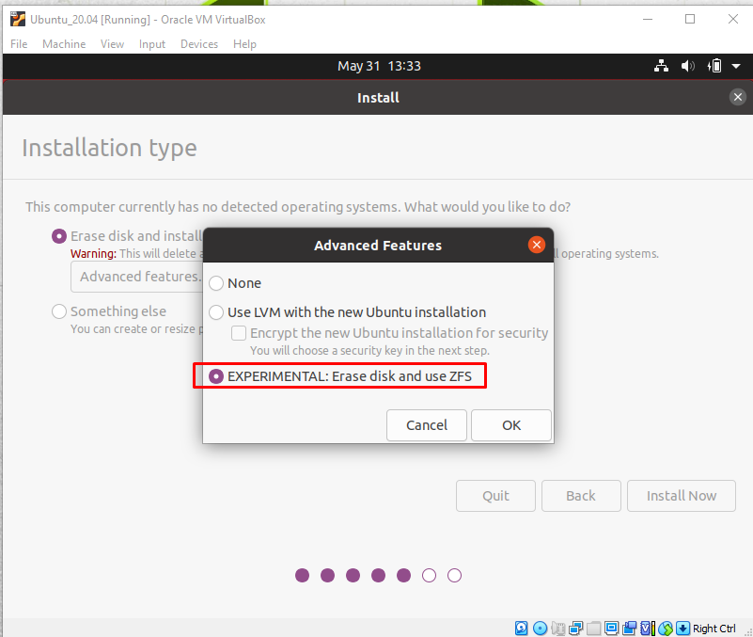

Step10: - After selecting **Install Now,** click on Continue.  
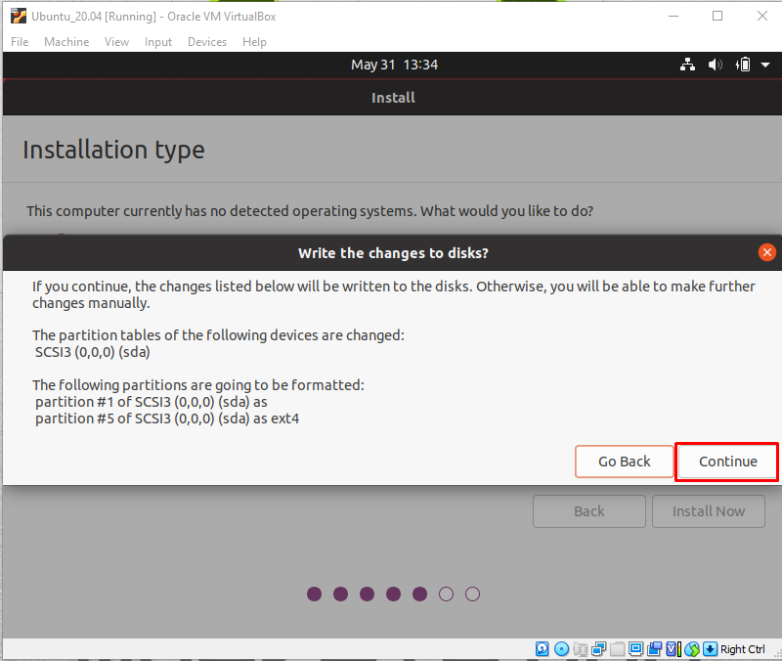

Step 11: - Select country from where you belongs to.  
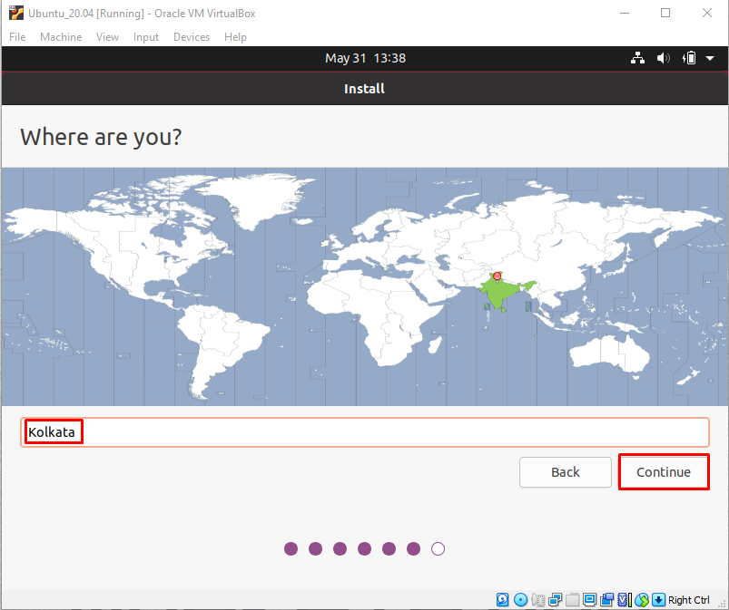  
Step12: - Create a **User** 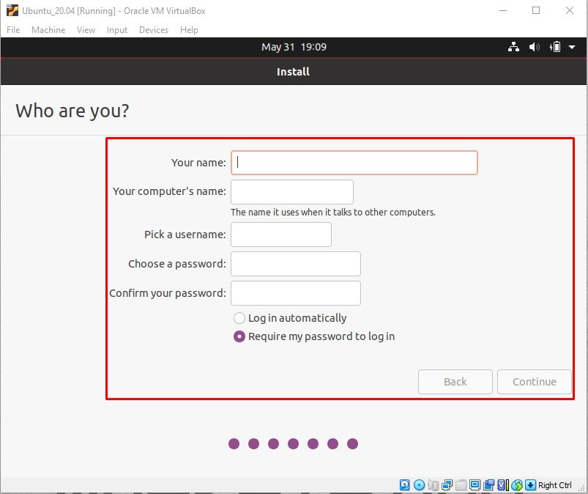

Step12: - Installation begins   
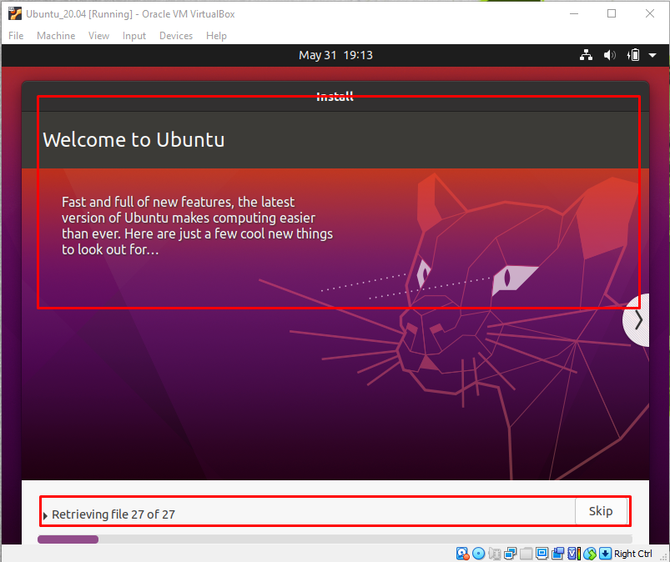

Step13: - After successful installation, this screen is shown up! Click on ‘**Restart now’**  
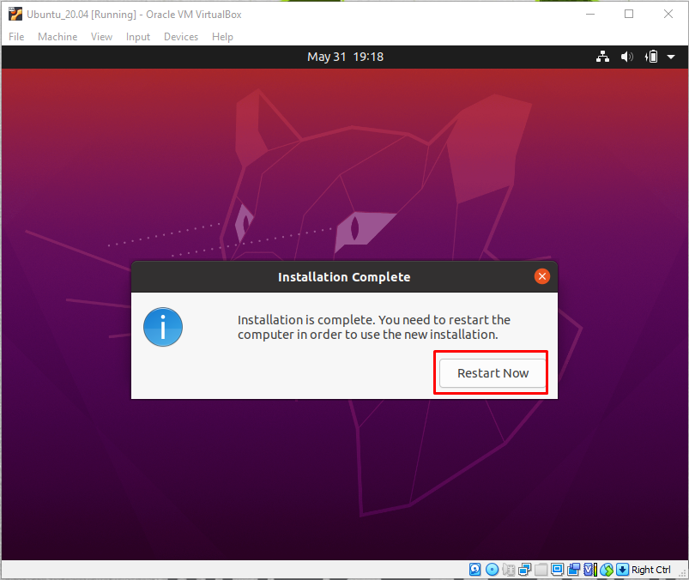  
Step14: - Press **ENTER**   
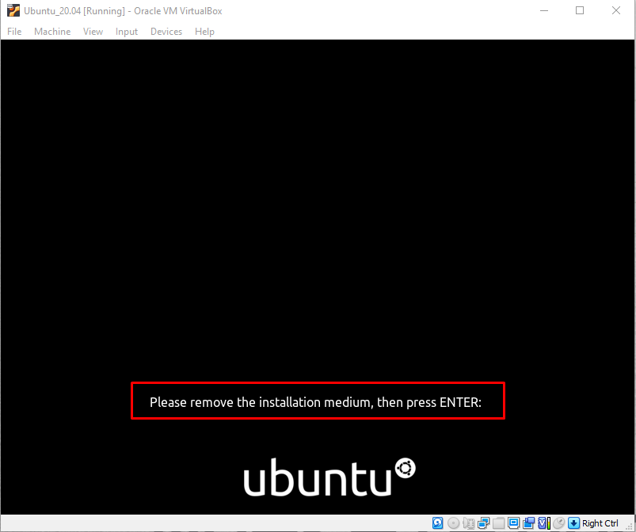  
Step15: - Now your Ubuntu_20.04 is installed. #KUDOS to you  
