**Skill_01**

Step_01: Select **‘Heart Diseases’** dataset& mark points randomly.   
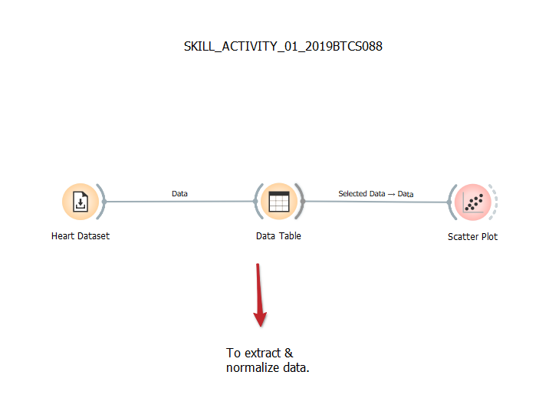  
Step_02: Viewing the dataset into **‘Data Table’.**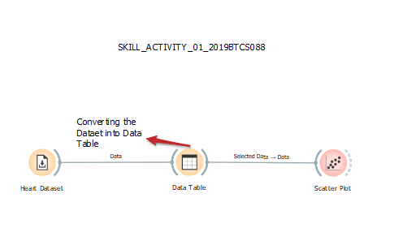

Step_03: Calling records from **‘Data Table’.** & it shows complete table information.  
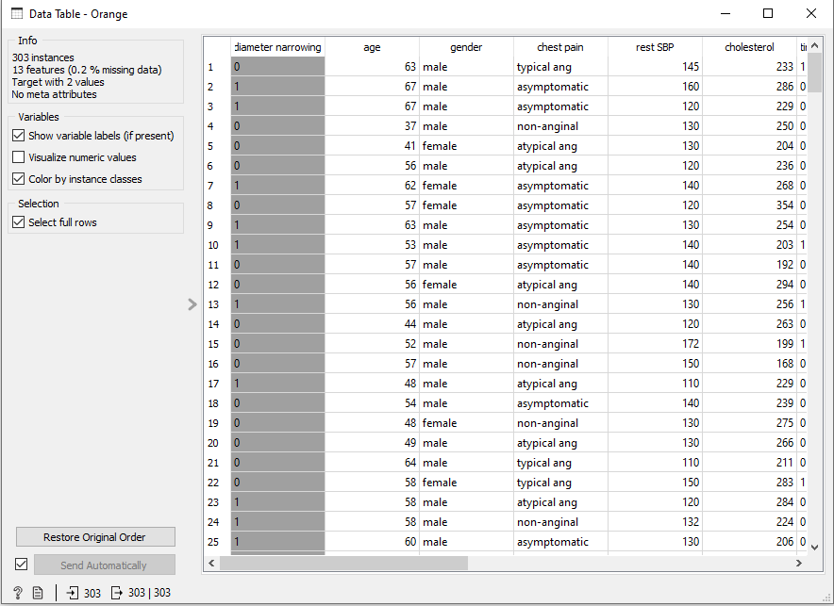

Step_04: Now plotting the **‘Scatter Plot’.**

