**Practical_01**

Step_01: Select **‘Dataset’** & **‘Data Table**’ from Data widget.   
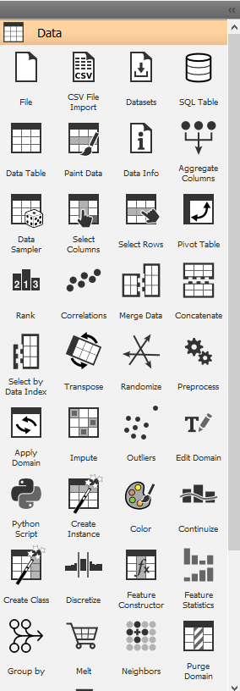

Step_02: Click on **‘Data Table’** to view the Dataset (Example of Logistics Regression).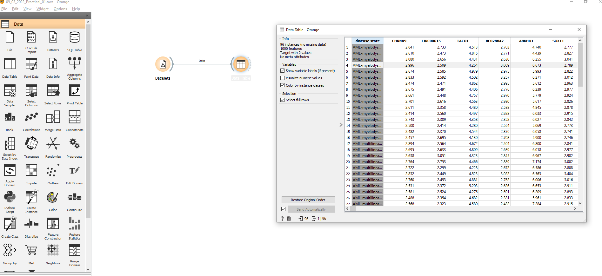

Step_03: Now taking **‘Numerical dataset**’ (example of Linear Regression).  
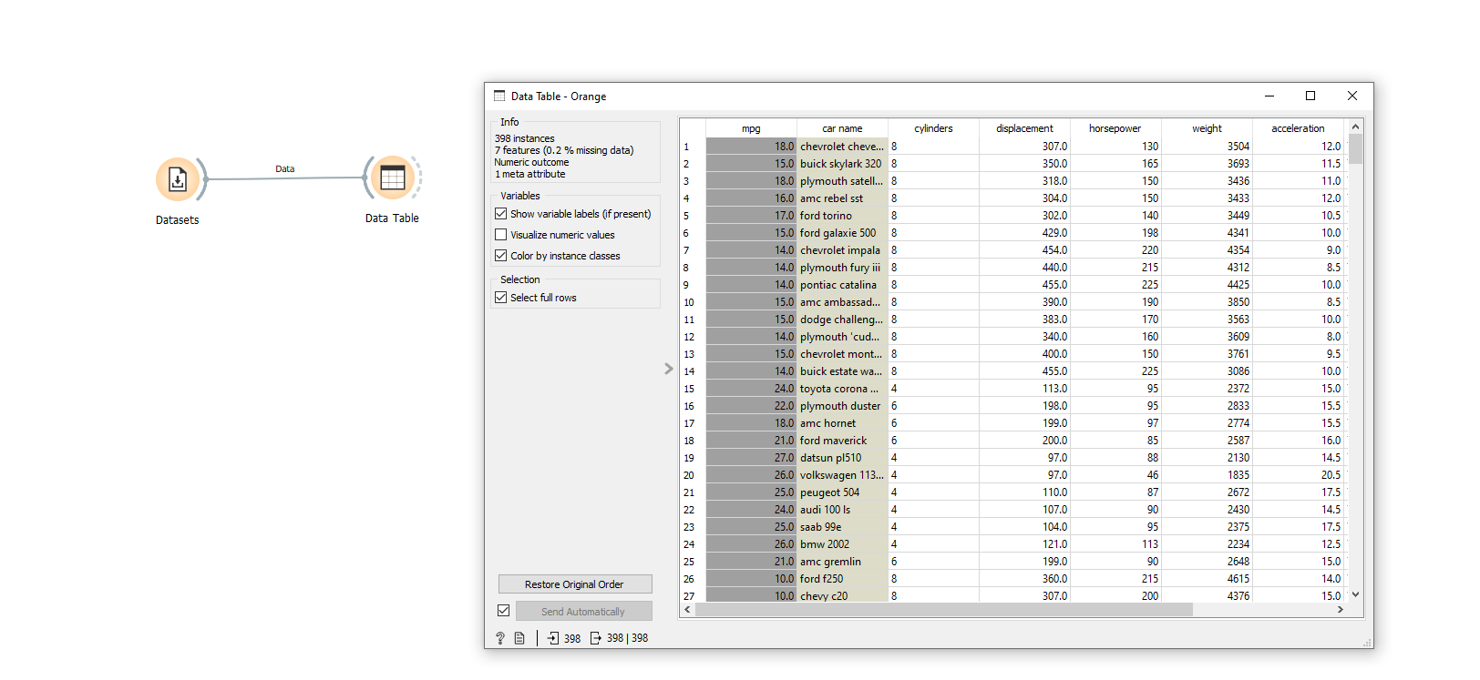

**Skill_01**

Step_01: Select **‘Heart Diseases’** dataset& mark points randomly.   
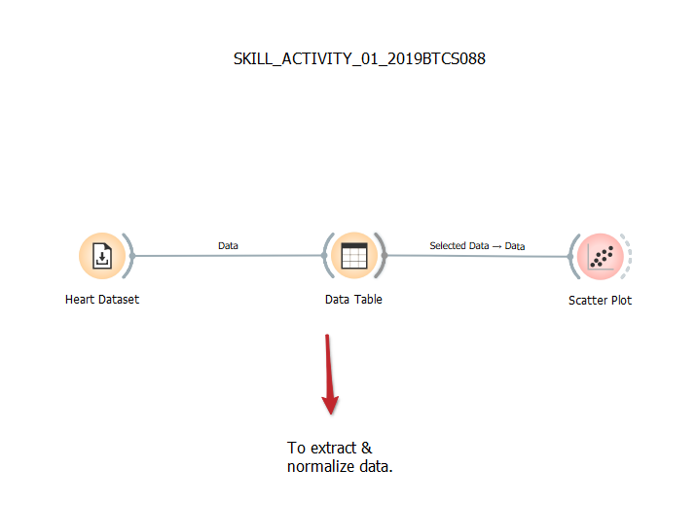  
Step_02: Converting the dataset into **‘Data Table’.**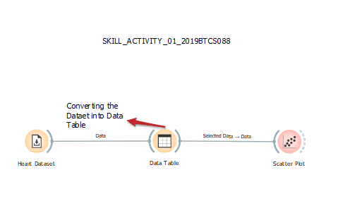

Step_03: Calling records from **‘Data Table’.** & it shows complete table information.  
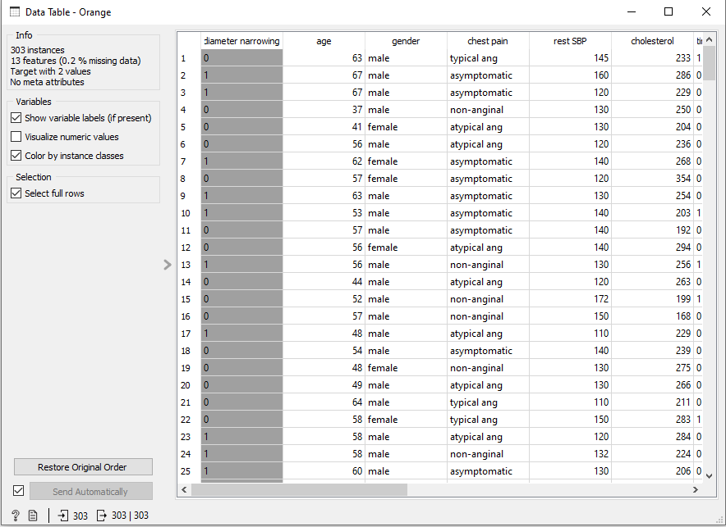

Step_04: Now plotting the **‘Scatter Plot’.**

