PathSense: Inferring Pedestrian Accessibility from Crowdsourced Smartphone Inertial Data
George C Mathew^{1*}, Yohan George¹ and Siddhant Gaddi¹
¹School of Computer Science and Engineering (SCOPE), Vellore Institute of Technology, Vellore, 632014, Tamil Nadu, India.
*Corresponding author(s). E-mail(s): [corresponding author e-mail to be added];
Register Nos.: 24BCE2753 (George C Mathew); 24BAI0356 (Yohan George); 24BCT0273 (Siddhant Gaddi).
Abstract
Navigation applications in India optimise for distance or driving time and carry almost no information about the walking surface. For a wheelchair user or a person on crutches, the shortest route is often unusable because of an uncut kerb, a broken footpath or an overly steep ramp. Existing accessibility maps depend on manual annotation of street imagery, which has not been carried out for most Indian cities. This paper presents PathSense, a system that infers surface and obstacle information passively from the accelerometer and gyroscope of ordinary smartphones. Because single traces are noisy, many traces over the same road segment are fused with a Dawid–Skene style probabilistic model that estimates segment state and contributor reliability together. The design also includes self-supervised contrastive pretraining to reduce labelling effort, domain-adversarial training for invariance to phone model, and graph-based propagation to segments that were never traversed. The resulting map drives a routing engine whose edge costs depend on the user’s mobility profile. This version reports the system design and evaluation protocol; experimental results are pending completion of data collection on the VIT Vellore campus and the adjoining Katpadi roads.
Keywords: Accessibility mapping, Inertial sensing, Crowdsourcing, Dawid–Skene, Self-supervised learning, Domain adaptation, Graph neural networks, Wheelchair routing
1 Introduction
Route-finding applications are built around vehicles. They rank paths by distance or travel time and say very little about the surface a pedestrian will meet. For most people this is a small inconvenience. For a manual or powered wheelchair user, a person on crutches, an elderly pedestrian or a person with low vision, one missing kerb cut or one broken stretch of footpath can make an otherwise short route impassable.
Accessibility-aware maps exist, but they are built by people. Project Sidewalk [1] asks volunteers to label sidewalk problems in street-level imagery, and AccessMap [2] provides pedestrian routing over curated sidewalk data. In an Indian setting this approach has two weaknesses. It needs current street imagery together with a large pool of annotators, and neither has been available at scale for most Indian cities. In addition, the surfaces themselves are often unpaved, uneven or interrupted by informal obstructions, and so differ from the sidewalks that Western mobility profiles assume.
PathSense obtains the same information in a different way. A phone carried in a pocket or fixed to a wheelchair records the physical effect of the ground beneath it. A kerb produces a sharp vertical acceleration transient, a gradient produces a sustained pitch offset, and broken ground produces high-frequency vibration. One trace is unreliable, since GPS drifts, phones differ and people move differently. Many traces over the same stretch of road can, however, be combined into a confident estimate.
The contributions we aim to make are as follows:
(i) a method for inferring kerbs, steps, gradient and roughness directly from raw inertial streams, without manual annotation of imagery;
(ii) a probabilistic multi-trace fusion model that treats each trace as an unreliable annotator and estimates segment state and contributor reliability jointly;
(iii) three learning components suited to the practical limits of this setting: contrastive pretraining for scarce labels, adversarial training for device heterogeneity, and graph propagation for sparse coverage; and
(iv) a mobility-profile-conditioned routing engine and an annotated trace dataset for Indian pedestrian infrastructure, with a comparison against Western-centric mobility profiles.
The rest of the paper is organised as follows. Section 2 reviews related work, Section 3 gives an overview of the system, Section 4 describes the methods, Section 5 sets out the experimental design, Section 6 is reserved for results, and Sections 7 and 8 discuss threats to validity and future work.
2 Related Work
2.1 Crowdsourced and imagery-based accessibility mapping
Project Sidewalk [1] collects sidewalk accessibility labels through a browser tool in which volunteers audit street-level imagery. AccessMap [2] offers pedestrian routing over sidewalk networks with user-adjustable preferences. Both rely on human interpretation of images or on existing municipal data. The primary signal in PathSense is physical motion instead.
2.2 Inertial sensing for activity and surface recognition
Human activity recognition from accelerometer and gyroscope data is a mature area, and its standard pipelines cut signals into fixed windows tied to the periodic gait cycle. Wheeled motion has no such cycle and its frequency content differs, so parameters inherited from gait-based pipelines do not suit it. We re-derive windowing, filtering and segmentation for wheeled motion after a pilot collection.
2.3 Fusion of unreliable annotators
Dawid and Skene [3] gave an expectation–maximisation procedure that estimates the true label of each item and the error rates of each observer when no ground truth exists. This matches our setting, where each trace observes a road segment and its reliability is itself unknown.
2.4 Representation learning and domain adaptation
Contrastive methods such as SimCLR [4] and MoCo [5] learn representations from unlabelled data by drawing together augmented views of the same sample. Domain-adversarial networks [6] use a gradient reversal layer so that features predict the task label but not the domain. We adapt the first to one-dimensional inertial signals and apply the second to smartphone hardware, whereas domain adaptation for inertial data has mostly addressed differences between subjects.
2.5 Graph neural networks and routing
Graph convolutional networks [7] and graph attention networks [8] propagate information over graph structure and are widely used for semi-supervised node prediction. Shortest paths are classically found with Dijkstra’s algorithm [9] or A* [10]. Our contribution to routing lies in the cost function and not in the search algorithm.
3 System Overview
PathSense has three stages (Fig. 1). In the data-collection stage, raw accelerometer, gyroscope and GPS streams are recorded on Android devices. The inference stage converts each trace into per-segment observations, fuses them across traces and propagates estimates to unobserved segments. In the routing stage, the resulting accessibility layer is used to compute paths for a chosen mobility profile, and the output is shown in an Android application.
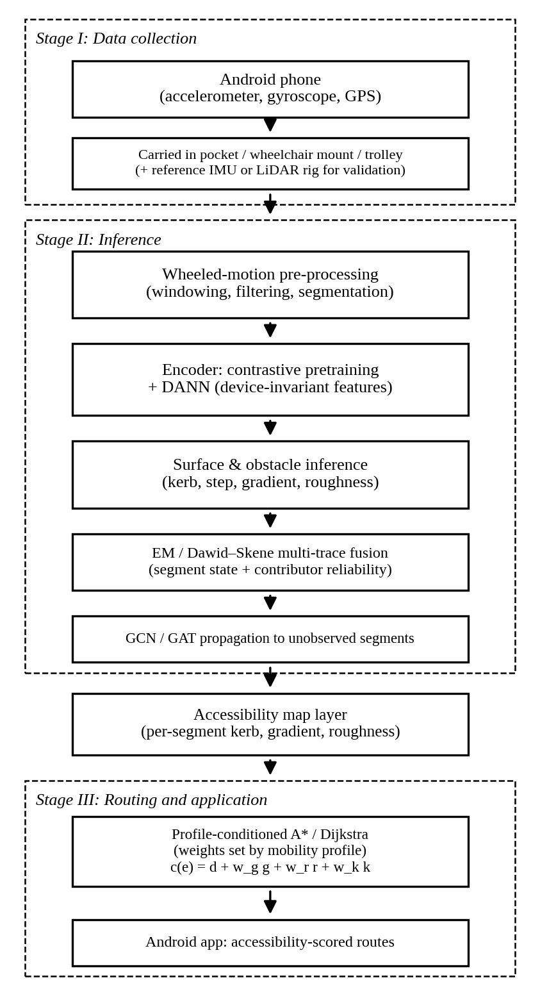
Fig. 1 Overall architecture of PathSense.
4 Materials and Methods
4.1 Data collection and pre-processing
Data will be collected on the VIT Vellore campus and the adjoining Katpadi roads using team-owned Android devices. Wheelchair traces depend on coordination with the campus accessibility office; if this cannot be arranged in time, the pilot will use walking traces and a manually pushed wheeled trolley as a stand-in. Sampling rate and window size will be fixed after an initial pilot collection. Window length, filter cut-offs and segmentation logic are chosen from the pilot data and not inherited from gait-based pipelines.
4.2 Inertial surface and obstacle inference
Three signal features correspond to the three physical effects of interest. Kerb and step events are detected as transients in vertical acceleration. Gradient is estimated from integrated pitch, using the gyroscope together with the gravity direction from the accelerometer. Roughness is measured as the energy in a high-frequency band of the vertical acceleration. Thresholds and band edges will be set from the pilot data and validated against the benchmarking rig described in Section 5.
4.3 Probabilistic multi-trace fusion
Let road segment i have an unknown state z_i from a set of K accessibility classes, and let trace t report label y_it for each segment it covers. Following Dawid and Skene [3], each contributor c has a confusion matrix π_c, where π_c(k, l) is the probability that c reports class l when the true class is k. The E-step computes the posterior over z_i given the current confusion matrices and class priors, and the M-step re-estimates both from those posteriors. Iterating to convergence yields a fused label for every segment and a reliability estimate for every contributor. Trace-quality indicators such as GPS accuracy, sensor noise and speed consistency are used to initialise or weight observations, which is how this model extends the earlier weighted-voting idea.
4.4 Self-supervised contrastive pretraining
Unlabelled inertial data is cheap to collect, whereas labelled data needs someone to traverse the route and record ground truth. A one-dimensional convolutional encoder is therefore pretrained with a SimCLR- or MoCo-style objective [4, 5], using time-series augmentations such as jittering, scaling and window cropping, and is then fine-tuned on the small labelled set.
4.5 Device-invariant feature learning
Phone models differ in sensors, mounting and noise. A domain classifier is attached to the encoder through a gradient reversal layer [6], so that the encoder learns to predict surface type while being unable to identify the device that produced the signal. The aim is that a trace from a new contributor’s phone can be used without per-device recalibration.
4.6 Graph-based propagation
The pedestrian network is modelled as a graph whose nodes are road segments and whose edges join adjacent segments. A GCN [7] or GAT [8] takes the fused estimates on observed nodes and predicts accessibility and roughness for adjacent unsampled nodes. This component depends on a usable segment graph for the study area from OpenStreetMap, whose footpath coverage in the region is incomplete; building or correcting that graph is part of the work.
4.7 Profile-conditioned routing
Routing uses A* [10] or Dijkstra’s algorithm [9] over the segment graph. The cost of an edge e is
c(e) = d(e) + w_g·g(e) + w_r·r(e) + w_k·k(e) (1)
where d is length, g a gradient penalty, r a roughness penalty and k the kerb count, and the weights w are set by the user’s mobility profile: manual wheelchair, powered wheelchair, crutches or low vision. Two users therefore receive different routes over the same map.
5 Experimental Design
5.1 Ground truth and benchmarking
To validate inferred surface profiles, a high-precision reference will be mounted on the pushed trolley, either calibrated IMUs or LiDAR where available. Kerb locations and gradients on the pilot routes will also be recorded manually.
5.2 Evaluation plan
Table 1 lists each component with the comparison used to judge whether it contributes.
Table 1 Planned evaluation of each component.
Component | Planned comparison
Inertial inference | Detection precision, recall and F1 against the reference rig
EM fusion | Segment accuracy versus majority and weighted voting
Contrastive pretraining | With versus without; accuracy against labelled fraction
DANN | Leave-one-device-out accuracy
Graph propagation | Error on held-out segments
Wheeled pre-processing | Gait-based versus retuned windows
Routing | Route cost and feasibility per mobility profile

Routes generated with our mobility profiles will also be compared with routes from a Western-centric default profile, to quantify where the latter fails on unpaved and irregular Indian surfaces.
6 Results and Discussion
6.1 Metrics and protocol
Kerb and step detection is scored with precision, recall and F1, counting a detection as correct if it falls within a fixed distance of a reference event on the benchmarking rig. Gradient error is the mean absolute difference, in degrees, between inferred and reference slope per segment. Roughness is compared with the reference by rank correlation. Surface classification uses accuracy and macro-F1. Fusion is compared with majority and weighted voting on segment-level accuracy. For pretraining, the labelled fraction is varied (10%, 25%, 50% and 100%) and accuracy is plotted against it. For the DANN, each phone model is held out in turn and accuracy on the unseen device is recorded. For graph propagation, a random subset of observed segments is hidden and predicted from the rest.
6.2 Results
Table 2 is the results table for the pilot study. The cells are to be completed from measured values once the experiments in Section 5 are run; they are marked TBD so that no figure appears that was not measured.
Table 2 Pilot results (to be completed from measured data).
Method | Metric 1 | Metric 2
Kerb detection (F1) | TBD | TBD
Majority vote | TBD | TBD
EM / Dawid–Skene | TBD | TBD
No pretraining | TBD | TBD
With pretraining | TBD | TBD
DANN (unseen device) | TBD | TBD
Graph propagation | TBD | TBD

6.3 Discussion
The experiments are designed to test specific claims. If fusion is useful, the EM model should beat voting most clearly on segments covered by few or disagreeing traces, and the estimated contributor reliabilities should separate careful from careless traces. If pretraining is useful, its advantage should be largest at small labelled fractions and shrink as labels increase. If the adversarial objective works, accuracy on a held-out phone should approach that on devices seen in training. Each of these can fail, and a negative outcome is a legitimate finding that will be reported as such.
7 Threats to Validity
The study area is a single campus and its surroundings, so conclusions may not transfer to other cities. Wheelchair data depends on access arrangements, and trolley data is only a stand-in for real wheelchair dynamics. Phone placement (pocket, mount or hand) changes the signal and is a source of variation that must be controlled or modelled. The graph component depends on the quality of the underlying map data. Crowdsourced location traces also raise privacy concerns, and a deployed system would need to store them without linking them to identifiable users.
8 Conclusions and Future Work
PathSense proposes to build an accessibility layer for Indian pedestrian infrastructure from the motion sensors people already carry. The design combines inertial inference, probabilistic fusion, label-efficient and device-invariant learning, graph propagation and profile-conditioned routing. The next steps are the pilot collection, fixing the pre-processing parameters, implementing and evaluating each component, and releasing the annotated trace dataset.
Declarations
Ethical approval
Initial traces are collected by the authors using their own devices. Any collection involving wheelchair users or other participants will take place only with informed consent and the required institutional approval.
Availability of supporting data
The annotated trace dataset will be made available after data collection is complete. [Authors to confirm the release terms.]
Competing interests
The authors have no competing interests to declare relevant to this article’s content. [Authors to confirm.]
Funding
This research received no specific grant from any funding agency. [Authors to confirm.]
Authors’ contributions
[To be completed by the authors, stating each person’s actual role.]
Acknowledgments
Not applicable.
References
[1] Saha, M., Saugstad, M., Maddali, H.T., Zeng, A., Holland, R., Bower, S., Dash, A., Chen, S., Li, A., Hara, K., Froehlich, J.: Project Sidewalk: A web-based crowdsourcing tool for collecting sidewalk accessibility data at scale. In: Proceedings of the 2019 CHI Conference on Human Factors in Computing Systems (2019)
[2] AccessMap: Taskar Center for Accessible Technology, University of Washington. https://www.accessmap.io
[3] Dawid, A.P., Skene, A.M.: Maximum likelihood estimation of observer error-rates using the EM algorithm. Journal of the Royal Statistical Society: Series C 28(1), 20–28 (1979)
[4] Chen, T., Kornblith, S., Norouzi, M., Hinton, G.: A simple framework for contrastive learning of visual representations. In: Proceedings of the 37th International Conference on Machine Learning (2020)
[5] He, K., Fan, H., Wu, Y., Xie, S., Girshick, R.: Momentum contrast for unsupervised visual representation learning. In: Proceedings of the IEEE/CVF Conference on Computer Vision and Pattern Recognition (2020)
[6] Ganin, Y., Ustinova, E., Ajakan, H., Germain, P., Larochelle, H., Laviolette, F., Marchand, M., Lempitsky, V.: Domain-adversarial training of neural networks. Journal of Machine Learning Research 17(59), 1–35 (2016)
[7] Kipf, T.N., Welling, M.: Semi-supervised classification with graph convolutional networks. In: International Conference on Learning Representations (2017)
[8] Veličković, P., Cucurull, G., Casanova, A., Romero, A., Liò, P., Bengio, Y.: Graph attention networks. In: International Conference on Learning Representations (2018)
[9] Dijkstra, E.W.: A note on two problems in connexion with graphs. Numerische Mathematik 1, 269–271 (1959)
[10] Hart, P.E., Nilsson, N.J., Raphael, B.: A formal basis for the heuristic determination of minimum cost paths. IEEE Transactions on Systems Science and Cybernetics 4(2), 100–107 (1968)

