Project Overview
Introduction
The Student Management Dashboard is a fully responsive web-based application built using the React JavaScript library. It is designed to streamline and digitize the processes involved in managing academic data for educational institutions. The application provides a centralized platform where multiple tasks related to student administration can be performed efficiently, such as adding student profiles, tracking attendance, registering for subjects (papers), and managing educational notes.
This project was undertaken as part of a college-level curriculum to demonstrate practical proficiency in frontend web development using modern technologies like React, JavaScript (ES6+), React Hooks, React Router, and Local Storage API. It is structured to simulate real-world use cases while maintaining simplicity by avoiding backend complexity.

Objective of the Project
The primary objective of the Student Management Dashboard is to develop a user-friendly and efficient web application that simplifies the process of managing student-related academic activities. This includes maintaining student profiles, registering subjects (papers), tracking attendance, and sharing academic notes—all within a single, unified interface. The project aims to eliminate the need for manual paperwork or complex backend systems by utilizing the browser’s local storage for data persistence. By doing so, it provides a lightweight, accessible solution that is ideal for small educational setups or prototype-level applications. Another key objective is to gain hands-on experience with React and its ecosystem, including component-based architecture, React Router for navigation, state and effect hooks for dynamic behavior, and conditional rendering. Additionally, the project demonstrates the use of role-based access simulation, allowing different users (such as Admins, Teachers, and Students) to access only the functionalities relevant to them. Overall, the goal is to build a real-world, practical application that showcases how frontend technologies can be leveraged to create a modular, interactive, and responsive student management system—without the complexity of a backend server.

The dashboard aims to:
- Simplify student record management.
- Provide role-based access (Admin, Teacher, Student) for personalized functionalities.
- Enable academic tasks such as subject registration and attendance tracking.
- Offer a practical understanding of how to create single-page applications (SPA) using React.

Target Users
The Student Management Dashboard has been thoughtfully designed to serve the needs of multiple user groups involved in the academic ecosystem. Its structure and functionalities make it useful for a diverse audience, including administrators, teachers, students, and developers or IT learners.
The primary users of the system are school and college administrators who are responsible for overseeing academic operations and maintaining structured records of student data. For them, the dashboard acts as a centralized platform to manage key tasks such as adding and updating student profiles, assigning roles, registering subjects, and managing attendance records. The system reduces the burden of manual work and allows administrators to have better control over institutional data through a simplified and intuitive interface.
The second major user group includes teachers, who play a crucial role in tracking student progress. The dashboard enables teachers to mark attendance, manage subject-specific notes, and view student details without the need for separate tools or spreadsheets. This not only saves time but also improves accuracy and consistency in academic reporting. Teachers can also benefit from the easy navigation and responsive design of the dashboard, which allows them to manage classroom-related tasks with just a few clicks.
The third category of users is the students themselves, who can use the platform to view their academic records, including registered subjects, attendance status, and uploaded notes. By having access to this information, students become more engaged and aware of their academic performance. The dashboard fosters a transparent environment where students can track their progress independently, without relying on manual reporting from teachers or administrators.
Lastly, this project is highly beneficial for frontend developers, IT students, or software engineering learners who want to understand how a real-world, role-based dashboard application is built using React. It offers a practical implementation of key frontend concepts like routing, state management, local storage integration, and user interface design. The simulated role-based access also helps developers understand how different components and views can be conditionally rendered based on user types.
In summary, the Student Management Dashboard is a versatile tool that brings together functionality and learning. It provides practical value to educational institutions by simplifying academic administration, while also serving as a hands-on development project for those looking to enhance their React skills through a meaningful, real-world use case.

Modules and Features Overview
The Student Management Dashboard is structured into various interconnected modules, each responsible for handling specific tasks and functionalities. These modules collectively contribute to creating a smooth, intuitive, and efficient experience for users belonging to different roles such as Admin, Teacher, and Student. Each module is designed with simplicity, clarity, and real-world applicability in mind, allowing users to interact with academic data with ease and precision.
1. Dashboard Home (Overview Page)
The dashboard home page serves as the central hub of the application, providing users with a summarized view of key statistics. It includes dynamic widgets or cards displaying metrics such as the total number of students, registered papers, attendance entries, and uploaded notes. This overview helps users—especially administrators—quickly assess the academic environment without diving into each module. The layout is clean, responsive, and designed to enhance user engagement by presenting relevant information upfront.

2. User Roles and Access Control
The application features a simulated Role-Based Access Control (RBAC) system, allowing different functionalities to be accessed depending on the user’s role. While real authentication is not implemented, the UI is designed in such a way that only relevant options appear for Admins, Teachers, or Students. For example:
- Admins have full access, including student management, subject registration, attendance viewing, and note uploading.
- Teachers can mark attendance and upload notes but cannot manage student profiles.
- Students can only view their personal data, subjects, attendance status, and notes. This module demonstrates how modern applications separate responsibilities between users to maintain security and functionality integrity.
3. Student Management Module
One of the core features of the dashboard, this module allows users (mainly Admins) to manage student records through a CRUD (Create, Read, Update, Delete) interface. Users can add new student profiles by entering basic information such as name, roll number, class, section, contact number, and status. The system provides the ability to edit or delete student records at any time. All information is stored and retrieved from localStorage, ensuring persistence without requiring a backend. This module is crucial for maintaining accurate and up-to-date student information.

4. Subject / Paper Registration Module
This module allows the registration of students for specific subjects or papers. Admins or teachers can assign subjects to students, enabling a clear mapping between learners and their academic focus areas. The system may provide a dropdown or checkbox interface where available subjects can be selected per student. This helps simulate a real-world registration scenario similar to university or school portals, where students enroll in specific courses for a semester or academic year.

5. Attendance Management Module
The attendance module is a practical tool for teachers to track daily or weekly attendance. Teachers can select a date and class, and then mark each student as present or absent using checkboxes or toggles. The records are then stored in localStorage and can be revisited for verification. This module provides an interactive and quick way to maintain attendance without paperwork and offers future scope for features like filtering by date or attendance percentage calculation.

6. Notes Management Module
This module allows teachers or admins to upload or write notes for students, categorized by subject or topic. The notes can be stored as plain text or in HTML-rich format depending on the implementation. Students can access these notes from their dashboard, ensuring they have the study material they need at all times. This promotes self-paced learning and reduces dependency on physical handouts or messaging groups for sharing study content.

7. Local Storage Integration
A standout feature of the project is its complete reliance on the browser's localStorage for data persistence. All CRUD operations—be it student records, attendance, subjects, or notes—are stored and retrieved using the localStorage API. This allows the app to function as a self-contained system without needing server-side technologies or database integration. It’s ideal for small-scale projects, learning purposes, and rapid prototyping.

8. Responsive and Interactive UI
The user interface is designed to be clean, responsive, and mobile-friendly. The use of frameworks like Tailwind CSS or Bootstrap ensures consistent design across devices. Interactive components such as modals, dropdowns, and data tables improve usability and help users perform actions quickly and intuitively. Each component is modular and reusable, aligning with best practices in React development.

9. Routing and Navigation
Navigation across the application is handled using React Router, allowing for smooth, single-page transitions between modules. Protected routes (simulated by role conditions) ensure that users only see pages relevant to their access level. This makes the user experience more focused and efficient.

10. Error Handling and Validation
Basic form validations are included throughout the app to ensure data integrity. For example, users are prompted to enter required fields when adding a student or note, and appropriate messages are displayed for missing or invalid data. While minimal, this feature helps simulate real-world app robustness.

Technology Stack
The Student Management Dashboard has been developed using modern web development technologies, with a strong emphasis on frontend tools and frameworks. The selected technology stack reflects a balance between simplicity, performance, and ease of learning, making the application both scalable and maintainable. Below is a detailed breakdown of the technologies used in the project:

1. React JS (Frontend Framework)
React is the core technology used to build the user interface of the application. Developed and maintained by Facebook, React is a highly efficient, declarative, and component-based JavaScript library for building dynamic single-page applications (SPAs). In this project, React is used to create reusable UI components, manage application state, and handle user interactions in real-time. Features like JSX (JavaScript XML) and Virtual DOM significantly improve performance and developer productivity. The modularity of React helps keep the code organized, scalable, and easy to maintain.

2. React Router DOM (Client-Side Routing)
To manage navigation within the application, React Router DOM is implemented. It allows the creation of multiple routes and pages without reloading the browser, thus maintaining the seamless experience of a Single Page Application (SPA). This enables smooth transitions between different sections such as Home, Student Management, Attendance, Notes, and Subject Registration. Conditional rendering of routes based on user roles (Admin, Teacher, Student) is also managed through this library.

3. React Hooks (State and Lifecycle Management)
The project makes extensive use of React Hooks such as useState, useEffect, and useContext (if applicable) for managing component state and side effects. Hooks help simplify the component logic and allow developers to use state and lifecycle features without writing class-based components. This contributes to cleaner, more readable, and functionally driven code architecture.

4. HTML5 & JSX
HTML5 forms the structural foundation of the application, embedded within JavaScript using JSX (JavaScript XML). JSX allows developers to write HTML-like syntax directly within JavaScript code, making the UI structure more intuitive and tightly coupled with the logic. This also improves code readability and enables powerful component-level rendering.

5. CSS3 / Tailwind CSS / Bootstrap (Styling & Layout)
For styling the user interface, the project can use either plain CSS3, Tailwind CSS, or Bootstrap—depending on what you've implemented. Here's a quick breakdown of each:
- CSS3 is used for basic styling, layout, and responsiveness through Flexbox and Grid systems.
- Tailwind CSS is a utility-first CSS framework that allows rapid UI development by using predefined classes directly in JSX.
- Bootstrap is a component-based CSS framework offering ready-made UI elements such as buttons, forms, and modals.
Each option helps create a responsive, clean, and visually appealing interface that adapts across different screen sizes and devices.

6. JavaScript (ES6+)
The logic and interactivity of the application are powered by modern JavaScript (ES6+), which includes features like arrow functions, destructuring, spread/rest operators, template literals, and promises. These modern features simplify code syntax, enhance performance, and promote better coding practices throughout the project.

7. Local Storage API (Client-Side Data Persistence)
To store and retrieve data without a backend, the application uses the Local Storage API provided by the browser. Local storage allows storing key-value pairs that persist even after the browser is closed or the page is refreshed. It is used for saving student records, attendance entries, subject data, and notes. This approach ensures that data remains intact across sessions while maintaining the simplicity of a fully frontend-based application.

8. React Icons (Visual Enhancements)
To improve user experience with visual cues, React Icons is used to import and render scalable vector icons. Icons enhance usability and design, making the interface more interactive and easier to navigate.

9. Git & GitHub (Version Control)
For version control and project collaboration, Git is used throughout the development lifecycle. The project is hosted and maintained on GitHub, providing easy access for backups, sharing, and showcasing the project. Git enables tracking changes, creating branches, and collaborating efficiently with others, if needed.

Future Scope
While the current version of the Student Management Dashboard is fully functional and achieves its core goals through a local frontend-only approach, there is significant scope for future development and enhancements. These upgrades can expand the system’s capabilities, improve scalability, and make the application more suitable for real-world institutional deployment. The following points outline various areas where the project can evolve:

1. Backend Integration for Real-Time Data Management
Currently, the application uses the browser’s localStorage to store student records, attendance, subjects, and notes. While this is suitable for prototyping and small-scale use, it lacks the security and scalability required for real-world scenarios. A major improvement would be integrating a backend server using technologies such as:
- Node.js with Express or Django/Flask (Python) for APIs
- MongoDB, MySQL, or PostgreSQL for persistent data storage
This would allow secure user authentication, multi-device access, centralized database management, and role-based authorization at the API level.

2. User Authentication and Role Management
Currently, the application simulates Role-Based Access Control (RBAC) through conditional rendering, without actual user login or identity verification. In the future, this can be enhanced by implementing:
- JWT (JSON Web Token) or OAuth-based authentication
- A login/signup system using email and password
- Secure role management stored in the database
This would allow multiple real users (Admins, Teachers, Students) to log in with credentials and interact with the dashboard based on their actual permissions, making the system production-ready.

3. Cloud Deployment and Multi-User Access
To extend the reach of the system beyond a single device, the application can be deployed to the cloud using platforms like Vercel, Netlify (frontend), and Render, Heroku, or Firebase (backend/database). This would allow real-time multi-user access from anywhere in the world and support a larger student base. Cloud deployment also makes the system more reliable and accessible across devices.

4. Advanced Features and Analytics
The project currently focuses on CRUD operations, subject registration, note sharing, and attendance marking. In the future, the following advanced features could be implemented:
- Attendance Reports: Generate monthly or yearly reports and calculate attendance percentages.
- Student Performance Tracking: Add marks/grades, show progress charts, and performance history.
- Notification System: Alert students when notes are uploaded or when they have low attendance.
- Search and Filter Options: Make it easier to search for students, filter attendance by date, and categorize notes.
- Export Options: Export data to PDF/Excel for offline use or printing.

5. Admin Panel & Settings
Introduce a dedicated Admin Control Panel where administrators can configure subjects, semesters, user roles, and system-wide settings. This would make the system more customizable and institution-friendly.

6. UI/UX Enhancements
While the current UI is responsive and clean, future upgrades could include:
- Dark mode support
- Drag-and-drop UI for student/subject management
- Animations and transitions using Framer Motion
- Improved mobile layout for touch-based usability

7. Real-Time Communication Tools
To support more interaction between teachers and students, the system could be expanded to include:
- Chat/Messaging system
- Live announcements or bulletin board
- Comment sections on shared notes

8. Integration with External Tools
For added functionality, the system could integrate with tools such as:
- Google Calendar (for scheduling)
- Google Drive or OneDrive (for storing documents)
- Email services or SMS gateways (for notifications)

System Architecture
Introduction
System architecture is the foundational blueprint that defines the structure, behavior, and interaction of the components within a software application. For the Student Management Dashboard, the system architecture plays a critical role in ensuring the application is modular, scalable, user-friendly, and adaptable to different user roles such as Admin, Teacher, and Student.
The architecture provides a clear roadmap of how different parts of the system communicate with each other—from the user interface (UI) to internal logic and data handling mechanisms. It outlines how users interact with the system, how the interface responds, and how data is managed and stored efficiently.
In this project, the architecture follows a component-based structure using React.js, making each module (like Student Management, Attendance, Notes, etc.) independent and reusable. Furthermore, the project adopts the Single Page Application (SPA) model, which ensures that the entire application runs within a single browser page, enhancing performance and user experience.
Since the project is built as a frontend-only application, the architecture also takes advantage of client-side storage (LocalStorage API) to mimic backend-like data persistence. The system design is thoughtfully implemented to support role-based access, conditional rendering, and dynamic routing—allowing each user type to view only the features relevant to their role.
This chapter explores the technical and logical structure of the Student Management Dashboard, describing how its different layers work together seamlessly. It also highlights the modularity of components, the flow of data, and how user roles shape the overall navigation and access across the system.

Architectural Style
The architectural style defines the overall structure, design pattern, and development approach used to build the Student Management Dashboard. This project adopts a Component-Based Architecture with a Single Page Application (SPA) model using React.js as the primary frontend framework. This architectural style promotes modularity, scalability, and ease of maintenance, which are essential characteristics of modern web applications.
1. Component-Based Architecture
In a component-based architecture, the application is divided into small, independent, and reusable UI components. Each component in the Student Management Dashboard is responsible for handling a specific part of the user interface or a distinct functionality, such as:
- Navbar Component: For navigation and role-based display.
- Sidebar Component: For menu and quick access to modules.
- StudentForm and StudentTable: For adding, displaying, editing, and deleting student information.
- AttendanceTable: For recording and viewing attendance.
- NotesUpload and NotesViewer: For uploading and viewing shared documents.
These components communicate through props and shared states, allowing for a well-structured and maintainable codebase. The separation of concerns enables developers to isolate logic, update features independently, and reuse code across different parts of the application.

2. Single Page Application (SPA)
The dashboard follows a Single Page Application model. In a SPA, only one HTML page is loaded initially, and subsequent navigation or user interactions dynamically update the content without requiring a full page reload. This is achieved using React Router DOM, which manages routes like:
- /dashboard
- /students
- /attendance
- /notes
- /settings
Benefits of SPA:
- Faster navigation and better performance.
- Seamless user experience without page refreshes.
- Easier to manage route-based permissions and views for different roles.

3. Client-Side Rendering and Local Storage
All data handling and view rendering occur on the client-side. The application stores data such as student details, attendance records, and uploaded notes in the browser’s LocalStorage API. This eliminates the need for a server or database in the current version of the application. Each time the user performs an operation, React updates the local state, syncs it with localStorage, and re-renders the UI accordingly.

4. Role-Based Conditional Rendering
The architectural style also incorporates Role-Based Access Control (RBAC) at the UI level. Instead of relying on a backend for permission validation, the app uses conditional rendering in React to show or hide features based on the user’s selected role. For example:
- Admins see all modules (Students, Attendance, Notes, Settings).
- Teachers see attendance and notes only.
- Students can only view notes and their own attendance.
This method ensures that each user interacts only with the functionalities relevant to their role, improving usability and security at the interface level.

5. Lightweight and Extensible Design
The overall architectural style emphasizes:
- Simplicity: Easy to understand and modify.
- Lightweight execution: Ideal for small-scale use without requiring server infrastructure.
- Extensibility: Future-ready architecture that can be expanded with backend APIs, databases, or cloud hosting

High-Level Architecture Overview
The High-Level Architecture of the Student Management Dashboard provides a simplified yet comprehensive view of how various components of the system interact with each other to fulfill its core functionalities. It outlines the structural layers, data flow, and the relationship between user roles and system modules.
This architecture is designed to prioritize modularity, usability, and clarity, making it easier to manage and scale the application. Since the project is built as a frontend-only system using React.js, all processing, state management, and data storage are handled directly within the browser using client-side logic and the Local Storage API.

Core Architectural Layers
The system architecture can be divided into three primary layers:

1. Presentation Layer (User Interface)
- This is the topmost layer that interacts directly with the users (Admin, Teacher, Student).
- It is responsible for rendering visual components and managing user interactions.
- Built entirely using React.js, it includes reusable UI elements such as:
  - Dashboard cards
  - Forms (for adding/editing students, subjects)
  - Tables (for displaying lists)
  - Upload interfaces (for sharing notes)
- This layer also handles routing and navigation using React Router DOM, enabling dynamic rendering of pages without full-page reloads.

2. Application Logic Layer
- This layer contains the core logic of the application.
- Manages user actions like:
  - Adding/deleting/editing student information
  - Registering subjects
  - Marking attendance
  - Uploading/viewing notes
- Uses React state hooks (useState, useEffect) to handle and update data.
- Contains role-based logic for controlling access to features and UI elements.
- This is where the RBAC logic (Role-Based Access Control) is implemented via conditional rendering.

3. Data Management Layer (Local Storage Layer)
- Acts as a temporary client-side data storage system using the browser's LocalStorage API.
- All data such as:
  - studentsData
  - attendanceRecords
  - notesData
  - registeredSubjects is stored as JSON strings in the browser’s local storage.
- Ensures that the application retains data even after page reloads or browser restarts.
- Eliminates the need for a backend or external database in the current version.

User Role and Module Mapping
The architecture is role-sensitive and delivers different functionalities depending on the logged-in user type. Here's how different roles map to modules:
User Role | Accessible Modules
Admin | Full access: Dashboard, Students, Subjects, Attendance, Notes
Teacher | Attendance module, Notes upload and view, Subject overview
Student | Subject view, Attendance status, Notes viewer

Data Flow Overview
Here’s a simplified flow of how data moves through the system:
- User Interaction: A user clicks a button, submits a form, or navigates a route.
- Application Logic: React processes the interaction and updates the internal state.
- Local Storage Sync: Updated state is written to or read from LocalStorage.
- UI Re-render: The component tree re-renders to reflect the new data.
This cycle ensures a real-time, reactive user experience that feels smooth and dynamic.

UI/UX Design of the Student Management Dashboard
Overview
The User Interface (UI) and User Experience (UX) design of the Student Management Dashboard play a crucial role in making the system intuitive, efficient, and accessible for all users—Admins, Teachers, and Students. The design is structured to ensure clarity, responsiveness, and ease of navigation while maintaining a modern and visually appealing layout. Every screen and component has been thoughtfully crafted to serve its intended function while reducing user effort and confusion.

Design Objectives
The core goals of the UI/UX design were:
- To simplify interactions for non-technical users such as teachers and students.
- To maintain visual consistency across different modules.
- To support role-specific views, ensuring that each user type only sees what’s relevant to them.
- To offer a responsive layout that works seamlessly across desktops, laptops, and tablets.
- To implement clean, minimal interfaces that prioritize content and functionality over visual noise.

1. Layout and Navigation
The dashboard layout follows a two-column structure:
- A Sidebar on the left for primary navigation (Dashboard, Students, Subjects, Attendance, Notes, Settings).
- A Top Navbar (optional) for quick actions and user information (e.g., role display, logout).
- A Main Content Area where pages dynamically render based on the selected route.
The use of React Router DOM ensures smooth, SPA-style navigation where clicking on a menu item updates only the content area, not the entire page.

2. Consistent Theming and Color Scheme
- A neutral and calming color palette is used (e.g., light blues, whites, grays), which is suitable for educational platforms.
- Each role (Admin, Teacher, Student) may have subtle color differences to indicate their current mode or access level.
- Primary action buttons (like “Add”, “Submit”, “Upload”) are highlighted with accent colors (e.g., blue or green) to attract user attention.

3. Role-Based User Interfaces
Each user role experiences a customized interface:
- Admin Dashboard: Full navigation options, access to all modules. Features like adding/editing students and subjects are always visible.
- Teacher Dashboard: Only attendance and notes sections are visible. Buttons and actions related to student editing are hidden.
- Student Dashboard: Minimal view—only subjects, attendance summary, and downloadable notes. No editable components or forms.
This role-based UI is achieved through conditional rendering in React, enhancing usability and reducing clutter for each user type.

4. Responsive and Adaptive Design
- Built using CSS Flexbox/Grid and media queries for responsiveness.
- Supports screen resizing: content adjusts gracefully on various devices, ensuring accessibility in classroom or home environments.
- Mobile-friendly components like collapsible sidebars or stacked views are used for smaller screens.

5. Forms and Tables
- All forms (e.g., Add Student, Register Subject) follow a clean and minimal structure with clear input labels and validation messages.
- Tables (e.g., student list, attendance records) are sortable, neatly aligned, and optionally paginated.
- Action buttons (Edit/Delete) are placed consistently for each row, improving predictability in user interaction.

6. Feedback and Notifications
- Users receive visual feedback for actions like adding, deleting, or updating data.
- Simple modals or alert boxes confirm critical actions (e.g., “Are you sure you want to delete this student?”).
- Success or error messages appear via toast notifications or banners for better guidance.

7. Accessibility and Usability
- Fonts are readable and appropriately sized.
- Adequate contrast ensures readability for all users, including those with visual impairments.
- Clickable elements have enough padding and hover effects to indicate interactivity.
- Keyboard navigation is partially supported for accessibility purposes.

8. UX Best Practices Followed
- Minimal cognitive load: Interfaces avoid clutter and focus only on essential features.
- User-friendly error handling: Invalid inputs are highlighted, with helpful error messages.
- Progressive disclosure: Complex actions (like uploading notes or marking attendance) are split into manageable steps.
- Immediate visual feedback: UI updates in real-time as users interact with the system.

Core Functionality
The core functionality of the Student Management Dashboard defines the essential features that drive the purpose and performance of the system. Designed to enhance the management of academic data and streamline everyday administrative tasks, these functionalities enable users to interact with the system in role-specific ways.
At its core, the dashboard facilitates the digital handling of student information, subject registrations, attendance records, and study material sharing—all within a user-friendly interface. The application is structured to offer a smooth and efficient experience for different user types such as Admins, Teachers, and Students. Each user role is given access to only those features that are relevant to their responsibilities, helping to maintain clarity, security, and usability.
By implementing critical operations like CRUD (Create, Read, Update, Delete) using React's component-based architecture and localStorage for data persistence, the system successfully simulates a full-stack experience on the frontend. This makes the dashboard not only powerful but also lightweight and easy to deploy without the need for server-side infrastructure.
In this section, we explore the various functional modules that make up the core of the Student Management Dashboard and how they work together to deliver a seamless, role-driven user experience.

1. Role-Based Access Control (RBAC)
Role-Based Access Control (RBAC) is a fundamental feature of the Student Management Dashboard that ensures system security, simplicity, and user relevance. It controls what each type of user can see and do within the application based on their assigned role—Admin, Teacher, or Student.
RBAC improves the user experience by hiding unnecessary features and prevents unauthorized access to sensitive data or functionality. This access control mechanism is implemented on the frontend using React's conditional rendering.
Role-wise Access Breakdown:
- Admin:
  - Has complete access to all modules.
  - Can add/edit/delete student records.
  - Can assign subjects and view all attendance reports.
  - Has permission to upload and view shared notes.
- Teacher:
  - Can view the list of students (read-only).
  - Can mark and update attendance records.
  - Can upload notes for students.
  - Cannot edit student details or register new students.
- Student:
  - Has view-only access.
  - Can check their own attendance.
  - Can view subjects assigned to them.
  - Can download or view notes uploaded by teachers.
How it Works Technically:
- When a user logs in or accesses the dashboard, their role is identified from their data (e.g., a "role" field stored in localStorage or state).
This ensures that only permitted features are visible to the current user.
- The UI and routes are dynamically controlled to prevent users from manually accessing unauthorized modules by typing URLs.
Benefits of RBAC in This Project:
- Security: Prevents misuse of features like deleting student data.
- User-Friendliness: Keeps the interface clean and relevant for each user type.
- Scalability: Makes it easy to add new roles or permissions in the future.
- Maintainability: Logic is centralized, making the system easier to manage and debug.

2. Student Information Management
The Student Information Management module is one of the core components of the Student Management Dashboard. It allows authorized users—primarily the Admin—to efficiently handle all student-related data within the system. This includes creating new student profiles, updating existing records, and deleting or viewing student information. The feature aims to provide a digital alternative to traditional record-keeping, thereby reducing manual workload and ensuring data consistency.

Key Functionalities:
- Add Student:
Admins can input and store new student details such as:
  - Full name
  - Email or contact information
  - Assigned role (Student, Teacher, etc.)
  - Subjects (registered under the student)
This data is immediately stored in the browser’s localStorage to ensure persistence across sessions.
- Edit Student:
Admins can select any existing student and update their details when needed. This is useful in cases like:
  - Changing contact info
  - Reassigning subjects
  - Updating roles
- Delete Student:
Admins have the ability to remove a student’s record completely from the system. A confirmation prompt is usually shown to prevent accidental deletions.
- View Student List:
All registered students are displayed in a structured table format with key information shown at a glance. This table typically includes:
  - Student ID (auto-generated or unique field)
  - Name
  - Assigned subjects
  - Role
Additional options like “Edit” and “Delete” are available as action buttons next to each student entry.

Technical Implementation:
- Data is managed using React state hooks (useState) and is synchronized with localStorage using JSON.stringify() and JSON.parse() for persistence.
- Form components are built using reusable input fields and validation checks to ensure data accuracy.
- A table component (or list view) displays all student data and allows actions to be performed through buttons like “Edit” and “Delete.”

Benefits:
- Centralized Data Management: All student information is stored and accessed in one place.
- Time Efficiency: Reduces the time spent managing student records manually.
- Error Reduction: With form validations and consistent data formats, human error is minimized.
- Scalable Design: New data fields can be added easily in the future (e.g., grade, class section, etc.).

User Roles and Access:
- Admin: Full access—can create, edit, view, and delete student records.
- Teacher: Can view student data but cannot modify it.
- Student: Cannot access student management module.

3. Subject Registration
The Subject Registration module plays a key role in associating students with the subjects they are enrolled in. This functionality ensures that each student has a clear academic track and that both administrators and teachers can view and manage the subjects relevant to each learner. It is a foundational feature that enables other modules—such as attendance tracking and note sharing—to work in a targeted, subject-specific manner.

Key Functionalities:
- Assign Subjects to Students: Admins can select one or more subjects and assign them to a student during the student creation or editing process. This is typically done using multi-select dropdowns or checkboxes for subject selection.
- View Subject List:
  - Admins and Teachers can view a list of subjects associated with each student.
  - Students can view only the subjects assigned to them on their dashboard.
- Update Subjects: Admins can update a student’s subject list at any time—whether it’s adding new subjects or removing outdated ones.
- Subject Master List (Optional Feature): A centralized list of all available subjects may be maintained by the Admin. This makes it easier to manage and reuse subjects across students.

Technical Implementation:
- The subjects are stored either as a standalone array or as part of each student’s object in localStorage.
- A subject list is rendered as a part of the student form, using React controlled inputs.
- Upon submission, selected subjects are stored and rendered conditionally based on the user’s role.
- Conditional rendering ensures that:
  - Admins can edit subject lists.
  - Students can only view their subjects.
  - Teachers can see subject assignments for better planning and content delivery.

Benefits:
- Personalized Academic Tracking: Each student’s learning path is clearly defined.
- Simplifies Teacher Interaction: Teachers can upload notes or take attendance for subject-specific groups.
- Organized Data Management: Subjects are clearly linked to student profiles, making the entire system more structured.

Role-Based Access:
- Admin: Full control—can assign, update, or remove subjects.
- Teacher: Can view subject assignments for students.
- Student: View-only access to their own registered subjects.

4. Attendance Management
The Attendance Management module is a core component of the Student Management Dashboard, designed to help teachers keep accurate records of student attendance. It provides a simple yet effective interface to mark, update, and review attendance on a daily basis. This functionality improves accountability, ensures record consistency, and gives students access to their own attendance performance for better self-monitoring.

Key Functionalities:
- Daily Attendance Marking: Teachers can mark each student as Present or Absent for a selected date.
  - Typically displayed in a table format listing all students.
  - A date picker allows teachers to select the specific day they are entering data for.
  - Radio buttons, checkboxes, or dropdowns are used to choose "Present" or "Absent".
- View Attendance Records:
  - Teachers and Admins can view attendance logs by date or by student.
  - Records can be filtered to track a student’s overall attendance trend.
- Update/Delete Records:
  - Teachers can modify attendance if a mistake is made or if a student provides a valid reason.
  - Admins may also have access to clear or edit bulk records, depending on implementation.
- Student Access:
  - Each student can log in and view their personal attendance history.
  - This promotes transparency and helps students stay accountable.

Technical Implementation:
- Attendance data is stored in localStorage as a list of records, often using a structure like:
- Data is linked to both the student’s ID and the date, enabling filters by either dimension.
- React’s useState and useEffect hooks are used to handle real-time updates and save to localStorage.
- A typical attendance marking table in React might look like:

Benefits:
- Streamlined Tracking: Teachers can easily manage attendance with minimal clicks.
- Accurate Records: Digital format reduces human error and data loss.
- Student Awareness: When students can view their attendance, they’re more likely to stay engaged and consistent.
- No Server Needed: All attendance data is saved locally, which is ideal for offline or testing environments.

Access Control:
- Teacher: Full access to add, view, and update attendance.
- Admin: Can view and manage all attendance records across classes.
- Student: View-only access to their own attendance.

5. Notes Sharing
The Notes Sharing module is designed to simplify and digitize the distribution of academic resources such as lecture notes, PDFs, assignments, and study material. This feature primarily empowers teachers to upload relevant documents that students can easily access from their dashboard. It promotes a collaborative and paperless learning environment, helping students stay updated with their coursework and reducing the dependence on physical materials.

Key Functionalities:
- Upload Notes (Teacher Role):
  - Teachers can upload notes associated with a particular subject.
  - Notes can be added in the form of:
    - Text content
    - File URLs (for documents or PDFs)
    - External links to resources (Google Docs, YouTube, etc.)
  - A subject selection dropdown ensures that notes are categorized correctly.
- View Notes (Student Role):
  - Students can see notes relevant only to their registered subjects.
  - Notes are displayed in a clean card or list format for easy reading and access.
  - Students can download/view the files or open external links provided.
- Edit/Delete Notes (Teacher/Admin Role):
  - Teachers can update or delete their uploaded notes.
  - Admins may also have access to manage all shared content, ensuring quality and relevance.

Technical Implementation:
- In React, notes are displayed using mapped components with filters based on the subject and user role.
- Conditional rendering ensures that:
  - Only teachers see the upload/edit/delete buttons.
  - Students only see notes related to their subjects.
Benefits:
- Centralized Learning Materials: All study notes are stored and accessed from one location.
- Paperless Environment: Reduces dependency on printed materials.
- Improved Learning: Students can access materials anytime, from anywhere.
- Teacher Control: Teachers have autonomy over what content is shared and updated.

Access Levels:
- Teacher: Can upload, update, and delete notes for subjects they teach.
- Student: Can only view/download notes assigned to their subjects.
- Admin: May have control over all content for monitoring or moderation.
6. Local Storage-Based Data Persistence
In the absence of a backend server or database, the Student Management Dashboard relies on the browser’s localStorage to store and retrieve data. This approach enables the application to function as a fully self-contained system while still retaining user and operational data between sessions. It makes the project lightweight, easy to deploy, and ideal for small-scale use cases, prototypes, or offline environments.

What is Local Storage?
Local Storage is a Web API provided by modern browsers that allows data to be stored in key-value pairs within the user's browser. Unlike session storage, data in localStorage persists even after the browser is closed, making it suitable for applications where long-term retention is necessary.

How It’s Used in the Dashboard:
Each module in the dashboard uses localStorage to manage data without relying on a backend or external database. Here's how it applies to various features:
- Student Records:
  - Stored in an array format with unique IDs.
  - Includes name, email, subjects, and role.
- Subjects:
  - Predefined or dynamically created subjects stored for use during student registration or filtering.
- Attendance:
  - Each record is saved with a student ID, date, and status.
  - Data can be filtered by student or date.
- Notes:
  - Stored as objects containing subject, title, uploadedBy, and content/link fields.
React state (useState) is used in sync with localStorage to manage data in real time. When data changes, it’s updated both in state and in storage.

Benefits of Using localStorage:
- No Backend Required: Perfect for lightweight applications and quick demos.
- Persistence Across Sessions: Data remains even after closing the browser.
- Faster Access: All data is accessed directly from the client without any network calls.
- Offline Friendly: Works without an internet connection once loaded.

Limitations:
- Storage Limit (~5MB): Not suitable for large-scale data or file uploads.
- No Real Authentication: Anyone with browser access can manipulate data via DevTools.
- No Multi-User Sync: Data is local to the user’s browser and does not sync across devices.

7. Role-Based Access Control (RBAC)
Role-Based Access Control (RBAC) is a fundamental security and design principle implemented in the Student Management Dashboard to regulate what users can see and do within the system based on their assigned roles. By defining different levels of access, RBAC helps ensure that each user interacts with only the functionalities relevant to their responsibilities, improving security, organization, and user experience.

What is RBAC?
RBAC is a system where permissions and access rights are assigned to roles rather than to individual users. Users are then assigned roles, and automatically inherit the permissions associated with them. This model is widely used in both frontend and backend applications to control user behavior and visibility of content.

Roles Defined in the Dashboard:
- Admin
  - Full access to all modules and data.
  - Can create, edit, and delete student and teacher accounts.
  - Assign roles and subjects.
  - Manage attendance and view all notes.
- Teacher
  - Can view student lists.
  - Can upload, edit, and delete notes.
  - Can mark and view attendance for their students.
  - Cannot manage user roles or add new users.
- Student
  - View-only access to their:
    - Registered subjects
    - Attendance history
    - Shared notes
  - Cannot make edits or access data of other users.

Implementation in React:
The RBAC is typically implemented using conditional rendering based on the user's role stored in localStorage or state.
Example:
jsx
CopyEdit
{user.role === "admin" && (
<AdminDashboard />
)}

{user.role === "teacher" && (
<TeacherPanel />
)}

{user.role === "student" && (
<StudentView />
)}
On login, the user’s role is fetched and saved, and all navigational routes and screen components check this value before rendering content.

Benefits of RBAC:
- Security: Prevents unauthorized access to sensitive features.
- Clarity: Each user sees only the features relevant to them, improving usability.
- Scalability: New roles and permissions can be added easily without major code changes.
- Maintainability: Makes the codebase cleaner by separating concerns across roles.

Example Use Case:
- A teacher logs in and goes to the dashboard. They can:
  - See the list of their students
  - Upload notes for "Physics"
  - Mark attendance for April 10
- A student logs in and:
  - Sees their attendance for the week
  - Views notes uploaded under their subjects
  - Cannot access student lists or edit anything
- An admin can do everything from managing accounts to modifying role access.
8. User Interface and Experience (UI/UX) Design
The UI/UX design of the Student Management Dashboard focuses on delivering a clean, intuitive, and responsive experience for all types of users—Admins, Teachers, and Students. Since the dashboard caters to diverse functionalities like student management, attendance, and notes sharing, its design plays a crucial role in ensuring that users can perform tasks efficiently without confusion or clutter.

UI (User Interface) Design:
The UI design emphasizes clarity, consistency, and simplicity. Built using React and Tailwind CSS, the dashboard includes components that are visually organized and functional across different screen sizes.
Key UI Features:
- Dashboard Navigation:
  - A sidebar or top menu with navigation links based on user role.
  - Icons and labels make it easy to understand sections at a glance.
- Modular Components:
  - Reusable components like cards, tables, modals, and dropdowns.
  - These components maintain consistency across screens like student lists, subject registration, and notes display.
- Forms and Inputs:
  - Simple and responsive forms for adding/editing users, assigning roles, and uploading notes.
  - Error messages and success alerts enhance usability.
- Responsive Design:
  - The layout adapts to mobile, tablet, and desktop screens.
  - Grid systems and flexbox are used for fluid resizing.
UX (User Experience) Design:
The UX design ensures the system is easy to use, with minimal training required, even for first-time users. The focus is on guiding users toward completing their tasks quickly and confidently.
Key UX Features:
- Role-Based Dashboards:
  - Each role sees only what’s relevant to them, reducing cognitive overload.
  - For example, students don’t see editing tools, and teachers don’t see admin panels.
- Intuitive Workflows:
  - Step-by-step processes such as student creation, subject assignment, and attendance marking follow natural patterns.
  - Buttons and prompts are placed where users expect them to be.
- Feedback and Validation:
  - Users receive immediate visual feedback when they perform actions (e.g., "Note uploaded successfully").
  - Form validations prevent incorrect data entries.
- Minimalist Design:
  - Uses whitespace effectively to reduce visual clutter.
  - Font hierarchy and color contrasts are applied to guide attention.

Technology Behind UI/UX:
- React for component-based rendering and conditional UI updates.
- Tailwind CSS for utility-first styling with responsiveness and theming.
- Conditional Rendering for role-based access views.
- React Router for navigation between screens.

Example Screens:
- Admin Dashboard: View user list, assign roles, manage subjects.
- Teacher Dashboard: View students, mark attendance, upload notes.
- Student Dashboard: View registered subjects, notes, and attendance.

State Management and Local Storage in Student Management Dashboard
State management and data persistence are two critical aspects of the Student Management Dashboard, which is built entirely using ReactJS on the frontend without any backend integration. To achieve a responsive UI and retain data between sessions, the application relies on React’s state management and browser localStorage.

1. State Management in React
React uses component-based state and unidirectional data flow, making it easier to manage dynamic data in an organized manner.
Key Concepts Used:
- useState Hook: To handle component-level data such as student lists, notes, and attendance records.
- useEffect Hook: To initialize state from localStorage and perform updates.
- Prop Drilling: Data is passed from parent to child components using props for interaction and rendering.
- Centralized State Per Module: Each functional module (students, teachers, attendance, notes) manages its own localized state, avoiding unnecessary complexity.
Example: Managing Student State
jsx
CopyEdit
const [students, setStudents] = useState([]);

useEffect(() => {
const saved = JSON.parse(localStorage.getItem("students")) || [];
setStudents(saved);
}, []);

const addStudent = (newStudent) => {
const updated = [...students, newStudent];
setStudents(updated);
localStorage.setItem("students", JSON.stringify(updated));
};

2. Local Storage for Data Persistence
Since this dashboard is a frontend-only app, it uses localStorage to mimic backend behavior by saving all user data in the browser.
What is Local Storage?
- A browser-based storage solution for key-value data pairs.
- Synchronous, simple to use, and persists data even after the browser is closed.
- Suitable for small-scale, prototype, or demo applications.

Data Stored in Local Storage
Key | Data Type | Description
students | Array of objects | Stores student profiles, names, subjects
users | Array of objects | Stores user login credentials and roles
notes | Array of objects | Stores notes uploaded by teachers
attendanceData | Array of records | Stores daily attendance per student
loggedInUser | Object | Holds current session user info

Workflow Example:
Adding a Note as Teacher:
- Teacher inputs note title and content.
- Data is stored in component state via useState.
- On form submission:
  - The note is appended to the notes array in state.
  - localStorage.setItem("notes", JSON.stringify(updatedNotes)) persists it.
This workflow ensures:
- UI updates in real time (via state)
- Data is saved permanently (via localStorage)

Advantages of This Approach
Offline Capability
Works without internet access—data is stored in the user’s browser.
Fast and Lightweight
No network calls; data access is instantaneous.
Simplicity
Easy to implement for small-scale applications and demo projects.
Seamless Integration with React
Hooks (useState, useEffect) make it easy to synchronize with localStorage.

Limitations
Not Secure for Sensitive Data
localStorage is visible and editable from browser developer tools.
No Multi-Device Sync
Data does not sync across users or devices.

Routing and Navigation – Introduction
Routing and navigation form the backbone of user interaction in any web application, especially in a multi-role system like the Student Management Dashboard. In this project, React Router is used to handle all routing functionalities within the app, allowing users to seamlessly move between different sections such as the login page, dashboards, attendance records, notes, and user management modules.
The dashboard supports role-based navigation, ensuring that users only have access to the modules relevant to their assigned roles—Admin, Teacher, or Student. When a user logs in, they are automatically redirected to their specific dashboard, and all navigation elements adjust accordingly.
The system is designed as a Single Page Application (SPA), which means the page does not reload when navigating. This provides a smoother, faster, and more responsive experience. Each route is mapped to a specific React component, and data is passed or protected using conditional logic and local storage.
By implementing a clean, organized routing system, the Student Management Dashboard ensures an intuitive flow, easy accessibility, and strong separation of concerns for all user types.

1. Purpose of Routing
Routing defines what component should be rendered when a specific URL path is visited. This helps organize the application into logical sections (e.g., Dashboard, Attendance, Notes, etc.), making it easier for users to interact with the system.
2. Tools and Libraries Used
- React Router DOM (v6)
This library is used to manage all routing in the app, including:
  - Page switching
  - Role-based route protection
  - Redirections for unauthorized access
bash
CopyEdit
npm install react-router-dom

3. Basic Structure of Routing
Here’s a simplified example of how routing is structured in your app:
jsx
CopyEdit
import { BrowserRouter, Routes, Route } from 'react-router-dom';
import AdminDashboard from './components/AdminDashboard';
import TeacherDashboard from './components/TeacherDashboard';
import StudentDashboard from './components/StudentDashboard';
import Login from './components/Login';

function App() {
return (
<BrowserRouter>
<Routes>
<Route path="/" element={<Login />} />
<Route path="/admin" element={<AdminDashboard />} />
<Route path="/teacher" element={<TeacherDashboard />} />
<Route path="/student" element={<StudentDashboard />} />
</Routes>
</BrowserRouter>
);
}

4. Role-Based Navigation
Once a user logs in, their role is determined (e.g., admin, teacher, student), and they are redirected to the appropriate dashboard.
jsx
CopyEdit
const role = JSON.parse(localStorage.getItem("loggedInUser"))?.role;

useEffect(() => {
if (role === "admin") navigate("/admin");
else if (role === "teacher") navigate("/teacher");
else if (role === "student") navigate("/student");
}, []);
This ensures:
- Users only access their relevant pages.
- Security and UX are maintained by not exposing other dashboards.

5. Protected Routes (Optional Enhancement)
To prevent unauthorized access, you can implement protected routes by checking login status or role before rendering components:
jsx
CopyEdit
const PrivateRoute = ({ children, allowedRole }) => {
const user = JSON.parse(localStorage.getItem("loggedInUser"));

return user && user.role === allowedRole ? children : <Navigate to="/" />;
};
Usage:
jsx
CopyEdit
<Route path="/admin" element={
<PrivateRoute allowedRole="admin">
<AdminDashboard />
</PrivateRoute>
} />

6. Navigation Menu (Sidebar or Header)
Each dashboard contains a navigation menu (either top navbar or sidebar) with links to modules relevant to the logged-in user's role.
Example (Admin Sidebar):
- Manage Students
- Manage Teachers
- Assign Subjects
- View Attendance
- Logout
jsx
CopyEdit
<NavLink to="/admin/students">Students</NavLink>
<NavLink to="/admin/attendance">Attendance</NavLink>
These links use NavLink to style the active page and manage routing smoothly.
7. Responsive Navigation
With the use of Tailwind CSS or any CSS framework, the navigation is designed to be responsive:
- Collapsible sidebar for smaller screens.
- Hamburger menu for mobile-friendly access.

Performance and Optimization – Introduction
- Performance and optimization are essential aspects of any web-based application, directly impacting the user experience, responsiveness, and efficiency of the system. In the context of the Student Management Dashboard, built using React and browser-based local storage, optimization focuses on ensuring that the application runs smoothly, loads quickly, and responds instantly to user actions—despite being entirely frontend-driven.
- Since there is no backend server involved, the application relies heavily on the browser for storing and retrieving data. Therefore, it becomes crucial to implement strategies that minimize unnecessary re-renders, manage state efficiently, and reduce data processing time. By following performance best practices such as component-based rendering, minimal DOM manipulation, conditional loading, and clean UI design, the dashboard ensures a seamless experience for administrators, teachers, and students alike.
- This section explores the techniques and decisions made to optimize the application’s performance and highlights how these choices contribute to a lightweight, fast, and scalable solution for managing student information.

1. Lightweight Architecture
The dashboard is designed as a Single Page Application (SPA) using React, with no external APIs or server requests. This reduces dependency on external systems and enables quick page transitions.
- All assets (JS, CSS, images) are loaded once and reused.
- Component-based design ensures only required UI parts are re-rendered.

2. Efficient State Management
State is scoped to individual components using useState and useEffect, preventing unnecessary global re-renders.
Optimization Techniques:
- Use of shallow comparisons before re-rendering lists or tables.
- Controlled component rendering through conditional logic ({show && <Component />}).

3. Memoization and Component Reuse
React’s memoization techniques like React.memo or useMemo can be used to prevent re-rendering of static or infrequently changing components.
Example Use Cases:
- Student list that only updates when a student is added or deleted.
- Attendance history that does not change unless a specific date is updated.

4. Minimal Use of External Libraries
The dashboard relies on:
- React
- React Router
- Tailwind CSS
This limited use of dependencies keeps the bundle size small and performance high. No heavy UI frameworks are used, which improves initial load time.

5. Local Storage Access Optimization
Since all data (students, notes, users, etc.) is stored in localStorage, it's crucial to:
- Minimize repetitive reads/writes.
- Store structured data (JSON) and parse it efficiently.
- Use caching with React state: Load data once from localStorage, then manage updates locally.

6. Lazy Loading (Optional Enhancement)
For further optimization, lazy loading can be implemented to delay the loading of certain components (e.g., dashboards) until needed.
jsx
CopyEdit
const AdminDashboard = React.lazy(() => import('./AdminDashboard'));
Used with <Suspense>, this improves the initial load time of the app.

7. Clean, Minimal UI Design
By using Tailwind CSS, the UI is not only responsive but also fast-loading:
- Minimal inline styles and optimized CSS classes.
- No bloated CSS frameworks or themes.

8. Code Splitting and Build Optimization
When building the app for production (npm run build), the React app is optimized using:
- Minification and bundling.
- Tree shaking to remove unused code.
- Chunking for faster file delivery.

9. Best Practices Followed
Avoided unnecessary re-renders by managing state carefully.
Kept components small and modular.
Reduced image and asset sizes.
Used browser caching via localStorage for offline performance.
Responsive design for smooth experience on all devices.

Security Considerations
In any application that handles user data and offers role-based functionality, security plays a vital role in protecting both the integrity of the system and the privacy of its users. Even though the Student Management Dashboard is a frontend-only application with no server-side components, it still requires thoughtful planning to ensure that users interact with the system in a safe and controlled manner.
This section outlines the security practices and precautions implemented within the dashboard to prevent unauthorized access, restrict role-based operations, and handle local data securely. While the current version is built for demonstration or offline educational use, it still simulates real-world security scenarios such as access control, input validation, route protection, and session management using localStorage and frontend logic.
By addressing security early in the development process, the dashboard ensures a safer environment for managing student records, teacher actions, and admin-level operations — all within the browser context.

1. Role-Based Access Control (RBAC)
The application implements role-based access control to ensure that users can only access features permitted by their roles:
- Admins can manage users, assign roles, and access full system functionality.
- Teachers can take attendance, upload notes, and view student data.
- Students have read-only access to their personal information, notes, and attendance.
This logical separation prevents unauthorized users from viewing or modifying data beyond their scope.

2. Route Protection (Frontend)
Although data is stored locally, the application uses conditional rendering and route redirection to prevent unauthorized access to dashboard pages.
Examples:
- A user without a valid login or role is redirected to the login page.
- Admin-only routes are hidden or disabled for teachers and students.
jsx
CopyEdit
if (user.role !== "admin") {
navigate("/");
}

3. Local Storage Security
All data in the system is saved in localStorage, which is not secure for storing sensitive information, since it can be accessed and modified through browser developer tools.
To reduce risk:
- Only non-sensitive data (like student names, subjects, attendance) is stored.
- No personal contact information or passwords are stored.
- Login credentials are stored in simple form, with basic checks (not actual authentication).
Note: In a production system, secure login, encrypted sessions, and server-based storage should be used instead.

4. Input Validation and Sanitization
Even though the app runs entirely in the browser, basic input validation is used to prevent malformed data or misuse of forms:
- Empty fields are restricted using simple validations.
- Notes and student data entries are trimmed and checked for format consistency.
- Prevents issues like users submitting blank names or duplicate records.

5. Session Handling
To simulate session-like behavior:
- Logged-in user info is stored in localStorage under loggedInUser.
- Conditional rendering of dashboard content is done based on this object.
- On logout, the object is removed and access to dashboard routes is blocked.
js
CopyEdit
localStorage.removeItem("loggedInUser");
navigate("/");

6. Navigation and UI Restrictions
- Users cannot manually enter URLs to access other dashboards. The app checks user roles and prevents redirection.
- Hidden buttons or features based on the logged-in role to avoid misuse.

7. Code Exposure and Best Practices
Even though the app is frontend-only:
- Code is organized and readable, minimizing risks of errors.
- No hard-coded sensitive logic is exposed that could be exploited.

Limitations (Security Risks Due to No Backend)
- No actual authentication or password protection.
- Data stored in browser can be manually altered by users.
- No encryption, no secure communication (HTTPS not enforced).
These limitations are acceptable in this prototype, demo, or educational version of the system, but must be addressed in future upgrades.

Testing and Debugging
Testing and debugging are essential phases in the development lifecycle of any software project. They help ensure that the application is functioning correctly, efficiently, and as intended for its end users. In the case of the Student Management Dashboard, built using React and local storage, a combination of manual testing, component-level checks, and browser-based debugging tools was employed to validate core functionalities and resolve issues.
Although the project is frontend-only, significant attention was paid to ensuring that each user role — Admin, Teacher, and Student — experiences a bug-free and smooth workflow, with all features performing reliably under different scenarios.

1. Manual Testing
Since the dashboard is relatively lightweight and does not include backend integration, manual testing was the primary method used. This involved:
- Navigating through all dashboard views for each user role.
- Creating and editing student data, notes, and attendance.
- Logging in with different roles and checking proper redirection and access control.
- Logging out and verifying that session data was cleared.
Manual testing helped simulate real-world user behavior and identify bugs in navigation, data handling, or display logic.

2. Component-Level Testing
Each React component was tested individually to ensure it performed its intended function:
- Form components were tested for validation behavior, such as preventing empty or incorrect submissions.
- Tables and lists were checked for dynamic rendering when new data is added, edited, or deleted.
- Conditional rendering was tested to ensure buttons, forms, and links were visible only to the correct roles.

3. Debugging with Browser Dev Tools
Google Chrome Developer Tools was the primary tool used for debugging:
- Console logs (console.log) helped trace values and app behavior during development.
- The Network tab (for future enhancements) can monitor localStorage reads/writes or API calls (if added).
- The Elements tab helped inspect and adjust layout/styling issues in real time.

4. Local Storage Debugging
Since the app uses localStorage to manage user sessions, roles, and records, debugging involved:
- Inspecting localStorage data directly in the browser to ensure proper formatting.
- Verifying that data was updated or removed correctly when actions like login, logout, or data edits occurred.
- Catching and handling scenarios like null or malformed entries to prevent crashes.

5. Edge Case Testing
Testing also covered possible edge cases, including:
- What happens if a user tries to access a restricted page without logging in?
- What if localStorage is cleared or tampered with?
- What if the same student is entered multiple times?
- What happens if a user refreshes the page during a session?
These tests ensured the app handled abnormal situations gracefully.

6. Styling and Responsiveness Checks
- Tailwind CSS classes were tested across various screen sizes to ensure mobile responsiveness.
- UI components were checked for consistent padding, alignment, and visibility.
- Elements like tables, forms, and buttons were tested in dark/light modes and on different devices.

7. Known Limitations and Bugs (Optional Section)
You can optionally include a short note on any known bugs or limitations you discovered but chose not to fix in this version — like:
- Data persistence limited to browser session.
- No backend verification for login.
- Potential data overwrite with the same IDs/names.

Future Improvements and Challenges
As with any software project, the Student Management Dashboard has room for further enhancement and evolution. While the current version is fully functional within a browser environment and serves as a strong proof of concept, several future improvements can help increase its scalability, security, and real-world usability. At the same time, the development process also revealed certain challenges that were either overcome or acknowledged for future consideration.

Future Improvements
- Backend Integration
  - Currently, the system operates entirely on the client-side using localStorage. Integrating a backend (e.g., Node.js with Express or Firebase) would enable:
    - Persistent data storage
    - User authentication with real credentials
    - Better scalability across devices and users
- Authentication and Authorization
  - Implementing secure login with password hashing and token-based sessions (e.g., JWT) would improve security.
  - Role-based route protection could be enforced both on frontend and backend.
- Data Encryption
  - Encrypting sensitive data in localStorage (or in a database once integrated) will enhance privacy, especially for student records.
- Automated Testing
  - Integrating tools like Jest, React Testing Library, or Cypress for automated testing can ensure long-term maintainability and reliability as the app scales.
- Cloud Hosting and Deployment
  - Hosting the app on a platform like Vercel, Netlify, or GitHub Pages will make it accessible for demonstration and real-time usage.
  - Pairing it with a backend API hosted on platforms like Render, Firebase, or Heroku would complete the stack.
- Export and Print Features
  - Enabling teachers or admins to export attendance reports, student data, or notes as PDF/CSV files.
  - Adding print-ready views for physical records.
- Notifications and Alerts
  - Implementing in-app notifications or email alerts for new notes, attendance summaries, or login attempts.
- Mobile App Version
  - Building a mobile version using React Native for greater accessibility among students and teachers.
- User Interface Enhancements
  - Adding a theme switcher (light/dark mode), animations, and customizable dashboards.
  - Better UI feedback (e.g., modals, toasts, loaders) for actions like saving data or logging in.

Challenges Faced During Development
- LocalStorage Limitations
  - Handling data storage entirely in localStorage came with limitations like:
    - No user-level data separation
    - Risk of data loss on browser clear
    - Manual management of unique identifiers and structure
- Role-Based Access in Frontend
  - Ensuring that users couldn’t access unauthorized routes using browser URL manipulation was a challenge without server-side enforcement.
- Data Validation
  - Since all validation had to be done in the frontend, additional checks were needed to prevent blank or invalid submissions.
- Routing and Navigation Flow
  - Managing seamless navigation across different dashboards (Admin, Teacher, Student) required careful route protection and conditional UI rendering.
- Maintaining State on Refresh
  - Because React state resets on page refresh, it was necessary to sync localStorage with components after every reload, increasing complexity.

Conclusion
The Student Management Dashboard has successfully demonstrated the power and flexibility of building a role-based system using React and localStorage. It currently serves as a powerful prototype suitable for small-scale usage or educational purposes. However, with planned improvements—particularly involving backend integration, secure authentication, and cloud deployment—the project can evolve into a production-ready application capable of serving schools, coaching centers, or institutions.

Appendices
The appendices section provides supplementary materials and supporting information that enhance the understanding of the project. These materials include screenshots, code snippets, sample data formats, and additional design references that were too detailed to be included in the main chapters but are important for documentation and evaluation purposes.

Appendix A: Screenshots of the Application
- Login Page
Displays the role-based login form used to access the dashboard. Users can choose between Admin, Teacher, and Student roles.
- Admin Dashboard
  - Interface for managing users and assigning roles
  - View of registered users and their roles
  - Option to delete or update user data
- Teacher Dashboard
  - Student attendance marking form
  - Upload section for notes
  - Access to class and subject-wise data
- Student Dashboard
  - View attendance record
  - Access and download shared notes
  - Display of personal profile data
- Role-Based Navigation Example
Screens showing how the navigation bar changes based on the logged-in user’s role.

Appendix B: Sample Data Format (localStorage)
Below is an example of how student and note data is stored in localStorage:
json
CopyEdit
{
"students": [
{
"id": "STU001",
"name": "Raj Patel",
"class": "12th Science",
"attendance": 85
}
],
"notes": [
{
"title": "Physics - Motion",
"uploadedBy": "Teacher1",
"link": "https://example.com/notes/motion.pdf"
}
]
}

Appendix C: Key Code Snippets
- Role-Based Login Logic
javascript
CopyEdit
const handleLogin = () => {
const user = { name: inputName, role: selectedRole };
localStorage.setItem("loggedInUser", JSON.stringify(user));
navigate(`/${selectedRole}-dashboard`);
};
- Route Protection Example
javascript
CopyEdit
useEffect(() => {
const user = JSON.parse(localStorage.getItem("loggedInUser"));
if (!user || user.role !== "admin") {
navigate("/");
}
}, []);
- Adding Attendance Record
javascript
CopyEdit
const markAttendance = (studentId, status) => {
let records = JSON.parse(localStorage.getItem("attendance")) || {};
records[studentId] = status;
localStorage.setItem("attendance", JSON.stringify(records));
};

Appendix D: Tools & Libraries Used
Tool/Library | Purpose
React | Frontend UI framework
React Router | Page navigation & route handling
Tailwind CSS | Responsive UI styling
localStorage API | Client-side data persistence
VS Code | Code editor
Chrome Dev Tools | Testing & debugging

Appendix E: Glossary of Terms
- Dashboard: A user interface that organizes and presents information in a structured way.
- localStorage: A web API used for storing data locally in the user's browser.
- RBAC (Role-Based Access Control): A system of limiting access based on user roles.
- Frontend: The part of a web application visible and interactable by the user.
- Component: Reusable UI elements in React.

Screenshots of the working project



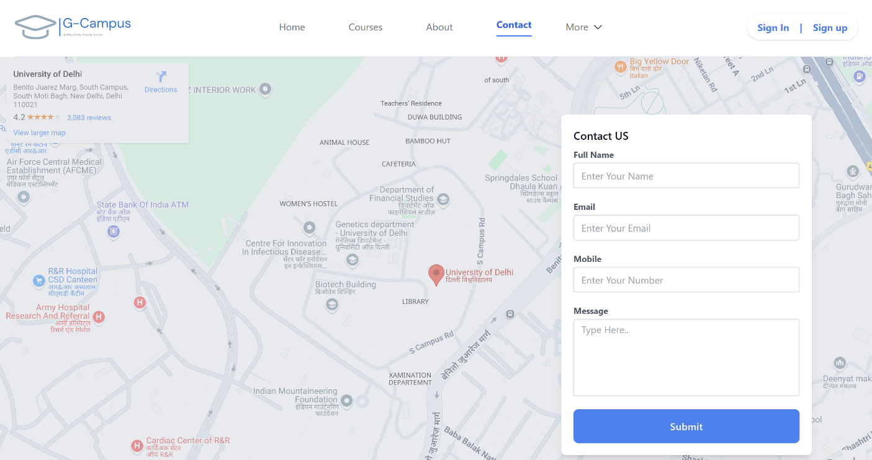
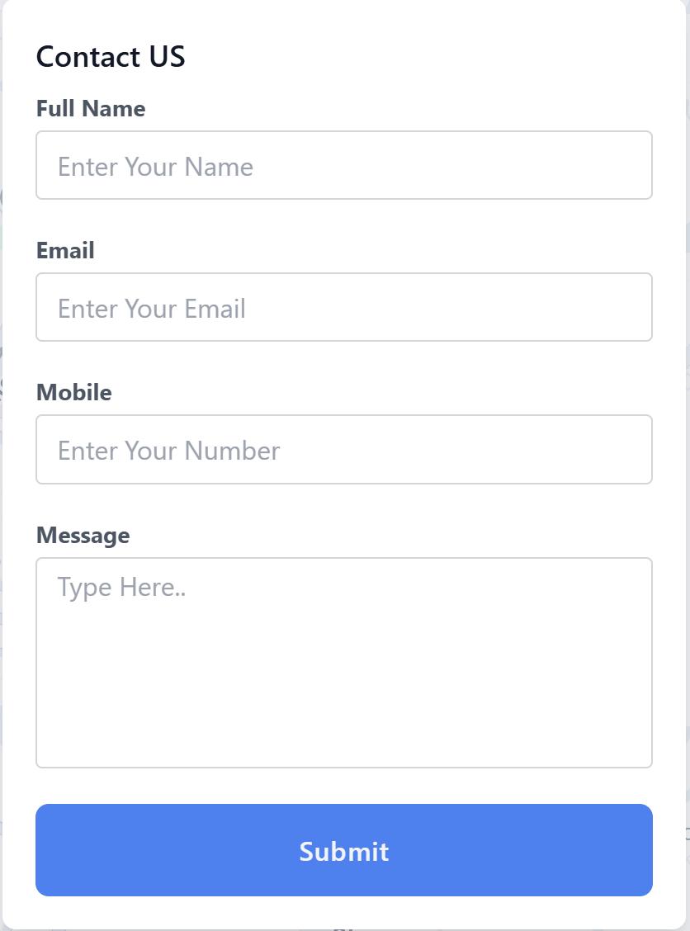




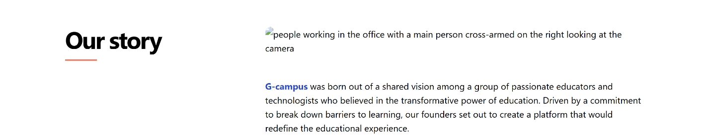

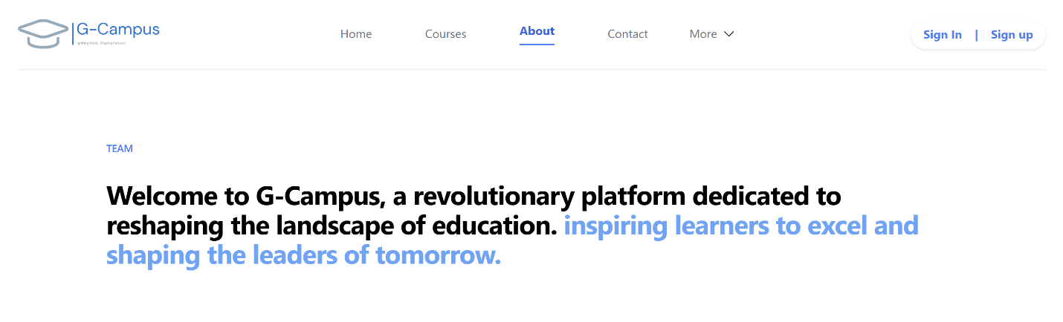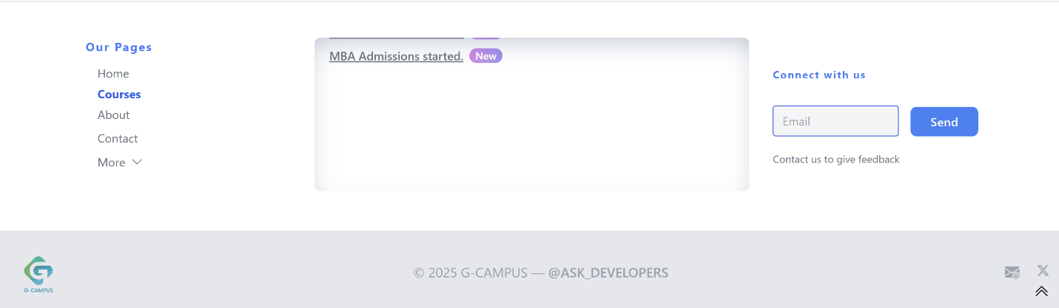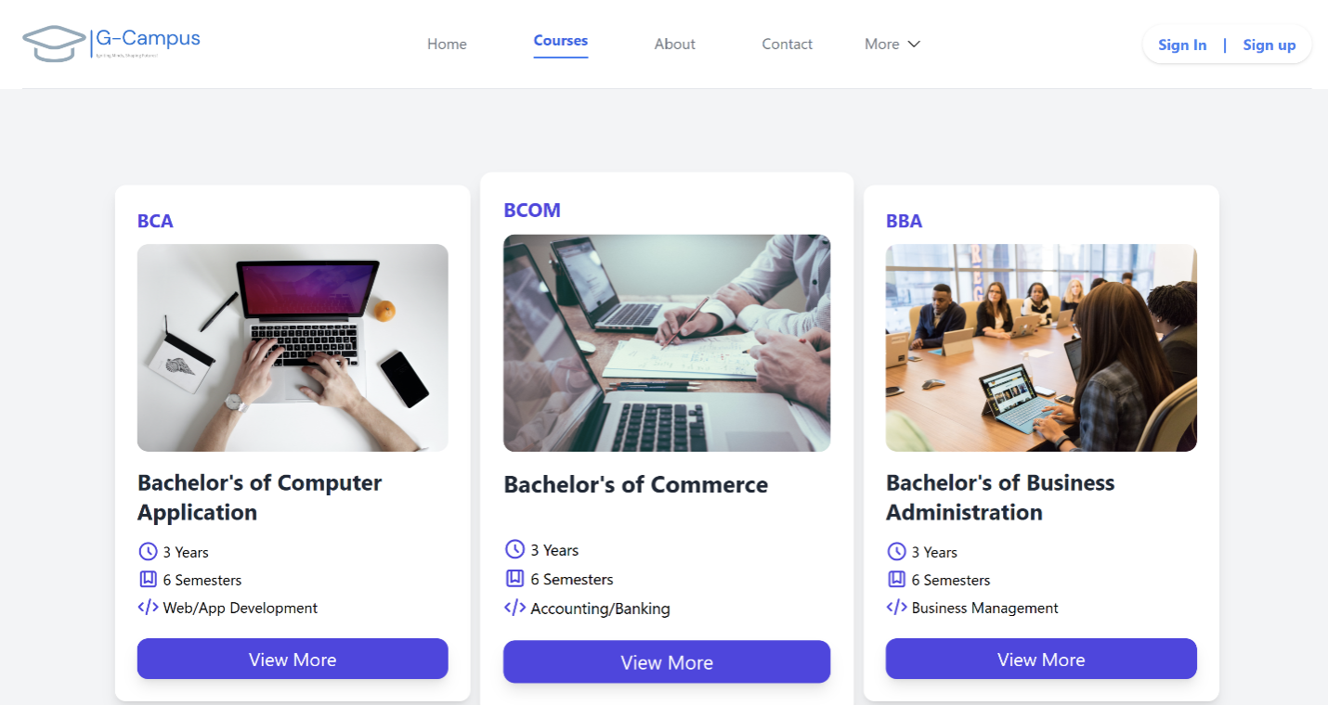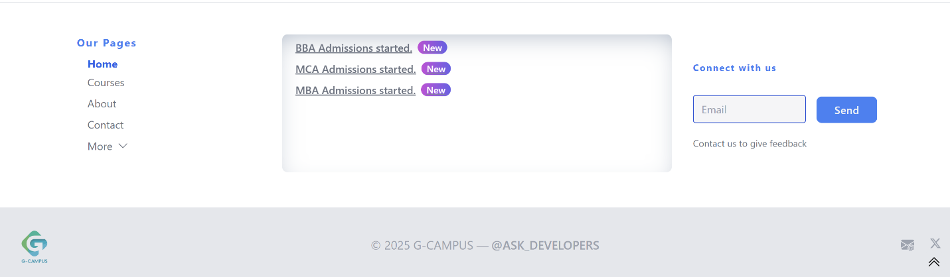

Registration Form
