# Homework: Bugs and Bug Tracking

## Bug Hunting: Google Home Page

|  |  |
| --- | --- |
| **Bug** | **Description** |
| **Bug #1** | The page has no title. |
| **Bug #2** | Logo colors/ brand not accurate. |
| **Bug #3** | ”Images and Gmail” text should bi in the same line. |
| **Bug #4** | “i’m feling Lucky” → “I’m feeling lucky” (typo). |
| **Bug #5** | The text “Bulgaria” wrong font. |
| **Bug #6** | How search works is duplicated → should be different. |
| **Bug #7** | ”Image search icon” → missing . |
| **Bug #8** | ”Advertising link” is missing. |
| **Bug #9** | ”Business link” is missing. |
| **Bug #10** | ”Privacy link” is missing. |
| **Bug# 11** | “The search icon” is mirrored: → |
| **Bug# 11** | Google app number dots are incorrect → |

## Bug Hunting: Notepad Application

|  |  |
| --- | --- |
|  | **Bug #1:** Missing title.  **Bug #2:** Missing **[Minimize]** button.  **Bug #3:** Missing **[Maximize]** button.  **Bug #4:** The **[Close]** button is cut off.  **Bug #5:** Missing **[navigation up arrow]** button.  **Bug #6:** Missing **[View]** button.  **Bug #7:** Missing short cut command [Ctrl+O] button.  **Bug #8:** Missing short cut command [Ctrl+P] button.  **Bug #9:**Missing **[Exit]** button.  **Bug #10:[navigation right arrow]** button is in red.  **Bug #11:** Missing 6 dots in the right bottom corner.   * Expected:      * Actual: |

## Bug Reporting: Gmail

|  |  |
| --- | --- |
| **Bug ID** | #2345 |
| **Priority** | High |
| **Severity** | High |
| **Assigned to** | (Empty) |
| **Reported by** | Yordan Grozdev |
| **Reported on** | 15-mart-2023 |
| **Status** | New |
| **Environment** | Mozila Firefox 111.0 (64-bit) |
| **Summary** | "After logging into Gmail, it navigates to Google.com" |
| **Description** | When I login to Gmail.com ([https://gmail.com](https://gmail.com/) → login with username+password, the browser opens [https://google.com](https://gmail.com/) instead of Gmail inbox ) |
| **Expected behavior** | Open my Gmail inbox |
| **Actual behavior** | The browser opens [https://google.com](https://gmail.com/) |
| **Steps to reproduce** | 1. Open anonymous (incognito Web browser): [Shift+Ctrl+N]    2. [https://gmail.com](https://gmail.com/) It will redirect you to the Google account login page:  3. Fill in a valid username+ passsword |

## Bug Reporting: Reset Password

|  |  |
| --- | --- |
| **Bug ID** | #2345 |
| **Priority** | Low |
| **Severity** | Medium |
| **Assigned to** | (Empty) |
| **Reported by** | Yordan Grozdev |
| **Reported on** | 15-mart-2023 |
| **Status** | New |
| **Environment** | Mobile Mozila Firefox 111.0 (64-bit) |
| **Summary** | When the user registers via mobile, he receives the e-mail two times. |
| **Description** | After registering to the site – samplepage.com, via mobole a new user receives two identical e-mail, which contains a link to reset the initial (default) password instead of receiving only one e-mail. |
| **Expected behavior** | Receiving only one e-mail, which contains a link to reset the initial (default) password |
| **Actual behavior** | Receiving two identical e-mail, which contains a link to reset the initial (default) password |

## Register in Atlassian Jira Cloud

*[Insert a screenshot of your Jira bug tracking project]*

## Bug Reporting: Registration Form

Briefly describe all bugs you have found in the table below. You may add screenshots where it is relevant.

|  |  |
| --- | --- |
| **Bug** | **Description** |
| **Bug #1** | When I fill **exactly 4 or 5 alphanumeric chars**, the form should give a “User name field requires at least 6 letters and numbers” info, but it accept the username with 4 or 5 length alphanumeric chars. |
| **Bug #2** | **Usability** issues: validation error should be displayed in red, right after or below the incorrectly filled field  Bad usability:    Better usability example: |
| **Bug #3** | **Usability** issue:When a **button is active** (selected by pressing [Tab] key several times), this is not visualized. |
| **Bug #4** | [**Confirm Email :**] label is written incorrect. It should be written [Confirm Password:], instead of [Confirm Email :]   * Expected: ”**Confirm** **Password** :” * Actual: **”Confirm Email :”** |
| **Bug #5** | [**Clear Form**] button doesn’t work as expected. |
| **Bug #6** | **Username** should have max length limit, e.g. 50 chars. |
| **Bug #7** | **5-letter password** should be invalid, but the password ”1Ab*5” is accepted. |
| **Bug #8** | Duplicated username/ email should not be allowed. |
| **Bug #9** | The message ”redirecting” is not needed. |
| **Bug #10** | Welcome message mismatch:   * Expected: ”**You are now logged in**.” * Actual: “**Thank you for registering**” |
| **Bug #11** | Incorrect punctuation in the text labels: space before “:” should be removed:   * Expected: ”**Password**:” * Actual: **”Password :”** |
| **Bug #12** | Typo “Account” typed wrongly:   * Expected: ”**Create your account**” * Actual: **”Create your acount”** |

**Report all bugs** found in your **Jira** project.  
*[Insert a screenshot of your Jira bug tracking project, holding your issues]*

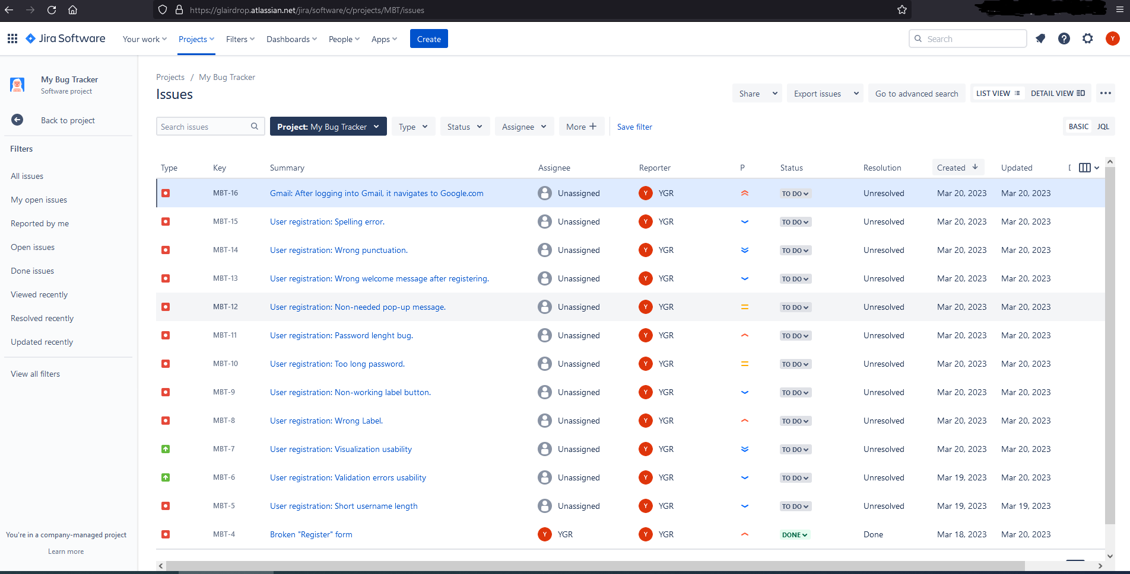

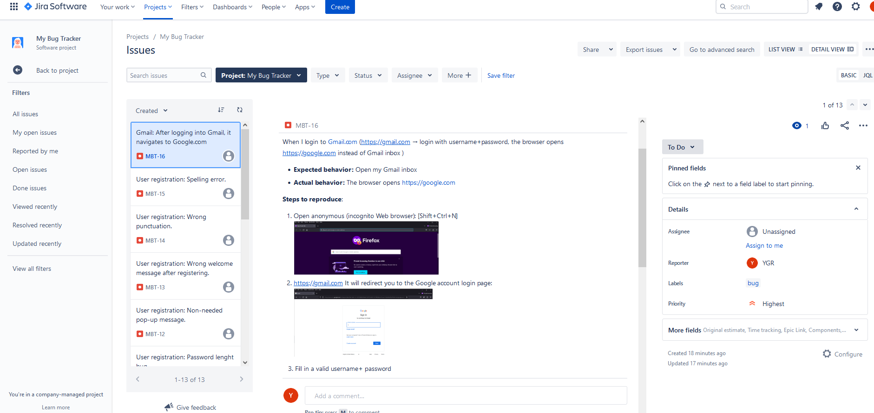

<https://glairdrop.atlassian.net/browse/MBT-16>

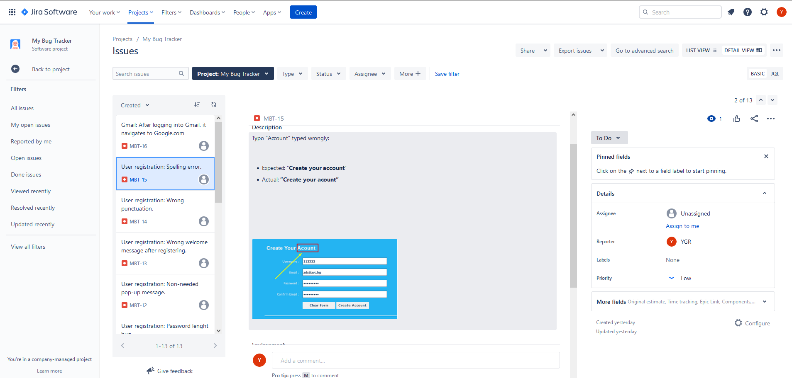

<https://glairdrop.atlassian.net/browse/MBT-15>

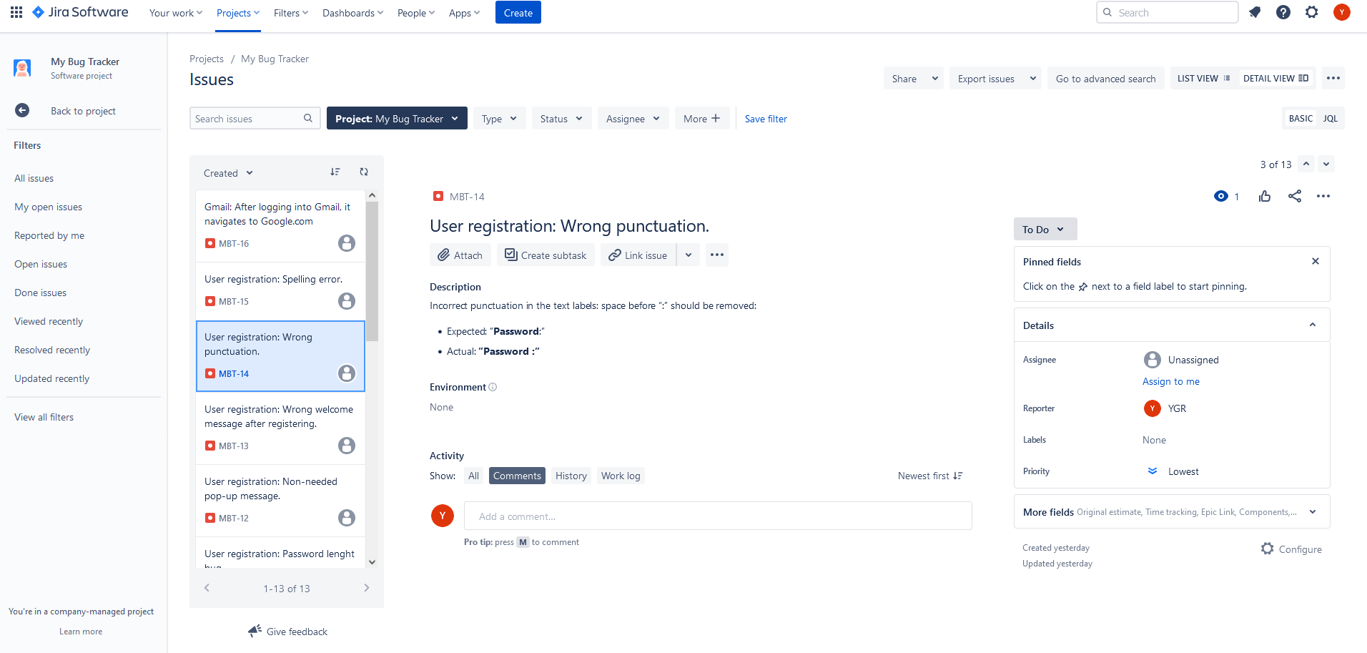

<https://glairdrop.atlassian.net/browse/MBT-14>

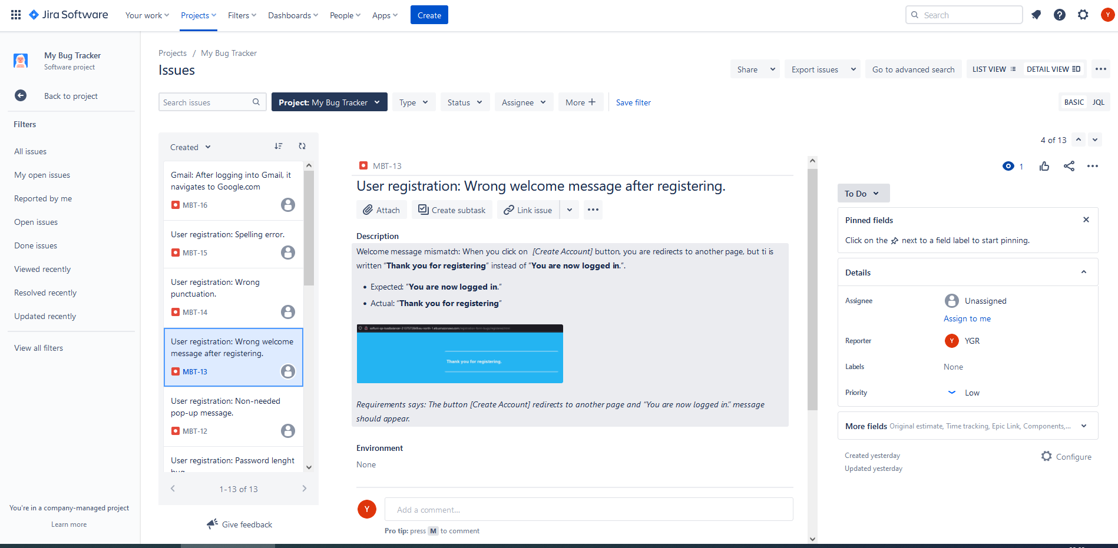

<https://glairdrop.atlassian.net/browse/MBT-13>

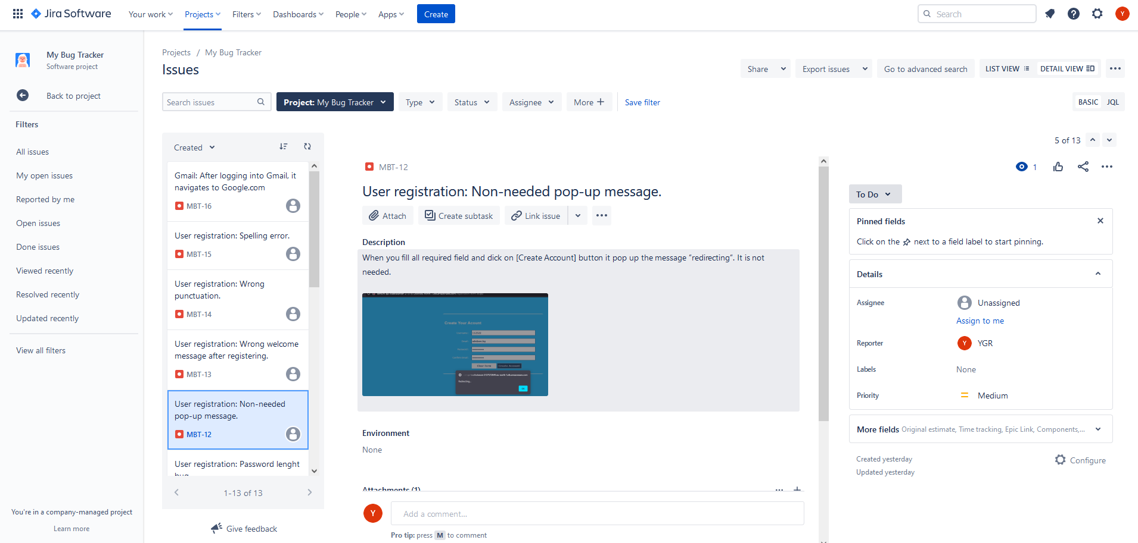

<https://glairdrop.atlassian.net/browse/MBT-12>

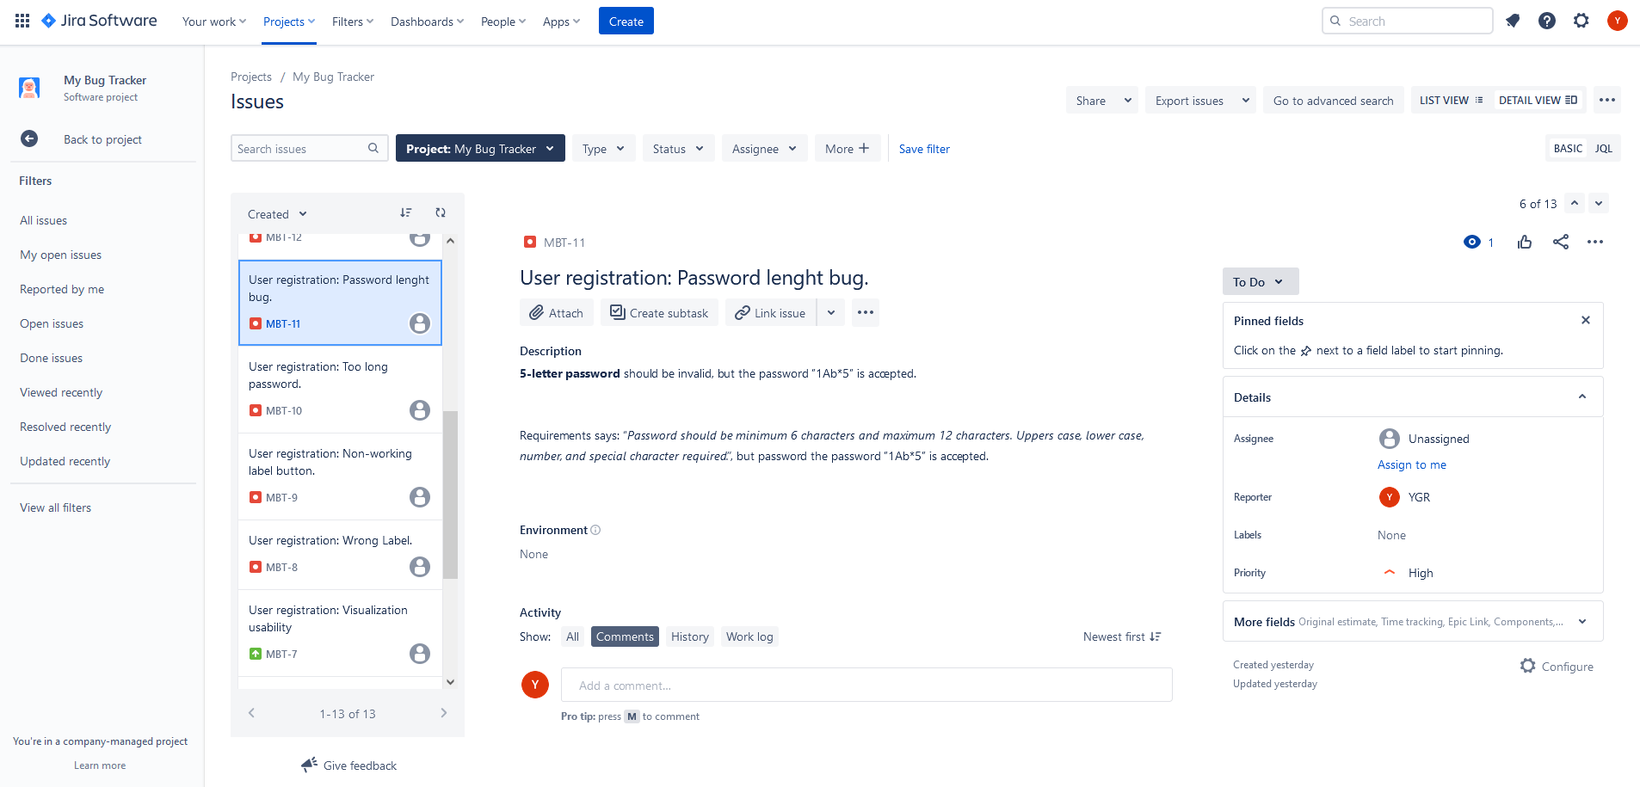

<https://glairdrop.atlassian.net/browse/MBT-11>

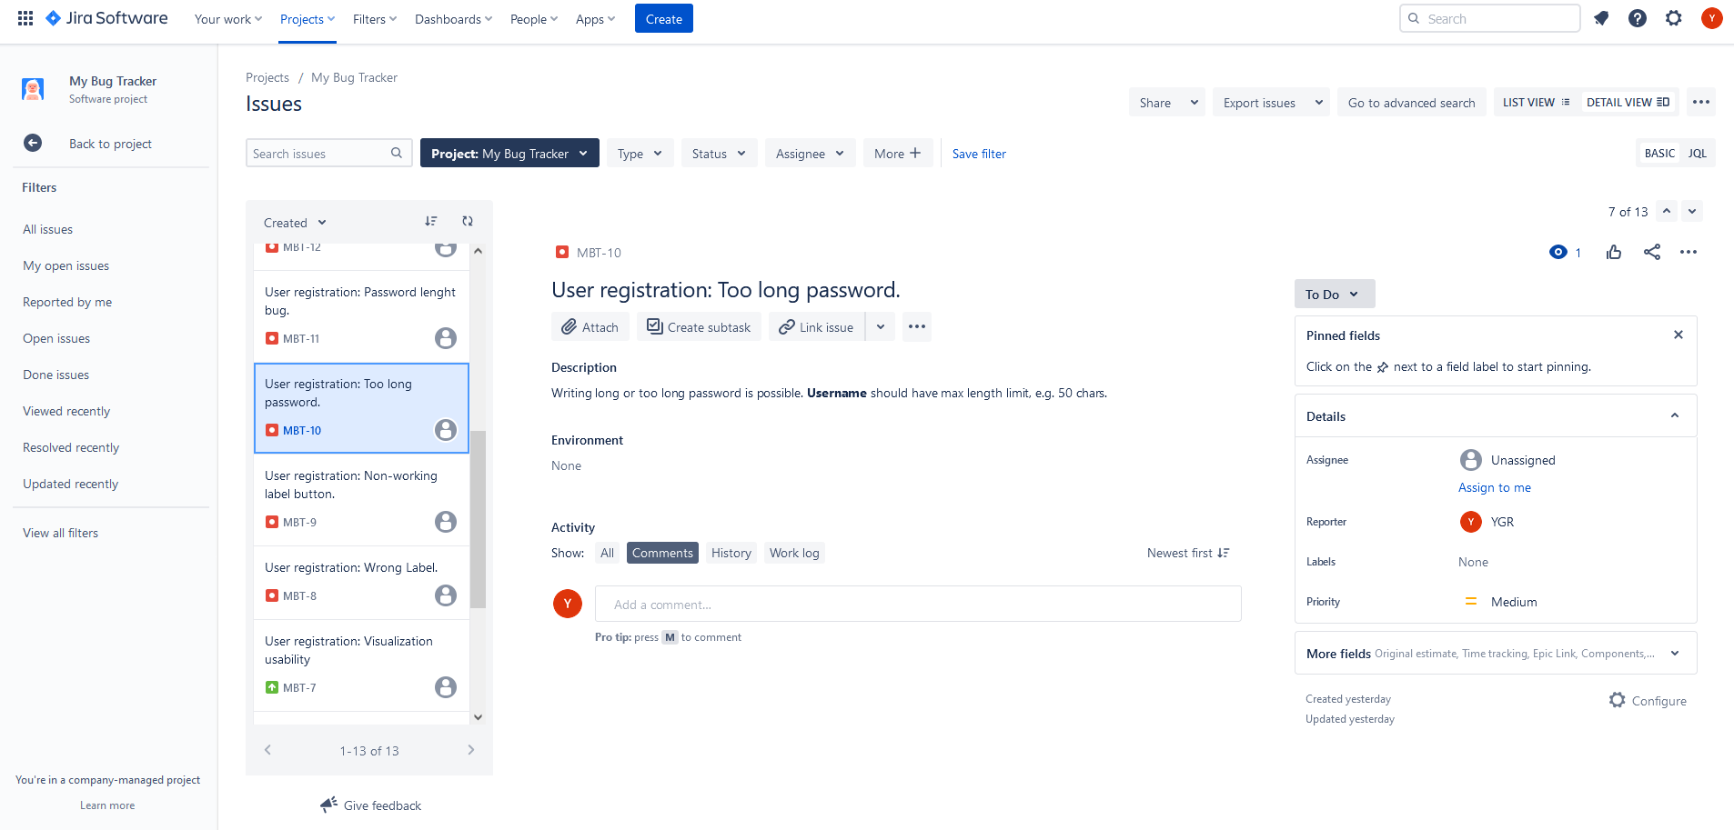

<https://glairdrop.atlassian.net/browse/MBT-10>

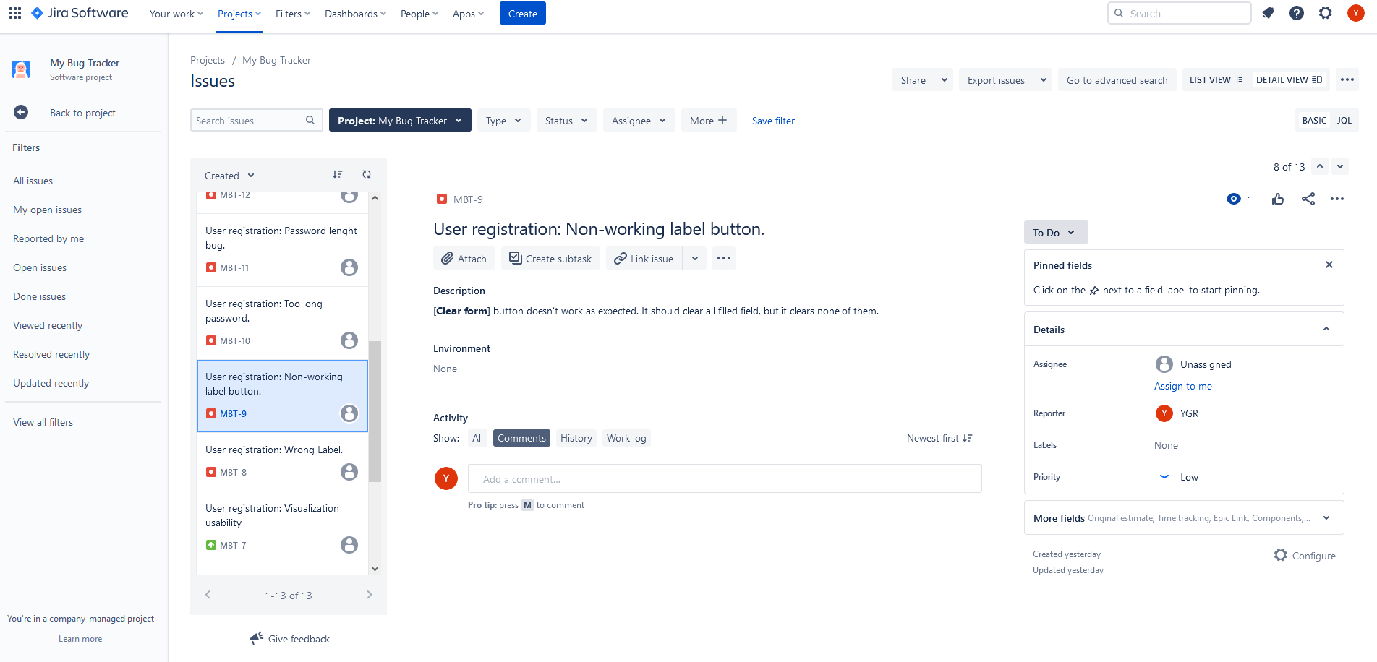

<https://glairdrop.atlassian.net/browse/MBT-9>

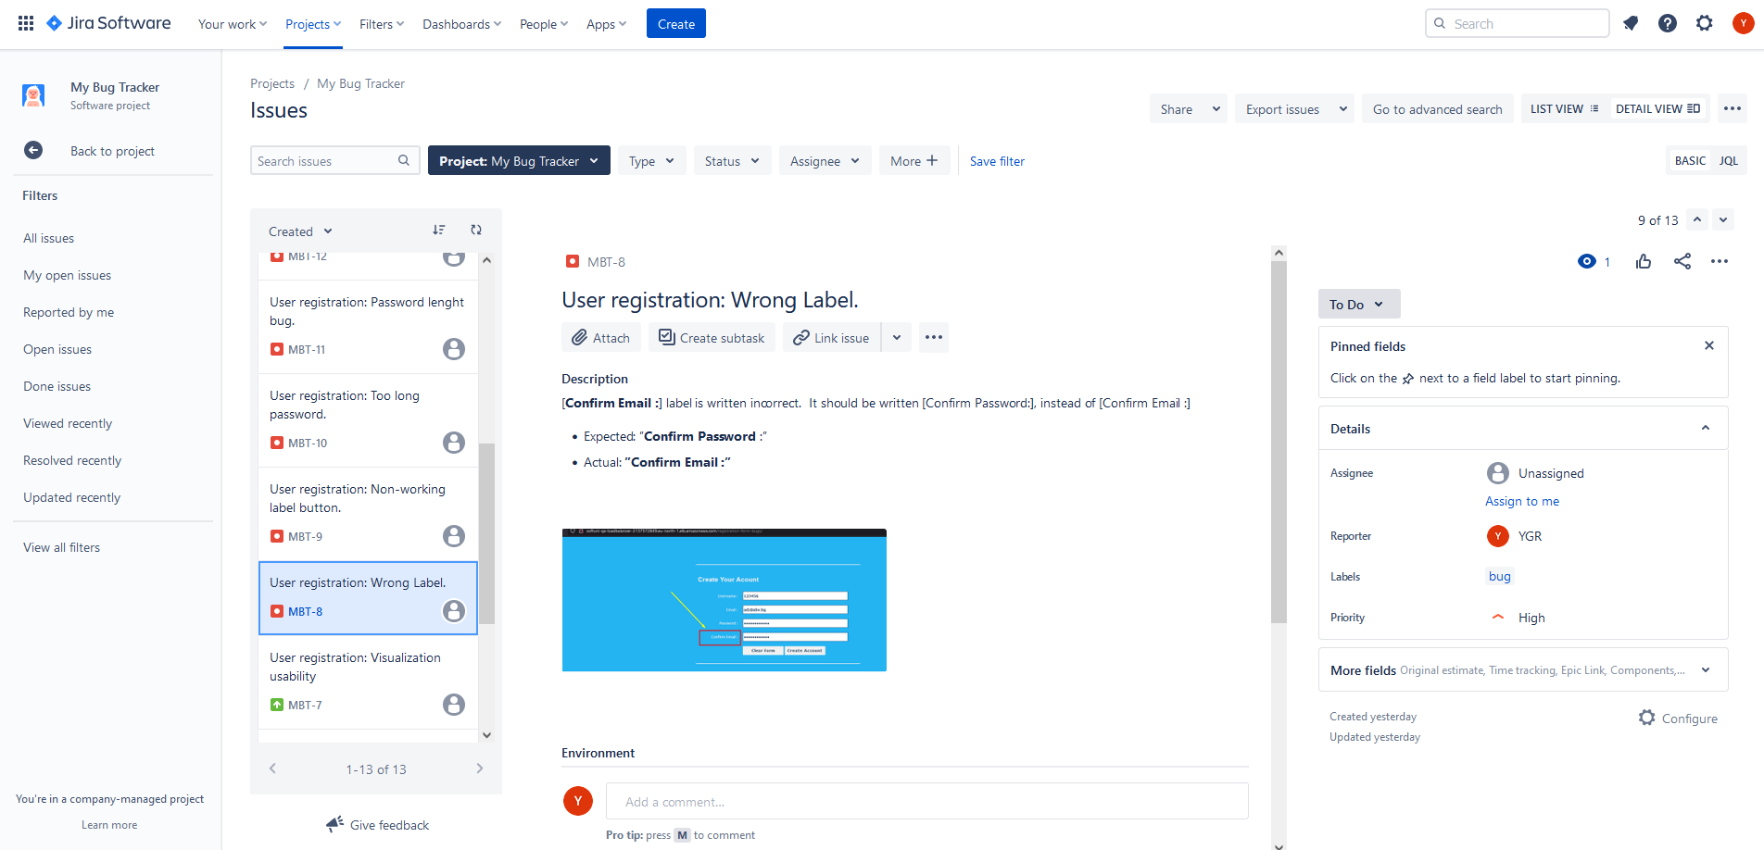

<https://glairdrop.atlassian.net/browse/MBT-8>

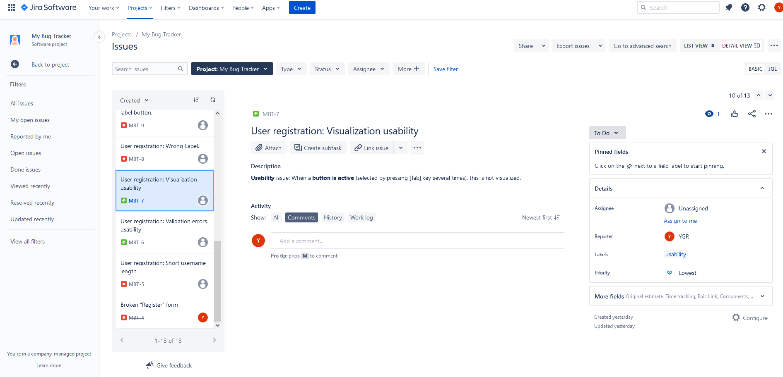

<https://glairdrop.atlassian.net/browse/MBT-7>

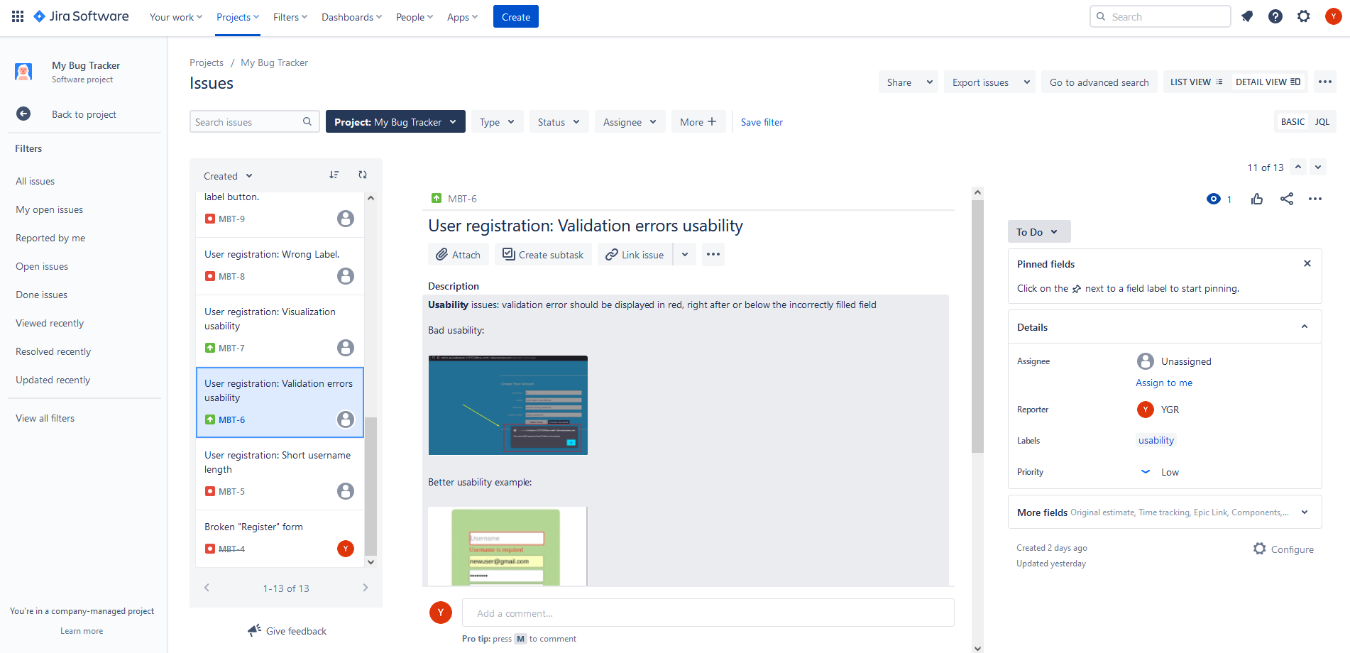

<https://glairdrop.atlassian.net/browse/MBT-6>

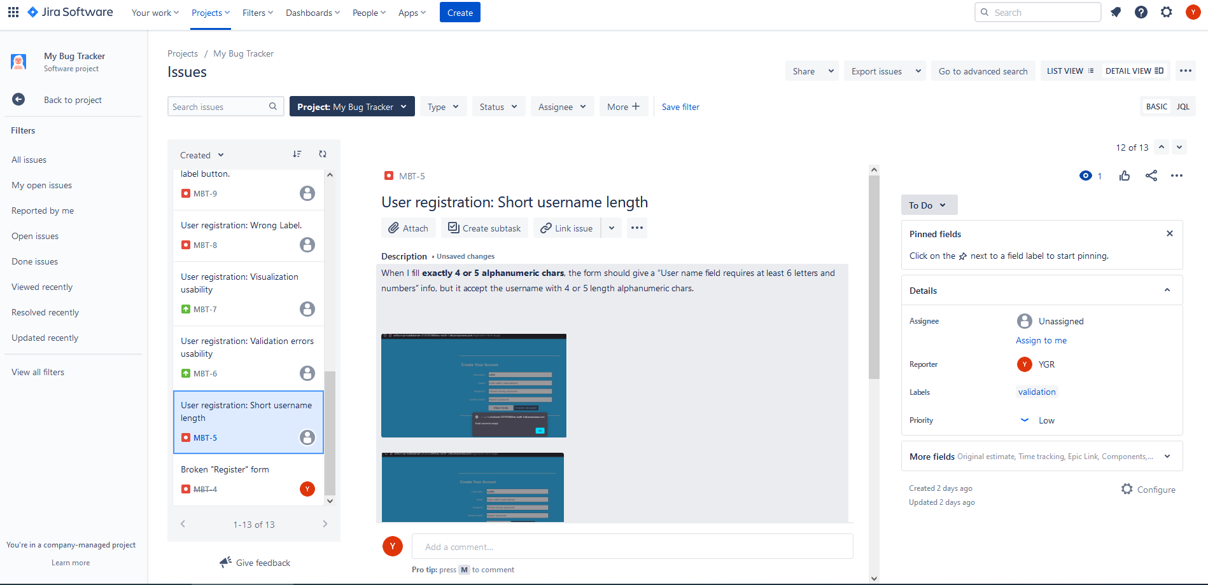

<https://glairdrop.atlassian.net/browse/MBT-5>

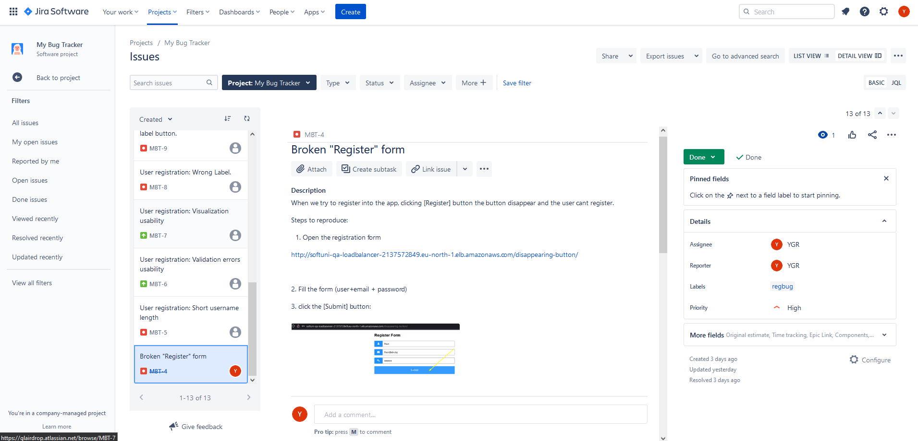

<https://glairdrop.atlassian.net/browse/MBT-4>