Clean Energy supported data centers and 6G base stations with smart EVs and buildings for multi-asset grid services
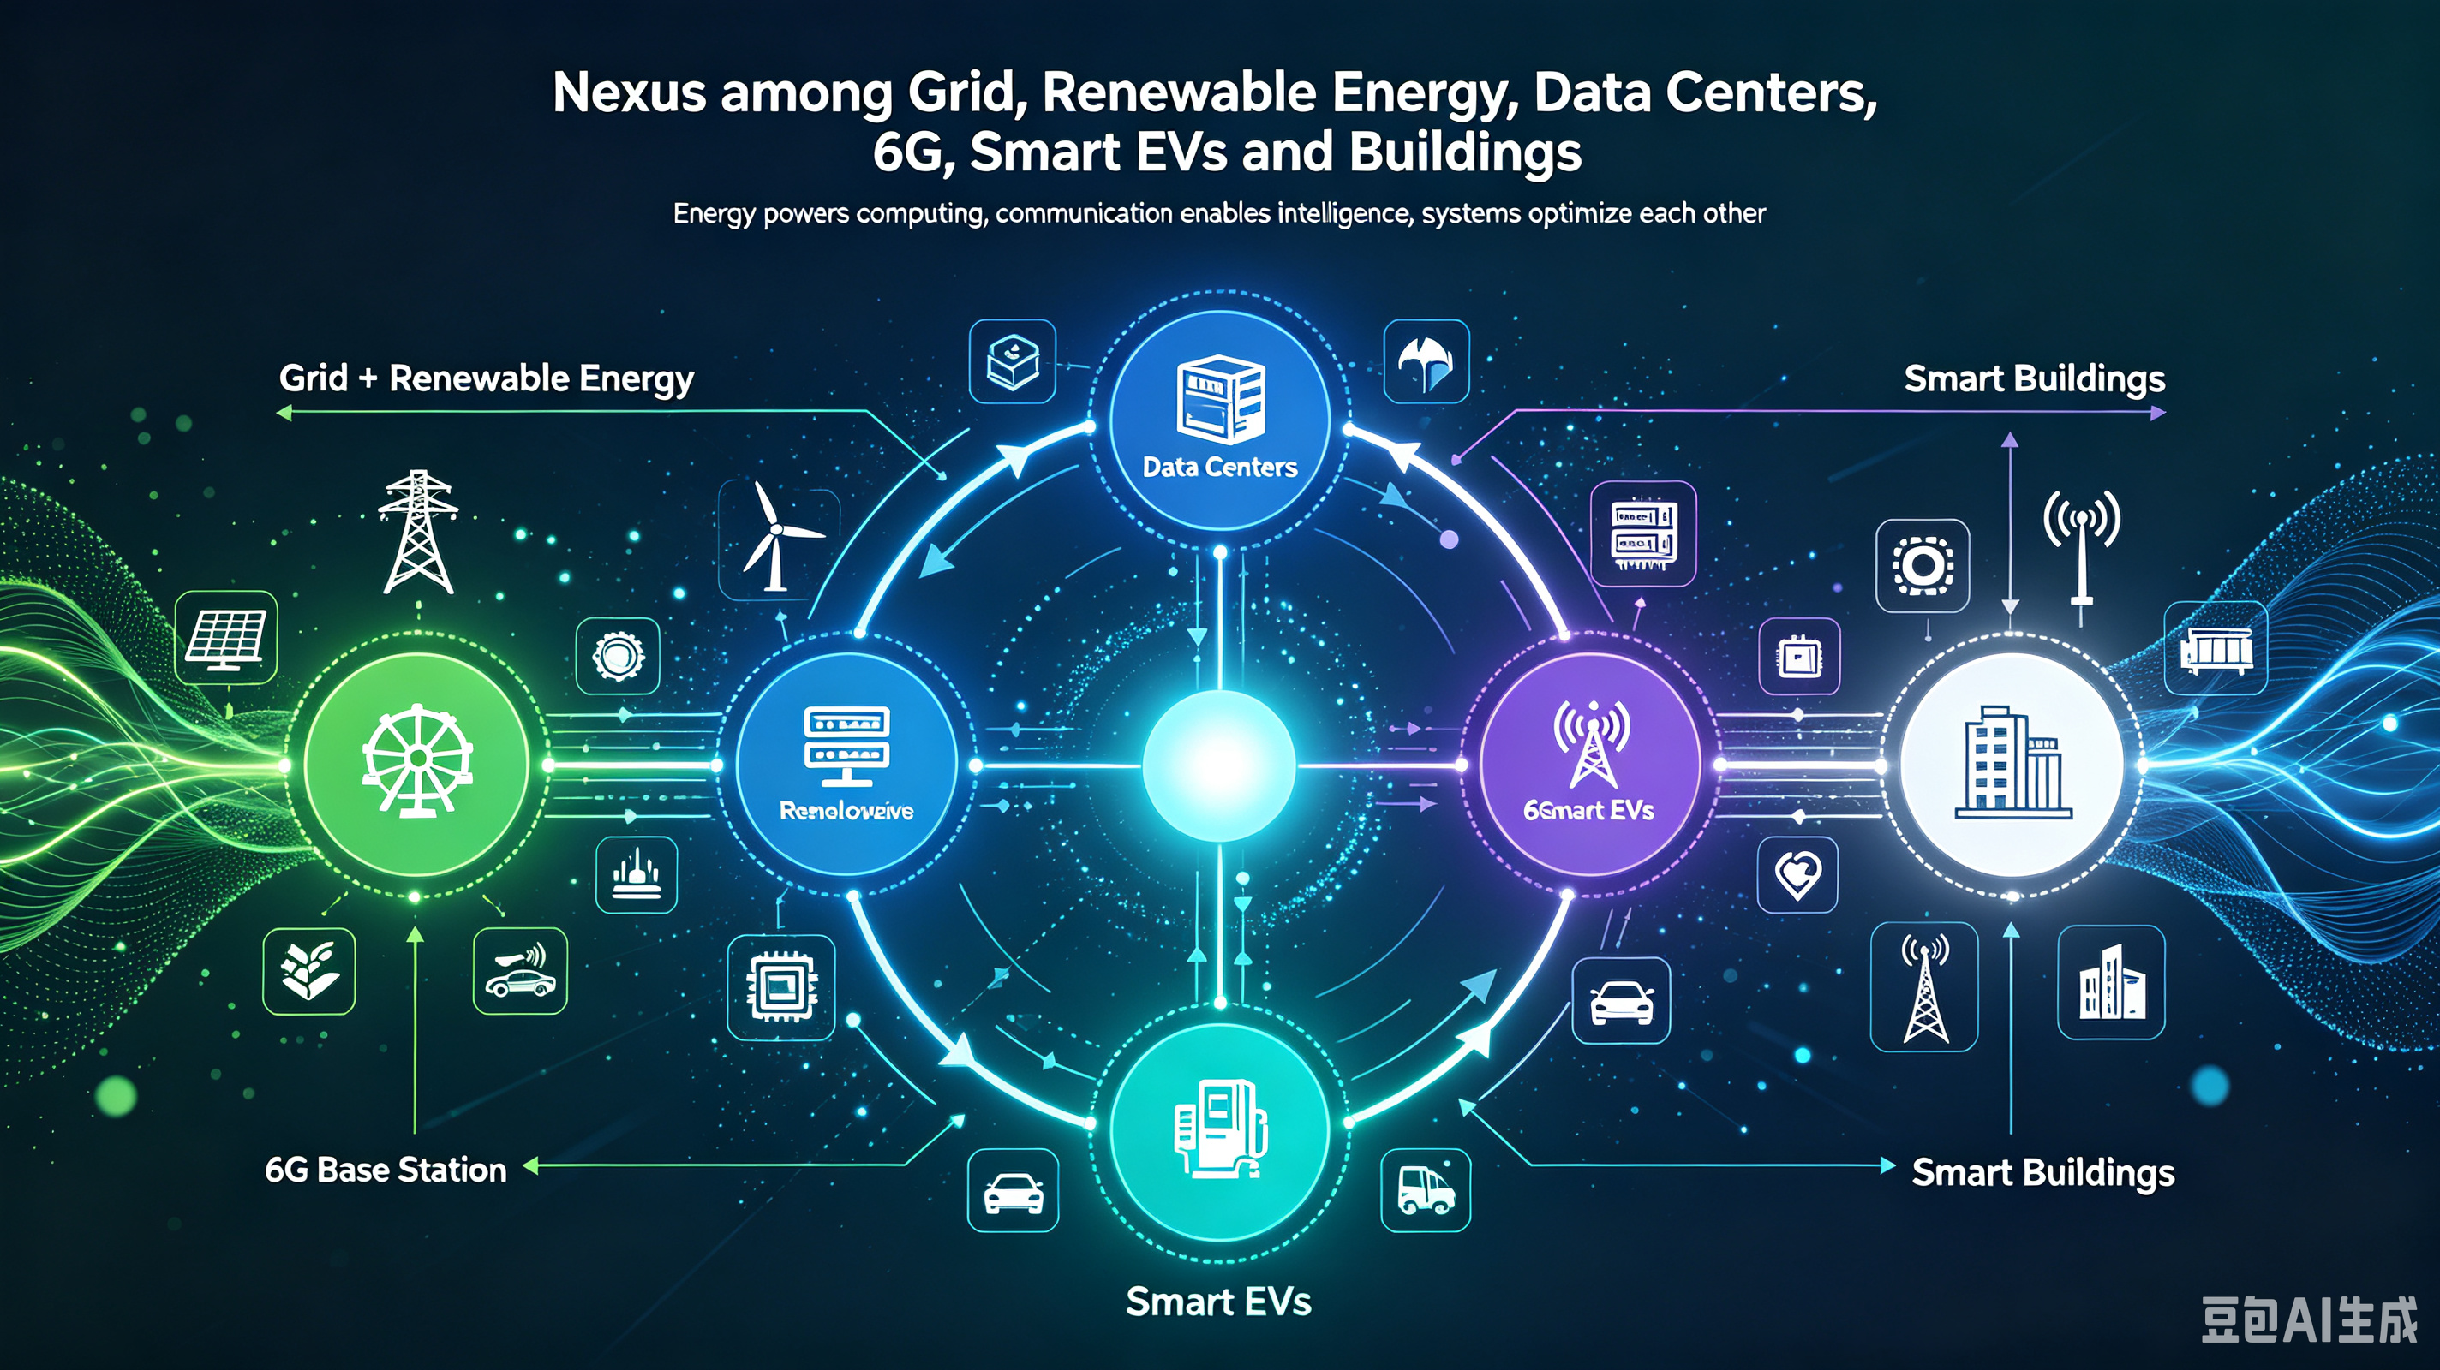
Graphic Abstract
Grid+Renewable energy->data centers and 6G base station-> smart EVs and buildings
Abstract
The accelerating convergence of digital infrastructure—data centers and 6G base stations—with transportation electrification and intelligent buildings presents a paradigm-shifting opportunity for power grid modernization. This review synthesizes interdisciplinary research on the integration of clean energy-powered digital assets, electric vehicles, and active buildings as grid-interactive resources. We examine how data centers and 6G base stations, traditionally viewed as passive load centers, can leverage their backup energy storage and workload flexibility to provide grid ancillary services. Concurrently, we analyze the synergistic potential of vehicle-to-grid (V2G) technologies and smart buildings as distributed energy prosumers. Key findings reveal that coordinated control frameworks can achieve sub-second frequency response, with data center cooling systems and IT workloads providing regulation services comparable to conventional battery storage. We identify critical challenges including interoperability standards, communication latency requirements, and the energy-security trade-off, while proposing future research directions at the intersection of telecommunications, power systems, and sustainable computing.
Keywords: Data centers; 6G base stations; vehicle-to-grid (V2G); smart buildings; grid-interactive assets; frequency regulation; demand response; renewable energy integration

1. Introduction

1.1 Background
The global energy landscape is undergoing a profound transformation driven by three simultaneous megatrends: the exponential growth of digital infrastructure, the electrification of transportation, and the imperative for grid decarbonization. Data centers, essential to the artificial intelligence revolution, are experiencing unprecedented electricity demand growth. Concurrently, the deployment of beyond-5G and 6G communication networks promises to connect billions of devices while introducing new energy challenges—China alone plans to deploy 8.28 million base stations by 2025.

1.2 Literature review
Central to this review is the concept of "grid-interactive assets"—energy resources that can dynamically communicate with and respond to grid conditions. This paradigm represents a fundamental departure from the traditional unidirectional power flow model, transforming passive consumers into active prosumers capable of providing flexibility services.

1.3 Research gaps and Contributions
This paper provides a comprehensive review of:
- Nexus among Grid, Renewable energy, data centers and 6G base station, smart EVs and buildings
- Clean energy integration strategies for data centers and 6G infrastructure
- Vehicle-to-grid and vehicle-to-fog technologies as mobile energy assets
- Active buildings as distributed energy nodes
- Coordinated control frameworks for multi-asset grid services

2. The Energy Challenge: Digital Infrastructure and Grid Decarbonization

2.1 Data Center Energy Consumption Trends
The rapid proliferation of artificial intelligence technologies has catalyzed unprecedented growth in data center infrastructure, creating significant pressure on electricity grids. Research indicates that power consumption in distributed computing systems is not linearly related to CPU utilization—I/O operations significantly impact energy consumption, necessitating sophisticated power modeling approaches.

2.2 6G Network Energy Requirements
The transition to 6G communications, with standardization expected to commence in 2025 and commercialization targeted for 2030, introduces both challenges and opportunities. The massive deployment of base stations—each equipped with backup batteries—creates a distributed energy storage network potentially exceeding the capacity of conventional grid storage systems.

2.3 Renewable Energy Integration Challenges
Integrating variable renewable energy sources requires unprecedented grid flexibility. Seasonal climate variability significantly affects electricity demand patterns—studies project increased summer peak loads and winter peaking shifts in some regions, requiring expanded generation capacity that may become underutilized.

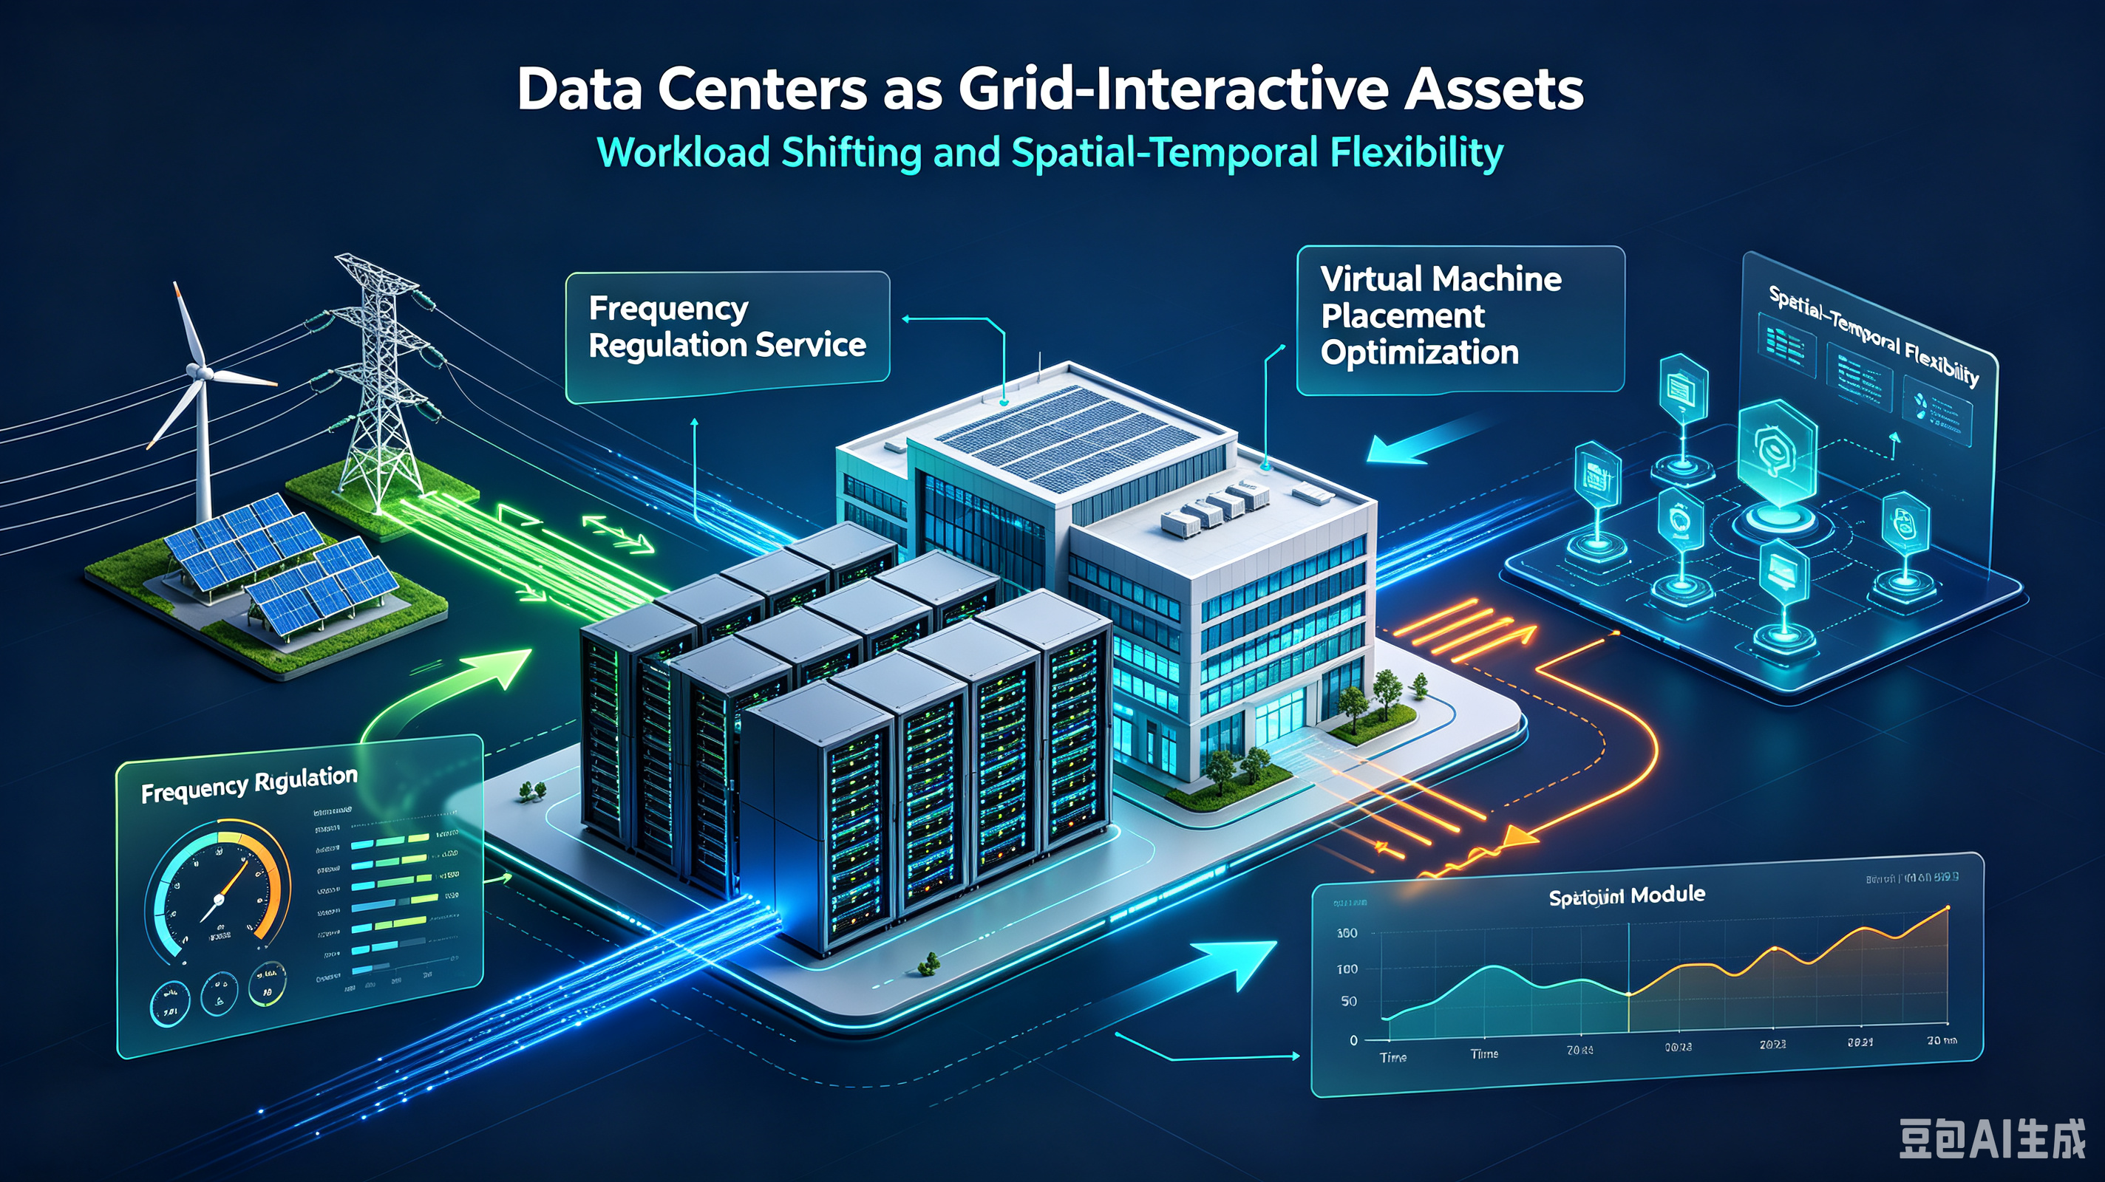
3. Data Centers as Grid-Interactive Assets

3.1 Workload Shifting and Spatial-Temporal Flexibility
Data centers can provide load-shifting flexibility by migrating computational workloads across both space and time. This enables data centers to function as prosumers, simultaneously requesting load and providing flexibility services, with remuneration based on nodal price differences.

3.2 Frequency Regulation Services
Research demonstrates that data centers can provide fast frequency response (FFR) services through coordinated control of both IT workloads and cooling systems. Key mechanisms include:
- Server-level power management
- Chilled water supply temperature control
- UPS battery participation in frequency regulation
A synergistic control strategy combining these approaches can effectively track regulation signals from electricity markets.

3.3 Virtual Machine Placement Optimization
Energy-efficient virtual machine (VM) placement is a constrained optimization problem that significantly impacts data center efficiency. Accelerated genetic algorithms have demonstrated 8% energy savings compared to traditional algorithms, with 66% reduction in execution time for large-scale deployments.

4. 6G Base Stations as Energy Resources

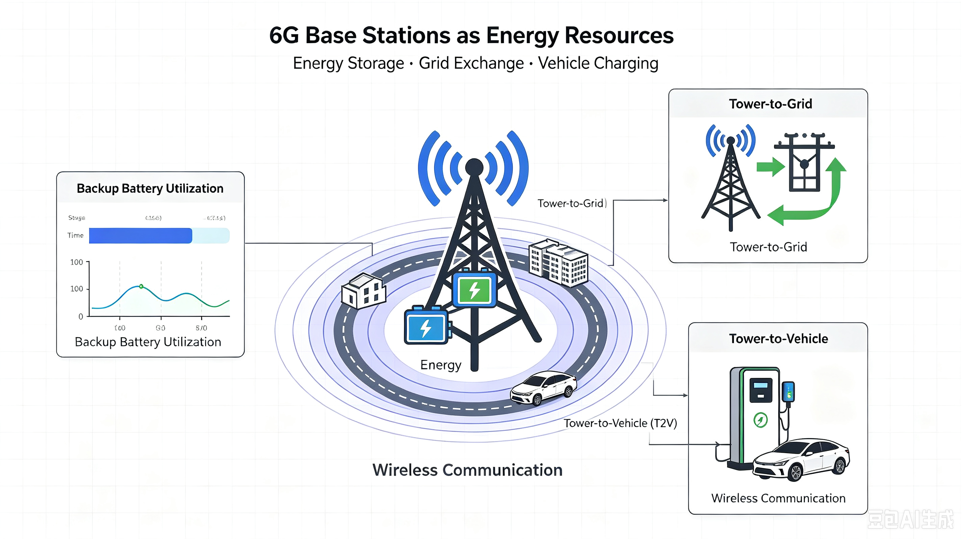

4.1 Backup Battery Utilization
Base stations are uniquely positioned as grid assets because they are already grid-connected, with batteries primarily serving as backup power. These batteries can be charged during off-peak hours and discharged during peak demand, enabling telecom operators to participate in energy markets . Crucially, retired electric vehicle batteries retain sufficient capacity for base station backup applications, enabling circular economy approaches.

4.2 Tower-to-Grid (T2G) and Tower-to-Vehicle (T2V) Energy Exchange Models
Three primary implementation models for base station energy exchange have been identified :
Grid-Centralized T2G: Bidirectional exchange between base stations and the grid, enabling dynamic pricing participation. At most 50% of backup battery capacity is dispatchable during low traffic periods.
Cloud-Based Virtual Power Plant: Aggregates decentralized resources including solar, wind, and storage through unified control, enabling peer-to-peer energy exchange that avoids transmission losses.
Direct T2V Exchange: Enables electric vehicles to directly obtain energy from base stations, reducing communication overhead and transmission losses.

4.3 Communication Requirements and Latency Constraints
The smart grid requires low-latency, ultra-reliable communication for stability-critical operations. 5G technology addresses these requirements through enhanced Mobile Broadband (eMBB), Ultra-Reliable Low-Latency Communications (URLLC), and Massive Machine-Type Communications (mMTC) schemes -11. Smart grid applications requiring wireless communication include low-voltage distribution data acquisition, intelligent distributed feeder automation, and millisecond-level precise load control.

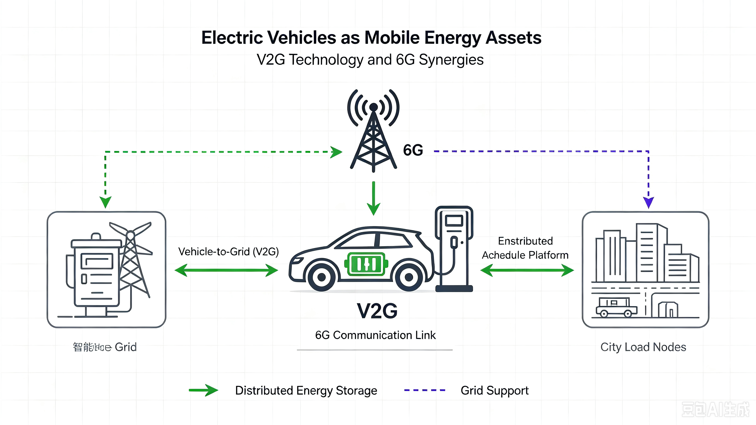
5. Electric Vehicles as Mobile Energy Assets

5.1 Vehicle-to-Grid (V2G) Technology
Vehicle-to-grid technology leverages electric vehicles as mobile energy storage units, providing promising solutions for peak demand management, renewable energy integration, and grid stabilization . Coordinated control frameworks for fast frequency response from electric vehicles, data centers, and battery energy storage systems demonstrate the potential for sub-second active power support from distributed resources.

5.2 V2G and 6G Synergies
The integration of V2G with next-generation networks enables decentralized energy processing, representing what some researchers identify as the optimal industrial application of 5G/6G technology for energy challenges . Vehicle-to-fog computing architectures extend this concept, enabling even greater decentralization of energy resources.

5.3 Implementation Challenges
Key challenges include:
- Potentially disrupting telecom infrastructure if not carefully planned
- Record-keeping requirements for energy origin tracing
- Dynamic pricing and buyer-seller matching
- Privacy-preserving energy management

6. Smart Buildings as Distributed Energy Nodes

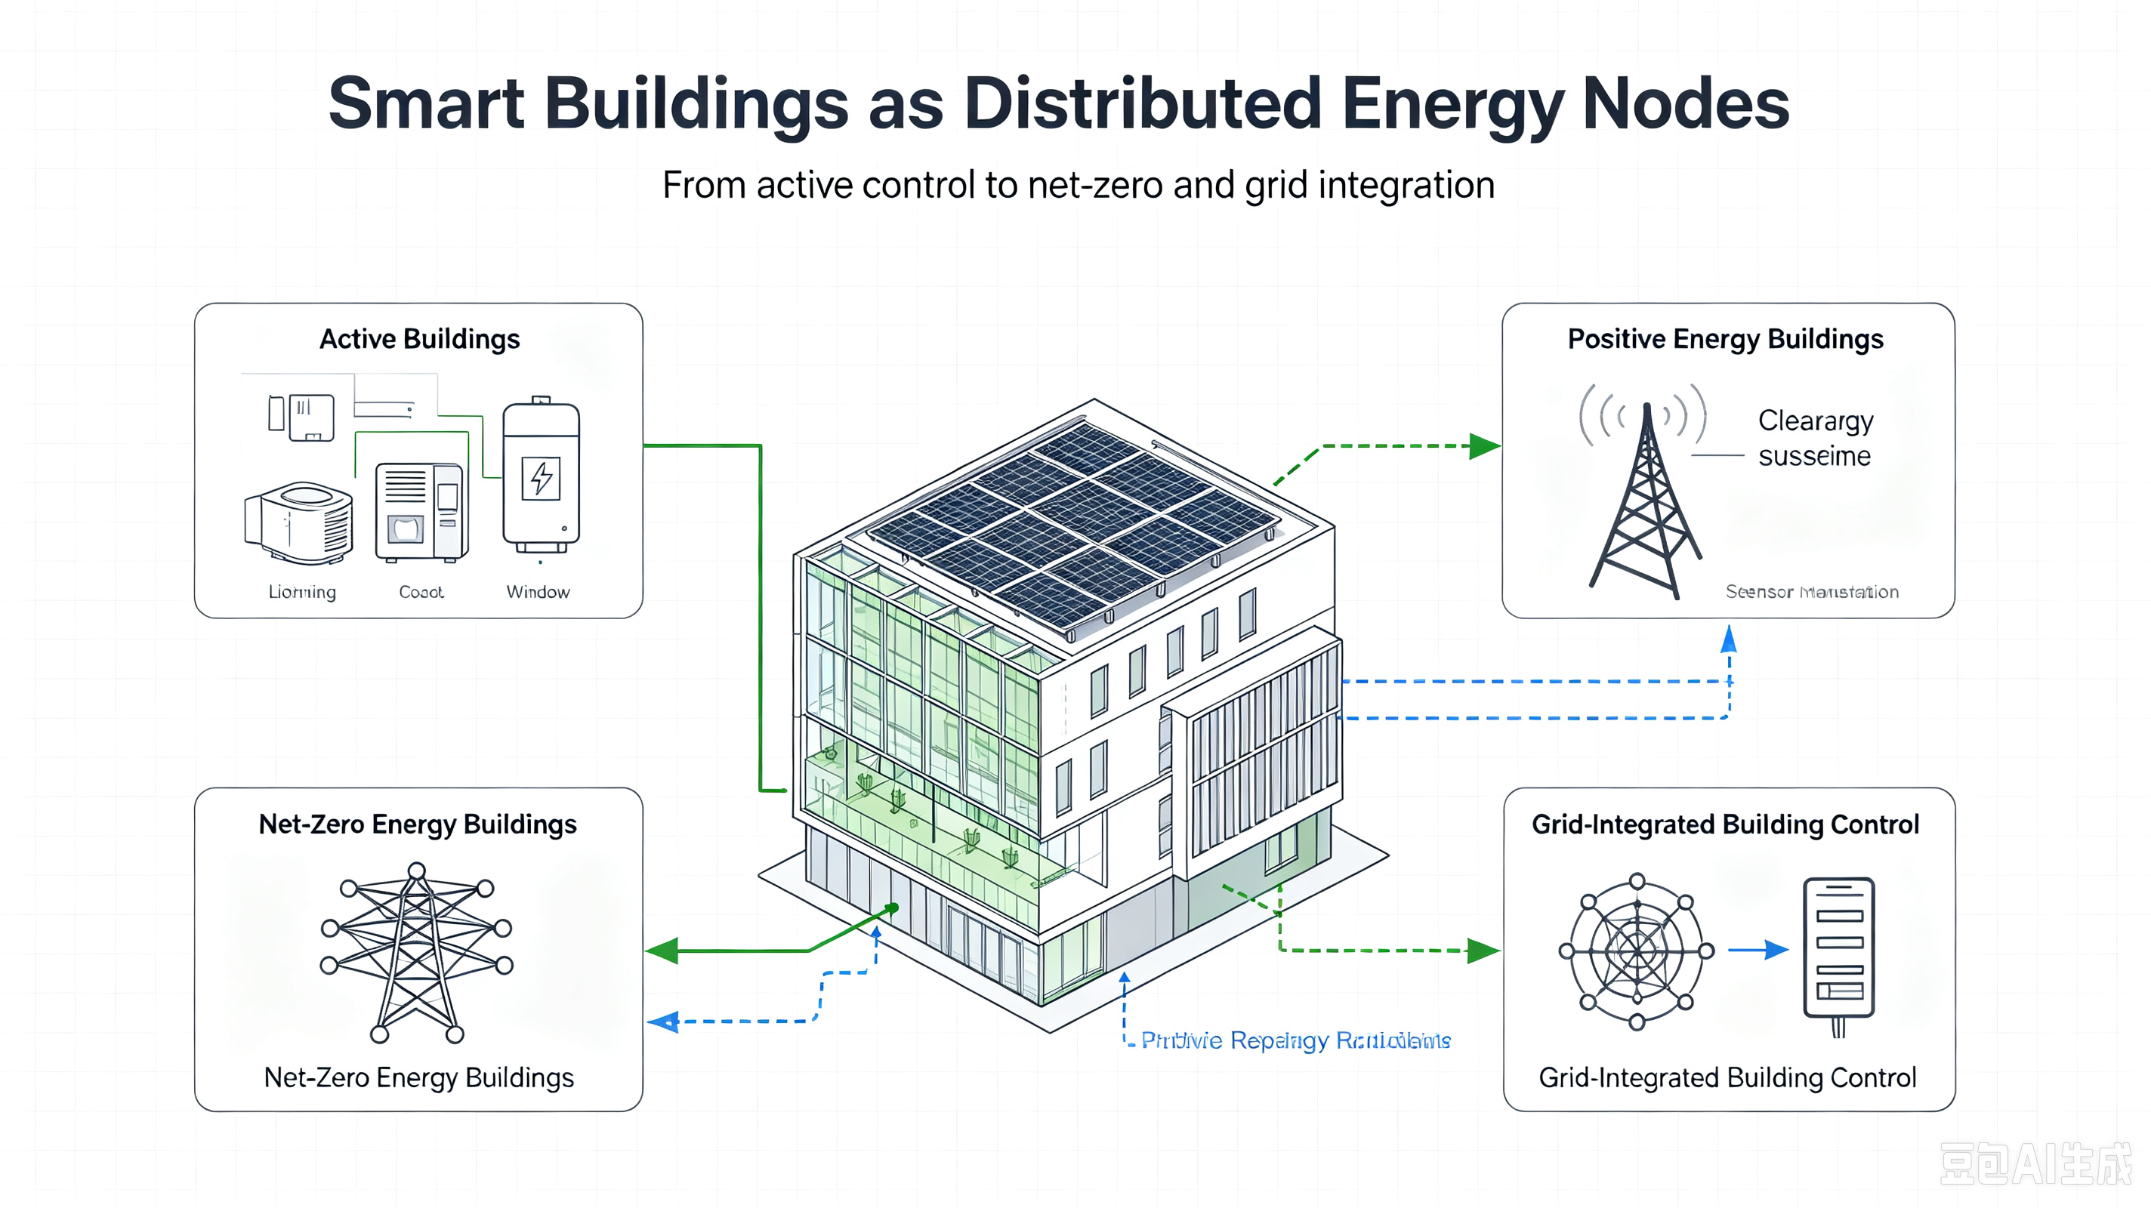

6.1 Active Buildings
Buildings are transitioning from passive consumers to active participants in energy systems. This transformation is enabled by renewable energy sources, smart technologies, and information and communication technologies, allowing buildings to participate in balancing markets and support network operators as service providers.

6.2 Positive Energy Buildings and Net-Zero Energy Buildings
Positive Energy Buildings (PEBs) represent a paradigm shift toward high-performance building-sector infrastructure, focusing on exploiting interactions between individual Net-Zero Energy Buildings and smart grids through energy surplus exchange. This requires rethinking buildings as nodes in intelligent energy infrastructures with distributed renewable energy resources

6.3 Grid-Integrated Building Control
Collaborative control optimization using game-theoretic frameworks for grid-connected buildings has demonstrated:
- Peak demand reduction
- Improved grid stability
- Increased renewable energy utilization
Photovoltaic systems integrated with buildings can provide significant ancillary services including frequency regulation and voltage control

7. Integration and Coordination Frameworks
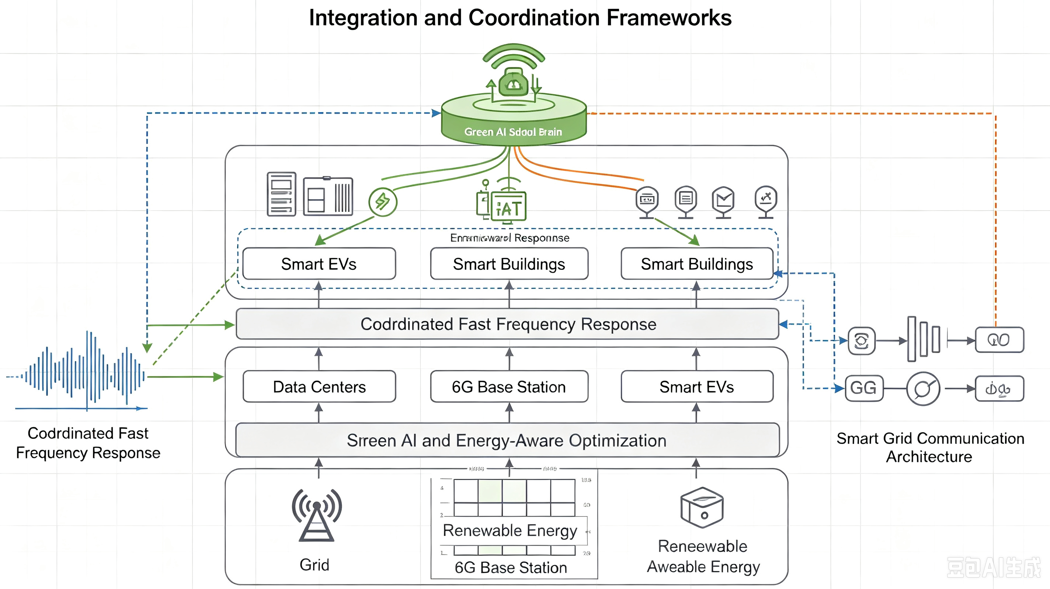

7.1 Coordinated Fast Frequency Response
Recent research proposes unified control frameworks enabling electric vehicles, data centers, and battery energy storage systems to provide coordinated fast frequency response. High renewable penetration has reduced system inertia, increasing the criticality of distributed frequency response

7.2 Smart Grid Communication Architectures
The general architecture of the smart grid requires robust telecommunication infrastructure for addressing reliability, capacity, and security issues. Smart grids enable two-way communication between central controllers and local actuators, enabling rapid response to urgent situations such as sudden load increases.

7.3 Green AI and Energy-Aware Optimization
Energy-aware optimization strategies in 5G/6G networks and data centers increasingly rely on AI-driven orchestration and resource management. Future research directions include developing computationally light and efficient AI models that balance energy efficiency with AI performance

8. Research limitations, challenges and future works

8.1 Research limitations and challenges

8.2 Future works
8.2.1 Cross-Layer Energy Optimization
Developing integrated optimization approaches that span application, network, and infrastructure layers is essential for achieving maximum efficiency
8.2.2 Standardization and Interoperability
The lack of unified standards for grid-interactive digital assets requires collaborative efforts across telecommunications, energy, and computing sectors
8.2.3 Empirical Validation
Research must advance from theoretical and simulation-based studies to testbed-validated implementations in real-world smart grid environments
8.2.4 Policy and Regulatory Frameworks
Public policy development in telecommunications and energy sectors must focus on encouraging green technologies and decentralized renewable energy generation.

9. Conclusions
The integration of clean energy-supported data centers, 6G base stations, electric vehicles, and smart buildings as grid-interactive assets represents a transformative opportunity for sustainable energy systems. This review has demonstrated that distributed digital infrastructure, traditionally viewed as grid load, can provide valuable ancillary services including frequency regulation, load shifting, and peak demand management. The synergistic coordination of these assets, enabled by next-generation communication networks and artificial intelligence, offers a pathway toward resilient, decarbonized grid infrastructure.
Critical to realizing this vision is the continued development of interoperable standards, robust communication infrastructure, and innovative policy frameworks that incentivize participation while maintaining system reliability. As 6G deployment approaches and data center demand continues to grow, the integration of these systems as grid assets will become increasingly essential to achieving global decarbonization goals.

