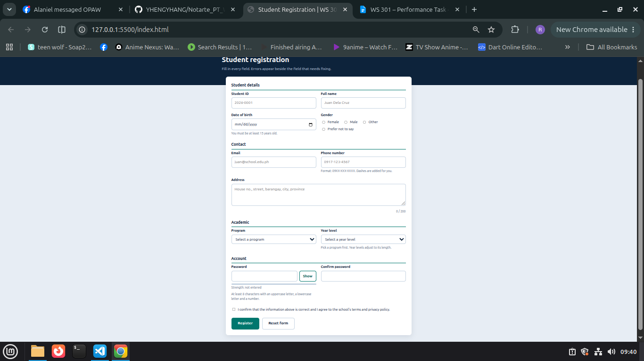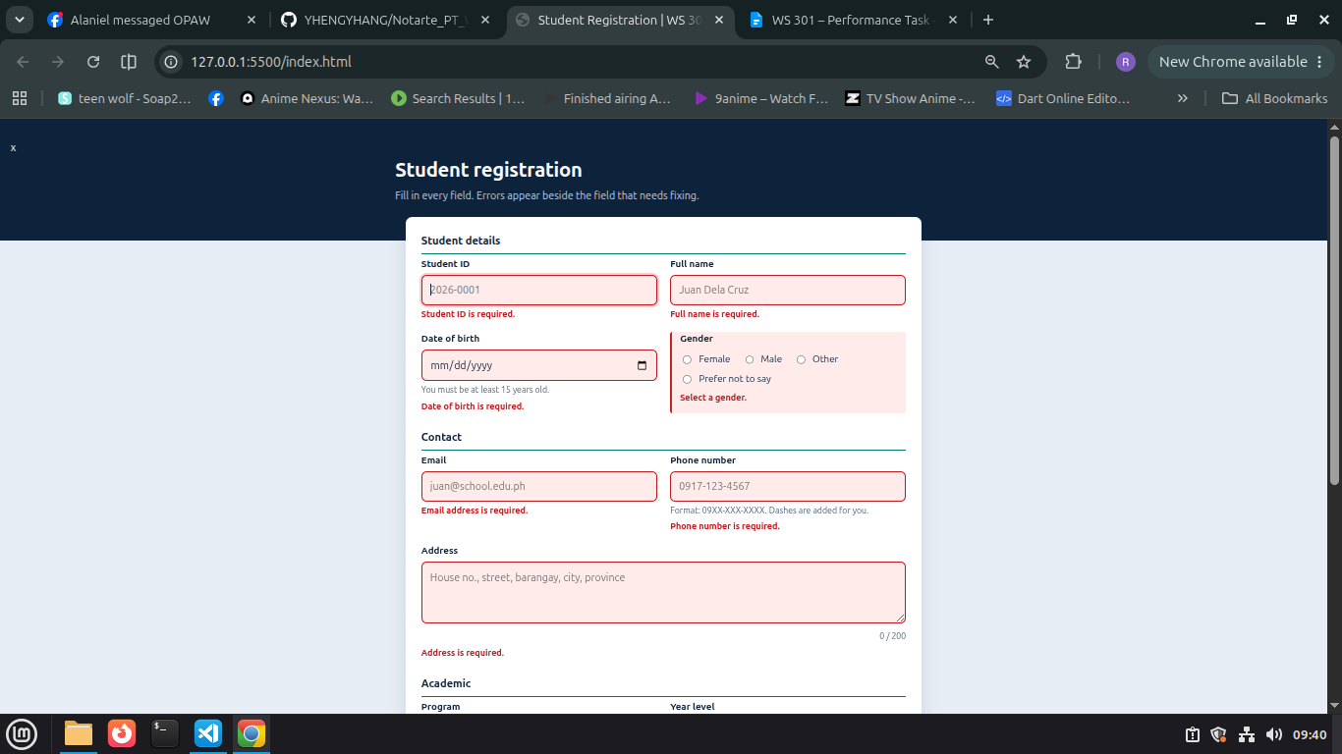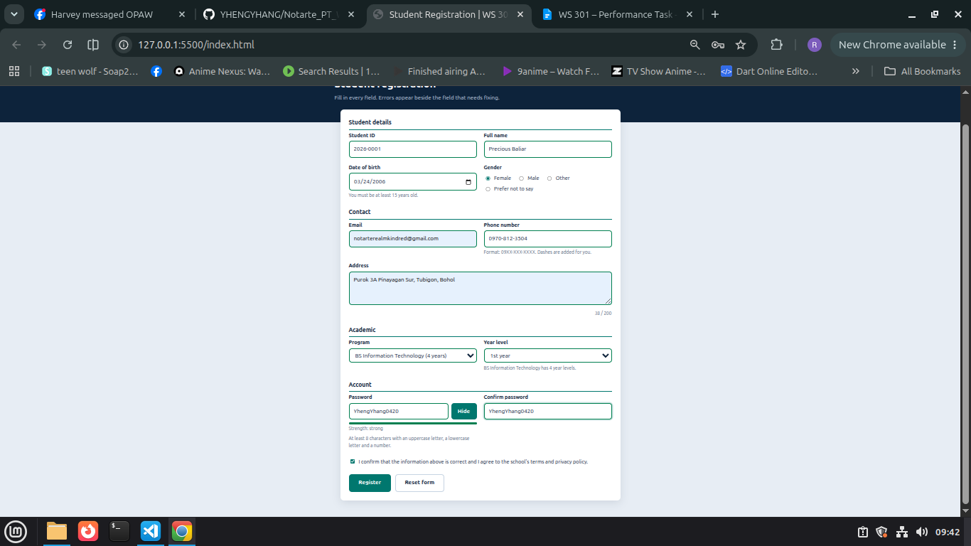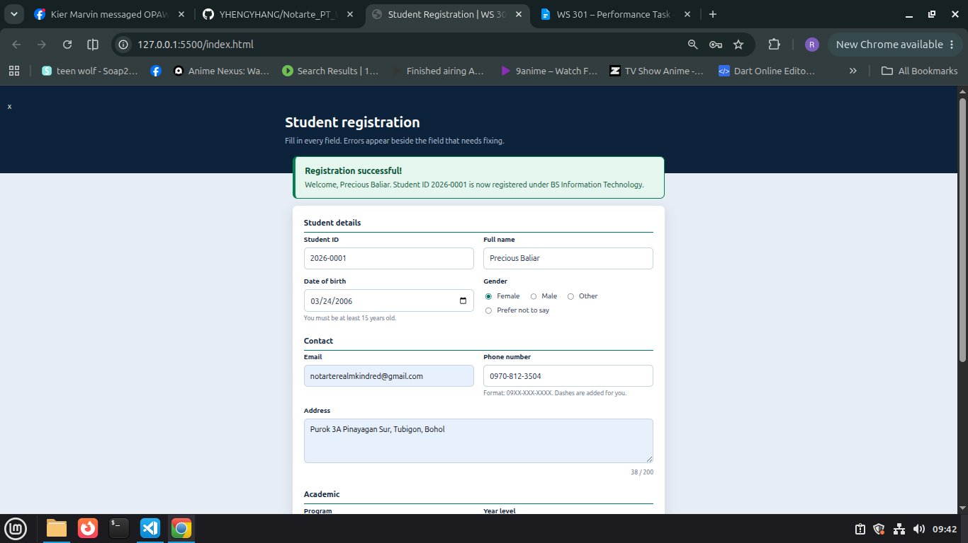
SHORT EXPLANATION:

This Student Registration Form collects a student’s ID, name, date of birth, gender, email, phone number, address, program, year level and password, and it shows “Registration successful!” only when every field is valid. To validate the information, I use trim() to remove extra spaces, regular expressions for the email and phone number (format 09XX-XXX-XXXX), and checks that a gender, program and year level are selected, that the password and confirm password match, and that the agreement checkbox is ticked. I use addEventListener("submit", function(event) { ... }) and call event.preventDefault() first, so the page never submits or reloads when validation fails. Each invalid field displays its own specific error message in a paragraph under that field, instead of one general message for the whole form. For CSS classes, I use classList.add("error") to highlight an invalid field in red and classList.remove("error") to clear it as soon as the input is corrected. I also use classList.toggle("is-active") on the Show/Hide password button to change its appearance. I added data-* attributes such as data-label, data-format, data-min-length and data-years in the HTML, and JavaScript reads them through element.dataset to build the error messages and set the rules. The attribute I manipulated most is type: setAttribute("type") switches the password fields between password and text so the user can see what they typed. I also use setAttribute("disabled") to block year levels that a chosen program doesn’t have, and setAttribute("max") to stop future birth dates.

