II. Materials and Methods

Benchmark dataset
The drug-target interaction data employed in this study were derived from the internationally authoritative database BindingDB (Binding Database), which was developed and maintained by the Michael K. Gilson research group at the University of California, San Diego (UCSD). As one of the most influential open-access platforms for drug-molecule interaction resources worldwide, BindingDB has systematically integrated multi-source information including scientific literature, patent data, PubChem BioAssays, and ChEMBL. It determines various affinity parameters (e.g., Ki, IC50, Kd) through cutting-edge technologies such as enzyme activity assays, isothermal titration calorimetry (ITC), and nuclear magnetic resonance (NMR), and establishes bidirectional links with authoritative databases like PDB, PubMed, and DrugBank. The current version covers over 2.5 million precisely measured records between 1.1 million compounds and 8,800 target proteins. To ensure the frontier nature and reproducibility of the research data, this study specifically adopted a standardized dataset preprocessed by deep learning methods [1] (sourced from the open-source GitHub project: https://github.com/maxischuh/BarlowDTI/tree/main/dataset), which has been repeatedly validated by international peers and applied in innovative drug discovery research. The data classification criteria strictly adhere to biological activity thresholds: high-affinity samples (Label=1, Kd ≤ 100 nM) and low-affinity samples (Label=0, Kd > 10 μM). The experimental design adopted a scientifically rigorous three-way partitioning strategy, and the reliability of model evaluation was ensured through a hierarchical validation system consisting of a training set, validation set, and independent test set. For detailed statistical characteristics of the data distribution, see the analysis in APPENDIX TABLE I.
APPENDIX TABLE I
The distribution of the original samples in the BindingDB dataset
BindingDB | Sample quantity | Positive sample | Negative sample
train | 12667 | 6334 | 6333
val | 6642 | 927 | 5715
test | 13284 | 1905 | 11379
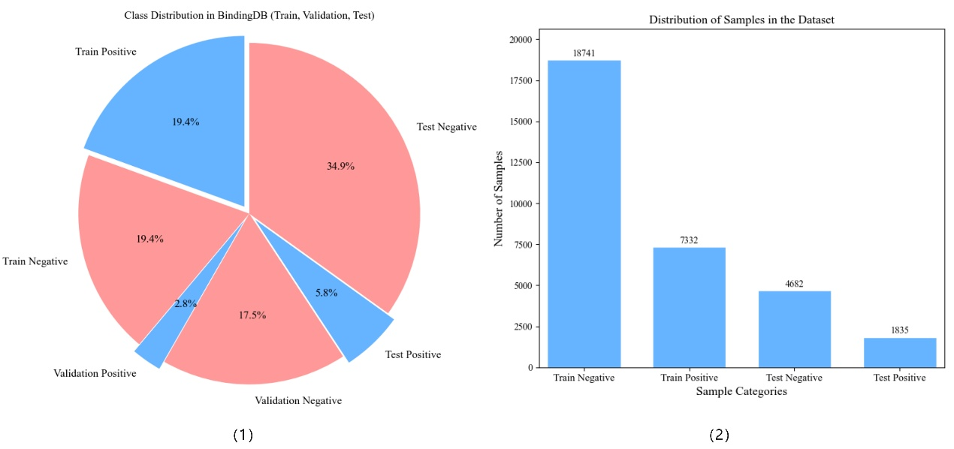
Fig. S1. Visualize the distribution of sample categories in the BindingDB dataset
As shown in Figure S1(1), the distribution of positive and negative samples in the original dataset exhibits a significant imbalance. Particularly in the independent test dataset, the ratio of positive to negative samples exceeds 1:5. To effectively address this critical issue, this study adopts the following innovative data optimization scheme: In the first phase, systematic integration and reconstruction of three subsets from the BindingDB database are performed; in the second phase, in accordance with the statistical golden rule, the total samples are divided into a training set and a validation set at an 8:2 ratio; in the third phase, stratified random sampling is employed to ensure dynamic balance between positive and negative samples in both the training set and the test set. Through this systematic data reshaping, not only the model convergence efficiency is significantly improved, but also the final performance evaluation metrics possess sufficient statistical significance. The specific implementation steps of data reconstruction are detailed in the algorithm workflow in APPENDIX TABLE II, and its optimization effect is prominently reflected in the statistical analysis in TABLE I. As can be clearly observed from Figure S1(2), the data distribution after structural adjustment exhibits superior balance characteristics, which not only effectively improves the convergence speed of model training but also significantly enhances the reliability of prediction results. Through systematic preprocessing and standardization procedures, this dataset constructs a high-quality benchmark testing environment for the development and validation of machine learning models. Its rigorous design philosophy and comprehensive functional support lay a solid foundation for subsequent algorithmic innovation and performance evaluation.
APPENDIX TABLE II
BindingDB Dataset Integration, Sample Separation and Balanced Split
Algorithm 1: Balancing BindingDB Dataset
input: raw_datasets: A collection of three datasets (train, val, test);
Each dataset contains columns: "drug_smiles", "target_sequence", "Label";
Label definition: 1 for positive samples, 0 for negative samples
output: train_data: Balanced training dataset containing both positive and negative samples;
test_data: Balanced test dataset containing both positive and negative samples
1. Read the train, val, and test datasets; check consistency of column names and formats across all datasets.
2. If columns are consistent, combine the three datasets into a single combined dataset; otherwise, return an error.
3. From the combined dataset, extract positive samples (where Label=1) and negative samples (where Label=0) separately, and record the count of each.
4. For both positive and negative sample sets, perform a train-test split with the following parameters: n_splits=1, test_size=0.2, random_state=42.
5. Ensure the distribution of positive and negative samples in the split datasets matches the proportions specified in Table 2.
6. Merge the split positive and negative samples to form train_data and test_data respectively.
7. RETURN train_data and test_data.

B. Drug Sequence Feature Extraction
In drug-target interaction (DTI) prediction tasks, the structural representation of drug molecules plays a decisive role in model performance. This study employs the Mol2vec algorithm to convert the SMILES (Simplified Molecular Input Line Entry System) [2] encoding of drug molecules into continuous feature vectors containing rich chemical semantic information. As a widely adopted standard in the current field of computer-aided drug design (CADD), SMILES encoding accurately describes molecular topological structures through ASCII strings. For example, a water molecule is represented as "O", and an ethanol molecule is encoded as "CCO". This concise and efficient representation method significantly improves the standardization of chemical information processing.
The Mol2vec [3] model draws on the idea of Word2vec in natural language processing (NLP), regarding molecular structural fragments as "words" and entire molecules as "sentences". Based on unsupervised training on large-scale molecular databases, the model can effectively learn distributed representations of molecular fragments. In specific implementation: first, the SMILES sequence is parsed into Morgan fingerprint substructures by means of the RDKit tool; then, each substructure is mapped to a low-dimensional embedding vector using the pre-trained Mol2vec model; finally, weighted integration of all fragment vectors is performed to obtain a fixed-length full-molecular representation vector of the drug. Feature encoding of drug sequences using Mol2vec preserves the structural and semantic information of molecules and can adapt to the requirements of subsequent model training. The workflow of drug molecule feature encoding is illustrated in Figure S2.
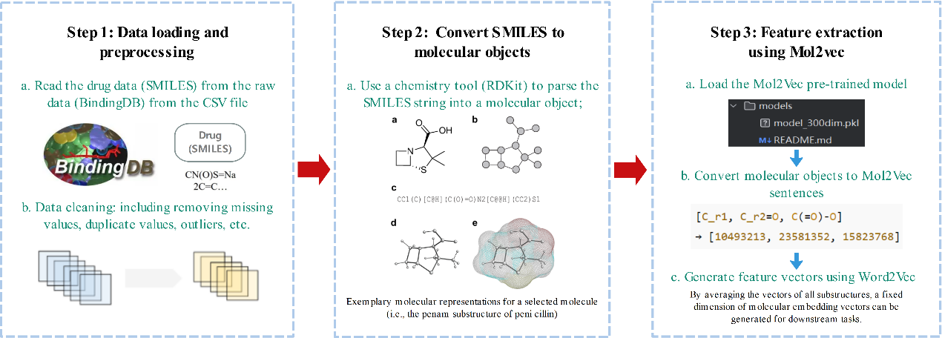
Fig. S2. The process of feature encoding of drug molecules by the Mol2Vec model
This method can not only capture the local conformational information of molecules but also reflect the semantic structural features of drugs on a global scale. Compared with traditional one-hot encoding or molecular fingerprints, the feature representations generated by Mol2vec exhibit enhanced stability and generalization ability when dealing with complex structures and diverse molecular spaces. Experiments demonstrate that using Mol2vec embeddings as drug feature inputs can provide a more discriminative representational basis for subsequent classification models, thereby effectively supporting learning and prediction in DTI tasks.

C. Target Sequence Feature Extraction
Similar to the structural features of drug molecules, the sequence information of target proteins plays a crucial role in drug-target interaction (DTI) prediction. To efficiently mine the semantic features and functional patterns of protein sequences, this study introduces the protein language model ProstT5 [4] based on the T5 architecture, replacing traditional statistical encoding methods for feature extraction. Pre-trained on ProtT5-XL-U50 as the foundation, this model is fine-tuned with high-quality 3D structural data from AlphaFoldDB [5]. Its core advantage lies in integrating the amino acid sequence and structural information of proteins, achieving efficient mapping between sequences and structures.
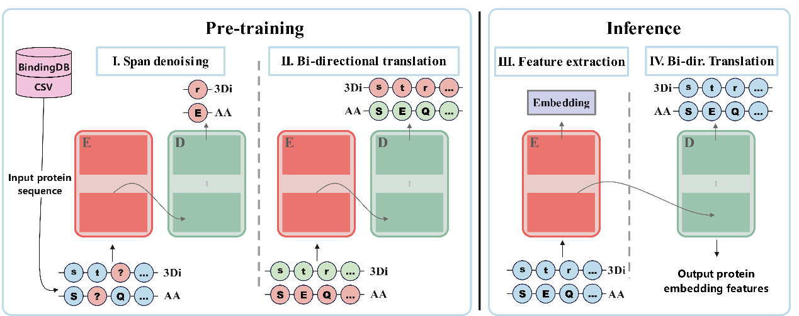
Fig. S3. ProstT5 protein feature extraction flow chart
As can be seen from Figure S3, the training and fine-tuning strategy of ProstT5 differs from traditional protein sequence modeling methods. By incorporating both the amino acid sequences of proteins and structural information into the model, ProstT5 can more efficiently address the mapping problem between protein sequences and structures. Its specific advantages are as follows:
1. ProstT5 adopts an encoder-decoder architecture, specifically optimized for the processing of protein sequence and structural information. In the first phase of pre-training, it utilizes a large volume of protein 3Di (3D Structure Discretized Encoding) and AA (Amino Acid) sequences as training data, and is trained via the span corruption method. The core objective is to learn the bidirectional mapping rules between sequences and structures. For the mapping from amino acid sequences to 3Di structures, the model aims to maximize the conditional probability P(3Di ∣ AA), i.e., the probability of generating 3Di sequences from amino acid sequences (AA), which is defined as Equation (1):
$$\begin{aligned}P\left(AA | 3Di\right)=\prod_{i=1}^{N}{\operatorname{Pr}\left(3Di_{i} | AA_{i}\right)}\#\left(1\right)\end{aligned}$$
In Equation (1), П denotes the product operator, which accumulates the conditional probabilities of mapping at each position; i represents an index parameter ranging from 1 to N, corresponding to the basic units of protein sequence-structure; N is the total number of basic units involved in the mapping; Pr(3Dii ∣ AAi) denotes the conditional probability of obtaining the corresponding 3Di structural unit (3Di) given the i-th amino acid residue (AAi). For the mapping from 3Di structures to amino acid sequences, the model aims to maximize the conditional probability P(AA ∣ 3Di), i.e., the probability of generating amino acid sequences from 3Di sequences, which is defined as Equation (2):
$$\begin{aligned}P\left(AA | 3Di\right)=\prod_{i=1}^{M}{\operatorname{Pr}\left(AA_{i} | 3Di_{i}\right)}\#\left(2\right)\end{aligned}$$
In Equation (2), П is similarly the product operator; i represents an index parameter ranging from 1 to M; M denotes the total number of basic units in this mapping direction; Pr(AAi ∣ 3Dii) is the conditional probability of obtaining the corresponding amino acid residue (AAi) given the i-th 3Di structural unit (3Di).
2. Translation between protein sequences and structures: After pre-training, the model enters the fine-tuning phase to further optimize the bidirectional conversion capability between sequences and structures. Trained on specific protein sequence-3D structure pairs, it fulfills the folding (AA→3Di) and inverse folding (3Di→AA) tasks, relying primarily on two special tokens: <AA2fold> (for AA-to-3Di conversion) and <fold2AA> (for 3Di-to-AA conversion). During the fine-tuning process, the model performs the AA-to-3Di folding task via Equation (3):
$$\begin{aligned}P\left(AA | 3Di\right)=\sum_{3Di}{\operatorname{Pr}\left(3Di_{i} | AA_{i}\right)∙}Pr\left(3Di_{i}\right)\#\left(3\right)\end{aligned}$$
In Equation (3), ∑3Di denotes the sum over all possible combinations of 3Di structural units; Pr(3Dii) is the prior probability function of the occurrence of the i-th 3Di structural unit (3Dii), which is statistically derived from a large volume of known protein structure data. The model performs the inverse folding task (3Di→AA) via Equation (4):
$$\begin{aligned}P\left(AA | 3Di\right)=\sum_{AA}{\operatorname{Pr}\left(AA_{i} | 3Di_{i}\right)∙}Pr\left(AA_{i}\right)\#\left(4\right)\end{aligned}$$
In Equation (4), ∑AA denotes the sum over all possible combinations of amino acid residues; Pr(AAi) is the prior probability of the i-th amino acid residue (AAi), which is statistically derived from known protein sequence data.
3. Feature extraction and application: The ProstT5 model can be applied to protein feature extraction tasks. In this application scenario, the model is capable of embedding the amino acid sequences and 3D structural representations of proteins to generate feature vectors for subsequent machine learning tasks. Feature extraction does not require inference of the entire translation process, thus offering relatively high speed—especially when half-precision computing is adopted.
4. Training and optimization details: The training process of ProstT5 is accelerated using DeepSpeed, incorporating gradient accumulation and mixed-precision training. During inference, feature extraction takes approximately 35 minutes per protein, while the time required for translation tasks varies depending on the sequence length. On average, the time to generate 3Di structures ranges from 0.6 to 2.5 seconds per protein. The standard operational paradigm for protein feature extraction using the ProstT5 model is detailed in the pseudocode workflow shown in APPENDIX TABLE III.
APPENDIX TABLE III
Pseudo-code for feature extraction of target sequences using ProstT5
Algorithm 2: Feature extraction of target sequences using ProstT5
input: sequence: A list of protein target sequences composed of uppercase amino acid letters；moldel_name: ProstT5
output: features: The extracted 1024-dimensional feature vectors of each amino acid residue
1. Load ProstT5 model and the corresponding tokenizer
2. Initialize the empty list features_list to store per-residue embeddings
3. FOR EACH seq in sequences DO
4. Tokenize the amino acid sequence using the ProstT5 tokenizer
5. Convert tokens into input_ids with special tokens (e.g., <pad>, </s>)
6. Feed input_ids into the ProstT5 encoder to obtain the output tensor: outputs
7. Remove the embeddings of special tokens to retain only residue representations
8. Add the residue-wise embeddings to features_list
9. Convert the features_list to a tensor or array as features
10. RETURN features

D. ENN Undersampling Algorithm
In the process of constructing the drug-target interaction (DTI) prediction model, the class imbalance problem is one of the key factors affecting model performance. Although the ratio of positive to negative samples in the training and test sets has been reconstructed and adjusted during the data partitioning phase, negative samples still dominate the training set due to the inherent scarcity of positive samples in real-world biological data. This significant imbalance can cause the model to bias towards the majority class during training, reducing its discriminative ability for the critical minority class (i.e., drug-target pairs with binding interactions), and particularly leading to performance degradation in metrics such as Sensitivity and AUPR. To alleviate this issue, this study introduces the Edited Nearest Neighbours (ENN) [6] undersampling algorithm to further optimize and balance the training data.
ENN is a cleaning-based undersampling method based on nearest neighbor consistency judgment. Its core idea is not to directly randomly delete majority-class samples, but to identify potential boundary samples or noisy samples by analyzing the label relationships between samples and their neighbors, and selectively eliminate them. Compared with traditional random undersampling strategies, ENN pays more attention to local structural information, which can effectively retain representative negative samples and remove confusing atypical samples that interfere with the decision boundary, thereby improving the quality of the training set and the generalization ability of the model.
Specifically, the ENN undersampling process comprises the following steps:
First, for each sample xi in the training set, a distance metric method (e.g., Euclidean distance or Manhattan distance) is used to calculate its k nearest neighbors N(xi) in the feature space.
Second, the consistency between the label y(xi) of sample xi and the labels of its neighbors is compared. If the sample’s label is inconsistent with the majority of its neighbors—i.e., the sample lies in a category-mixed boundary region—it is classified as a noisy sample.
Third, these inconsistent samples are removed to eliminate potential noise or boundary points, while retaining representative samples whose labels are highly consistent with their neighbors. This process can be regarded as a local cleaning operation on the training set and can be performed iteratively until convergence if necessary.
Fourth, after the above steps, the number of negative samples in the training set is significantly reduced, making the ratio of positive to negative samples closer. A more balanced dataset is thus constructed for model training.
Through this process, ENN can effectively reduce majority-class noise and enhance the model's learning ability for the minority class without disrupting the original data distribution. In this study, the training set processed by the ENN algorithm significantly improved key metrics such as Sensitivity and AUPR during model training, verifying the practical effectiveness and robustness of this method in handling imbalanced DTI data tasks.

E. SHAP Dimensionality Reduction
When dealing with high-dimensional biological sequence embedding features, reasonable feature dimensionality reduction strategies play an important role in reducing model complexity and improving generalization performance. High-dimensional feature spaces often contain a great deal of redundant information, which not only increases training computational cost but also may introduce noise, thereby leading to model overfitting. Traditional dimensionality reduction methods such as Principal Component Analysis (PCA) and Kernel Principal Component Analysis (KPCA) can alleviate the aforementioned problems to a certain extent, but their linear assumptions or non-parametric constraints result in insufficient interpretability and explainability for deep embedding features.
To address this issue, this study draws on the idea of the Shap-Select framework proposed by Kraev et al. [7] and introduces the SHAP (SHapley Additive exPlanations) method based on game theory for explainable feature selection of drug and target features. Built on Shapley value theory, SHAP quantifies the marginal contribution of each feature to the model's prediction results [8], assigning a globally consistent importance score to each input feature. It offers advantages such as fairness, interpretability, and model-agnosticism. Compared with traditional feature selection methods, SHAP is more suitable for understanding the structure of nonlinear high-dimensional embedding features, and particularly well-suited for interpretive analysis of ensemble tree models such as XGBoost and LightGBM.
In this experiment, drug molecular sequences are first converted into fixed-length 64-dimensional vector representations via Mol2Vec, while target protein sequences are extracted as 1024-dimensional deep semantic embeddings through the ProstT5 model. Since the dimensionality of target features is much higher than that of drug features, failure to perform feature compression would lead to reduced model training efficiency and may obscure information of key dimensions. Therefore, we applied the SHAP analysis method to the preliminarily trained XGBoost model, extracting SHAP values for each feature dimension in the training set via its TreeExplainer tool, and using the mean absolute SHAP value of each dimension as the basis for ranking feature importance.To systematically implement this feature selection strategy, we have designed the implementation workflow as illustrated in Figure 2.
As shown in Figure 3(1), the SHAP beeswarm plot illustrates the distribution of marginal impacts of each high-dimensional feature on the model output. It can be observed from the plot that features numbered 787, 157, and 709 exhibit the highest SHAP contributions in the model, and their high values show a significant positive correlation with the model's predictions. These features are widely distributed in the data, indicating that they not only possess global importance but also participate in the formation of critical decision boundaries. Furthermore, the SHAP bar plot in Figure 3(2) intuitively quantifies the average impact magnitude of the top 20 important features. Among them, the dimension numbered 787 has the highest average SHAP value among all features, demonstrating that it plays a determinative role in the model.
Based on the aforementioned analysis, we finally selected the top 200 key features ranked by their average SHAP values as the final input. These features cover more than 95% of the model's effective information while significantly reducing the input dimensionality (from the original 1024 to 200), which effectively mitigates redundant interference and improves training efficiency and model robustness. After retraining the fusion model in the streamlined feature space, evaluation results show that various metrics such as AUC and AUPR have been improved, verifying the effectiveness and generalization ability of this feature selection strategy. By embedding the SHAP interpretation mechanism into the feature dimensionality reduction process, this study not only enhances model performance but also achieves visualization of the model's decision-making basis and restoration of its underlying mechanisms, providing methodological support for subsequent DTI biological mechanism interpretation and clinical reasoning.

III. Model construction

A. XGBoost Model: Principle and Application
XGBoost (Extreme Gradient Boosting) is an ensemble learning algorithm based on the Gradient Boosting framework, which is widely applied in structured data modeling tasks due to its excellent prediction performance and training efficiency. In this study, XGBoost is selected as one of the baseline classification models to fully explore the nonlinear interaction relationships between drug molecules and target proteins, enabling accurate identification of high-affinity drug-target pairs. Its core idea is to iteratively build new regression trees on the basis of weak learners from the previous round, minimizing the objective loss function to gradually optimize model performance. In each iteration, XGBoost updates the model by fitting the residuals from the previous round and incorporates second-order gradient information (i.e., the Hessian matrix), endowing the optimization process with enhanced directionality and stability. Specifically in this project, the form of XGBoost’s regularized objective function is expressed as Equation (5) below:
$$\begin{aligned}L(θ)=\sum_{i=1}^{n}{l}(y_{i},{\overset{^}{y}}_{i}^{(t)})+\sum_{k=1}^{t}{Ω}(f_{k})\#\left(5\right)\end{aligned}$$
Among them, Ɩ denotes the loss function (e.g., log loss), and $Ω(f_{k})$ represents the complexity penalty term for each tree, which effectively avoids overfitting. At the data level, the features processed in this project are high-dimensional unstructured vectors: drug molecules are encoded into 64-dimensional vectors via Mol2Vec, while target protein sequences are embedded into 1024-dimensional representations through ProstT5. In such a high-dimensional feature space, there may exist significant redundancy and complex interactions between features. The automatic feature selection mechanism and strong nonlinear fitting capability inherent in XGBoost exactly meet the needs of learning such feature patterns.
In addition, to enhance the model's discriminative ability under imbalanced data, we incorporated class weights (scale_pos_weight) combined with the ENN undersampling strategy into XGBoost, ensuring the model can pay more attention to the positive class (i.e., drug-target pairs with true binding interactions), thereby improving key evaluation metrics such as Recall and AUPR. Notably, XGBoost also played a crucial role in the SHAP interpretive analysis process. Leveraging its TreeExplainer structure, we efficiently calculated the marginal contribution values (SHAP values) of each feature dimension to the prediction results, further assisting in feature selection and dimensionality reduction, and providing a more discriminative input subset for model training. In this study, the XGBoost model not only undertakes the basic task of predictive modeling but also participates in the feature dimensionality reduction process through an interpretive mechanism, providing dual support for the performance and interpretability of the final model.

B. LightGBM Model: Principle and Application
LightGBM (Light Gradient Boosting Machine) is an efficient distributed algorithm proposed by Microsoft based on the Gradient Boosting framework. Compared with traditional GBDT and XGBoost, it exhibits faster training speed and lower memory usage when processing large-scale high-dimensional data. By introducing histogram optimization, leaf-wise growth strategy, and efficient support for sparse features, LightGBM significantly improves computational efficiency while maintaining model accuracy. It is particularly suitable for the drug-target interaction (DTI) prediction task in this study, which features high dimensionality, sparse samples, and class imbalance.
In terms of model construction, LightGBM employs Gradient-based One-Side Sampling (GOSS) and a unique Exclusive Feature Bundling (EFB) mechanism, which are used for sample sampling and feature compression, respectively. This mechanism reduces computational complexity while maintaining the stability of gradient information distribution, and can merge redundant or sparse features without sacrificing model performance, thereby accelerating model training. This strategy is particularly applicable to the high-dimensional protein embedding features in this study.
Considering the actual situation of the feature space in this project, LightGBM can process the 200-dimensional feature subset filtered by SHAP with fewer computational resources while retaining the ability to model nonlinear relationships between features. During the training process, we adopted a cross-validation parameter tuning method, and key hyperparameters such as num_leaves, max_depth, and learning_rate were systematically optimized to achieve the optimal trade-off between metrics including AUC and AUPR.
Unlike XGBoost, LightGBM by default adopts the leaf-wise strategy for decision tree expansion—i.e., selecting the leaf node with the maximum gain for expansion instead of level-wise growth. Although this approach may lead to overfitting under certain conditions, combined with appropriate regularization and early stopping mechanisms, it can fully explore the boundary features of minority class samples and effectively enhance the model's discriminative ability in imbalanced data scenarios.

C. Model Structure Design
Based on the preliminary performance comparison and experimental validation of various classification algorithms, this study ultimately selects two gradient boosting models—XGBoost (Extreme Gradient Boosting) and LightGBM (Light Gradient Boosting Machine)—to construct a fusion prediction framework. This combination scheme balances the models’ expressive capability, training efficiency, and generalization performance, which can effectively improve the prediction accuracy and stability of drug-target interactions (DTI).
This study adopts the Soft Voting ensemble strategy, which takes the prediction probabilities of the two base learners (XGBoost and LightGBM) as the basis and fuses the final prediction results via an equal-weighted averaging method. Specifically, the two models respectively output the interaction probability values 𝑃XGB and 𝑃LGB for the same input sample, and then calculate the fused probability through weighted averaging as shown in Equation (6) below:
$$\begin{aligned}P_{ensemble }=α⋅P_{XGB}+\left(1-α\right)⋅P_{LGB}\#\left(6\right)\end{aligned}$$
Among them, α denotes the fusion weight coefficient. Considering that the model performances are basically comparable, α is set to 0.5 in the experiment—i.e., equal weights are assigned to the two models. Based on the fused probability, a decision threshold (default: 0.5) is set to make the final binary classification decision. To enhance the robustness and generalization ability of the fusion model, the overall training process is based on a K-fold cross-validation framework (K=10). In each fold, the LightGBM and XGBoost models are independently trained respectively, and their respective output probabilities are fused to generate the final prediction. The workflow of the entire model structure is illustrated in Figure 4.

IV. Results and discussion

A. Performance Evaluation
For the drug-target interaction (DTI) prediction task, to comprehensively evaluate the model's predictive performance across multiple dimensions, this study selects several mainstream performance metrics to measure and compare the experimental results. Specifically, these metrics include: Accuracy (ACC), Precision (PR), Sensitivity (SN), Specificity (SP), Matthews Correlation Coefficient (MCC), Area Under the Receiver Operating Characteristic Curve (AUC), and Area Under the Precision-Recall Curve (AUPRC).
The definitions and calculation formulas of each metric are presented as follows:
$$\begin{aligned} Accuracy =\frac{TP+TN}{TP+TN+FP+FN}\#\left(7\right)\end{aligned}$$
Accuracy represents the proportion of the number of correctly classified samples to the total number of samples. Herein, TP (True Positive) denotes the number of true positives, TN (True Negative) the number of true negatives, FP (False Positive) the number of false positives, and FN (False Negative) the number of false negatives.
$$\begin{aligned}\text{Precision }=\frac{TP}{TP+FP}\#\left(8\right)\end{aligned}$$
Precision (PR) denotes the proportion of correctly classified binding site data to the total number of predicted positive cases.
$$\begin{aligned}\text{Sensitivity }=\frac{TP}{TP+FN}\#\left(9\right)\end{aligned}$$
Sensitivity (SN) denotes the proportion of correctly classified binding site data to all actual positive cases.
$$\begin{aligned}\text{Specificity }=\frac{TN}{TN+FP}\#\left(10\right)\end{aligned}$$
Specificity (SP) denotes the proportion of data incorrectly predicted as binding sites to all actual negative cases.
$$\begin{aligned}MCC=\frac{\left(TP×TN\right)-\left(FN×FP\right)}{\sqrt{\left(TP+FN\right)×\left(TN+FP\right)×\left(TP+FP\right)×\left(TN+FN\right)}}\#\left(11\right)\end{aligned}$$
Because of the class imbalance problem between positive and negative samples, MCC is considered a comprehensive metric for evaluating the overall performance of the model. MCC = 0 indicates completely random prediction, MCC = 1 denotes perfect prediction, and a higher MCC value implies better prediction accuracy.
$$\begin{aligned}AUC=\frac{\sum_{i=1}^{n}{T_{i}}}{nT}\#\left(12\right)\end{aligned}$$
The Receiver Operating Characteristic (ROC) curve, with the True Positive Rate (TPR, also known as Recall) as the vertical axis and the False Positive Rate (FPR) as the horizontal axis, can intuitively demonstrate the model’s classification performance under different decision thresholds. Specifically, we employ the ROC curve to evaluate the classification performance of DTI models across various datasets. The Area Under the Curve (AUC) — the area enclosed by the ROC curve — is used to quantify the overall performance of the classification model. The closer the AUC value is to 1, the better the model performance; when the AUC value equals 0.5, the model performance is equivalent to that of a random classifier. By observing the ROC curve and calculating the AUC value, we can intuitively grasp the model’s prediction effectiveness under different thresholds, thereby enabling comprehensive evaluation and comparison of model performance.
$$\begin{aligned}AUPRC =\sum_{i=1}^{n-1}{(}{ Recall }_{i+1}-{ Recall }_{i})×\frac{{ Precision }_{i+1}+{ Precision }_{i}}{2}\#\left(13\right)\end{aligned}$$
The Area Under the Precision-Recall Curve (AUPRC) provides a single numerical value to summarize the model’s performance across all decision thresholds. Unlike some simple performance metrics (e.g., Accuracy), the calculation of AUPRC does not have a direct mathematical formula; instead, it solves for the area under the curve through numerical integration. Generally, this is achieved by calculating Precision and Recall at each point on the curve, followed by numerical integration. A higher AUPRC indicates better model performance, especially when dealing with class imbalance between positive and negative samples.

B. Advantages of the ProstT5 Model in Target Feature Extraction
In drug-target interaction (DTI) prediction tasks, the quality of feature extraction is crucial to model performance. To verify the effectiveness of different feature extraction methods, this study compares various traditional sequence feature encoding methods (e.g., k-mer, One-hot, TCC) with emerging deep pre-trained language models in recent years, including ProtGPT2, ProtBERT-BFD, and ProstT5. To ensure the reliability of the test results, we uniformly adopt the ENN undersampling strategy for data preprocessing and use Random Forest (RF) as the classification model for experimental evaluation. All methods are compared through ten-fold cross-validation.
As shown in TABLE II, ProstT5 outperforms other methods across all evaluation metrics in ten-fold cross-validation, demonstrating its significant advantages in target sequence feature extraction. Specifically, ProstT5 achieves the best performance in six metrics: Sensitivity (SN), Specificity (SP), Accuracy (ACC), Matthews Correlation Coefficient (MCC), AUC, and AUPR. It particularly shows a significant lead over other methods in Sensitivity (SN=0.8760), Accuracy (ACC=0.8120), AUC (0.8794), and AUPR (0.8532).
Compared with traditional k-mer methods (e.g., k=1 and k=2) and One-hot encoding, ProstT5 increases Sensitivity by nearly 15% and Accuracy by approximately 8%, while exhibiting superior performance in both AUC and AUPR. This indicates that ProstT5 can better capture the deep-level features of protein sequences. In contrast to ProtBERT-BFD and TCC methods, although ProtBERT-BFD has a slight advantage in Specificity (SP), ProstT5 achieves higher overall performance across multiple key metrics (e.g., SN and AUC). Particularly in terms of the model’s Sensitivity and comprehensive discriminative ability, the results demonstrate that ProstT5 can more effectively capture the potential relationships between target sequences and drug interactions in high-dimensional feature spaces. Compared to ProtGPT2, ProstT5 shows a significant lead in both Sensitivity and Accuracy, with remarkably better performance in AUC and AUPR. This confirms that ProstT5 is more suitable for the in-depth understanding and modeling of protein sequence features in drug-target interaction (DTI) prediction tasks.
As a deep learning-based pre-trained language model, ProstT5 can more accurately capture the complex features in protein sequences and provide high-quality feature representations for downstream tasks. This advantage enables it to demonstrate greater potential than traditional methods in DTI prediction tasks, especially in terms of efficient feature expression and the model’s predictive capability.

C. Comparative Analysis of the ENN Undersampling Strategy
In drug-target interaction (DTI) prediction tasks, class distribution imbalance is a critical factor affecting model performance. To alleviate this issue, this study compares six typical undersampling methods, including Fuzzy, Neighbourhood Cleaning Rule (NCR), Tomek Links, One-Sided Selection (OSS), Edited Nearest Neighbours (ENN), and NearMiss. Their performance is comprehensively evaluated across multiple metrics, such as Sensitivity (SN), Specificity (SP), Accuracy (ACC), Matthews Correlation Coefficient (MCC), AUC, and AUPR.
As shown in Figure 5, based on ten-fold cross-validation, the ENN strategy achieves a good balance between Sensitivity and Specificity, with SN=0.825, SP=0.857, and Accuracy reaching 84.77%, demonstrating stability in overall classification capability. By contrast, although Fuzzy and NearMiss achieve relatively high Sensitivity values of 0.900 and 0.911 respectively, their Specificity values are both below 0.51. These models show a significant bias towards the positive class, leading to a substantial drop in MCC (0.375 and 0.382) and AUPR (0.572 and 0.574), thus posing a risk of overfitting.
Further analysis shows that the OSS method achieves the optimal performance in Specificity (0.971), but its Sensitivity is only 0.612, indicating a serious deficiency in the model's ability to identify positive samples. Similarly, although Tomek Links and NCR maintain high levels in AUC and SP, their Sensitivity is insufficient (0.691 and 0.721 respectively), resulting in relatively limited ability to capture true positive samples. In the biomedical field, missed reporting of potential interactions will lead to high experimental or clinical risks.
In contrast, the ENN method exhibits relatively balanced performance across all metrics: MCC=0.649, AUC=0.925, and AUPR=0.846. This demonstrates that ENN not only enhances the model's discriminative ability but also improves its probability calibration level. Its core advantage lies in the neighborhood-based consistency judgment mechanism, which can effectively eliminate noise or ambiguous points on the sample boundaries. While retaining representative negative samples, it enhances the ability to identify positive samples, thereby optimizing the quality of the training set and improving the model's generalization ability. In summary, the ENN strategy performs excellently in all evaluation metrics and is the final undersampling method adopted for sample balance processing in this study.

D. Advantages of the Soft Voting Fusion Method for XGBoost and LightGBM
In drug-target interaction (DTI) prediction tasks, the selection of classification models directly affects the predictive accuracy and stability of the model. This study adopts a Soft Voting fusion strategy combining XGBoost and LightGBM, aiming to integrate the advantages of the two models through ensemble learning and enhance overall model performance. By comparing the performance of different classification models (as shown in TABLE III), we find that the Soft Voting fusion model of XGBoost and LightGBM exhibits excellent performance across multiple key metrics through ten-fold cross-validation, significantly outperforming single models and other traditional classification methods.
Specifically, the fusion model achieves the best results in six key evaluation metrics: Sensitivity (SN), Specificity (SP), Accuracy (ACC), Matthews Correlation Coefficient (MCC), AUC, and AUPR. The metrics of the fusion model are as follows: SN=0.8723, SP=0.8482, ACC=0.8603, MCC=0.7207, AUC=0.9287, and AUPR=0.9204, maintaining a leading position among all compared models.
Compared with single models, XGBoost and LightGBM each perform slightly worse than the fusion model in metrics such as MCC and AUC. For instance, XGBoost achieves an MCC of 0.7184 and an AUC of 0.9286; although its performance is close to that of the fusion model, it exhibits slight deficiencies in Sensitivity (SN=0.8696) and Accuracy (ACC=0.8591). LightGBM has an SN of 0.8711, which is marginally higher than that of XGBoost in terms of Sensitivity, yet its AUC (0.9271) and AUPR (0.9178) are still lower than those of the fusion model, revealing the limitations of single models in certain key metrics.
In comparison with traditional deep learning models such as biLSTM, GRU, and RNN, although these models demonstrate favorable performance in Sensitivity (e.g., SN=0.8363 for biLSTM and SN=0.8217 for GRU), they are generally weaker in other metrics—particularly MCC, AUC, and AUPR—indicating certain limitations in their judgment of classification boundaries. For example, biLSTM has an AUC of 0.8836, while RNN has an AUC of 0.8757, both significantly lower than the fusion model’s 0.9287.
A further comparison with traditional machine learning models such as Support Vector Machine (SVM), Random Forest (RF), and Multi-Layer Perceptron (MLP) shows that although RF performs well in Specificity (SP=0.8197), its low values in SN (0.7238) and ACC (0.7718) limit its effectiveness in this task. Similarly, SVM and DNN exhibit poor performance in Sensitivity and Accuracy, with SN=0.7856 and SN=0.5812 respectively, demonstrating the inadequacies of these traditional methods in learning high-dimensional data and complex relationships.

E. Performance Comparison between Soft Voting and Other Fusion Strategies
To further verify the superiority of the Soft Voting fusion strategy in drug-target interaction (DTI) prediction tasks, this study conducts a systematic comparison between it and three mainstream fusion methods—weighted averaging, Stacking ensemble, and Bagging ensemble. From two dimensions (quantitative performance metrics and algorithmic mechanisms), an in-depth analysis is performed on the core advantages of Soft Voting and the limitations of other strategies. The relevant results are shown in Figure S4 and Figure S5.
As shown in the experimental results of Figure S4, Soft Voting achieves comprehensive leadership across all metrics: Accuracy (ACC=0.8602) is improved by 0.71-0.90 percentage points compared with other strategies, thereby reducing the resource and time costs of subsequent experiments; Matthews Correlation Coefficient (MCC=0.7207) is increased by 1.43-1.83 percentage points, effectively adapting to the class imbalance (greater than 1:5) between positive and negative samples in the BindingDB dataset while balancing minority class recognition and false positive control; AUC (0.9287) and AUPR (0.9203) are enhanced by 0.44-0.56 and 0.40-0.56 percentage points respectively, with the advantage of AUPR further highlighting its robustness in imbalanced data.
Figure S5 intuitively presents the distribution of performance differences: the improvements of Soft Voting in AUPR and MCC are more significant, which aligns with the core requirement of "minority class recognition" in DTI prediction; moreover, stable positive gaps are maintained across all metrics, verifying the systematic advantages of the fusion mechanism.
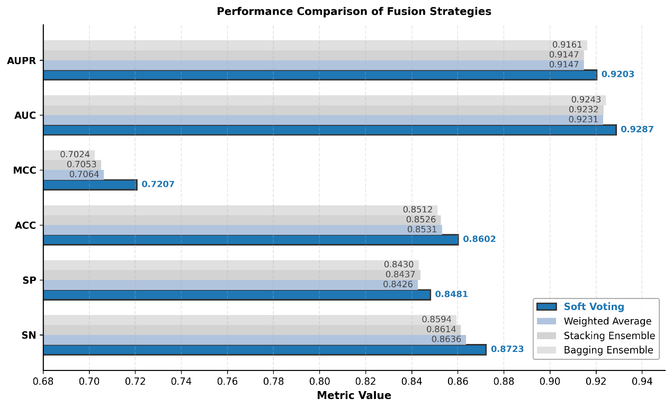
Fig. S4. Comparison Chart of the Performance of Soft Voting Fusion Strategy with Other Fusion Strategies.
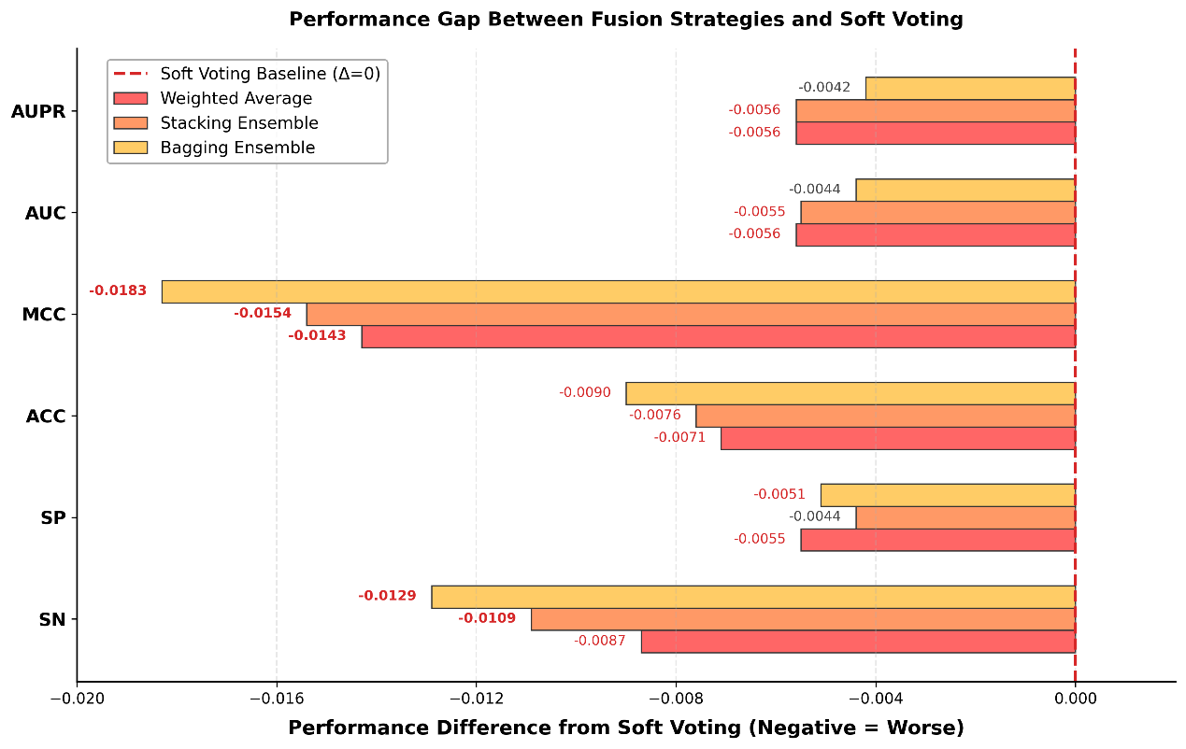
Fig. S5. Gap Analysis Chart of Soft Voting Fusion Strategy Compared to Other Fusion Strategies.
At the algorithmic level, Soft Voting performs equal-weighted fusion of the prediction probabilities from XGBoost and LightGBM. This approach not only retains the advantages of the two models in error correction and high-dimensional data processing but also avoids the issues of overfitting in Stacking's meta-model, the subjectivity of weights in weighted averaging, and the limited improvement of Bagging for highly correlated base models, thus balancing performance and efficiency.
In summary, the Soft Voting fusion model of XGBoost and LightGBM demonstrates outstanding performance in key metrics such as Sensitivity, ACC, AUC, and AUPR, effectively improving the accuracy and stability of DTI prediction and providing reliable support for subsequent experimental validation. Therefore, it serves as the core prediction model of this study.

F. SHAP-based Feature Selection and Determination of the Optimal Dimensionality for Targets
To effectively address the issues of high dimensionality and strong redundancy in protein target features, this study adopts the SHAP (SHapley Additive exPlanations) method for dimensionality reduction of the initial 1024-dimensional ProstT5 feature vectors, aiming to evaluate its performance in feature selection and model performance improvement. Compared with traditional methods such as Principal Component Analysis (PCA), Kernel Principal Component Analysis (KPCA), Linear Discriminant Analysis (LDA), UMAP, and Chi-Square test, SHAP significantly enhances the model’s predictive capability while maintaining a low dimensionality. As shown in TABLE IV, under the premise of uniformly compressing features to 300 dimensions, the SHAP method achieves the highest value in the AUPR metric (0.9207), which is significantly superior to PCA (0.9188), KPCA (0.9189), and Chi-Square (0.8541); it also performs best in MCC (0.7187), indicating stronger discriminative ability for boundary samples and higher classifier stability.
On the basis of confirming SHAP as the core dimensionality reduction method, a systematic investigation was conducted to explore the impact of different feature dimension settings on model performance. Specifically, the feature subsets evaluated by SHAP were increased at fixed intervals within the dimension range of 150 to 250, and the performance metrics of the model under each dimension were quantitatively evaluated (as shown in TABLE V), covering six core metrics including Sensitivity (SN), Specificity (SP), Accuracy (ACC), Matthews Correlation Coefficient (MCC), AUC, and AUPR. As the feature dimension gradually increases from 150 to 250, the model's performance across all metrics generally exhibits a trend of "first increasing and then tending to stabilize." In the low-dimensional stage (150–170), due to the significant feature compression, some potential discriminative information is weakened, resulting in slightly lower metrics such as AUC, AUPR, and MCC. As the dimension increases to the range of 190–210, the model performance gradually improves and stabilizes, indicating that the number of features and information redundancy have achieved an optimal balance within this range.
Notably, when the feature dimension is 200, the model reaches the peak performance across all core metrics (SN=0.8723, SP=0.8482, MCC=0.7207, ACC=0.8603), demonstrating the comprehensive optimal performance in classification accuracy, stability, and generalization ability. At this point, the changes in AUC and AUPR curves are extremely minimal (fluctuations of less than 0.001), indicating that the model can maintain a high level of stability under different decision thresholds. However, when the feature dimension further increases to 250, slight declines are observed in both MCC and AUC, suggesting that excessive feature dimensions may introduce noise or redundant information, thereby reducing the reliability of boundary discrimination.
In summary, the SHAP-based feature selection strategy can effectively compress the high-dimensional embedding space and improve prediction performance while ensuring model interpretability and the fidelity of key features. Through systematic dimension sensitivity experiments, this study determines 200 dimensions as the optimal feature dimension for the ProstEDTI model. This setting achieves an ideal balance between computational efficiency, discriminative ability, and stability, laying a solid foundation for subsequent fusion model training and mechanism interpretation.

H. Model Interpretability Analysis
To further reveal the internal decision-making mechanism and feature contribution patterns of the fusion model, this study conducts an interpretability analysis of the model based on the LIME (Local Interpretable Model-agnostic Explanations) method. LIME approximates the local decision boundaries of complex models by constructing linear surrogate models in the neighborhood of individual samples, thereby quantifying the positive and negative contributions of each input feature to the prediction results. Compared with traditional global feature importance evaluation, LIME can reveal the specific discriminative basis of the model at the sample level, facilitating the understanding of the model's biological rationality from the perspective of dual representations of molecules and proteins.
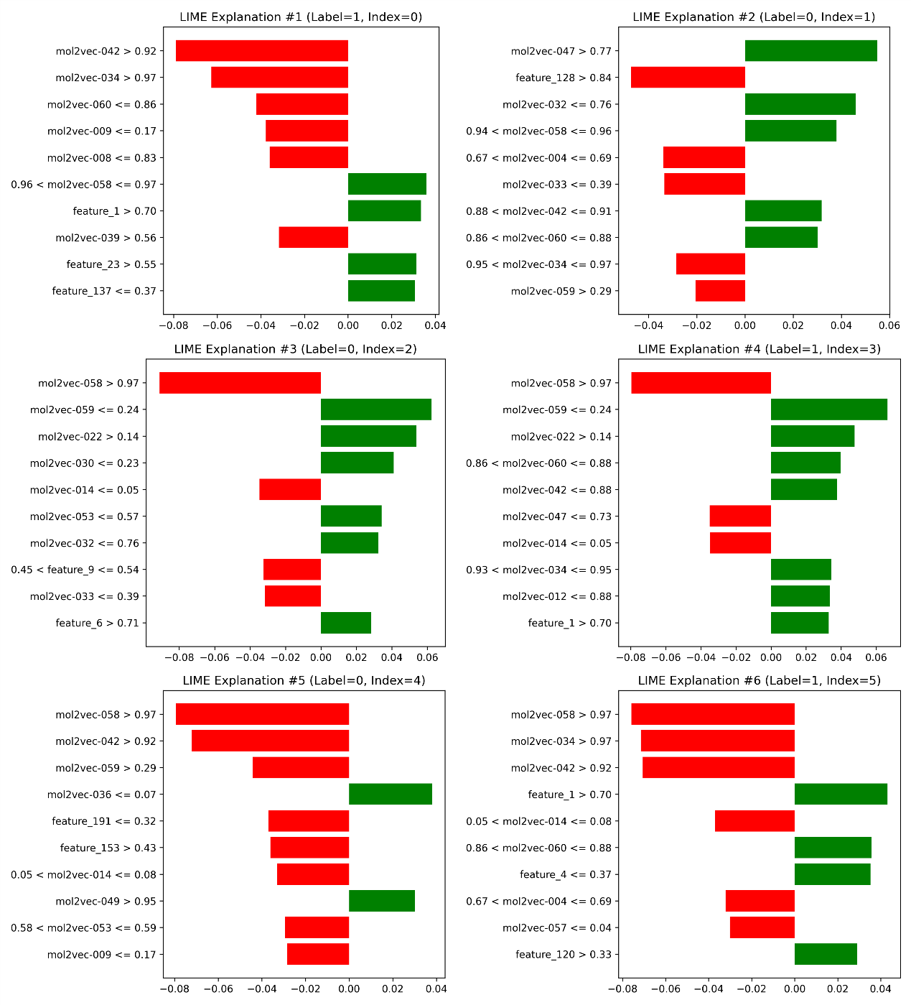
Fig. S6. Local interpretability results of the fusion model (LIME local explanation diagram).
As shown in Figure S6, LIME performs local interpretability analysis on several representative samples. Green bars indicate features with a positive contribution to the prediction of binding status (Binding), while red bars represent features with an inhibitory effect on binding prediction. There are significant differences in the influence of features on model decisions across different samples. Among them, several drug representation dimensions (e.g., mol2vec-058, mol2vec-047) and target representation features (e.g., feature_1, feature_120) exhibit significant positive contributions across multiple samples, indicating that the model tends to rely on these drug and protein representation dimensions to judge binding propensity during prediction. Meanwhile, some features show obvious negative contributions in non-binding samples, demonstrating that the model has been able to learn the repulsive features of drugs and targets in the embedding space, reflecting a certain degree of biological discriminability.
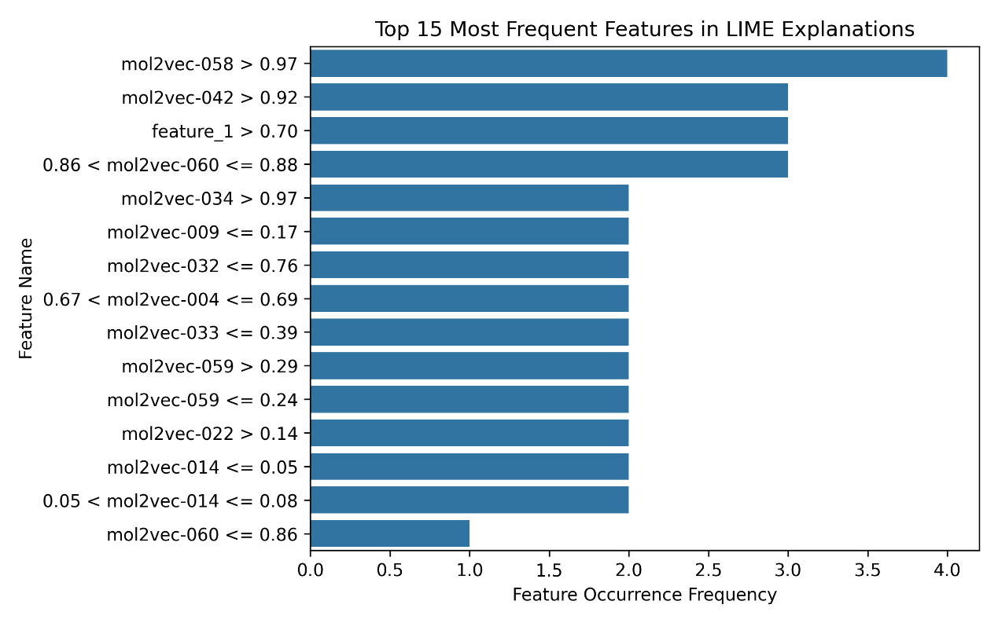
Fig. S7. Feature occurrence frequency statistics based on LIME.
To evaluate the consistency of the model’s discriminative features at the global level, this study further counted the high-frequency features in the LIME interpretation results (as shown in Figure S7). The results show that mol2vec-058 (>0.97) has the highest occurrence frequency, followed by mol2vec-042 (>0.92), feature_1 (>0.70), and several feature intervals closely related to the physicochemical properties of drug molecules, such as mol2vec-060 (0.86–0.88), mol2vec-034 (>0.97), and mol2vec-009 (≤0.17). These features are mainly derived from the mol2vec vector dimensions in the drug molecular embedding space, representing the sensitive directions of the model to molecular structures and physicochemical properties when predicting drug–target binding relationships. Among them, the high-value intervals of mol2vec-058 and mol2vec-042 consistently promote the model to output "Binding" predictions across multiple samples, indicating that these dimensions may be associated with chemical bonding capacity or molecular affinity. In contrast, ProstT5-derived features such as feature_1, feature_23, and feature_137 reflect protein domains, residue hydrophobicity, and local conformational features, playing an auxiliary role in the model’s distinction between binding and non-binding samples. Through retrospective analysis of the drug feature extraction data, it was further clarified that in the 64-dimensional drug feature model, mol2vec-058 exhibits specific sensitivity to structures of the "tetrafluorobenzene ring + sulfonamide" type, while mol2vec-042 shows strong sensitivity to structures of the "methoxyphenyl ring + amino chain" type.
To address the interpretability limitation of ProstT5 features in target prediction models—wherein they possess sequence abstract representation capabilities but struggle to link to original amino acid positions—this study proposes a two-branch unequal-weight ensemble strategy while maintaining the original model’s core architecture. The base feature branch adopts a combination of mol2vec and ProstT5, while the complementary branch uses a combination of mol2vec and k-mer (k=1). Both branches follow the original model’s training paradigm, with cross-branch fusion weighted at 0.9:0.1. This design retains the core performance advantages of the base model while incorporating complementary information at the sequence motif level. Ten-fold cross-validation results show no significant degradation in key evaluation metrics of the ensemble model compared to the original base model, validating the effectiveness of the proposed strategy. Further local interpretability analysis of the Kmer branch via LIME successfully traced and identified key amino acids with significant contributions to target binding prediction, including phenylalanine, glutamic acid, aspartic acid, tryptophan, and tyrosine. The chemical properties of these amino acids—such as aromaticity and acidity—are highly consistent with core binding mechanisms between targets and ligands, including hydrophobic interactions, hydrogen bonds, and electrostatic interactions. This effectively remedies the "black-box" limitation of ProstT5 features, ultimately achieving synergistic optimization of both performance and interpretability for the target prediction model.
Overall, the recurrence of high-frequency features indicates that the fusion model exhibits strong consistency and stability in its decision-making logic across different samples. Rather than relying on a single feature, the model’s predictions are built on a high-dimensional information space synergistically driven by drug structural representations (mol2vec) and protein sequence representations (ProstT5 features). This result further validates the model’s biological rationality in learning drug-target interaction mechanisms and provides important references for subsequent key molecular structure identification and potential binding site mining. In summary, the LIME-based interpretability analysis not only reveals the refined decision-making logic of the model at the individual sample level but also verifies the stability and consistency of feature utilization from a global perspective. It provides robust support for the biological interpretation of the fusion model and significantly enhances the credibility and practical value of the model’s prediction results.

References
[1] M. G. Schuh, D. Boldini, A. I. Bohne, et al., “Barlow Twins deep neural network for advanced 1D drug–target interaction prediction,” J. Cheminf., vol. 17, no. 1, p. 18, 2025.
[2] D. Weininger, “SMILES, a chemical language and information system. 1. Introduction to methodology and encoding rules,” J. Chem. Inf. Comput. Sci., vol. 28, no. 1, pp. 31–36, 1988.
[3] S. Jaeger, S. Fulle, S. Turk, “Mol2vec: unsupervised machine learning approach with chemical intuition,” J. Chem. Inf. Model., vol. 58, no. 1, pp. 27–35, 2018.
[4] M. Heinzinger, K. Weissenow, G. J. Sanchez, et al., “Bilingual language model for protein sequence and structure,” NAR Genomics Bioinform., vol. 6, no. 4, p. lqae150, 2024.
[5] J. Jumper, et al., “Highly accurate protein structure prediction with AlphaFold,” Nature, vol. 596, pp. 583–589, 2021.
[6] L. D. Wilson, “Asymptotic Properties of Nearest Neighbor Rules Using Edited Data,” IEEE Trans. Syst., Man, Cybern., vol. 2, no. 3, pp. 408–421, 1972.
[7] E. Kraev, B. Koseoglu, L. Traverso, et al., “Shap-Select: Lightweight Feature Selection Using SHAP Values and Regression,” arXiv preprint arXiv:2410.06815, 2024.
[8] H. Wang, Q. Liang, J. T. Hancock, et al., “Feature selection strategies: a comparative analysis of SHAP-value and importance-based methods,” J. Big Data, vol. 11, no. 1, p. 44, 2024.

