제 6회 전자구조계산 여름학교
Hands-On Tutorial
서로 다른 XC functional과 DFT+U+V 를 이용한 QE 전자구조계산 연습

In this session, we will carry out electronic‐structure calculations using various exchange–correlation (XC) functionals using the Quantum ESPRESSO (QE) package. Below
are the basic steps for computing a band structure in QE.

Calculation steps
- $PATH_TO_QE/pw.x -in Prefix.scf.in > Prefix.scf.out
- We obtain the charge density from the self-consistent field calculation.
- $PATH_TO_QE/pw.x -in Prefix.bands.in > Prefix.bands.out
- We obtain the energy eigenvalues along the high-symmetry line from the converged charge density.
- $PATH_TO_QE/bands.x -in pp.in > pp.out
- We use the post-processing tool provided by QE package to obtain the data file suitable for plotting with gnuplot.

If not otherwise specified, the script file will execute the above steps automatically, so you only need to run
./cal_es.sh

in your working directory.
We will compute and compare the electronic structures of silicon and NiO using a variety of XC functionals (including DFT+U+V and HSE). You should see the following
subdirectories in your working folder:

List of folders and files for different XC functionals
1.Si/
1.PBE, 2.LDA, 3.PBEsol, 4.LDAU, 5.eACBN0, 6.HSE
2.NiO/
1.PBE, 2.LDA, 3.PBEsol, 4.LDAU, 5.eACBN0
1.PBE ~ 5.eACBN0 folders contain the following files:
XC.scf.in: Input for the charge density calculation.
XC.bands.in: Input for the bands calculation.
pp.in: Input for the post-processing.
XC_pband.gnu: Plotting script using gnuplot.
cal_es.sh: Calculation script.
6.HSE folder in 1.Si/ contains the following files:
SI_HSE.scf.in: Input for the HSE self-consistent field calculation
Si_HSE.openg.in: Input for the opengrid.x to generate unreduced k-point grid.
Si_HSE.pw2wan.in: Input for the pw2wannier.x to generate overlap matrices.
Si.win: Wannier90 input file.
HSE_pband.gnu: Plotting script using gnuplot.
Si_band.dat: Pre-wannierized band data for plotting.
cal_es.sh: Calculation script.

Pseudopotential files
We require pseudopotentials in UPF format for these calculations. In the pp/ directory you will find the PBE, LDA, and PBEsol pseudopotentials, which were obtained from the PseudoDojo repository (https://www.pseudo-dojo.org/). Alternatively, Quantum ESPRESSO provides its own library of pseudopotentials on the official QE website (https://www.quantum-espresso.org/pseudopotentials/).

Exercise 1 – Silicon band structure
In this exercise we will compute the band structure of Silicon.
1.PBE
The scf input file (Si_PBE.scf.in)
&control
calculation = 'scf',
prefix = 'Si',
pseudo_dir = '../../pp/PBE/', #pseudopotential directory
outdir = './outdir',
disk_io = 'low',
verbosity = 'high',
/
&system
ibrav = 0,
nat = 2, ntyp = 1, nbnd = 36
ecutwfc = 50, #Energy cutoff for wavefunctions
occupations = 'smearing', smearing = 'gauss', degauss = 0.01,
/
&electrons
diagonalization = 'david',
diago_full_acc = .true.,
conv_thr = 1.0D-8,
mixing_beta = 0.7,
startingwfc = 'random',
/
ATOMIC_SPECIES
Si 28.09 Si.upf
ATOMIC_POSITIONS crystal
Si 0.000 0.000 0.000
Si 0.250 0.250 0.250
K_POINTS automatic #Uniform momentum grid
7 7 7 0 0 0
CELL_PARAMETERS angstrom
2.7155 2.7155 0.0000
0.0000 2.7155 2.7155
2.7155 0.0000 2.7155
The bands input file (Si_PBE.bands.in)
&control
calculation = 'bands',
…
K_POINTS crystal_b. #Momentum line for the band calculation
6
0.500 0.500 0.500 20
0.000 0.000 0.000 20
0.500 0.500 0.000 20
0.625 0.625 0.250 1
0.750 0.375 0.375 20
0.000 0.000 0.000 1

The post-processing input file (pp.in)
&bands
prefix = 'Si',
outdir = './outdir'
filband = 'pp.out'
/
Once the calculation is completed, ‘pp.out.gnu’ file will be generated. You can plot the band structure by running
$gnuplot PBE_pband.gnu
and the pbe.png file will be generated. Each subdirectory contains its own gnuplot script, so you can generate the band-structure plot by following the same procedure.

2.LDA, 3.PBEsol
The only difference in the scf & bands inputs is the path to pseudopotentials.
pseudo_dir = '../../pp/LDA/'

4.LDA+U
Looking at the 1.Si/4.LDA_U/Si.scf.in, you will find and extra Hubbard card that defines the on-site U for the silicon p-orbitals. Here you simply specify the atom index(“Si”), the orbital type (“3p”), and the desired Hubbard U value (“3.4814”).
Hubbard (ortho-atomic)
U Si-3p 3.4814

5.eACBN0
The inputs for the use of eACBN0 functional is as below.
nspin=2: We need spin-polarized calculation for eACBN0.
starting_magnetization(1) = 0.0: Si is non-magnetic
acbn0_type = 2: The extended ACBN0 with U and V.
ehub_nn_distance = 3: Cut-off for inter-atomic distance [ang].
ehub_conv_thr = 1.0D-8: Convergence threshold on Hubbard energy.
ehub_mixing = 0.7: Linear mixing parameter for Hubbard energy.
ehub_l_choice(a,b) = 1: Type of atom(a) and orbital(b) index for the DFT+U+V calculation.
b 1: s orbital, 2: p orbital, 3: d orbital.
remove_ehub_u(1,1) = 0: We remove the on-site Hubbard interaction U of s orbital.
nspin = 2,
starting_magnetization(1) = 0.0,
lacbn0 = .true., acbn0_type = 2, lda_plus_v = .true., ehub_pot_fix = .false.,
ehub_nn_distance = 3.0, ehub_conv_thr = 1.0D-8, ehub_mixing = 0.7,
ehub_l_choice(1,1) = 1, ehub_l_choice(1,2) = 1
remove_ehub_u(1,1) = 0
In the SCF output file, the converged Hubbard parameters appear immediately above the line ‘End of self-consistent calculation’
-----------------------------------
V[atom i, atom j, #orb(i), #orb(j)]
-----------------------------------
[ 1, 1, 4, 4 ]
[ 0 0 0 ]
0.0000 0.0000 0.0000 0.0000
0.0000 3.5125 3.5125 3.5125
0.0000 3.5125 3.5125 3.5125
0.0000 3.5125 3.5125 3.5125
The first line [1,1,4,4] indicates that both atom indices are 1 and that there are four orbitals in total (the s and three p orbitals of a single Si atom). The next entry, [0,0,0] is the translation vector between atoms i and j; because we’re looking at an on-site interaction (i = j), the vector is (0, 0, 0) and only the U value is reported. Since we setremove_ehub_u(1,1) = 0, the Hubbard U for the s orbital is zero.

6.HSE
In the HSE calculation, the workflow differs slightly. Inside the folder, you will find (Si.win, Si.pw2wan, Si.opengrid.in). The process called Wannierization step with the Wannier90 package is needed to get the band structure when using the hybrid functional, but that is beyond the scope of this exercise. For now, simply run the scf step, and use the pre-computed Wannier90 band data in Si_band.gnu. The HSE bands can be generated by running
IIf you wish to generate the Wannierized band data yourself, please follow the steps outlined below. Ensure that the Wannier90 package is compiled and available on your cluster.
$gnuplot HSE_pband.gnu
$PATH_TO_QE/pw.x -in Si_HSE.scf.in > Si_HSE.scf.out
$PATH_TO_QE/open_grid.x -pd .true. -in Si_HSE.openg.in > Si_HSE.openg.out
$PATH_TO_W90/wannier90.x -pp Si
$PATH_TO_QE/pw2wannier90.x < Si_HSE.pw2wan.in > Si_HSE.pw2wan.out
$PATH_TO_W90/wannier90.x Si

The extra input for the HSE SCF calculation is as below:
input_dft = 'hse', nqx1 = 3, nqx2 = 3, nqx3 = 3
nqx1, nqx2, nqx3: Three-dimensional mesh for q (k1-k2) sampling of the Fock operator

Exercise 2 – NiO band structure
1.PBE, 2.LDA, 3.PBEsol
To obtain the antiferromagnetic ground state of NiO, initial magnetic moment on each Ni atom is specified.
nspin = 2,
starting_magnetization(1) = 0.5, starting_magnetization(2) = -0.5
The LDA and PBEsol functional has different path to pseudopotentials.
pseudo_dir = '../../pp/LDA/'
pseudo_dir = '../../pp/PBEsol/'

4.LDA+U
An additional Hubbard card specifies the on‐site U for each atom.
Hubbard (ortho-atomic)
U Ni1-3d 7.5683
U Ni2-3d 7.5683
U O-2p 2.3923
Because the antiferromagnetic ordering makes the two Ni sites inequivalent (Ni1 and Ni2), you must assign a separate Hubbard U parameter to each site.

5.eACBN0
nspin = 2,
starting_magnetization(1) = 0.5, starting_magnetization(2) = -0.5
lacbn0 = .true., acbn0_type = 2, lda_plus_v = .true., ehub_pot_fix = .false.,
ehub_nn_distance = 2.5, ehub_conv_thr = 1.0D-6, ehub_mixing = 0.7,
ehub_l_choice(1,3) = 1, ehub_l_choice(2,3) = 1
ehub_l_choice(3,2) = 1,
We have Ni d-orbitals (ehub_l_choice(1,3) = 1, ehub_l_choice(2,3) = 1) and Oxygen p-orbitals (ehub_l_choice(3,2) = 1) for the eACBN0 calculation.

Band plots
After all calculations with the various XC functionals have finished, generate comparative band-structure plots by running:
$cd 1.Si/
$gnuplot si.multiplot.gnu
$cd ../2.NiO/
$gnuplot NiO.multiplot.gnu
The resulting plots will appear as shown below.

1. Si multiplot
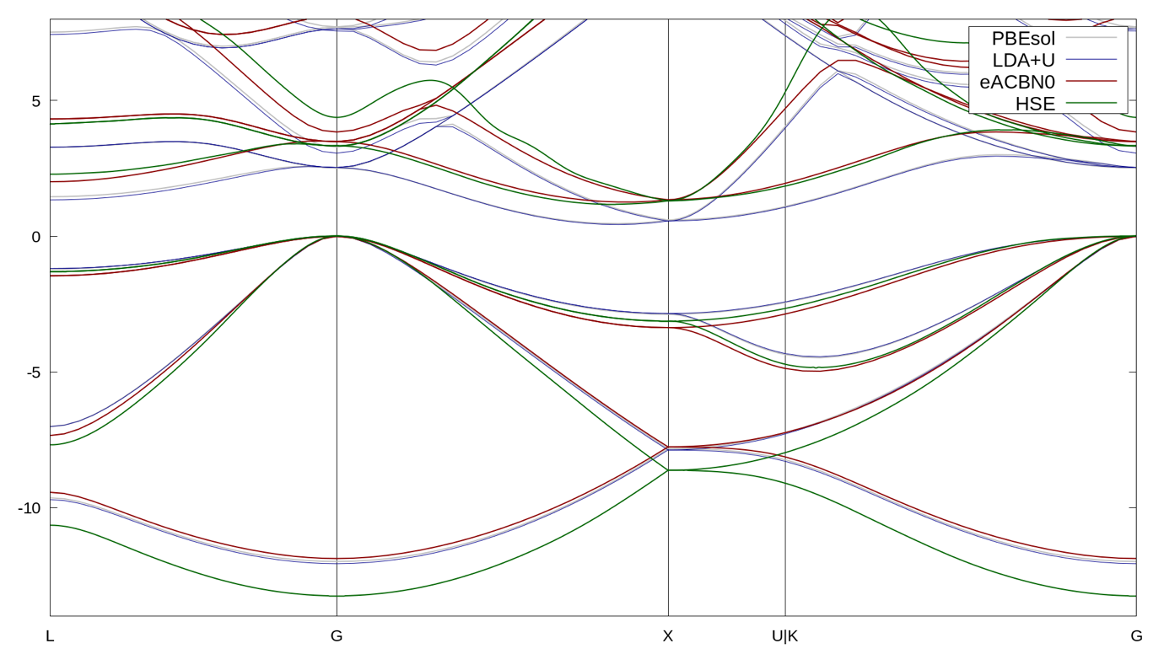
2. NiO multiplot
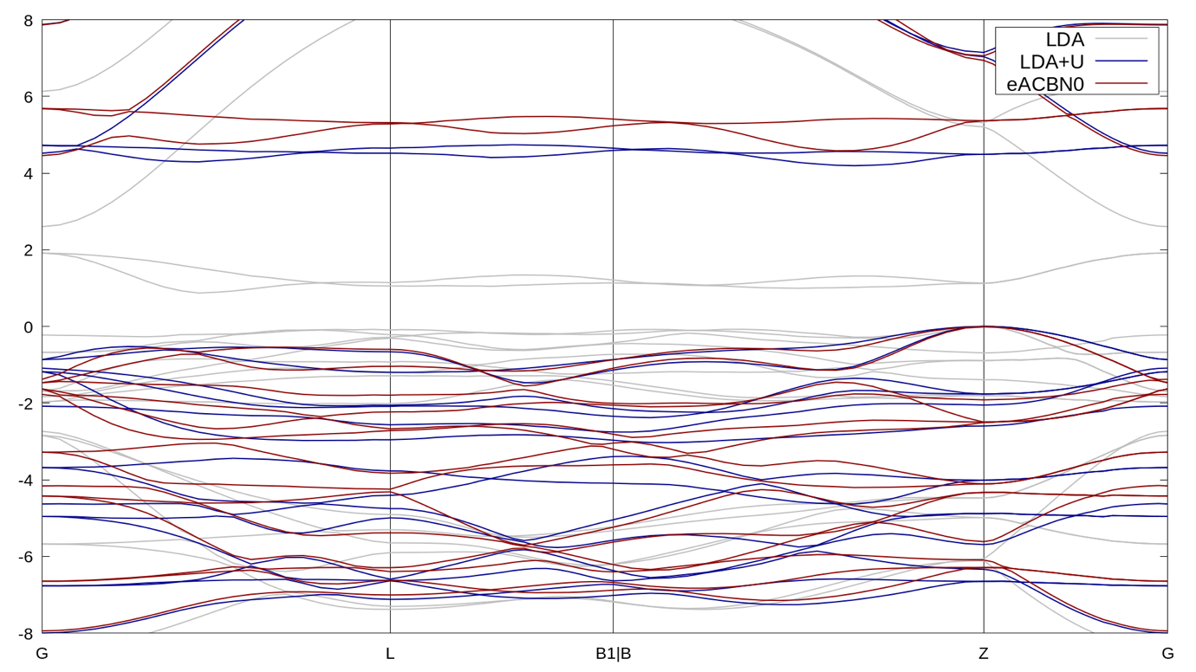
By comparing the calculated band structures, you can clearly observe how the electronic dispersion—and, in particular, the band gap—varies among the different XC functionals.

