Link to commit that introduced React-Bootstrap and “Hello React”.
https://github.com/YHS-2694/profiles-app/tree/099de1a3b8f5cfb464e3de55a0202db9029c7e58
Screenshot of the page
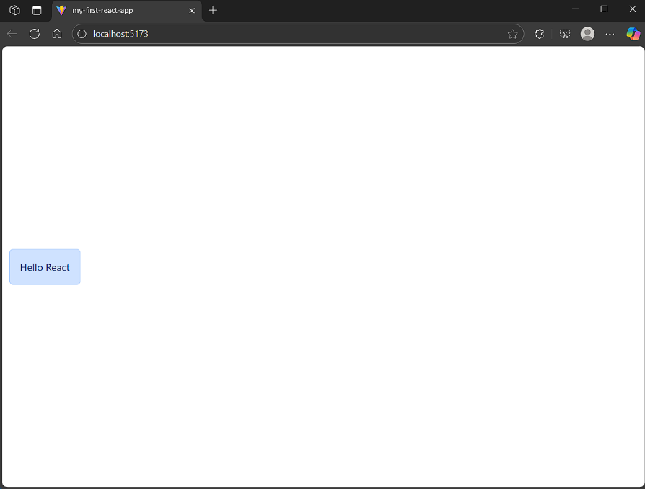
Live ReadMe:
https://github.com/YHS-2694/profiles-app/blob/main/README.md
Screenshot of rendered cards.
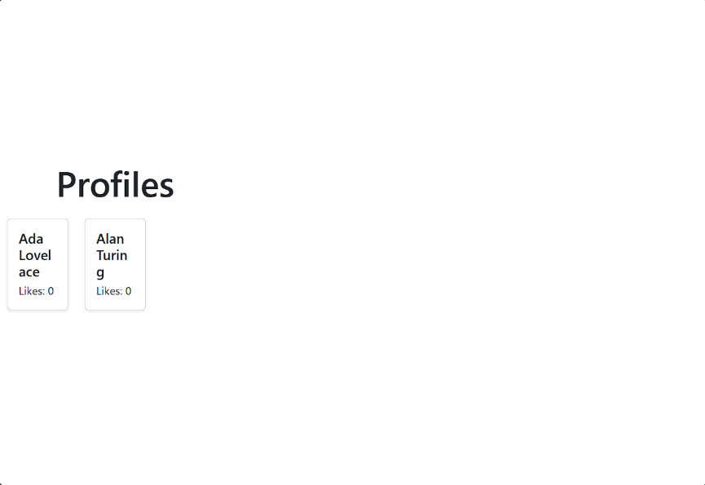
Link to commit diff that introduced components and .map():
https://github.com/YHS-2694/profiles-app/tree/6b419f17c9b806b0f6550433e6ede35f207efe13

GIF (or multiple screenshots) adding a new profile and error case.

