**G3樣區 低潮位僅有一筆DATA在SP 所以其他都會NA**

Edit by: Judge Wu, Albert Tsai

PC1 : 生物代謝物

TukeyHSD(aov_pc)

Tukey multiple comparisons of means

95% family-wise confidence level

Fit: aov(formula = 生物代謝物 ~ factor(year) + factor(season), data = PC_score)

$`factor(year)`

diff lwr upr p adj

2020-2019 -0.3921262 -0.6788814 -0.10537101 0.0027095

2021-2019 -0.2650056 -0.5517608 0.02174958 0.0815572

2022-2019 -1.0945395 -1.6799547 -0.50912436 0.0000139

2021-2020 0.1271206 -0.1280668 0.38230795 0.5710176

2022-2020 -0.7024133 -1.2730296 -0.13179702 0.0088514

2022-2021 -0.8295339 -1.4001502 -0.25891760 0.0012099

$`factor(season)`

diff lwr upr p adj

SM-A 1.7496875 1.36690642 2.1324685 0.0000000

SP-A 0.3499987 -0.01711831 0.7171157 0.0678735

W-A -0.4749285 -0.84141347 -0.1084436 0.0051126

SP-SM -1.3996888 -1.69283457 -1.1065430 0.0000000

W-SM -2.2246160 -2.51696985 -1.9322621 0.0000000

W-SP -0.8249272 -1.09644948 -0.5534049 0.0000000

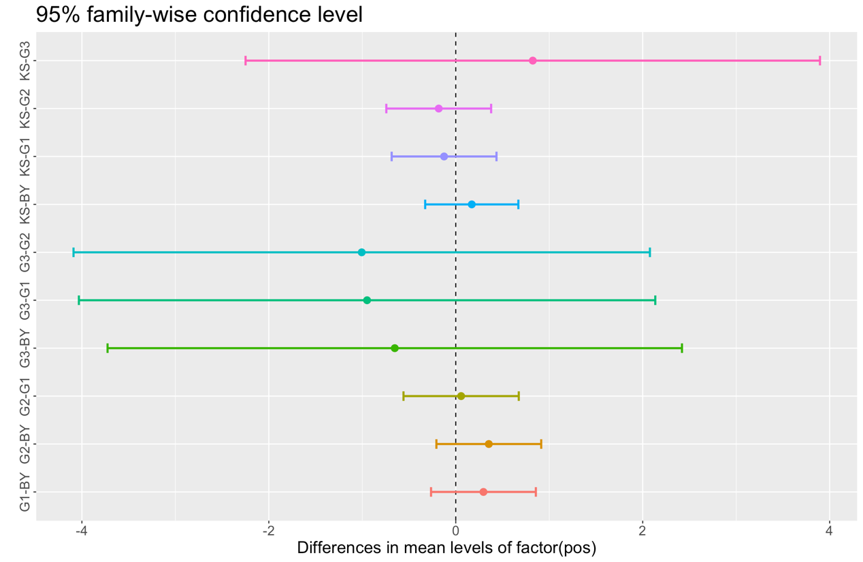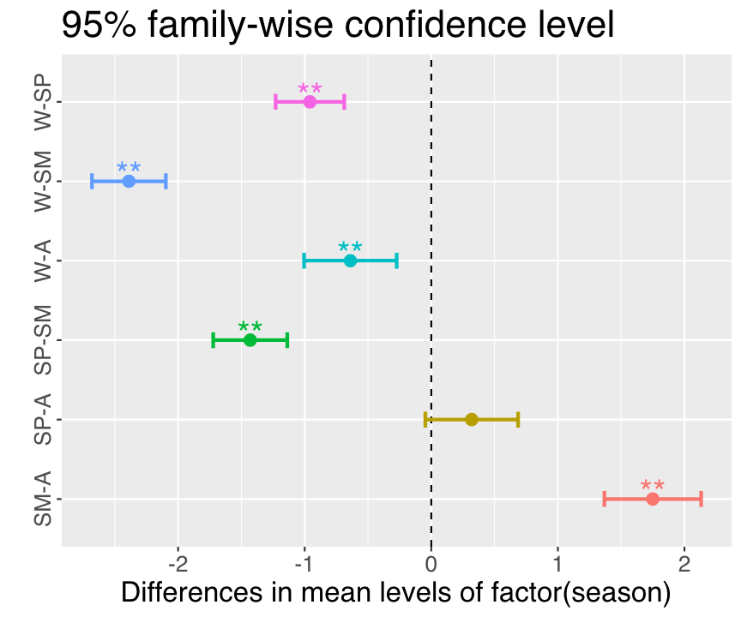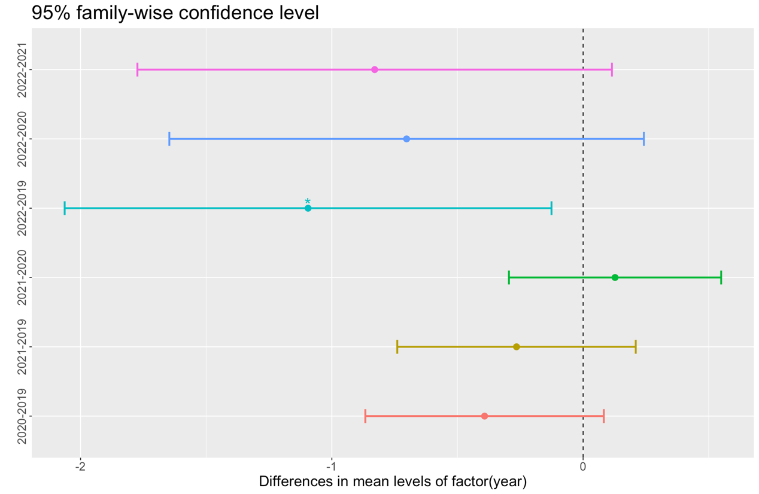

Tukey multiple comparisons of means

95% family-wise confidence level

Fit: aov(formula = 生物代謝物 ~ factor(season) + factor(pos) + factor(season) * factor(pos), data = PC_score)

$`factor(season)`

diff lwr upr p adj

SM-A 1.7496875 1.37148327 2.1278917 0.0000000

SP-A 0.3194989 -0.04322855 0.6822264 0.1058447

W-A -0.6391264 -1.00122941 -0.2770235 0.0000472

SP-SM -1.4301886 -1.71982927 -1.1405479 0.0000000

W-SM -2.3888139 -2.67767216 -2.0999557 0.0000000

W-SP -0.9586254 -1.22690108 -0.6903496 0.0000000

$`factor(pos)`

diff lwr upr p adj

G1-BY 0.29620463 -0.03388498 0.6262942 0.1017948

G2-BY 0.35356889 0.02347928 0.6836585 0.0290290

G3-BY -0.65448190 -2.46342894 1.1544651 0.8575493

KS-BY 0.17114972 -0.12230024 0.4645997 0.4966456

G2-G1 0.05736426 -0.30568591 0.4204144 0.9925541

G3-G1 -0.95068653 -2.76593739 0.8645643 0.6025398

KS-G1 -0.12505491 -0.45514453 0.2050347 0.8357247

G3-G2 -1.00805080 -2.82330165 0.8072001 0.5461359

KS-G2 -0.18241918 -0.51250879 0.1476704 0.5509314

KS-G3 0.82563162 -0.98331542 2.6345787 0.7190441

$`factor(season):factor(pos)`

diff lwr upr p adj

SM:BY-A:BY 2.2242277895 1.26748893 3.18096665 0.0000000

SP:BY-A:BY 0.5221577972 -0.39384992 1.43816552 0.8806114

W:BY-A:BY -0.3427353097 -1.25874303 0.57327241 0.9986460

A:G1-A:BY 0.5991418579 -0.63600270 1.83428642 0.9717821

SM:G1-A:BY 2.1579324999 1.12453642 3.19132858 0.0000000

SP:G1-A:BY 0.9990700333 0.01095439 1.98718568 0.0441372

W:G1-A:BY -0.0621035031 -1.03857101 0.91436401 1.0000000

A:G2-A:BY 0.7554739614 -0.47967060 1.99061852 0.8016830

SM:G2-A:BY 2.3571912755 1.32379520 3.39058735 0.0000000

SP:G2-A:BY 0.9573209806 -0.03079467 1.94543663 0.0701892

W:G2-A:BY -0.0553543282 -1.03182184 0.92111318 1.0000000

A:G3-A:BY NA NA NA NA

SM:G3-A:BY NA NA NA NA

SP:G3-A:BY -0.0613973128 -2.53168643 2.40889180 1.0000000

W:G3-A:BY NA NA NA NA

A:KS-A:BY 0.5981742577 -0.50657262 1.70292113 0.9214277

SM:KS-A:BY 2.0992327555 1.14249390 3.05597162 0.0000000

SP:KS-A:BY 0.7918257690 -0.12418195 1.70783349 0.1915033

W:KS-A:BY -0.2081294840 -1.12413720 0.70787824 0.9999993

SP:BY-SM:BY -1.7020699923 -2.43279137 -0.97134862 0.0000000

W:BY-SM:BY -2.5669630991 -3.29768447 -1.83624172 0.0000000

A:G1-SM:BY -1.6250859315 -2.72983281 -0.52033905 0.0000551

SM:G1-SM:BY -0.0662952895 -0.93967438 0.80708380 1.0000000

SP:G1-SM:BY -1.2251577562 -2.04445997 -0.40585554 0.0000361

W:G1-SM:BY -2.2863312926 -3.09154703 -1.48111556 0.0000000

A:G2-SM:BY -1.4687538280 -2.57350070 -0.36400695 0.0005669

SM:G2-SM:BY 0.1329634861 -0.74041561 1.00634258 1.0000000

SP:G2-SM:BY -1.2669068088 -2.08620902 -0.44760460 0.0000147

W:G2-SM:BY -2.2795821176 -3.08479785 -1.47436638 0.0000000

A:G3-SM:BY NA NA NA NA

SM:G3-SM:BY NA NA NA NA

SP:G3-SM:BY -2.2856251023 -4.69336510 0.12211489 0.0860649

W:G3-SM:BY NA NA NA NA

A:KS-SM:BY -1.6260535317 -2.58279239 -0.66931467 0.0000009

SM:KS-SM:BY -0.1249950340 -0.90616904 0.65617897 1.0000000

SP:KS-SM:BY -1.4324020204 -2.16312339 -0.70168065 0.0000000

W:KS-SM:BY -2.4323572735 -3.16307865 -1.70163590 0.0000000

W:BY-SP:BY -0.8648931069 -1.54140964 -0.18837657 0.0012454

A:G1-SP:BY 0.0769840607 -0.99268250 1.14665062 1.0000000

SM:G1-SP:BY 1.6357747027 0.80721455 2.46433486 0.0000000

SP:G1-SP:BY 0.4769122361 -0.29443529 1.24825976 0.7871071

W:G1-SP:BY -0.5842613003 -1.34062978 0.17210718 0.3837574

A:G2-SP:BY 0.2333161642 -0.83635040 1.30298273 0.9999996

SM:G2-SP:BY 1.8350334784 1.00647332 2.66359364 0.0000000

SP:G2-SP:BY 0.4351631834 -0.33618435 1.20651071 0.8899093

W:G2-SP:BY -0.5775121254 -1.33388061 0.17885636 0.4063258

A:G3-SP:BY NA NA NA NA

SM:G3-SP:BY NA NA NA NA

SP:G3-SP:BY -0.5835551100 -2.97540226 1.80829204 0.9999977

W:G3-SP:BY NA NA NA NA

A:KS-SP:BY 0.0760164605 -0.83999126 0.99202418 1.0000000

SM:KS-SP:BY 1.5770749583 0.84635358 2.30779633 0.0000000

SP:KS-SP:BY 0.2696679718 -0.40684856 0.94618451 0.9969502

W:KS-SP:BY -0.7302872812 -1.40680382 -0.05377075 0.0195536

A:G1-W:BY 0.9418771676 -0.12778940 2.01154373 0.1663739

SM:G1-W:BY 2.5006678096 1.67210765 3.32922797 0.0000000

SP:G1-W:BY 1.3418053429 0.57045781 2.11315287 0.0000004

W:G1-W:BY 0.2806318065 -0.47573667 1.03700029 0.9987883

A:G2-W:BY 1.0982092711 0.02854271 2.16787583 0.0369040

SM:G2-W:BY 2.6999265852 1.87136643 3.52848674 0.0000000

SP:G2-W:BY 1.3000562903 0.52870876 2.07140382 0.0000011

W:G2-W:BY 0.2873809815 -0.46898750 1.04374946 0.9983451

A:G3-W:BY NA NA NA NA

SM:G3-W:BY NA NA NA NA

SP:G3-W:BY 0.2813379968 -2.11050915 2.67318515 1.0000000

W:G3-W:BY NA NA NA NA

A:KS-W:BY 0.9409095674 0.02490185 1.85691729 0.0366898

SM:KS-W:BY 2.4419680651 1.71124669 3.17268944 0.0000000

SP:KS-W:BY 1.1345610787 0.45804454 1.81107761 0.0000013

W:KS-W:BY 0.1346058256 -0.54191071 0.81112236 0.9999999

SM:G1-A:G1 1.5587906420 0.38702963 2.73055165 0.0005598

SP:G1-A:G1 0.3999281754 -0.73210051 1.53195686 0.9993738

W:G1-A:G1 -0.6612453610 -1.78312112 0.46063040 0.8466562

A:G2-A:G1 0.1563321035 -1.19670097 1.50936518 1.0000000

SM:G2-A:G1 1.7580494176 0.58628841 2.92981043 0.0000331

SP:G2-A:G1 0.3581791227 -0.77384956 1.49020781 0.9998689

W:G2-A:G1 -0.6544961861 -1.77637194 0.46737957 0.8577368

A:G3-A:G1 NA NA NA NA

SM:G3-A:G1 NA NA NA NA

SP:G3-A:G1 -0.6605391707 -3.19183226 1.87075392 0.9999932

W:G3-A:G1 NA NA NA NA

A:KS-A:G1 -0.0009676002 -1.23611216 1.23417696 1.0000000

SM:KS-A:G1 1.5000908976 0.39534402 2.60483777 0.0003614

SP:KS-A:G1 0.1926839111 -0.87698265 1.26235048 1.0000000

W:KS-A:G1 -0.8072713419 -1.87693791 0.26239522 0.4291885

SP:G1-SM:G1 -1.1588624667 -2.06650464 -0.25122029 0.0012772

W:G1-SM:G1 -2.2200360031 -3.11498326 -1.32508875 0.0000000

A:G2-SM:G1 -1.4024585385 -2.57421955 -0.23069753 0.0041049

SM:G2-SM:G1 0.1992587756 -0.75748008 1.15599764 0.9999998

SP:G2-SM:G1 -1.2006115193 -2.10825370 -0.29296934 0.0006298

W:G2-SM:G1 -2.2132868281 -3.10823408 -1.31833957 0.0000000

A:G3-SM:G1 NA NA NA NA

SM:G3-SM:G1 NA NA NA NA

SP:G3-SM:G1 -2.2193298128 -4.65854487 0.21988525 0.1270354

W:G3-SM:G1 NA NA NA NA

A:KS-SM:G1 -1.5597582422 -2.59315432 -0.52636216 0.0000283

SM:KS-SM:G1 -0.0586997445 -0.93207884 0.81467935 1.0000000

SP:KS-SM:G1 -1.3661067309 -2.19466689 -0.53754657 0.0000022

W:KS-SM:G1 -2.3660619840 -3.19462214 -1.53750183 0.0000000

W:G1-SP:G1 -1.0611735364 -1.90342983 -0.21891724 0.0016449

A:G2-SP:G1 -0.2435960718 -1.37562476 0.88843261 0.9999997

SM:G2-SP:G1 1.3581212423 0.45047907 2.26576342 0.0000355

SP:G2-SP:G1 -0.0417490526 -0.89748230 0.81398420 1.0000000

W:G2-SP:G1 -1.0544243615 -1.89668066 -0.21216807 0.0018528

A:G3-SP:G1 NA NA NA NA

SM:G3-SP:G1 NA NA NA NA

SP:G3-SP:G1 -1.0604673461 -3.48084649 1.35991179 0.9905545

W:G3-SP:G1 NA NA NA NA

A:KS-SP:G1 -0.4008957755 -1.38901142 0.58721987 0.9962036

SM:KS-SP:G1 1.1001627222 0.28086051 1.91946493 0.0004594

SP:KS-SP:G1 -0.2072442642 -0.97859179 0.56410326 0.9999891

W:KS-SP:G1 -1.2071995173 -1.97854705 -0.43585199 0.0000105

A:G2-W:G1 0.8175774645 -0.30429829 1.93945322 0.4985596

SM:G2-W:G1 2.4192947787 1.52434752 3.31424203 0.0000000

SP:G2-W:G1 1.0194244838 0.17716819 1.86168078 0.0033907

W:G2-W:G1 0.0067491749 -0.82181098 0.83530933 1.0000000

A:G3-W:G1 NA NA NA NA

SM:G3-W:G1 NA NA NA NA

SP:G3-W:G1 0.0007061903 -2.41494102 2.41635340 1.0000000

W:G3-W:G1 NA NA NA NA

A:KS-W:G1 0.6602777608 -0.31618975 1.63674527 0.6425438

SM:KS-W:G1 2.1613362586 1.35612052 2.96655200 0.0000000

SP:KS-W:G1 0.8539292722 0.09756079 1.61029775 0.0103686

W:KS-W:G1 -0.1460259809 -0.90239446 0.61034250 1.0000000

SM:G2-A:G2 1.6017173141 0.42995630 2.77347833 0.0003123

SP:G2-A:G2 0.2018470192 -0.93018167 1.33387570 1.0000000

W:G2-A:G2 -0.8108282896 -1.93270405 0.31104747 0.5149954

A:G3-A:G2 NA NA NA NA

SM:G3-A:G2 NA NA NA NA

SP:G3-A:G2 -0.8168712743 -3.34816437 1.71442182 0.9998253

W:G3-A:G2 NA NA NA NA

A:KS-A:G2 -0.1572997037 -1.39244426 1.07784485 1.0000000

SM:KS-A:G2 1.3437587940 0.23901192 2.44850567 0.0031115

SP:KS-A:G2 0.0363518076 -1.03331476 1.10601837 1.0000000

W:KS-A:G2 -0.9636034454 -2.03327001 0.10606312 0.1382686

SP:G2-SM:G2 -1.3998702949 -2.30751247 -0.49222812 0.0000158

W:G2-SM:G2 -2.4125456037 -3.30749286 -1.51759835 0.0000000

A:G3-SM:G2 NA NA NA NA

SM:G3-SM:G2 NA NA NA NA

SP:G3-SM:G2 -2.4185885884 -4.85780365 0.02062647 0.0549123

W:G3-SM:G2 NA NA NA NA

A:KS-SM:G2 -1.7590170178 -2.79241310 -0.72562094 0.0000008

SM:KS-SM:G2 -0.2579585201 -1.13133761 0.61542057 0.9999530

SP:KS-SM:G2 -1.5653655065 -2.39392566 -0.73680535 0.0000000

W:KS-SM:G2 -2.5653207596 -3.39388092 -1.73676060 0.0000000

W:G2-SP:G2 -1.0126753088 -1.85493160 -0.17041901 0.0038002

A:G3-SP:G2 NA NA NA NA

SM:G3-SP:G2 NA NA NA NA

SP:G3-SP:G2 -1.0187182935 -3.43909743 1.40166085 0.9940821

W:G3-SP:G2 NA NA NA NA

A:KS-SP:G2 -0.3591467229 -1.34726237 0.62896892 0.9990792

SM:KS-SP:G2 1.1419117748 0.32260956 1.96121399 0.0002019

SP:KS-SP:G2 -0.1654952116 -0.93684274 0.60585232 0.9999997

W:KS-SP:G2 -1.1654504647 -1.93679799 -0.39410294 0.0000275

A:G3-W:G2 NA NA NA NA

SM:G3-W:G2 NA NA NA NA

SP:G3-W:G2 -0.0060429846 -2.42169020 2.40960423 1.0000000

W:G3-W:G2 NA NA NA NA

A:KS-W:G2 0.6535285859 -0.32293892 1.62999610 0.6610400

SM:KS-W:G2 2.1545870837 1.34937135 2.95980282 0.0000000

SP:KS-W:G2 0.8471800972 0.09081162 1.60354858 0.0116556

W:KS-W:G2 -0.1527751558 -0.90914364 0.60359333 0.9999999

SM:G3-A:G3 NA NA NA NA

SP:G3-A:G3 NA NA NA NA

W:G3-A:G3 NA NA NA NA

A:KS-A:G3 NA NA NA NA

SM:KS-A:G3 NA NA NA NA

SP:KS-A:G3 NA NA NA NA

W:KS-A:G3 NA NA NA NA

SP:G3-SM:G3 NA NA NA NA

W:G3-SM:G3 NA NA NA NA

A:KS-SM:G3 NA NA NA NA

SM:KS-SM:G3 NA NA NA NA

SP:KS-SM:G3 NA NA NA NA

W:KS-SM:G3 NA NA NA NA

W:G3-SP:G3 NA NA NA NA

A:KS-SP:G3 0.6595715705 -1.81071754 3.12986068 0.9999902

SM:KS-SP:G3 2.1606300683 -0.24710993 4.56837007 0.1428019

SP:KS-SP:G3 0.8532230819 -1.53862407 3.24507023 0.9992853

W:KS-SP:G3 -0.1467321712 -2.53857932 2.24511498 1.0000000

A:KS-W:G3 NA NA NA NA

SM:KS-W:G3 NA NA NA NA

SP:KS-W:G3 NA NA NA NA

W:KS-W:G3 NA NA NA NA

SM:KS-A:KS 1.5010584978 0.54431964 2.45779736 0.0000098

SP:KS-A:KS 0.1936515113 -0.72235621 1.10965923 0.9999998

W:KS-A:KS -0.8063037417 -1.72231146 0.10970398 0.1668137

SP:KS-SM:KS -1.3074069864 -2.03812836 -0.57668561 0.0000001

W:KS-SM:KS -2.3073622395 -3.03808361 -1.57664087 0.0000000

W:KS-SP:KS -0.9999552531 -1.67647179 -0.32343872 0.0000488

PC2 :氮循環

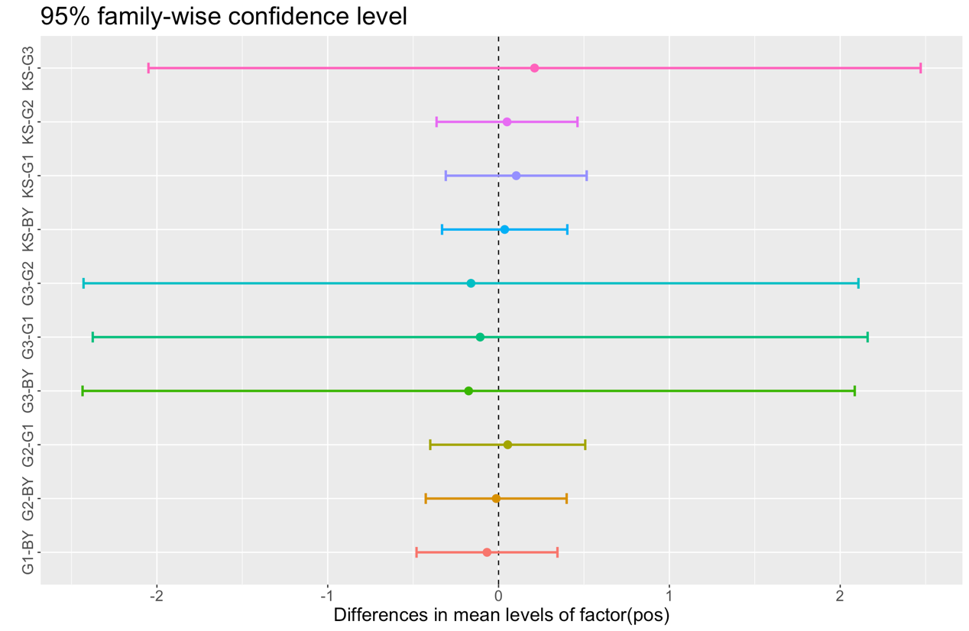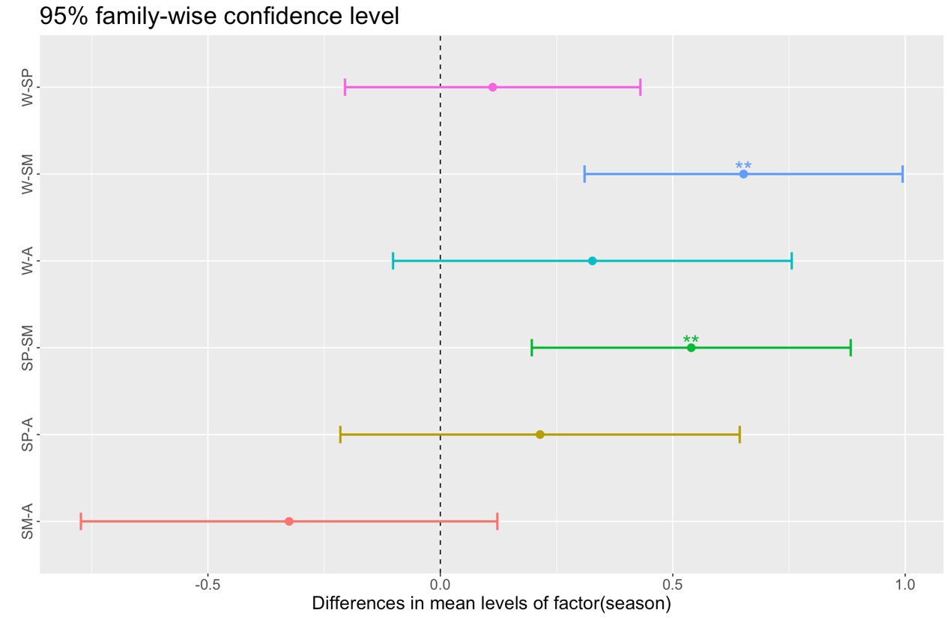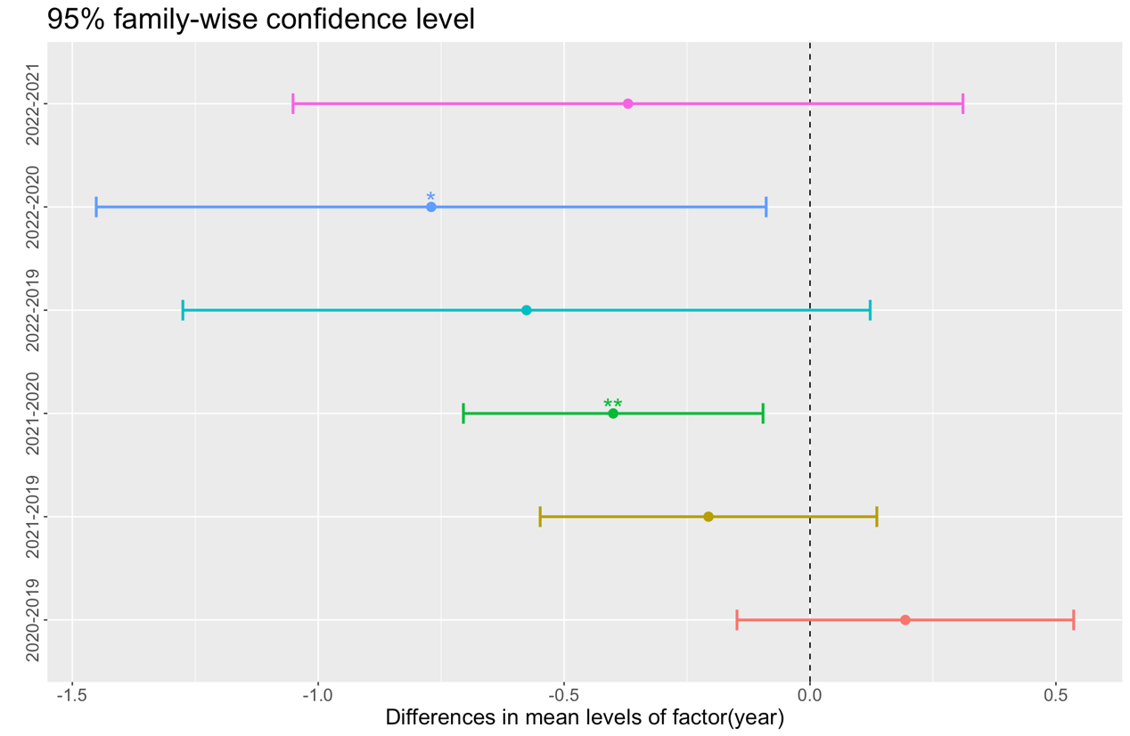

Tukey multiple comparisons of means

95% family-wise confidence level

Fit: aov(formula = 氮循環 ~ factor(year) + factor(season), data = PC_score)

$`factor(year)`

diff lwr upr p adj

2020-2019 0.1937822 -0.1263709 0.51393525 0.4001422

2021-2019 -0.2063761 -0.5265291 0.11377699 0.3431361

2022-2019 -0.5764542 -1.2300516 0.07714327 0.1051738

2021-2020 -0.4001583 -0.6850668 -0.11524968 0.0019269

2022-2020 -0.7702363 -1.4073113 -0.13316138 0.0105928

2022-2021 -0.3700781 -1.0071530 0.26699688 0.4374051

$`factor(season)`

diff lwr upr p adj

SM-A -0.3252924 -0.752655274 0.1020705 0.2026101

SP-A 0.2150558 -0.194818629 0.6249303 0.5273980

W-A 0.3996489 -0.009519925 0.8088177 0.0583483

SP-SM 0.5403482 0.213060284 0.8676362 0.0001634

W-SM 0.7249413 0.398537487 1.0513451 0.0000002

W-SP 0.1845930 -0.118552944 0.4877390 0.3946891

Tukey multiple comparisons of means

95% family-wise confidence level

Fit: aov(formula = 氮循環 ~ factor(season) + factor(pos) + factor(season) * factor(pos), data = PC_score)

$`factor(season)`

diff lwr upr p adj

SM-A -0.3252924 -0.7722459 0.1216611 0.2380201

SP-A 0.2144713 -0.2141921 0.6431347 0.5672159

W-A 0.3270674 -0.1008580 0.7549927 0.1993518

SP-SM 0.5397637 0.1974727 0.8820548 0.0003581

W-SM 0.6523598 0.3109934 0.9937261 0.0000087

W-SP 0.1125960 -0.2044464 0.4296385 0.7947128

$`factor(pos)`

diff lwr upr p adj

G1-BY -0.06516158 -0.4552543 0.3249311 0.9907953

G2-BY -0.01129068 -0.4013834 0.3788020 0.9999909

G3-BY -0.29426648 -2.4320406 1.8435077 0.9956188

KS-BY 0.03591278 -0.3108800 0.3827055 0.9985549

G2-G1 0.05387090 -0.3751739 0.4829157 0.9969325

G3-G1 -0.22910490 -2.3743288 1.9161190 0.9983693

KS-G1 0.10107435 -0.2890184 0.4911671 0.9535269

G3-G2 -0.28297580 -2.4281997 1.8622481 0.9962849

KS-G2 0.04720346 -0.3428892 0.4372962 0.9973433

KS-G3 0.33017926 -1.8075949 2.4679534 0.9931754

$`factor(season):factor(pos)`

diff lwr upr p adj

SM:BY-A:BY -0.095348864 -1.22600198 1.03530425 1.0000000

SP:BY-A:BY 0.422217679 -0.66030026 1.50473562 0.9976820

W:BY-A:BY 0.488029677 -0.59448826 1.57054762 0.9869874

A:G1-A:BY 0.700616237 -0.75905065 2.16028313 0.9746514

SM:G1-A:BY -0.158254645 -1.37949958 1.06299029 1.0000000

SP:G1-A:BY 0.033126441 -1.13460707 1.20085995 1.0000000

W:G1-A:BY 0.439854454 -0.71411355 1.59382245 0.9982748

A:G2-A:BY 0.184685193 -1.27498170 1.64435208 1.0000000

SM:G2-A:BY 0.047488236 -1.17375670 1.26873318 1.0000000

SP:G2-A:BY 0.191127514 -0.97660600 1.35886103 1.0000000

W:G2-A:BY 0.495875049 -0.65809295 1.64984305 0.9924478

A:G3-A:BY NA NA NA NA

SM:G3-A:BY NA NA NA NA

SP:G3-A:BY 0.093378061 -2.82595572 3.01271184 1.0000000

W:G3-A:BY NA NA NA NA

A:KS-A:BY -0.030988582 -1.33655434 1.27457718 1.0000000

SM:KS-A:BY -0.355902482 -1.48655559 0.77475063 0.9998785

SP:KS-A:BY 0.691923142 -0.39059480 1.77444108 0.7381460

W:KS-A:BY 0.537587572 -0.54493037 1.62010551 0.9643735

SP:BY-SM:BY 0.517566543 -0.34598404 1.38111712 0.8273238

W:BY-SM:BY 0.583378542 -0.28017204 1.44692912 0.6442445

A:G1-SM:BY 0.795965101 -0.50960066 2.10153086 0.8059281

SM:G1-SM:BY -0.062905781 -1.09504614 0.96923458 1.0000000

SP:G1-SM:BY 0.128475305 -0.83975817 1.09670878 1.0000000

W:G1-SM:BY 0.535203318 -0.41638307 1.48678971 0.8925523

A:G2-SM:BY 0.280034057 -1.02553170 1.58559981 0.9999997

SM:G2-SM:BY 0.142837100 -0.88930326 1.17497746 1.0000000

SP:G2-SM:BY 0.286476378 -0.68175710 1.25470986 0.9999517

W:G2-SM:BY 0.591223913 -0.36036248 1.54281030 0.7803126

A:G3-SM:BY NA NA NA NA

SM:G3-SM:BY NA NA NA NA

SP:G3-SM:BY 0.188726925 -2.65668767 3.03414152 1.0000000

W:G3-SM:BY NA NA NA NA

A:KS-SM:BY 0.064360283 -1.06629283 1.19501339 1.0000000

SM:KS-SM:BY -0.260553618 -1.18372802 0.66262078 0.9999766

SP:KS-SM:BY 0.787272006 -0.07627857 1.65082258 0.1248616

W:KS-SM:BY 0.632936436 -0.23061414 1.49648701 0.4871786

W:BY-SP:BY 0.065811999 -0.73368048 0.86530448 1.0000000

A:G1-SP:BY 0.278398558 -0.98571005 1.54250717 0.9999996

SM:G1-SP:BY -0.580472324 -1.55964664 0.39870199 0.8401693

SP:G1-SP:BY -0.389091238 -1.30065292 0.52247044 0.9930166

W:G1-SP:BY 0.017636775 -0.87622299 0.91149654 1.0000000

A:G2-SP:BY -0.237532486 -1.50164109 1.02657612 1.0000000

SM:G2-SP:BY -0.374729443 -1.35390376 0.60444487 0.9981829

SP:G2-SP:BY -0.231090165 -1.14265185 0.68047152 0.9999957

W:G2-SP:BY 0.073657370 -0.82020240 0.96751714 1.0000000

A:G3-SP:BY NA NA NA NA

SM:G3-SP:BY NA NA NA NA

SP:G3-SP:BY -0.328839618 -3.15547240 2.49779316 1.0000000

W:G3-SP:BY NA NA NA NA

A:KS-SP:BY -0.453206260 -1.53572420 0.62931168 0.9944453

SM:KS-SP:BY -0.778120161 -1.64167074 0.08543042 0.1379777

SP:KS-SP:BY 0.269705463 -0.52978702 1.06919795 0.9996706

W:KS-SP:BY 0.115369893 -0.68412259 0.91486238 1.0000000

A:G1-W:BY 0.212586559 -1.05152205 1.47669517 1.0000000

SM:G1-W:BY -0.646284322 -1.62545864 0.33289000 0.6853961

SP:G1-W:BY -0.454903236 -1.36646492 0.45665844 0.9626418

W:G1-W:BY -0.048175223 -0.94203499 0.84568455 1.0000000

A:G2-W:BY -0.303344485 -1.56745309 0.96076412 0.9999982

SM:G2-W:BY -0.440541442 -1.41971576 0.53863288 0.9872772

SP:G2-W:BY -0.296902164 -1.20846384 0.61465952 0.9998004

W:G2-W:BY 0.007845372 -0.88601440 0.90170514 1.0000000

A:G3-W:BY NA NA NA NA

SM:G3-W:BY NA NA NA NA

SP:G3-W:BY -0.394651617 -3.22128440 2.43198116 1.0000000

W:G3-W:BY NA NA NA NA

A:KS-W:BY -0.519018259 -1.60153620 0.56349968 0.9749359

SM:KS-W:BY -0.843932160 -1.70748274 0.01961842 0.0641333

SP:KS-W:BY 0.203893464 -0.59559902 1.00338595 0.9999953

W:KS-W:BY 0.049557895 -0.74993459 0.84905038 1.0000000

SM:G1-A:G1 -0.858870882 -2.24363248 0.52589072 0.7827397

SP:G1-A:G1 -0.667489796 -2.00529660 0.67031701 0.9627099

W:G1-A:G1 -0.260761783 -1.58657008 1.06504651 0.9999999

A:G2-A:G1 -0.515931044 -2.11491601 1.08305392 0.9998257

SM:G2-A:G1 -0.653128001 -2.03788960 0.73163360 0.9788505

SP:G2-A:G1 -0.509488723 -1.84729553 0.82831808 0.9982940

W:G2-A:G1 -0.204741188 -1.53054948 1.12106711 1.0000000

A:G3-A:G1 NA NA NA NA

SM:G3-A:G1 NA NA NA NA

SP:G3-A:G1 -0.607238176 -3.59866513 2.38418878 0.9999999

W:G3-A:G1 NA NA NA NA

A:KS-A:G1 -0.731604819 -2.19127171 0.72806207 0.9610373

SM:KS-A:G1 -1.056518719 -2.36208448 0.24904704 0.2973216

SP:KS-A:G1 -0.008693095 -1.27280170 1.25541551 1.0000000

W:KS-A:G1 -0.163028665 -1.42713727 1.10107994 1.0000000

SP:G1-SM:G1 0.191381086 -0.88125064 1.26401281 1.0000000

W:G1-SM:G1 0.598109099 -0.45952004 1.65573824 0.8878009

A:G2-SM:G1 0.342939838 -1.04182176 1.72770144 0.9999970

SM:G2-SM:G1 0.205742881 -0.92491023 1.33639599 1.0000000

SP:G2-SM:G1 0.349382159 -0.72324956 1.42201388 0.9998002

W:G2-SM:G1 0.654129694 -0.40349945 1.71175884 0.7866549

A:G3-SM:G1 NA NA NA NA

SM:G3-SM:G1 NA NA NA NA

SP:G3-SM:G1 0.251632706 -2.63097843 3.13424385 1.0000000

W:G3-SM:G1 NA NA NA NA

A:KS-SM:G1 0.127266063 -1.09397888 1.34851100 1.0000000

SM:KS-SM:G1 -0.197647837 -1.22978819 0.83449252 1.0000000

SP:KS-SM:G1 0.850177787 -0.12899653 1.82935210 0.1852951

W:KS-SM:G1 0.695842217 -0.28333210 1.67501653 0.5482561

W:G1-SP:G1 0.406728013 -0.58863210 1.40208813 0.9958565

A:G2-SP:G1 0.151558752 -1.18624805 1.48936555 1.0000000

SM:G2-SP:G1 0.014361795 -1.05826993 1.08699352 1.0000000

SP:G2-SP:G1 0.158001073 -0.85328581 1.16928796 1.0000000

W:G2-SP:G1 0.462748608 -0.53261151 1.45810872 0.9818350

A:G3-SP:G1 NA NA NA NA

SM:G3-SP:G1 NA NA NA NA

SP:G3-SP:G1 0.060251620 -2.80009964 2.92060288 1.0000000

W:G3-SP:G1 NA NA NA NA

A:KS-SP:G1 -0.064115023 -1.23184854 1.10361849 1.0000000

SM:KS-SP:G1 -0.389028923 -1.35726240 0.57920456 0.9966331

SP:KS-SP:G1 0.658796701 -0.25276498 1.57035838 0.5150809

W:KS-SP:G1 0.504461131 -0.40710055 1.41602281 0.9057105

A:G2-W:G1 -0.255169261 -1.58097755 1.07063903 1.0000000

SM:G2-W:G1 -0.392366218 -1.44999536 0.66526292 0.9987900

SP:G2-W:G1 -0.248726940 -1.24408705 0.74663317 0.9999966

W:G2-W:G1 0.056020595 -0.92315372 1.03519491 1.0000000

A:G3-W:G1 NA NA NA NA

SM:G3-W:G1 NA NA NA NA

SP:G3-W:G1 -0.346476393 -3.20123556 2.50828278 1.0000000

W:G3-W:G1 NA NA NA NA

A:KS-W:G1 -0.470843036 -1.62481104 0.68312496 0.9959306

SM:KS-W:G1 -0.795756936 -1.74734333 0.15582945 0.2417558

SP:KS-W:G1 0.252068688 -0.64179108 1.14592846 0.9999769

W:KS-W:G1 0.097733118 -0.79612665 0.99159289 1.0000000

SM:G2-A:G2 -0.137196957 -1.52195856 1.24756464 1.0000000

SP:G2-A:G2 0.006442321 -1.33136448 1.34424912 1.0000000

W:G2-A:G2 0.311189856 -1.01461844 1.63699815 0.9999988

A:G3-A:G2 NA NA NA NA

SM:G3-A:G2 NA NA NA NA

SP:G3-A:G2 -0.091307132 -3.08273408 2.90011982 1.0000000

W:G3-A:G2 NA NA NA NA

A:KS-A:G2 -0.215673774 -1.67534067 1.24399312 1.0000000

SM:KS-A:G2 -0.540587675 -1.84615343 0.76497808 0.9951346

SP:KS-A:G2 0.507237949 -0.75687066 1.77134656 0.9966880

W:KS-A:G2 0.352902379 -0.91120623 1.61701099 0.9999802

SP:G2-SM:G2 0.143639278 -0.92899244 1.21627100 1.0000000

W:G2-SM:G2 0.448386814 -0.60924233 1.50601596 0.9935518

A:G3-SM:G2 NA NA NA NA

SM:G3-SM:G2 NA NA NA NA

SP:G3-SM:G2 0.045889825 -2.83672131 2.92850096 1.0000000

W:G3-SM:G2 NA NA NA NA

A:KS-SM:G2 -0.078476817 -1.29972176 1.14276812 1.0000000

SM:KS-SM:G2 -0.403390718 -1.43553107 0.62874964 0.9976211

SP:KS-SM:G2 0.644434906 -0.33473941 1.62360922 0.6903063

W:KS-SM:G2 0.490099337 -0.48907498 1.46927365 0.9615518

W:G2-SP:G2 0.304747535 -0.69061258 1.30010765 0.9999194

A:G3-SP:G2 NA NA NA NA

SM:G3-SP:G2 NA NA NA NA

SP:G3-SP:G2 -0.097749453 -2.95810071 2.76260181 1.0000000

W:G3-SP:G2 NA NA NA NA

A:KS-SP:G2 -0.222116095 -1.38984961 0.94561742 1.0000000

SM:KS-SP:G2 -0.547029996 -1.51526347 0.42120348 0.8886438

SP:KS-SP:G2 0.500795628 -0.41076605 1.41235731 0.9112150

W:KS-SP:G2 0.346460058 -0.56510162 1.25802174 0.9983380

A:G3-W:G2 NA NA NA NA

SM:G3-W:G2 NA NA NA NA

SP:G3-W:G2 -0.402496988 -3.25725616 2.45226218 1.0000000

W:G3-W:G2 NA NA NA NA

A:KS-W:G2 -0.526863631 -1.68083163 0.62710437 0.9850516

SM:KS-W:G2 -0.851777531 -1.80336392 0.09980886 0.1458034

SP:KS-W:G2 0.196048093 -0.69781168 1.08990786 0.9999996

W:KS-W:G2 0.041712523 -0.85214725 0.93557229 1.0000000

SM:G3-A:G3 NA NA NA NA

SP:G3-A:G3 NA NA NA NA

W:G3-A:G3 NA NA NA NA

A:KS-A:G3 NA NA NA NA

SM:KS-A:G3 NA NA NA NA

SP:KS-A:G3 NA NA NA NA

W:KS-A:G3 NA NA NA NA

SP:G3-SM:G3 NA NA NA NA

W:G3-SM:G3 NA NA NA NA

A:KS-SM:G3 NA NA NA NA

SM:KS-SM:G3 NA NA NA NA

SP:KS-SM:G3 NA NA NA NA

W:KS-SM:G3 NA NA NA NA

W:G3-SP:G3 NA NA NA NA

A:KS-SP:G3 -0.124366642 -3.04370042 2.79496714 1.0000000

SM:KS-SP:G3 -0.449280543 -3.29469514 2.39613406 1.0000000

SP:KS-SP:G3 0.598545081 -2.22808770 3.42517786 0.9999998

W:KS-SP:G3 0.444209511 -2.38242327 3.27084229 1.0000000

A:KS-W:G3 NA NA NA NA

SM:KS-W:G3 NA NA NA NA

SP:KS-W:G3 NA NA NA NA

W:KS-W:G3 NA NA NA NA

SM:KS-A:KS -0.324913901 -1.45556701 0.80573921 0.9999691

SP:KS-A:KS 0.722911724 -0.35960622 1.80542966 0.6649504

W:KS-A:KS 0.568576154 -0.51394178 1.65109409 0.9397774

SP:KS-SM:KS 1.047825624 0.18427505 1.91137620 0.0032463

W:KS-SM:KS 0.893490054 0.02993948 1.75704063 0.0336197

W:KS-SP:KS -0.154335570 -0.95382805 0.64515691 1.0000000

PC3 : 酸鹼度

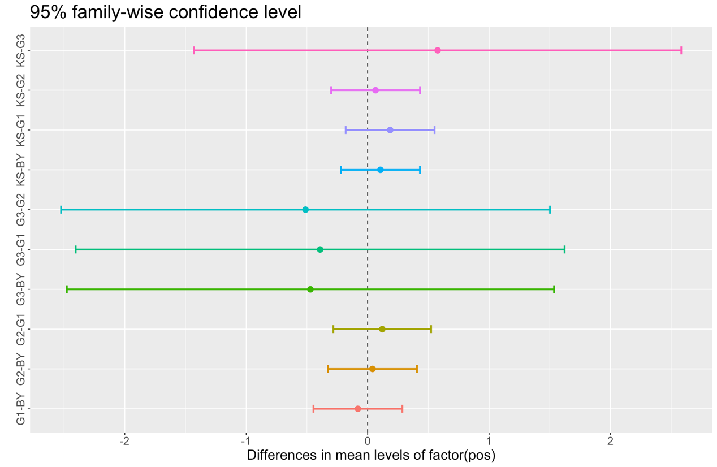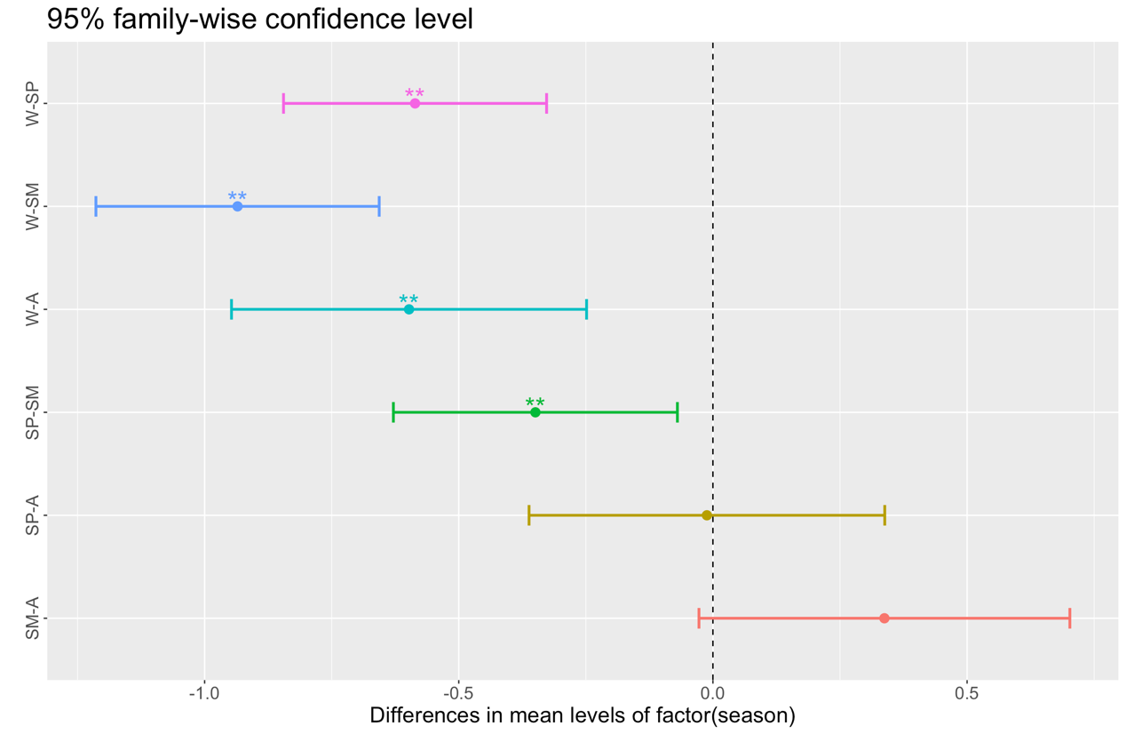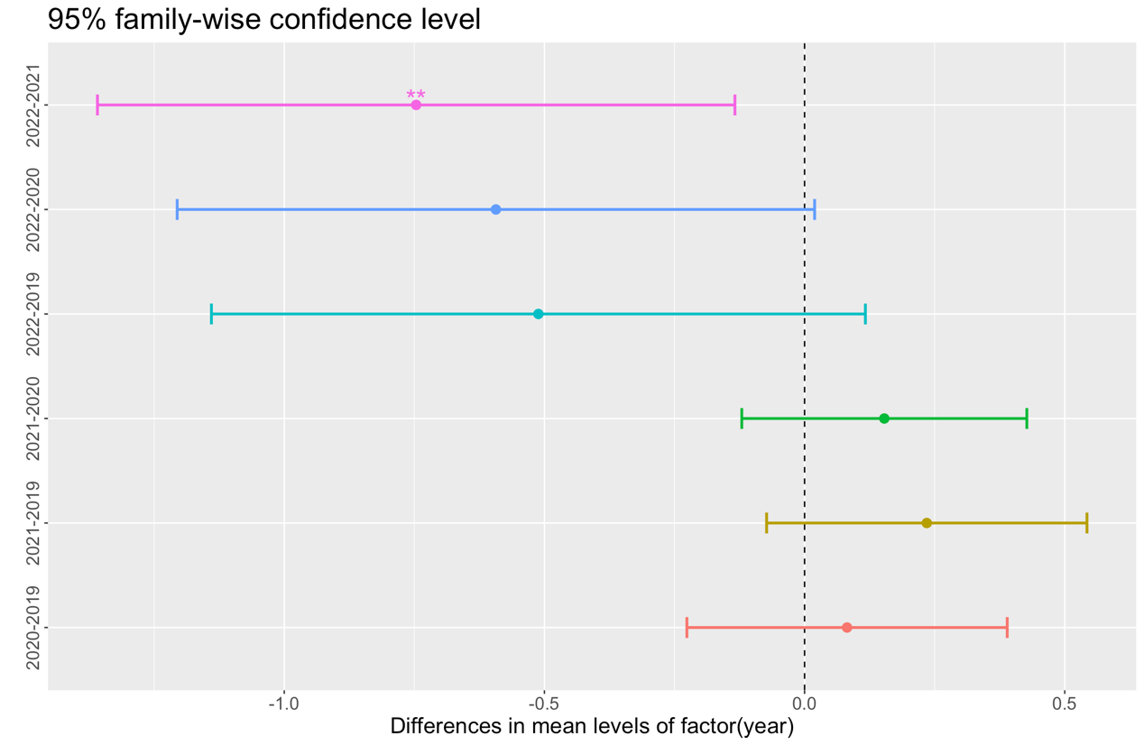

Tukey multiple comparisons of means

95% family-wise confidence level

Fit: aov(formula = 酸鹼度 ~ factor(year) + factor(season), data = PC_score)

$`factor(year)`

diff lwr upr p adj

2020-2019 0.08165062 -0.18598382 0.34928506 0.8593012

2021-2019 0.23488860 -0.03274584 0.50252304 0.1078728

2022-2019 -0.51156217 -1.05794200 0.03481766 0.0756292

2021-2020 0.15323798 -0.08493356 0.39140952 0.3448444

2022-2020 -0.59321279 -1.12578054 -0.06064504 0.0222565

2022-2021 -0.74645077 -1.27901852 -0.21388302 0.0019797

$`factor(season)`

diff lwr upr p adj

SM-A 0.33738328 -0.01987403 0.69464059 0.0718707

SP-A -0.02652728 -0.36916502 0.31611046 0.9971490

W-A -0.54706678 -0.88911461 -0.20501895 0.0002817

SP-SM -0.36391056 -0.63750946 -0.09031166 0.0037896

W-SM -0.88445006 -1.15730984 -0.61159029 0.0000000

W-SP -0.52053950 -0.77395673 -0.26712227 0.0000015

Tukey multiple comparisons of means

95% family-wise confidence level

Fit: aov(formula = 酸鹼度 ~ factor(season) + factor(pos) + factor(season) * factor(pos), data = PC_score)

$`factor(season)`

diff lwr upr p adj

SM-A 0.33738328 -0.02105724 0.69582380 0.0732834

SP-A -0.01183559 -0.35560812 0.33193695 0.9997460

W-A -0.59782292 -0.94100359 -0.25464225 0.0000611

SP-SM -0.34921887 -0.62372391 -0.07471383 0.0062804

W-SM -0.93520620 -1.20896967 -0.66144273 0.0000000

W-SP -0.58598733 -0.84024386 -0.33173080 0.0000001

$`factor(pos)`

diff lwr upr p adj

G1-BY -0.07798010 -0.3908203 0.2348601 0.9595007

G2-BY 0.04223566 -0.2706046 0.3550759 0.9959355

G3-BY -0.57352890 -2.2879464 1.1408886 0.8890837

KS-BY 0.10534462 -0.1727706 0.3834599 0.8358187

G2-G1 0.12021575 -0.2238626 0.4642941 0.8724369

G3-G1 -0.49554880 -2.2159407 1.2248431 0.9327689

KS-G1 0.18332471 -0.1295155 0.4961649 0.4917828

G3-G2 -0.61576455 -2.3361565 1.1046274 0.8622961

KS-G2 0.06310896 -0.2497313 0.3759492 0.9812819

KS-G3 0.67887351 -1.0355440 2.3932910 0.8122676

$`factor(season):factor(pos)`

diff lwr upr p adj

SM:BY-A:BY 0.579187621 -0.32755526 1.48593050 0.7391799

SP:BY-A:BY 0.253881569 -0.61425864 1.12202178 0.9999596

W:BY-A:BY -0.400626415 -1.26876663 0.46751380 0.9832182

A:G1-A:BY 0.376601817 -0.79399821 1.54720184 0.9998329

SM:G1-A:BY 0.602562906 -0.37683134 1.58195715 0.7938555

SP:G1-A:BY -0.145446219 -1.08192624 0.79103380 1.0000000

W:G1-A:BY -0.420105819 -1.34554640 0.50533476 0.9859604

A:G2-A:BY 0.127265441 -1.04333458 1.29786547 1.0000000

SM:G2-A:BY 0.812940473 -0.16645378 1.79233472 0.2538781

SP:G2-A:BY 0.016622425 -0.91985760 0.95310245 1.0000000

W:G2-A:BY -0.268166466 -1.19360704 0.65727411 0.9999649

A:G3-A:BY NA NA NA NA

SM:G3-A:BY NA NA NA NA

SP:G3-A:BY -0.379199070 -2.72039912 1.96200098 1.0000000

W:G3-A:BY NA NA NA NA

A:KS-A:BY 0.425949641 -0.62106685 1.47296613 0.9960747

SM:KS-A:BY 0.363615547 -0.54312733 1.27035843 0.9967134

SP:KS-A:BY 0.555812336 -0.31232788 1.42395255 0.7355640

W:KS-A:BY -0.371407309 -1.23954752 0.49673291 0.9928269

SP:BY-SM:BY -0.325306052 -1.01784237 0.36723026 0.9797373

W:BY-SM:BY -0.979814036 -1.67235035 -0.28727772 0.0001425

A:G1-SM:BY -0.202585805 -1.24960230 0.84443069 1.0000000

SM:G1-SM:BY 0.023375285 -0.80436393 0.85111450 1.0000000

SP:G1-SM:BY -0.724633840 -1.50112205 0.05185437 0.1012217

W:G1-SM:BY -0.999293441 -1.76243129 -0.23615559 0.0007749

A:G2-SM:BY -0.451922180 -1.49893867 0.59509431 0.9920477

SM:G2-SM:BY 0.233752852 -0.59398636 1.06149207 0.9999763

SP:G2-SM:BY -0.562565196 -1.33905341 0.21392302 0.5101891

W:G2-SM:BY -0.847354087 -1.61049194 -0.08421624 0.0132205

A:G3-SM:BY NA NA NA NA

SM:G3-SM:BY NA NA NA NA

SP:G3-SM:BY -0.958386692 -3.24030623 1.32353285 0.9942309

W:G3-SM:BY NA NA NA NA

A:KS-SM:BY -0.153237981 -1.05998086 0.75350490 1.0000000

SM:KS-SM:BY -0.215572074 -0.95592454 0.52478039 0.9999622

SP:KS-SM:BY -0.023375285 -0.71591160 0.66916103 1.0000000

W:KS-SM:BY -0.950594930 -1.64313124 -0.25805862 0.0002849

W:BY-SP:BY -0.654507985 -1.29567202 -0.01334394 0.0394950

A:G1-SP:BY 0.122720247 -0.89104911 1.13648961 1.0000000

SM:G1-SP:BY 0.348681337 -0.43658103 1.13394371 0.9890133

SP:G1-SP:BY -0.399327788 -1.13036727 0.33171169 0.9153563

W:G1-SP:BY -0.673987389 -1.39083058 0.04285580 0.0943730

A:G2-SP:BY -0.126616128 -1.14038549 0.88715323 1.0000000

SM:G2-SP:BY 0.559058903 -0.22620347 1.34432127 0.5446832

SP:G2-SP:BY -0.237259144 -0.96829863 0.49378034 0.9998103

W:G2-SP:BY -0.522048035 -1.23889122 0.19479515 0.4999211

A:G3-SP:BY NA NA NA NA

SM:G3-SP:BY NA NA NA NA

SP:G3-SP:BY -0.633080640 -2.89993784 1.63377656 0.9999801

W:G3-SP:BY NA NA NA NA

A:KS-SP:BY 0.172068071 -0.69607214 1.04020829 0.9999999

SM:KS-SP:BY 0.109733978 -0.58280234 0.80227029 1.0000000

SP:KS-SP:BY 0.301930767 -0.33923327 0.94309481 0.9791970

W:KS-SP:BY -0.625288878 -1.26645292 0.01587516 0.0655550

A:G1-W:BY 0.777228232 -0.23654113 1.79099759 0.3983250

SM:G1-W:BY 1.003189322 0.21792695 1.78845169 0.0012631

SP:G1-W:BY 0.255180196 -0.47585929 0.98621968 0.9994692

W:G1-W:BY -0.019479404 -0.73632259 0.69736378 1.0000000

A:G2-W:BY 0.527891857 -0.48587750 1.54166122 0.9442912

SM:G2-W:BY 1.213566888 0.42830452 1.99882926 0.0000149

SP:G2-W:BY 0.417248840 -0.31379064 1.14828832 0.8794325

W:G2-W:BY 0.132459949 -0.58438324 0.84930314 1.0000000

A:G3-W:BY NA NA NA NA

SM:G3-W:BY NA NA NA NA

SP:G3-W:BY 0.021427345 -2.24542986 2.28828455 1.0000000

W:G3-W:BY NA NA NA NA

A:KS-W:BY 0.826576056 -0.04156416 1.69471627 0.0835893

SM:KS-W:BY 0.764241962 0.07170565 1.45677828 0.0144310

SP:KS-W:BY 0.956438751 0.31527471 1.59760279 0.0000385

W:KS-W:BY 0.029219106 -0.61194493 0.67038315 1.0000000

SM:G1-A:G1 0.225961090 -0.88456760 1.33648978 0.9999999

SP:G1-A:G1 -0.522048035 -1.59492068 0.55082461 0.9708851

W:G1-A:G1 -0.796707636 -1.85995791 0.26654264 0.4433286

A:G2-A:G1 -0.249336375 -1.53166445 1.03299170 0.9999999

SM:G2-A:G1 0.436338656 -0.67419004 1.54686735 0.9974554

SP:G2-A:G1 -0.359979392 -1.43285204 0.71289325 0.9996948

W:G2-A:G1 -0.644768282 -1.70801856 0.41848199 0.8128207

A:G3-A:G1 NA NA NA NA

SM:G3-A:G1 NA NA NA NA

SP:G3-A:G1 -0.755800887 -3.15481705 1.64321528 0.9998770

W:G3-A:G1 NA NA NA NA

A:KS-A:G1 0.049347824 -1.12125220 1.21994785 1.0000000

SM:KS-A:G1 -0.012986270 -1.06000276 1.03403022 1.0000000

SP:KS-A:G1 0.179210520 -0.83455884 1.19297988 1.0000000

W:KS-A:G1 -0.748009125 -1.76177848 0.26576023 0.4739270

SP:G1-SM:G1 -0.748009125 -1.60822095 0.11220270 0.1832140

W:G1-SM:G1 -1.022668726 -1.87084903 -0.17448843 0.0036219

A:G2-SM:G1 -0.475297465 -1.58582616 0.63523123 0.9927930

SM:G2-SM:G1 0.210377566 -0.69636531 1.11712045 0.9999990

SP:G2-SM:G1 -0.585940481 -1.44615231 0.27427135 0.6291221

W:G2-SM:G1 -0.870729372 -1.71890967 -0.02254907 0.0369462

A:G3-SM:G1 NA NA NA NA

SM:G3-SM:G1 NA NA NA NA

SP:G3-SM:G1 -0.981761977 -3.29351180 1.32998784 0.9934200

W:G3-SM:G1 NA NA NA NA

A:KS-SM:G1 -0.176613266 -1.15600751 0.80278098 1.0000000

SM:KS-SM:G1 -0.238947359 -1.06668658 0.58879186 0.9999668

SP:KS-SM:G1 -0.046750570 -0.83201294 0.73851180 1.0000000

W:KS-SM:G1 -0.973970215 -1.75923258 -0.18870785 0.0021978

W:G1-SP:G1 -0.274659601 -1.07290239 0.52358319 0.9995653

A:G2-SP:G1 0.272711660 -0.80016098 1.34558431 0.9999955

SM:G2-SP:G1 0.958386692 0.09817487 1.81859852 0.0125907

SP:G2-SP:G1 0.162068644 -0.64894684 0.97308413 0.9999999

W:G2-SP:G1 -0.122720247 -0.92096304 0.67552254 1.0000000

A:G3-SP:G1 NA NA NA NA

SM:G3-SP:G1 NA NA NA NA

SP:G3-SP:G1 -0.233752852 -2.52765106 2.06014535 1.0000000

W:G3-SP:G1 NA NA NA NA

A:KS-SP:G1 0.571395860 -0.36508416 1.50787588 0.8048974

SM:KS-SP:G1 0.509061766 -0.26742645 1.28554998 0.6968880

SP:KS-SP:G1 0.701258555 -0.02978093 1.43229804 0.0776258

W:KS-SP:G1 -0.225961090 -0.95700057 0.50507839 0.9999071

A:G2-W:G1 0.547371261 -0.51587901 1.61062154 0.9498313

SM:G2-W:G1 1.233046292 0.38486599 2.08122659 0.0000740

SP:G2-W:G1 0.436728244 -0.36151455 1.23497104 0.9142263

W:G2-W:G1 0.151939354 -0.63332302 0.93720172 1.0000000

A:G3-W:G1 NA NA NA NA

SM:G3-W:G1 NA NA NA NA

SP:G3-W:G1 0.040906749 -2.24850680 2.33032030 1.0000000

W:G3-W:G1 NA NA NA NA

A:KS-W:G1 0.846055460 -0.07938512 1.77149604 0.1218556

SM:KS-W:G1 0.783721366 0.02058352 1.54685922 0.0367806

SP:KS-W:G1 0.975918156 0.25907497 1.69276134 0.0003414

W:KS-W:G1 0.048698511 -0.66814468 0.76554170 1.0000000

SM:G2-A:G2 0.685675031 -0.42485366 1.79620372 0.7890093

SP:G2-A:G2 -0.110643016 -1.18351566 0.96222963 1.0000000

W:G2-A:G2 -0.395431907 -1.45868218 0.66781837 0.9987496

A:G3-A:G2 NA NA NA NA

SM:G3-A:G2 NA NA NA NA

SP:G3-A:G2 -0.506464512 -2.90548068 1.89255165 0.9999998

W:G3-A:G2 NA NA NA NA

A:KS-A:G2 0.298684199 -0.87191583 1.46928422 0.9999952

SM:KS-A:G2 0.236350106 -0.81066639 1.28336660 0.9999994

SP:KS-A:G2 0.428546895 -0.58522247 1.44231625 0.9937691

W:KS-A:G2 -0.498672750 -1.51244211 0.51509661 0.9675580

SP:G2-SM:G2 -0.796318048 -1.65652987 0.06389378 0.1089991

W:G2-SM:G2 -1.081106939 -1.92928724 -0.23292664 0.0013196

A:G3-SM:G2 NA NA NA NA

SM:G3-SM:G2 NA NA NA NA

SP:G3-SM:G2 -1.192139543 -3.50388936 1.11961028 0.9490352

W:G3-SM:G2 NA NA NA NA

A:KS-SM:G2 -0.386990832 -1.36638508 0.59240342 0.9972678

SM:KS-SM:G2 -0.449324926 -1.27706414 0.37841429 0.9197145

SP:KS-SM:G2 -0.257128137 -1.04239051 0.52813423 0.9997845

W:KS-SM:G2 -1.184347782 -1.96961015 -0.39908541 0.0000289

W:G2-SP:G2 -0.284788891 -1.08303168 0.51345390 0.9992840

A:G3-SP:G2 NA NA NA NA

SM:G3-SP:G2 NA NA NA NA

SP:G3-SP:G2 -0.395821495 -2.68971970 1.89807671 1.0000000

W:G3-SP:G2 NA NA NA NA

A:KS-SP:G2 0.409327216 -0.52715280 1.34580724 0.9908096

SM:KS-SP:G2 0.346993122 -0.42949509 1.12348133 0.9881994

SP:KS-SP:G2 0.539189911 -0.19184957 1.27022939 0.4746905

W:KS-SP:G2 -0.388029734 -1.11906922 0.34300975 0.9338716

A:G3-W:G2 NA NA NA NA

SM:G3-W:G2 NA NA NA NA

SP:G3-W:G2 -0.111032605 -2.40044615 2.17838095 1.0000000

W:G3-W:G2 NA NA NA NA

A:KS-W:G2 0.694116107 -0.23132447 1.61955668 0.4414140

SM:KS-W:G2 0.631782013 -0.13135584 1.39491986 0.2582127

SP:KS-W:G2 0.823978802 0.10713561 1.54082199 0.0078941

W:KS-W:G2 -0.103240843 -0.82008403 0.61360235 1.0000000

SM:G3-A:G3 NA NA NA NA

SP:G3-A:G3 NA NA NA NA

W:G3-A:G3 NA NA NA NA

A:KS-A:G3 NA NA NA NA

SM:KS-A:G3 NA NA NA NA

SP:KS-A:G3 NA NA NA NA

W:KS-A:G3 NA NA NA NA

SP:G3-SM:G3 NA NA NA NA

W:G3-SM:G3 NA NA NA NA

A:KS-SM:G3 NA NA NA NA

SM:KS-SM:G3 NA NA NA NA

SP:KS-SM:G3 NA NA NA NA

W:KS-SM:G3 NA NA NA NA

W:G3-SP:G3 NA NA NA NA

A:KS-SP:G3 0.805148711 -1.53605134 3.14634876 0.9995684

SM:KS-SP:G3 0.742814617 -1.53910492 3.02473416 0.9998020

SP:KS-SP:G3 0.935011407 -1.33184580 3.20186861 0.9953562

W:KS-SP:G3 0.007791762 -2.25906544 2.27464896 1.0000000

A:KS-W:G3 NA NA NA NA

SM:KS-W:G3 NA NA NA NA

SP:KS-W:G3 NA NA NA NA

W:KS-W:G3 NA NA NA NA

SM:KS-A:KS -0.062334094 -0.96907697 0.84440879 1.0000000

SP:KS-A:KS 0.129862695 -0.73827752 0.99800291 1.0000000

W:KS-A:KS -0.797356949 -1.66549716 0.07078326 0.1169772

SP:KS-SM:KS 0.192196789 -0.50033953 0.88473310 0.9999819

W:KS-SM:KS -0.735022856 -1.42755917 -0.04248654 0.0244412

W:KS-SP:KS -0.927219645 -1.56838368 -0.28605561 0.0000842