The value of zero for the index 0 is added for every plot since matlab arrays don’t support using index 0. Values elsewhere beyond the boundaries are also all assumed to be 0.

* 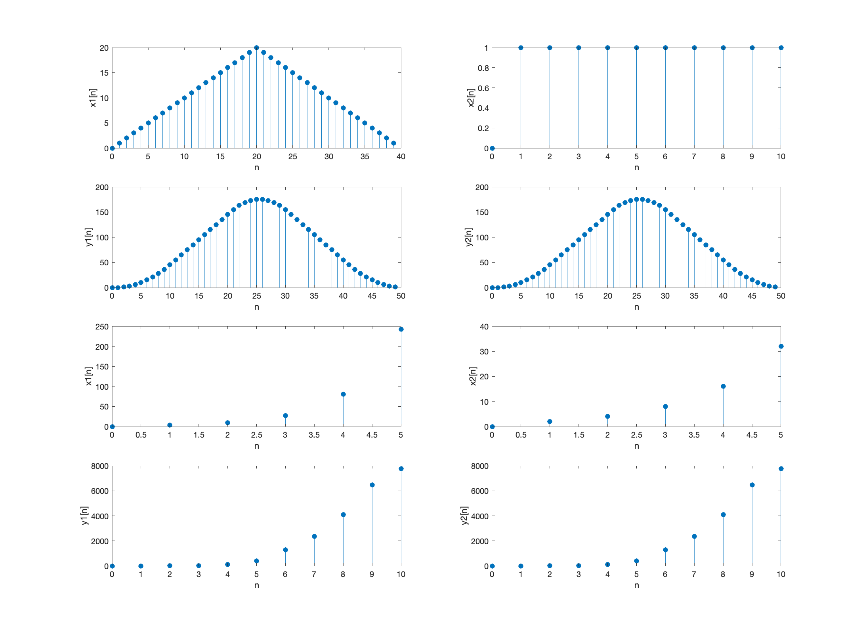B08902073資工一 陳宇浩