1.

(b)

(c)

(d)

(e)

Increasing L, which is the order of the Butterworth filter, will result in a narrower transition band near it’s its cutoff frequency. We get a sharper transition band similar to what an ideal lowpass filter has. By comparing (b) and (c), we can see that (c) with the higher order does a better job at preserving desired frequencies and attenuating undesired frequencies. Nevertheless, the price to pay is to get a more complicated transfer function, which might cause issues in filter stability. What’s more, the phase shift response of a Butterworth filter is also reduced by increasing its order.

Increasing , which is the cutoff frequency of the filter, will result in a larger passband for the lowpass Butterworth filter. By comparing (a) and (c), we can see that in (b), most of the signal is attenuated as its main frequency (0.2) is larger than 0.1. On the other hand, most of the signal is preserved as its main frequency (0.2) is smaller than 0.5.

Figure for butter1.m:

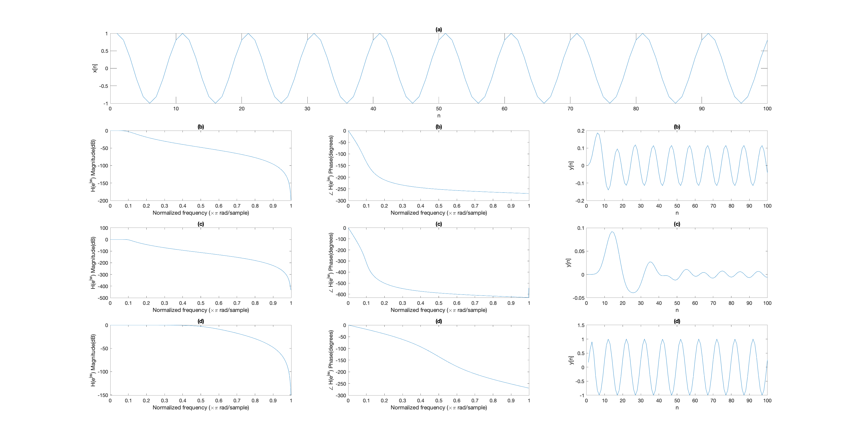

2.

(b)

(c)

Coefficients of b ()

|  |  |  |  |  |  |  |  |  |  |
| --- | --- | --- | --- | --- | --- | --- | --- | --- | --- |
| b1 | b2 | b3 | b4 | b5 | b6 | b7 | b8 | b9 | b10 |
| 0.0001 | 0 | -0.0009 | 0 | 0.007 | 0 | -0.0326 | 0 | 0.106 | 0 |
| b11 | b12 | b13 | b14 | b15 | b16 | b17 | b18 | b19 | b20 |
| -0.2544 | 0 | 0.4664 | 0 | -0.6663 | 0 | 0.7496 | 0 | -0.6663 | 0 |
| b21 | b22 | b23 | b24 | b25 | b26 | b27 | b28 | b29 | b30 |
| 0.4664 | 0 | -0.2544 | 0 | 0.106 | 0 | -0.0326 | 0 | 0.007 | 0 |

|  |  |  |
| --- | --- | --- |
| b31 | b32 | b33 |
| -0.0009 | 0 | 0.0001 |

Coefficients of a ()

|  |  |  |  |  |  |  |  |  |  |
| --- | --- | --- | --- | --- | --- | --- | --- | --- | --- |
| a1 | a2 | a3 | a4 | a5 | a6 | a7 | a8 | a9 | a10 |
| 0.0001 | -0.0008 | 0.0042 | -0.0155 | 0.0456 | -0.1126 | 0.2407 | -0.453 | 0.7622 | -1.1576 |
| a11 | a12 | a13 | a14 | a15 | a16 | a17 | a18 | a19 | a20 |
| 1.5992 | -2.0211 | 2.3471 | -2.5125 | 2.4853 | -2.275 | 1.9291 | -1.5115 | 1.1028 | -0.7424 |
| a21 | a22 | a23 | a24 | a25 | a26 | a27 | a28 | a29 | a30 |
| 0.4617 | -0.2645 | 0.1392 | -0.0669 | 0.0293 | -0.0115 | 0.0041 | -0.0013 | 0.0003 | -0.0001 |

|  |  |  |
| --- | --- | --- |
| a31 | a32 | a33 |
| 0 | 0 | 0 |

The above are the coefficients for the following equation,

Figure for mybutter2.m:

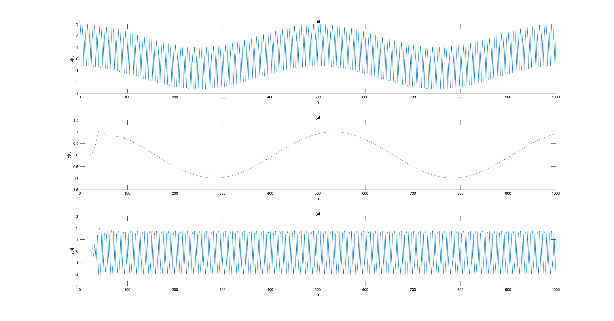

-B08902073資工一 陳宇浩