(a)

Since it is a causal LTI system, the signal is right-sided and the ROC is outside the outermost pole

$$ROC:\left|z\right|>0.5$$

(d)

$$H\left(z\right)=H_{1}\left(z\right)H_{2}\left(z\right)$$

$$H_{1}\left(z\right)=0.3(\frac{1-2z^{-1}+z^{-2}}{1-{0.2z}^{-1}+0.02z^{-2}})$$

$$H_{2}\left(z\right)=0.3(\frac{1+2z^{-1}+z^{-2}}{1-{0.6z}^{-1}+0.25z^{-2}})$$

(e)

The multiplication result of the magnitude response $|H_{1}(z)|$ and $|H_{2}(z)|$ is equivalent to the magnitude response of $|H\left(z\right)|$ in section (c). Therefore, we can see that a complex high-order system can be reduced the cascade of lower-order systems, making it easy to construct complex systems with simple building blocks.

(f)

The result is identical to the result of (a), which further verifies that (a) is the impulse response of the LTI system.

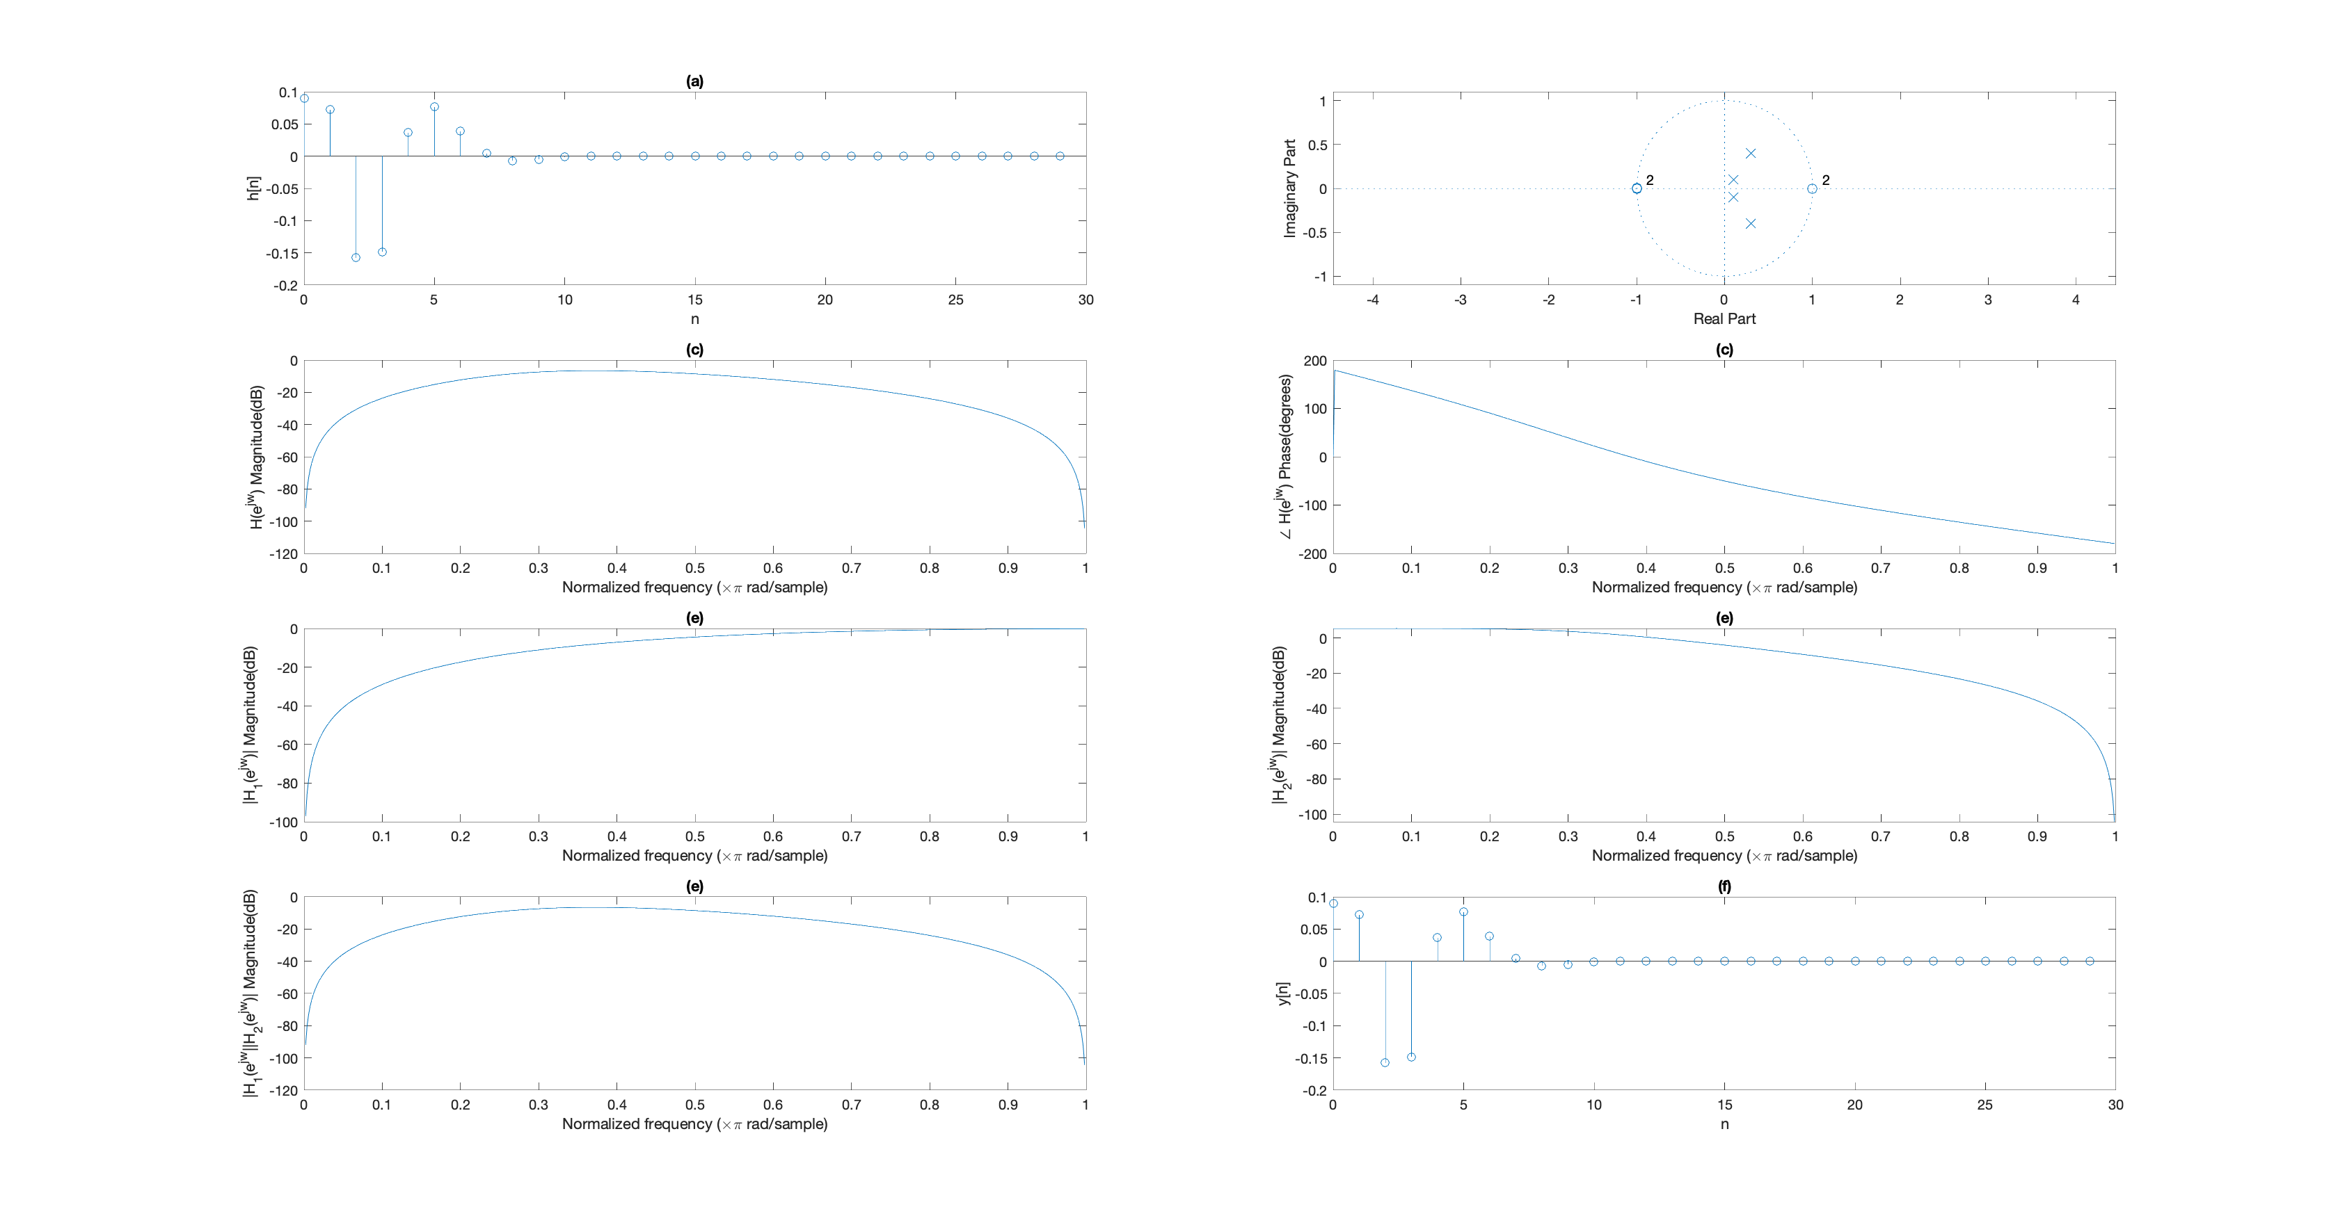

-B08902073資工一 陳宇浩