WatchTower
An AI operations copilot for the 24/7 monitoring team
Proposal for ICI Builders Day
October 2026 · Draft 3, revised for the refinement brief (copilot positioning, Cisco and OpenShift scope)

Contents

1. Executive summary
WatchTower is an AI operations copilot that sits above our existing monitoring tools, SolarWinds and Splunk. It is not another monitoring dashboard and it does not try to predict failures. It helps the 24/7 monitoring team with the work that today happens by hand after something looks wrong: it detects emerging issues through weak-signal and cross-domain correlation, does first-level fault diagnosis, explains the likely cause with supporting evidence, and recommends the next diagnostic steps and the right escalation.
The design follows one flow: existing monitoring tools observe, domain agents investigate, a parent agent connects the dots, and WatchTower explains and guides the SRE. A Network Agent covers Cisco switching and an OpenShift Agent covers the clusters. Both reuse what Splunk and SolarWinds already hold and probe devices only when they need live state or deeper evidence. Monitoring stays deterministic; the on-prem Gemma model helps with hypotheses, evidence interpretation, explanation and next steps. Every conclusion is traceable from observation to recommendation, and WatchTower is read-only: it stops at Recommend.
The scope is deliberately narrow: Cisco and Red Hat OpenShift only, demonstrated deeply on a real incident in which an OpenShift master's calls to the kubernetes Service timed out and the node dropped out and came back. Section 2.2 explains that behaviour: it is best described as a transient NotReady, or node flap, not a reboot.
For Builders Day we will build a proof of concept on an 8 GB MacBook Air M2 that reproduces this incident and shows both modes: proactive watch (spotting it building up while the existing tools are quiet) and incident investigation (an SRE asks WatchTower to investigate the alarm). The basic demo is feasible on the 8 GB Air with a lite lab profile, though memory is tight; the session is mainly a walkthrough with wireframes and a recorded replay, with a live demo if the Mac allows.

2. Background

2.1 Today the tools observe; people connect the dots
The monitoring tools work well inside their own domain. What they leave to the people on shift is the joining-up:
Tool | What it does well | What is left to the 24/7 team
SolarWinds | Polls Cisco switches over SNMP: status, utilisation, errors and discards; threshold alerts | Spotting a slow rise that never crosses a threshold; knowing which server a port feeds
Splunk | Collects OpenShift and switch logs and events; saved-search alerts | Knowing what to search for, and when; joining log lines to network counters
OpenShift console | Node, pod and operator status for one cluster | Seeing the switch port and network path underneath a node
The SRE on shift | Judgement and context; owns the decision | Pivoting across consoles at 2 a.m., correlating by hand, choosing the escalation

Scope for now: Cisco switching and Red Hat OpenShift only. Palo Alto and Nutanix, mentioned in the original brief, are out of scope until the pattern is proven; adding them later means adding a domain agent, not redesigning WatchTower.

2.2 The OpenShift incident, explained
What was observed: a master node was making API calls to the kubernetes Service (in effect, to the API server on itself) and the calls were timing out, probably because of a network bottleneck. The node then went down and came back up; the service was briefly out and recovered. The node did not appear to physically reboot, and key services did not seem to fully restart.
The most likely explanation, based on how OpenShift tracks node health by default:
- The network path congests. Packets to and from the master are dropped or delayed on its switch path. Average utilisation can look normal (bursts fill the egress queue), so SolarWinds does not alert.
- Calls to the kubernetes Service time out. The Service address (172.30.0.1 on OpenShift) is load-balanced across all the API servers. From a master with three API servers, about two in three calls go to the other masters, across the network, even though the caller is itself a master. Those are the calls that time out, which is why the failures look intermittent.
- The node is marked NotReady. The kubelet renews its node heartbeat (a Lease) every 10 seconds. If the control plane sees no renewal for 40 seconds (the node-monitor-grace-period), it marks the node NotReady. The node has not stopped; the control plane has lost contact with it.
- The node comes back. When traffic gets through again, the next renewal marks the node Ready. Pod eviction only starts after 300 seconds NotReady, so a short gap causes no evictions. The operating system does not reboot (its boot ID is unchanged) and static pods such as the API server and etcd keep running, which matches what was seen.
The accurate name is therefore a transient NotReady, or "node flap": a short loss of contact between the node and the control plane, recovered without a reboot. If the incident's data is available, four things would confirm it: the NodeNotReady and NodeReady event times (a gap of about 40 seconds or more), the absence of Rebooted or Starting events for the node, no restart events for the API server and etcd pods, and output drops on the master's switch port at the time.
OpenShift default (Default worker latency profile) | Value | What it means here
Kubelet node status / lease update frequency | 10 s | How often the node says "I am alive"
node-monitor-grace-period | 40 s | Silence after which the node is marked NotReady
default-not-ready / unreachable toleration | 300 s | NotReady time before pods are evicted

This explanation is inferred from the description and documented defaults (section 15). The PoC reproduces exactly this mechanism, and WatchTower's playbook for it checks each of the four points automatically.

3. Problem statement
Our monitoring tools see each domain separately and alert on thresholds. Weak signals that only make sense together, like a congested switch port slowing an OpenShift master, go unnoticed until something breaks. Then first-level diagnosis depends on an SRE pulling evidence from several consoles by hand.
This does not scale with people, and it is slowest exactly when it matters: at night, under pressure, for issues that span teams.

4. What WatchTower is

4.1 Positioning
WatchTower is an AI operations copilot that sits above existing monitoring tools. It:
- Detects emerging issues through weak-signal and cross-domain correlation, before major service impact.
- Assists with first-level fault diagnosis when an alarm fires or an SRE asks it to investigate.
- Explains the likely cause and shows the supporting evidence and where each piece came from.
- Recommends next diagnostic steps and the appropriate escalation.
It is not another monitoring dashboard, not a failure-prediction engine, not a replacement for SolarWinds or Splunk, and not an auto-remediation tool.

4.2 The end state
- Existing monitoring tools observe. SolarWinds and Splunk keep collecting, baselining and alerting, unchanged.
- Domain agents investigate. The Network and OpenShift agents read those tools, watch for weak signals and gather evidence on request.
- The parent agent connects the dots. It correlates across domains by topology and time, tests hypotheses and scores confidence from evidence.
- WatchTower explains and guides the SRE. Likely cause, evidence, next checks and escalation, in the Copilot.

4.3 Success criteria
- Earlier: cross-domain issues are flagged while the existing tools are still below threshold.
- Faster first-level diagnosis: an alarm gets a likely cause, evidence and next steps in minutes, not after a console hunt.
- Trusted: every statement links to its evidence and the exact query or probe behind it.
- Safe: read-only, audited, inside the air gap, with no new data collection where a tool already has the data.

5. Design principles
Principle | What it means in WatchTower
Domain-based agents | One agent per technology (Network for Cisco, OpenShift for OCP), not per device. New domains add an agent, not a redesign.
Parent agent | Owns cross-domain investigation and correlation across the domain agents' findings.
Reuse first, probe second | Splunk is the primary source for logs and events; SolarWinds for interface and device metrics. Native APIs and CLI only when live state or deeper evidence is needed.
Deterministic monitoring, AI-assisted reasoning | Thresholds, baselines, collection and basic correlation are plain code. AI does hypothesis generation, investigation planning, evidence interpretation, explanation and recommended next actions.
Evidence before opinion | Every conclusion is traceable: observation, evidence, correlation, hypothesis, confidence, recommended actions.
Read-only, human in the loop | Stops at Observe, Detect, Diagnose, Recommend. No remediation. Show-only CLI, get/list/watch APIs, full audit log.

6. Architecture: how the agents interact
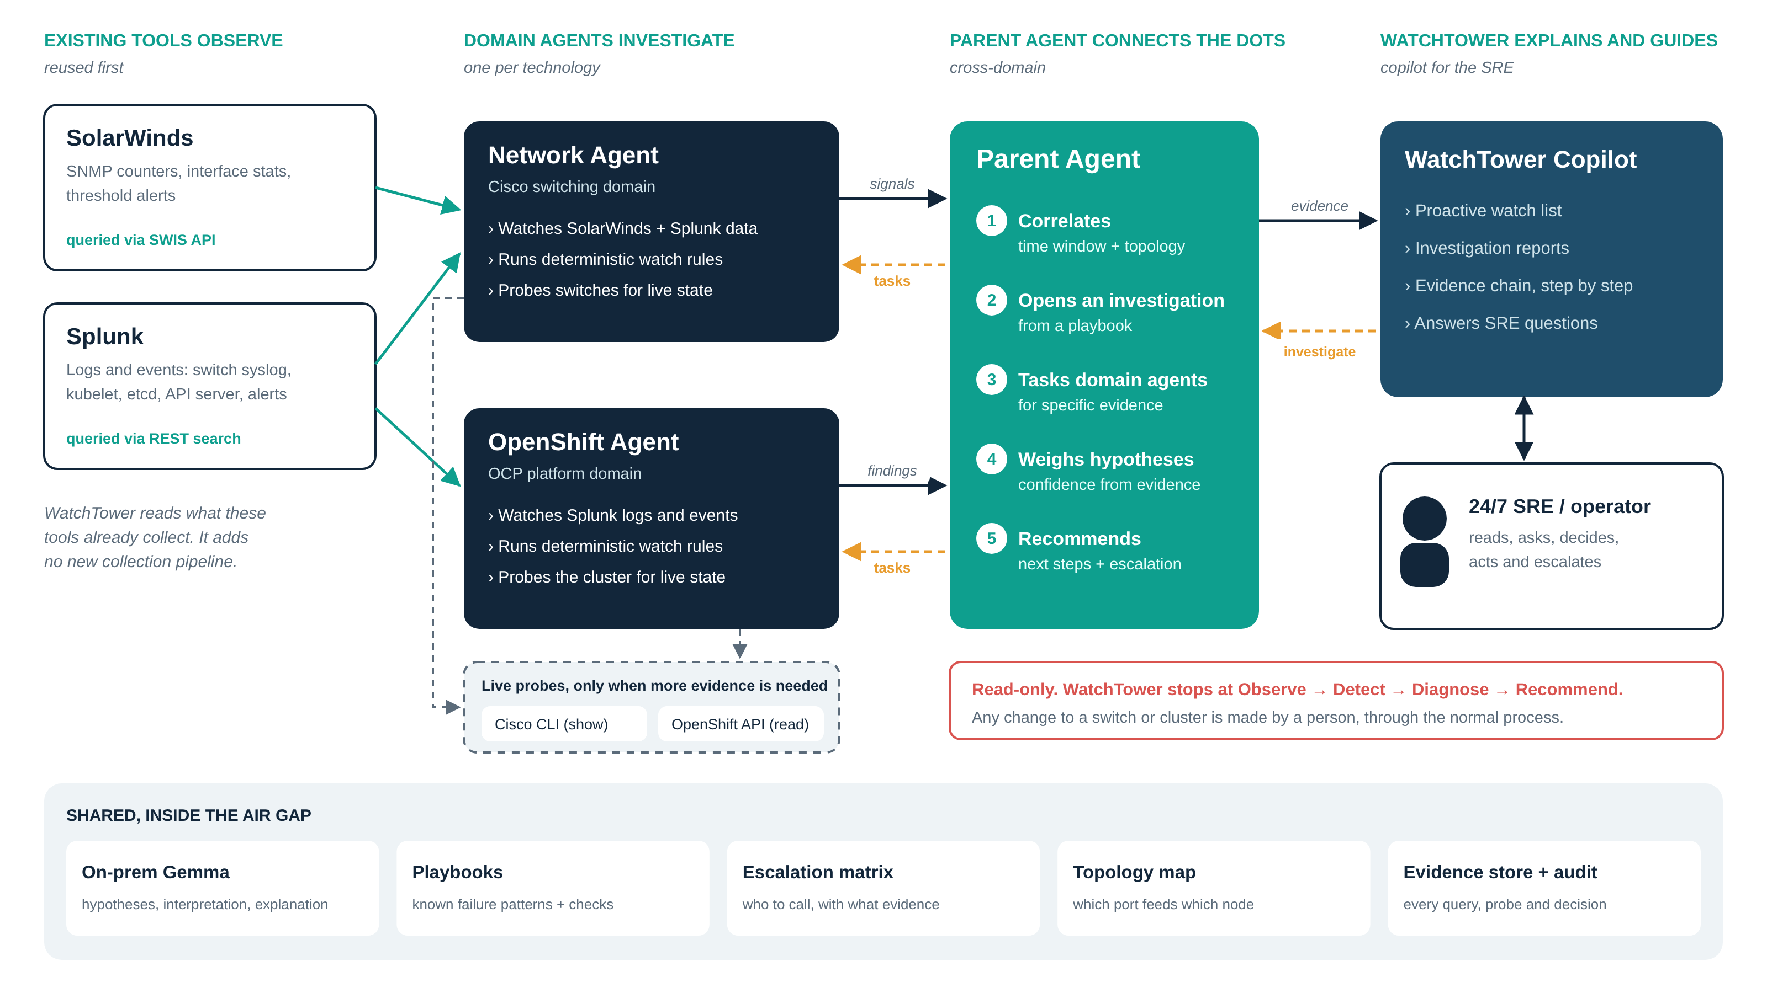
Figure 1. How the agents interact

6.1 The agents
- Network Agent (Cisco domain). Every minute it queries SolarWinds for interface traffic, discards and errors and Splunk for switch syslog, and runs watch rules such as "output drops rising for three polls" or "utilisation above its baseline". When tasked, it gathers named evidence, probing a switch over SSH with show commands only when the playbook needs live state.
- OpenShift Agent (OCP domain). Every 30 seconds it queries Splunk for API timeouts per node, kubelet lease errors, etcd latency warnings and node events. Because OpenShift events go into Splunk, it answers investigation questions from Splunk too: NotReady and Ready times, reboots and kubelet restarts (the kubelet's Rebooted and Starting events), API server and etcd restarts (pod restart events), evictions and resource pressure. Node CPU comes from SolarWinds where the node is monitored there. The OpenShift API (read-only) is only a fallback when Splunk has a gap.
- Parent Agent. Correlates signals across domains using the topology map and a time window, raises watch items, and opens investigations when a watch item becomes strong, a node changes state, or an SRE asks. It runs the matching playbook, tasks the domain agents for evidence, scores hypotheses and produces recommendations and an escalation.
- WatchTower Copilot. The SRE's interface: watch items, alarms from the existing tools with an Investigate button, investigation reports with the full evidence chain, an Ask box, and a copyable escalation note.

6.2 How they talk
Domain agents publish signals (deterministic watch-rule hits, each with the exact query that produced it). The Parent Agent sends tasks back ("collect evidence X for investigation Y"), and domain agents answer with evidence items. Investigations and watch items go to the Copilot; SRE questions and investigate requests come back the same way. In the PoC this is a Redis Streams bus; in production any durable queue inside the air gap would do. All agents share the on-prem Gemma, the playbooks, the escalation matrix, the topology map and an evidence store with a full audit log.

6.3 Reuse first, probe second
Question during an investigation | First: reuse | Second: probe, only if needed
Are API calls from master-2 timing out? | Splunk: API client and kubelet logs | None needed
Did master-2 go NotReady, and for how long? | Splunk: NodeNotReady / NodeReady events | None needed
Did it reboot, or did key services restart? | Splunk: Rebooted, Starting and pod restart events | None needed (OpenShift API only if Splunk has a gap)
Any evictions or resource pressure? | Splunk: eviction and pressure events; SolarWinds node CPU | None needed
Are drops rising on the switch port that feeds it? | SolarWinds: interface discards | CLI show interfaces, only if the last poll is over 2 minutes old
Congestion or a bad link? | SolarWinds: CRC and input errors | CLI per-queue drops: the one probe (SolarWinds does not poll them unless CBQoS is enabled)
Has any existing alarm fired? | SolarWinds active alerts, Splunk fired alerts | None needed

With OpenShift events in Splunk, 11 of the 12 evidence items in the master-2 investigation are reused from Splunk and SolarWinds. The only live probe is per-queue drops on the switch port, which separates bursty congestion from other causes and is not polled by SolarWinds. Each evidence item records its source, the exact SPL, SWQL, command or API call, a raw excerpt, and why any probe was needed. The Copilot shows the reuse rate for every investigation (target: 85% or more). Probes are capped at three per investigation and rate-limited per device. Nothing Splunk or SolarWinds already ingests is collected again.

7. How an investigation works
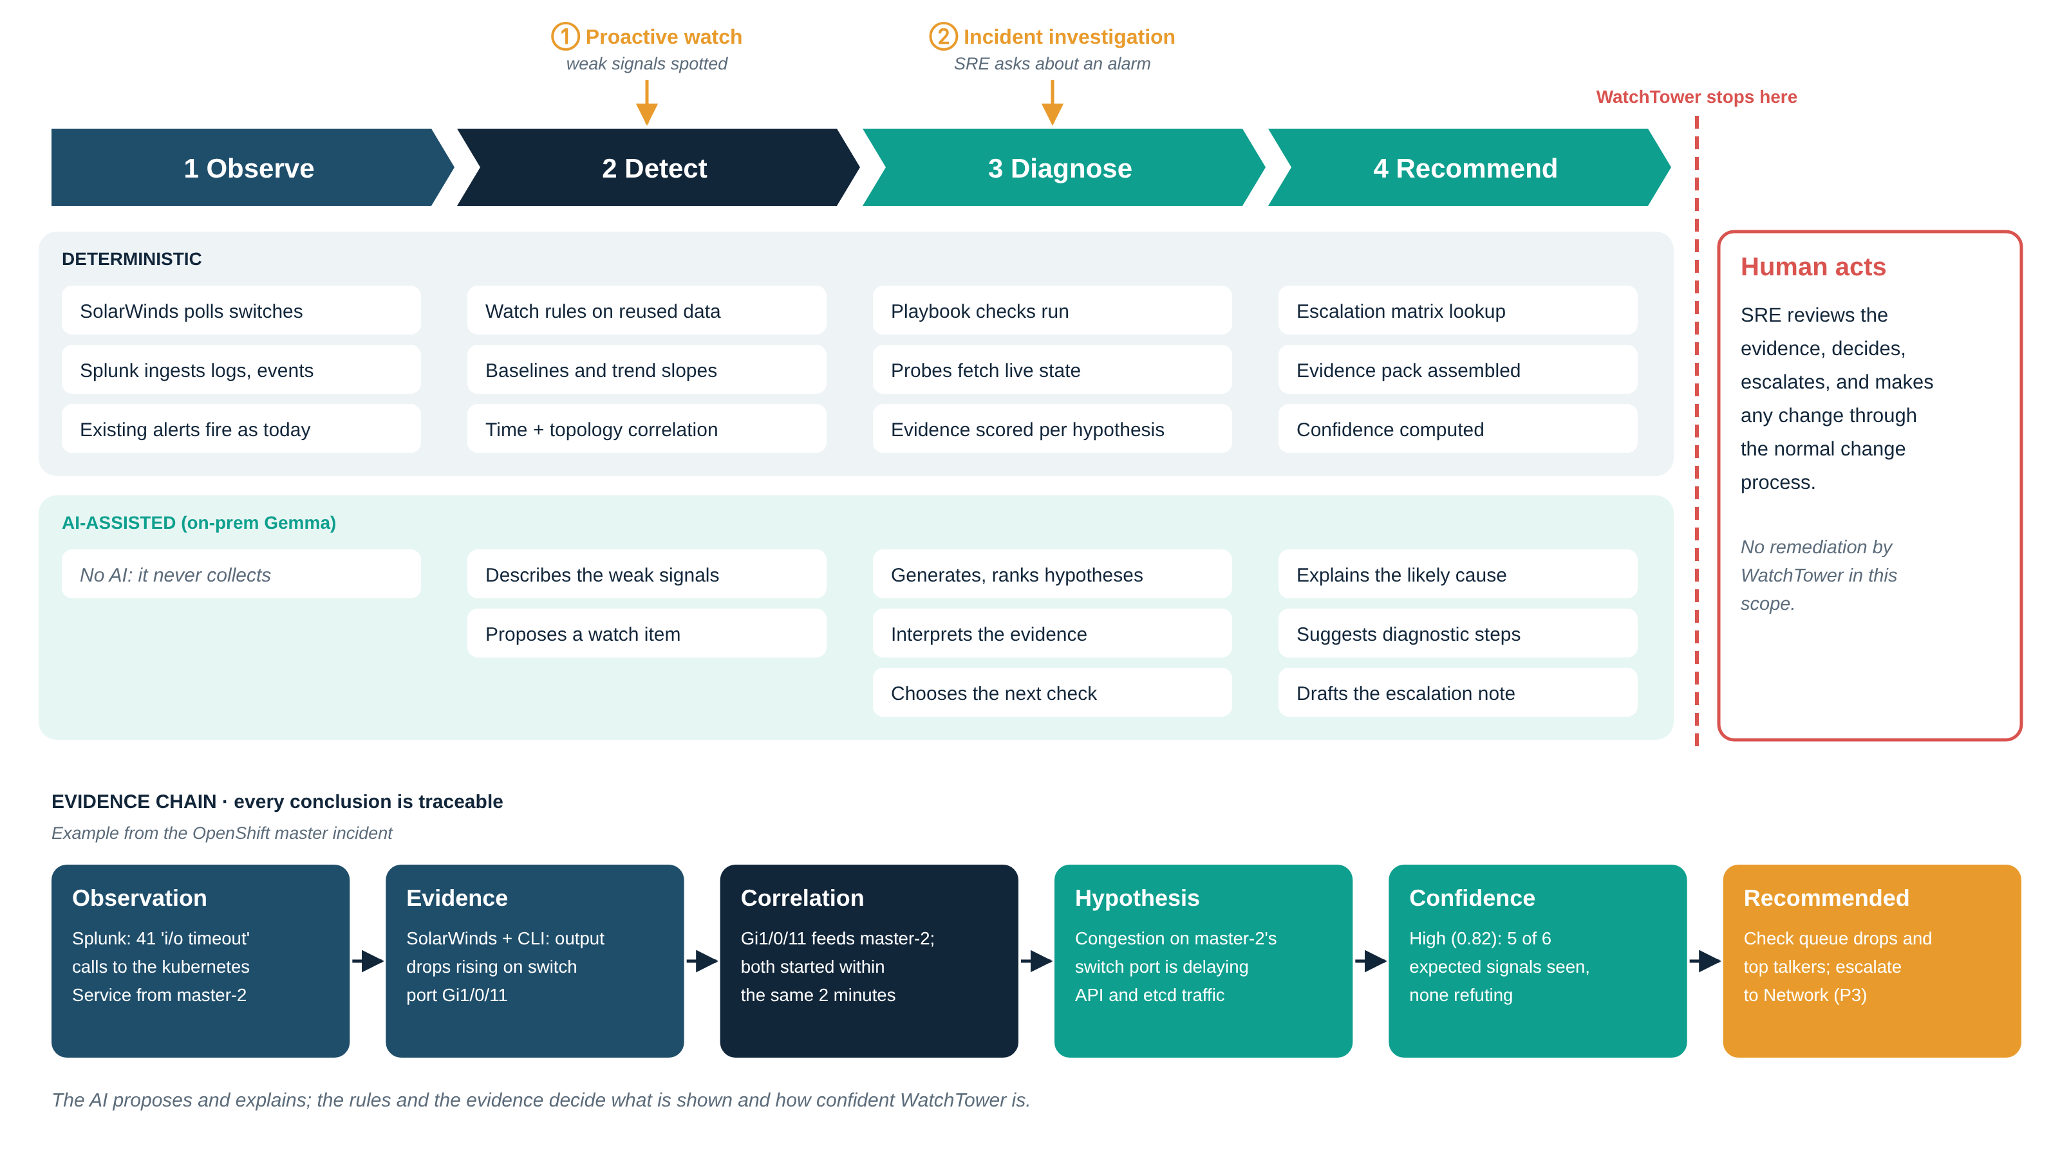
Figure 2. Observe, Detect, Diagnose, Recommend, with the evidence chain for the master-2 example

7.1 Two ways in
- Proactive watch enters at Detect: weak signals from different domains, linked by topology and time, become a watch item. A strong watch item opens an investigation on its own.
- Incident investigation enters at Diagnose: an SRE picks an alarm from Splunk or SolarWinds and asks WatchTower to investigate.

7.2 Playbooks, hypotheses and confidence
Each kind of problem has a playbook: the facts to establish first (what happened), the candidate hypotheses, the evidence each one expects, what would refute it, and the read-only actions that may be recommended. For the node flap:
Hypothesis | Evidence for | Evidence against | Score
H1 Congestion on master-2's network path | Partial timeouts, lease failures, drops rising on its port, drops in one queue, no CRC | None | 0.82
H2 SDN / OVN datapath fault | Timeouts from the node | Only calls that leave the node fail | 0.18
H3 etcd slow disk | etcd latency warnings | No fsync warnings; peer latency instead | 0.12
H4 Node resource starvation | None | No pressure events; CPU 22% (SolarWinds) | 0.06

Scores are computed in code: weighted supporting evidence minus refuting evidence, divided by all expected evidence. The model may propose extra hypotheses, interpret evidence that has no rule, and adjust a score by at most 0.10 with a stated reason. Values above are the wireframe example, not measured results.

7.3 Recommendations and escalation
Next steps are chosen from the playbook's catalogue of read-only checks (for example, per-queue drop statistics on the switch port, or watching the node's lease renewals). The escalation matrix routes by the top hypothesis and impact: a single recovered flap with the cause still present is P3 to the Network team; a repeat flap within an hour, or NotReady beyond 300 seconds, is P2. The Copilot drafts the escalation note with the evidence pack. WatchTower stops there: any change is made by the owning team through change control.

8. The two modes, as the SRE sees them

8.1 Mode 1: Proactive watch
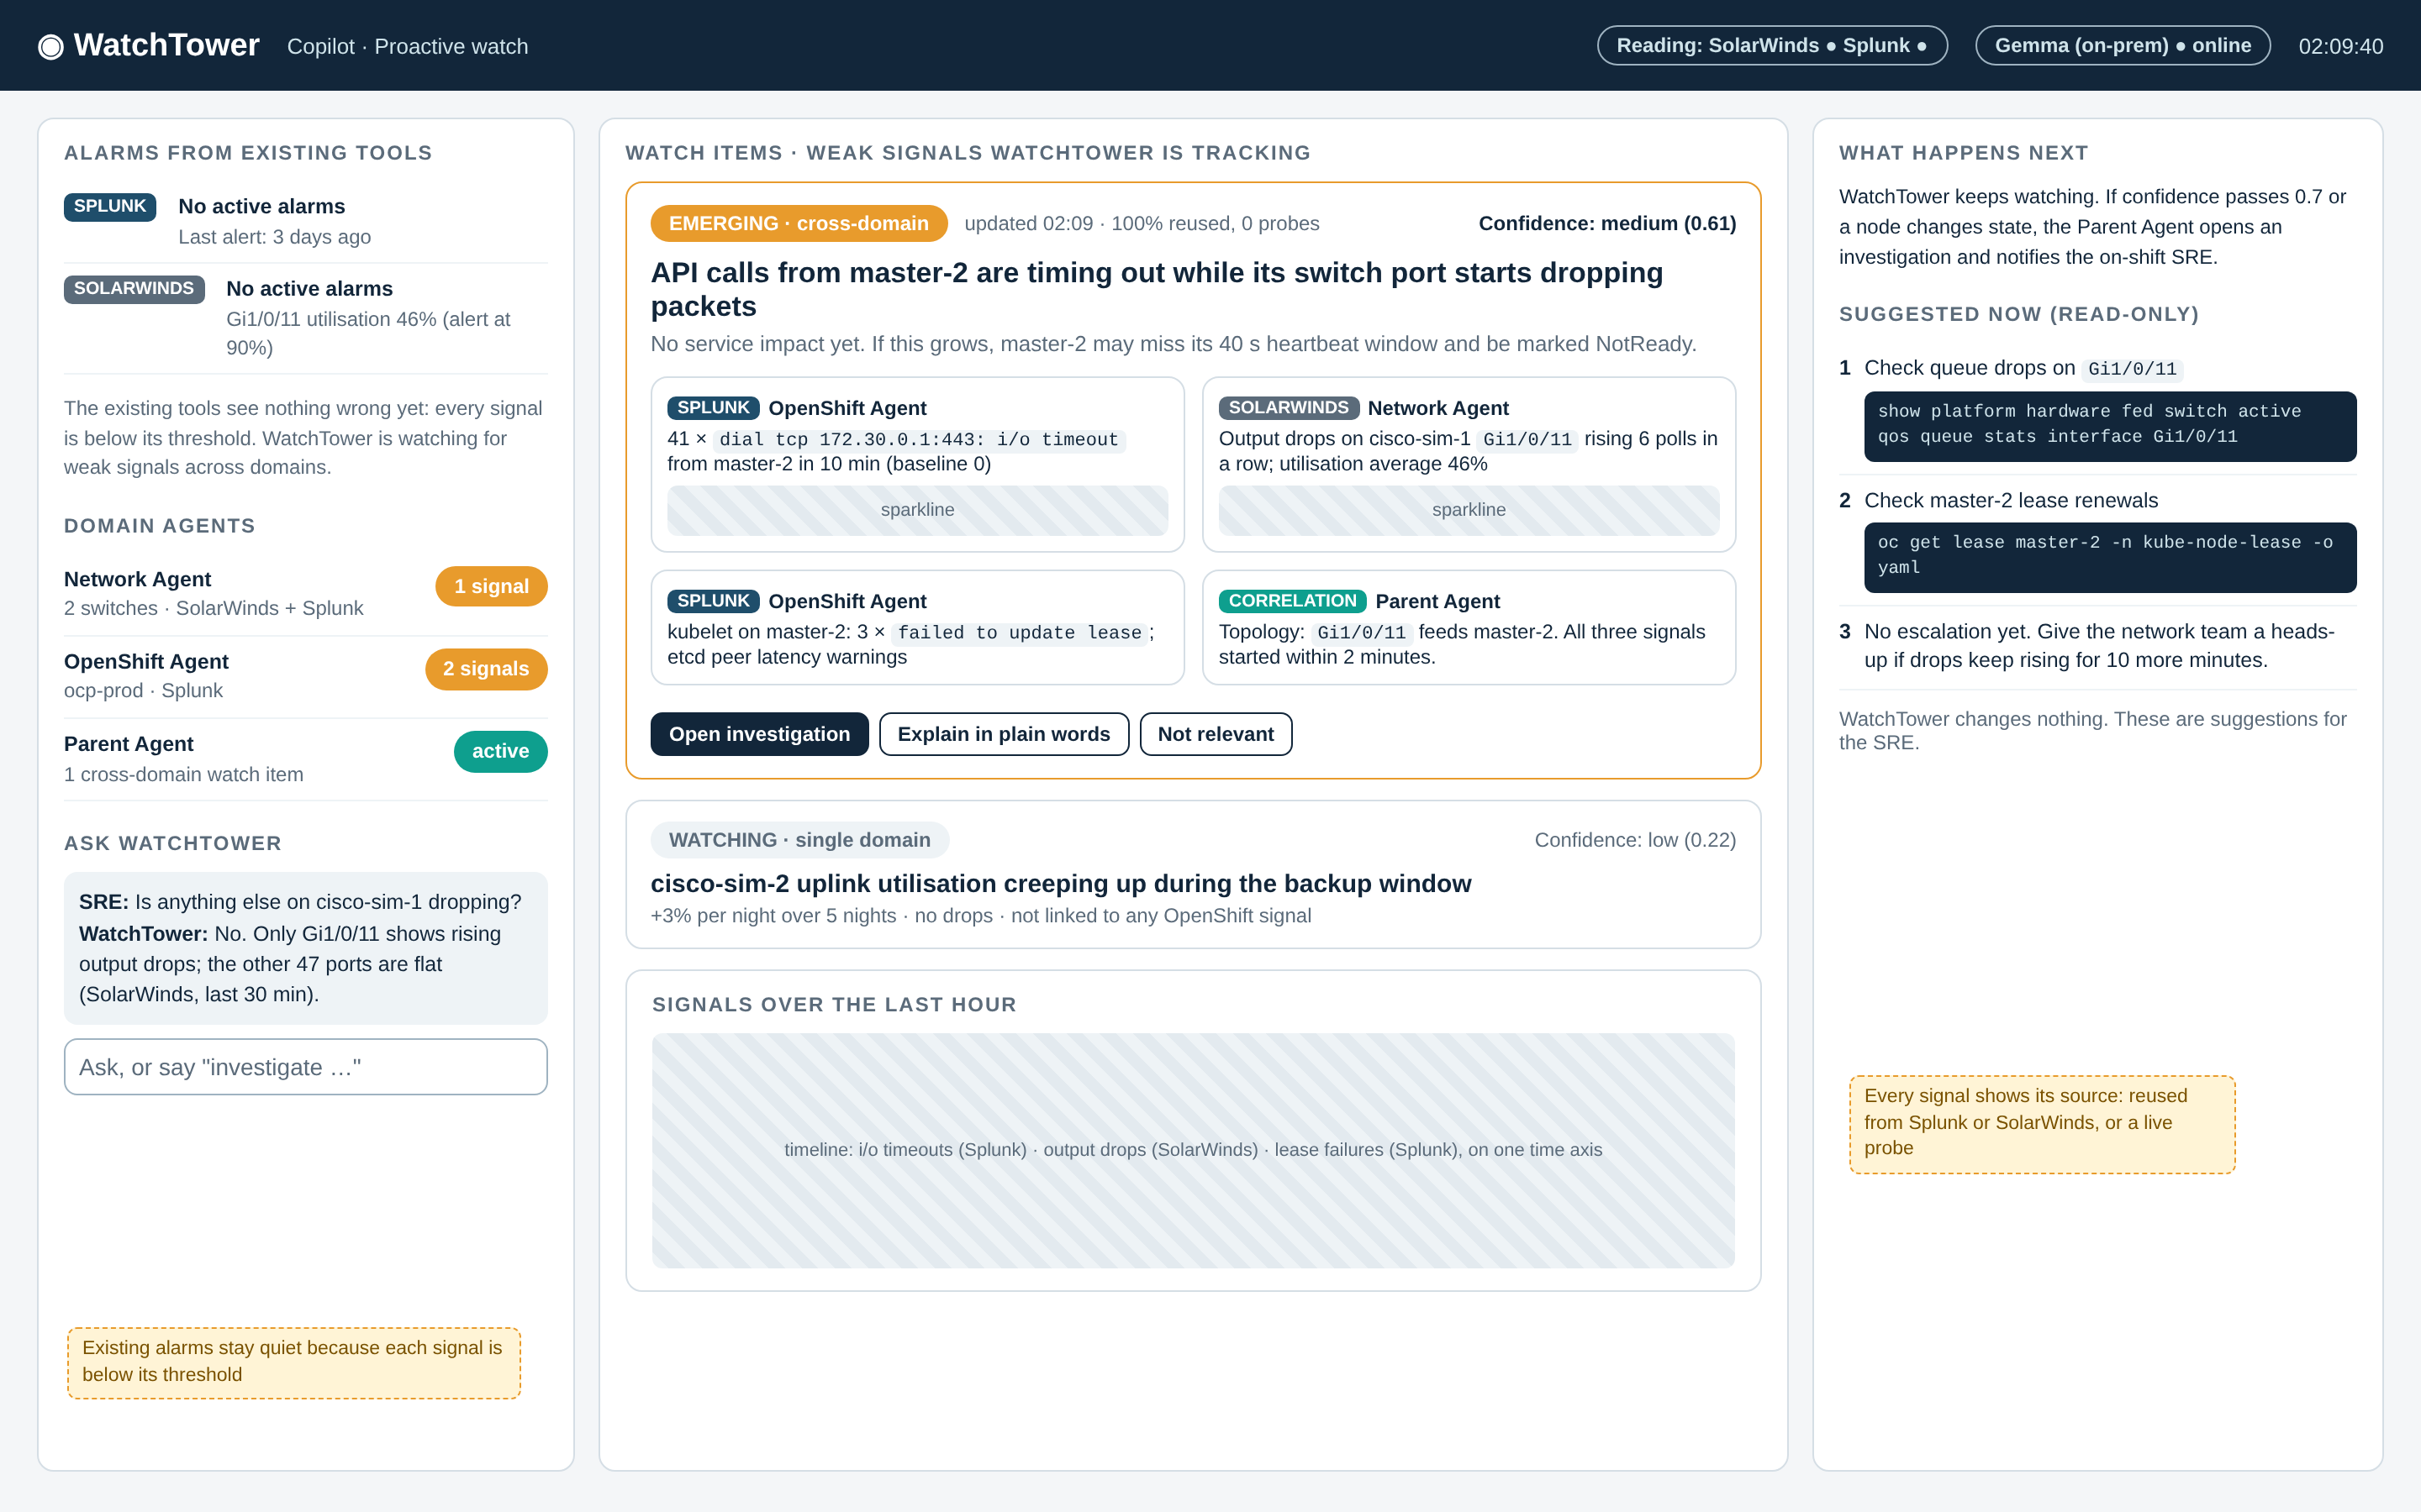
Figure 3. Wireframe: proactive watch
The existing tools show no alarms: the switch port averages 46% against a 90% threshold, and nobody has a search for API timeouts from one master. WatchTower joins three weak signals (timeouts in Splunk, rising output drops in SolarWinds, lease update failures) with the topology map and raises an emerging, cross-domain watch item at medium confidence, explaining what will happen if it grows and what to check now.

8.2 Mode 2: Incident investigation
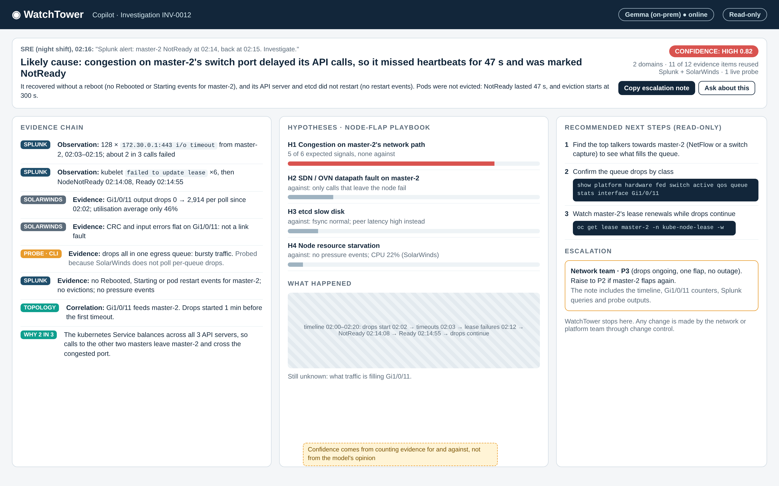
Figure 4. Wireframe: incident investigation
The SRE asks WatchTower to investigate a Splunk NodeNotReady alert. WatchTower answers with the likely cause and its confidence, a plain account of what happened (a 47-second NotReady, no reboot, no eviction, all shown from Splunk events), the evidence chain with each line tagged by source (11 of 12 items reused, one live probe), the ranked hypotheses with evidence for and against, three read-only next steps, and a recommended escalation to the Network team at P3.

9. Making a modest on-prem model useful
The on-prem Gemma (about 40B) may not be fully competent at agentic work. WatchTower therefore gives it six narrow jobs, each with a short prompt, two worked examples and a JSON schema:
- Summarise a watch item in plain words.
- Propose up to two hypotheses beyond the playbook (they start at zero confidence).
- Interpret evidence that no rule covers, such as a log excerpt: supports, refutes or neutral, with a reason.
- Explain the likely cause and what happened, including whether the node rebooted.
- Choose next steps from the playbook's catalogue and draft the escalation note.
- Answer SRE questions only from stored investigations, citing evidence.
Guard rails: detection, correlation and scoring never depend on the model, and the demo ranks the right cause with it switched off. Responses are schema-validated, retried once, then replaced by a rule-based fallback. The model is called only when inputs change. An evaluation harness scores any model on these six jobs, so the PoC can measure the small Gemma models and the pilot can measure the on-prem Gemma rather than guess.

10. Landscape
Existing work | Relevance
Red Hat OpenShift Lightspeed | AI assistant in the OpenShift console. One cluster, chat-driven, no network view. Could complement the OpenShift Agent if disconnected mode suits our version.
HolmesGPT, K8sGPT | Open-source projects that diagnose Kubernetes issues and work with local models. Useful ideas for OpenShift playbooks.
MCP servers for Kubernetes and Prometheus | Open-source tool servers that give agents safe, read-only access.
Red Hat FSE 2026 industry paper | Experience report on LLM agents for AIOps on OpenShift: useful, with clear limits on autonomy.
OpsBot (SolarWinds community) | Multi-agent AIOps idea on top of SolarWinds data.
Commercial AIOps (Dynatrace, Splunk ITSI) | Strong, but costly and often cloud-tied.

The gap: existing assistants are single-domain or need the cloud. None investigates across the switch and the cluster together, from the tools we already run, inside an air gap. WatchTower reuses the open pieces and adds cross-domain investigation with evidence.

11. Builders Day proof of concept

11.1 The lab
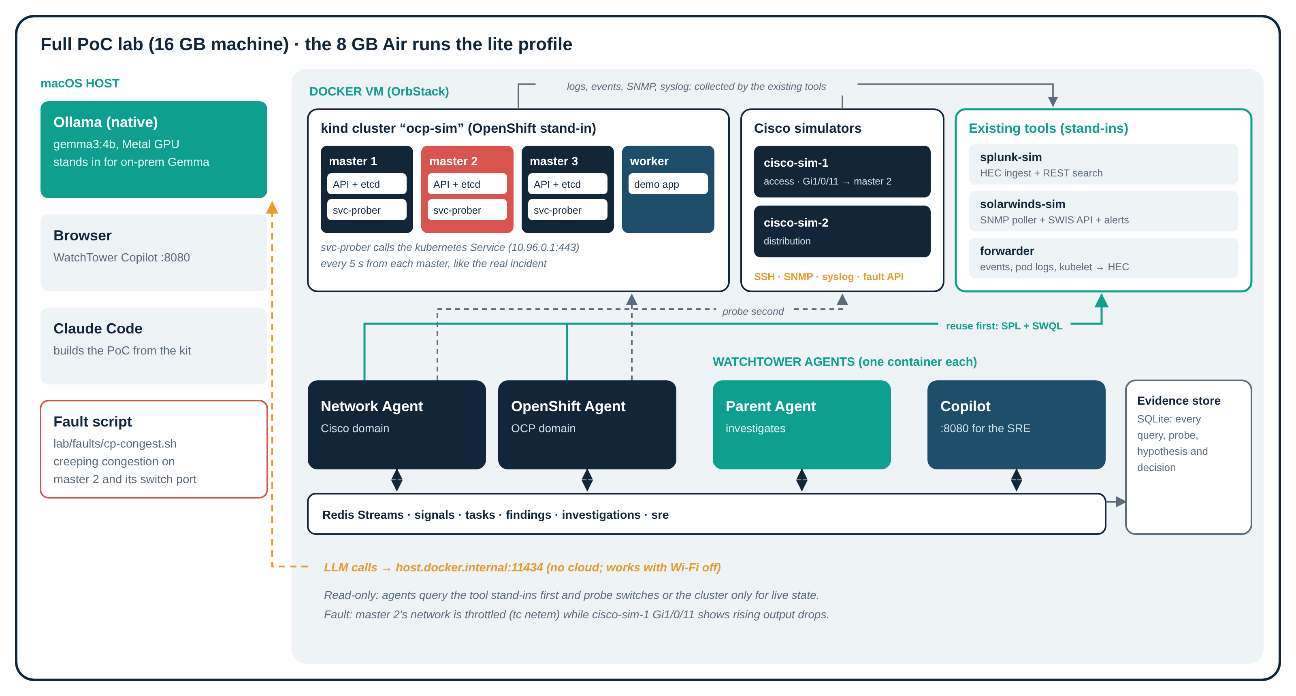
Figure 5. The PoC lab on a MacBook Air M2
Real system | PoC stand-in | Why
OpenShift (3 masters + workers) | kind: 3 control-plane nodes + 1 worker, plus svc-prober calling the kubernetes Service every 5 s | Three API servers make the Service load-balancing real; node network can be degraded with tc
Cisco access + distribution switch | Two Python simulators: IOS-style SSH CLI, SNMP, syslog, fault API | M2 cannot run VM-based IOS images; simulators give repeatable faults
Splunk (+ forwarders) | splunk-sim (HEC, SPL subset, saved-search alerts) + forwarder for events, pod logs, kubelet journal, syslog | WatchTower must query Splunk's real API shape
SolarWinds NPM | solarwinds-sim: SNMP poller + SWIS/SWQL subset + alerts | Same, for SolarWinds
On-prem Gemma | gemma3:1b in Ollama on the 8 GB Mac (gemma3:4b on 16 GB) | Same family; a harsher test

11.2 Reproducing the incident
A fault script degrades master-2's network in phases (creeping delay and loss, then a 75-second burst of heavy loss, then partial recovery) while the switch simulator raises output drops on the port that feeds master-2, with no CRC errors. Calls from master-2 to the kubernetes Service to the other two masters time out; lease renewals fail; after 40 seconds master-2 is marked NotReady and then returns to Ready, with no Rebooted or Starting event, exactly as WatchTower would see it in Splunk.

11.3 Feasibility on an M2 Air
Stand-in | Mimics | Fit on an M2 Air | Verdict
kind lite, 1 master + 1 worker | OpenShift | About 1.5 GB; fault goes on the worker | Use on 8 GB
kind full, 3 masters + 1 worker | OpenShift HA control plane | 4.5 to 5.5 GB | 16 GB only
OpenShift Local (CRC) | Real OpenShift | Single node, about 10.5 GB on its own | Not on an Air
Cisco simulators | IOS-XE CLI, SNMP, syslog | Native | Recommended
GNS3, vrnetlab, CML | Real Cisco IOS | x86 VMs; no nested virtualisation on M2 | Not feasible
splunk-sim, solarwinds-sim | Splunk search, SolarWinds SWIS | Native, small | Recommended
gemma3:1b in Ollama (4b on 16 GB) | On-prem Gemma | About 1 GB, Apple GPU; or model off | Use on 8 GB

The demo Mac is an 8 GB M2 Air, so the PoC runs a lite profile. It uses one master and one worker instead of three masters, all four agents in one container, the simulators in another (one switch), and gemma3:1b with a short context. Estimated total: 6 to 7.5 GB including macOS and Safari (not yet measured). The fault goes on the worker: its API calls and heartbeat renewals all cross the congested switch port, so it flaps NotReady through exactly the same mechanism as the real incident, without a reboot. What the lite lab cannot show is the master-specific "2 in 3 calls" pattern, which needs three API servers; the slides and wireframes carry that. If memory gets tight on the day, the model can be switched off: detection, ranking and the evidence chain do not depend on it.
Recommended order on the day: slides and wireframes, then the replay of a recorded lite run, then the live lite run as the finale if the Mac is behaving. The full profile (three masters, gemma3:4b, about 12.5 to 15 GB) needs a 16 GB machine.

11.4 Demo storyline and definition of done
- 0:00 Inject. The fault script starts creeping congestion on master-2's path and switch port.
- About 5:00 Proactive watch. Splunk and SolarWinds are quiet; WatchTower raises a cross-domain watch item at medium confidence.
- About 10:30 Node flap. master-2 is NotReady for about 45 seconds, then Ready; the Splunk NodeNotReady alert fires.
- 11:00 Investigate. The SRE clicks Investigate; evidence arrives live.
- About 13:00 Answer. Likely cause, no reboot, evidence chain, next steps, Network team P3.
Done when: the watch item names master-2 and switch port Gi1/0/11 within 6 minutes while neither stand-in tool has alarmed; the investigation ranks congestion first at 0.7 or more within 3 minutes, shows "no reboot" from Splunk events, takes at least 85% of its evidence from Splunk and SolarWinds, lists at least three read-only steps and recommends the Network team at P3; the same top cause comes out with the LLM off; and the recorded replay reproduces both screens with the lab stopped.

11.5 Build plan and PoC kit
Eight phases, each with a prompt and a "done when" check: skeleton; lab; Splunk and SolarWinds stand-ins; domain agents; parent agent; Copilot; demo, record and replay; eval and polish. The PoC kit contains the master prompt and CLAUDE.md for Claude Code, the eight phase prompts, four skills (lab control, domain agent, investigation playbooks, demo scenario), the contracts (signal, investigation, sources, topology, escalation), two playbooks, the wireframes and the fault script.

12. Roadmap
Phase | Scope
PoC (Builders Day) | MacBook Air lab: Cisco + OpenShift, one incident, both modes.
Pilot | One real OpenShift cluster and its access switches, real Splunk and SolarWinds, the on-prem Gemma, read-only. Measure the model with the eval and tune playbooks on past incidents.
Expand | More playbooks and clusters. Palo Alto and Nutanix agents on the same pattern, reusing Splunk and SolarWinds first.
Out of scope | Remediation. Only ever with SRE approval and change control, if at all.

13. Risks and mitigations
Risk | Mitigation
Wrong or invented explanation | Rules rank hypotheses; the model must cite evidence; schema-validated; rule fallback; ±0.10 cap
Noisy watch items erode trust | Only cross-domain, topology-linked items rise to medium; SRE "not relevant" feedback tunes rules
Probes add load or risk on devices | Reuse first; show-only allowlist; probe cap per investigation; rate limit per device; audit log
Splunk or SolarWinds lack a needed signal | The sources map shows the gap; add it to the existing tool rather than a new collector where possible
On-prem Gemma not competent enough | Narrow jobs, worked examples, schemas; the demo works with the model off; the eval measures it
Agent credentials widen the attack surface | Read-only scoped accounts in a vault; get/list/watch RBAC; security review before the pilot
Live demo fails on the day (8 GB, fanless) | Lite profile; walkthrough first, recorded replay, model can be switched off, lab started shortly before presenting
Lab realism (kind is not OpenShift; simulators are not IOS) | The agent design carries over; OpenShift-specific sources and real fixtures come in the pilot

14. Confirmed answers and open questions

14.1 Confirmed
Topic | Answer and effect on the design
Positioning | AI operations copilot above SolarWinds and Splunk; not a dashboard or failure predictor.
Scope | Cisco and Red Hat OpenShift only for now.
On-prem LLM | Air-gapped Gemma (about 40B), possibly not fully competent. Monitoring and scoring stay deterministic; the model is measured with an eval.
Access | Read-only. No remediation: stop at Recommend.
SolarWinds and Splunk | Reuse first; do not re-ingest what another source already ingests. Keep reuse as high as possible.
OpenShift events | Go into Splunk. Reboot, restart, eviction and NotReady checks therefore come from Splunk, not the OpenShift API.
PoC | One to two of each device type. MacBook Air M2 with 8 GB, so the lite profile. Walkthrough with wireframes, live demo if possible.

14.2 Still open
- Incident data to confirm the node-flap explanation: NotReady and Ready event times, any Rebooted or restart events, switch drops at the time.
- Do kubelet and control-plane container logs reach Splunk as well as events (assumed), and under which index and sourcetype?
- Which switch metrics SolarWinds polls (discards and errors per interface?).
- How the on-prem Gemma is served (OpenAI-compatible endpoint or not) and its context window.

15. References
- OpenShift worker latency profiles (OKD 4.17 documentation): https://docs.okd.io/4.17/nodes/clusters/nodes-cluster-worker-latency-profiles.html
- How to improve cluster stability in different latency environments using worker latency profiles (Red Hat blog): https://www.redhat.com/it/blog/how-to-improve-cluster-stability-in-different-latency-environments-using-worker-latency-profiles-for-openshift
- Kubernetes nodes: heartbeats: https://kubernetes.io/docs/concepts/architecture/nodes/#node-heartbeats
- LLM Agents for AIOps in Kubernetes: An Industrial Experience Report with Red Hat OpenShift (FSE 2026): https://conf.researchr.org/details/fse-2026/fse-2026-industry-papers/38/LLM-Agents-for-AIOps-in-Kubernetes-An-Industrial-Experience-Report-with-Red-Hat-Open
- How to operate OpenShift in air-gapped environments (Red Hat Developer, 2026): https://developers.redhat.com/articles/2026/03/19/how-operate-openshift-air-gapped-environments
- Red Hat OpenShift Lightspeed documentation: https://docs.redhat.com/de/documentation/red_hat_openshift_lightspeed/1.0/html-single/about/index
- Kubernetes MCP server (containers/kubernetes-mcp-server): https://glama.ai/mcp/servers/@containers/kubernetes-mcp-server/blob/8e4d5fe4d0f97b88d9fd5277c6aee3b95638c525/README.md
- HolmesGPT overview: https://dev.co/devops/open-source/holmesgpt
- OpsBot: multi-agent AIOps for SolarWinds (THWACK): https://thwack.solarwinds.com/discussion/comment/525395
- containerlab on macOS: https://containerlab.dev/macos/
- GNS3 on Apple Silicon notes: https://nerdydrunk.info/cisco:gns3-apple-silicon

