AeroSense IoT Data Engineering Platform
Final Practical Assessment Report
Student ID | 20252190
Student name | YIN BANGYAO
School e-mail | bangyao.yin@efrei.net
Course | XICS404 Big Data Engineering
EFREI Paris - School of Engineering and Computer Science
Generated evidence date: 19 May 2026

1. Executive Summary
This report documents a complete local data engineering platform for AeroSense IoT sensor data. The implementation covers Kafka ingestion, reliable Python production, Spark Structured Streaming, a three-zone data lake, Spark SQL analytics and a Flask REST API. The platform was executed locally with Docker Desktop and produced real evidence screenshots and output files.
Area | Evidence | Result | Status
Kafka | 3 brokers, RF=3, ISR=2 | Topic sensor-events created | Passed
Producer | 300 messages | 36 anomalies, 12.0% | Passed
Spark | raw/curated/consumption zones | 300 curated rows, 3 aggregate rows | Passed
Analytics | 4 Spark SQL queries | CSV files in outputs/analytics | Passed
REST API | 6 endpoints tested | 200/201/422 responses verified | Passed

2. Target Architecture
The system follows the required lifecycle: Generation -> Ingestion -> Processing -> Storage -> Exposure -> Consumption. Kafka receives keyed sensor events, Spark processes them into lake zones, and the API plus analytics scripts consume the resulting data.
Python producer -> Kafka topic sensor-events -> Spark Structured Streaming
-> raw JSON zone
-> curated Parquet zone
-> consumption Parquet zone
-> Spark SQL analytics and Flask REST API
- Kafka topic: sensor-events, 3 partitions, replication factor 3, min.insync.replicas 2.
- Message key: sensor type, preserving ordering per sensor type.
- Data lake layout: raw by ingestion time, curated by event-time sensor partitions, consumption by aggregate use case.

3. Step 1 - Infrastructure and Kafka Topic
The Docker Compose stack starts three Confluent Kafka 7.5 brokers in KRaft mode and one Kafka UI container on port 8080. The topic was created with three partitions and replication factor three.
docker compose up -d
docker exec kafka1 kafka-topics --bootstrap-server kafka1:29092 --create --if-not-exists --topic sensor-events --partitions 3 --replication-factor 3
docker exec kafka1 kafka-configs --bootstrap-server kafka1:29092 --alter --entity-type topics --entity-name sensor-events --add-config min.insync.replicas=2
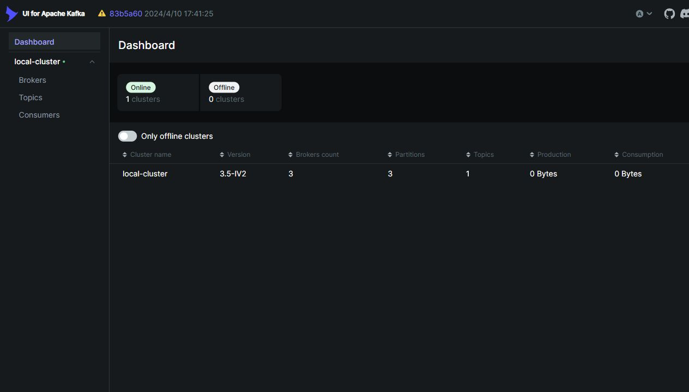
Figure 1 - Kafka UI showing the local cluster online with 3 brokers.
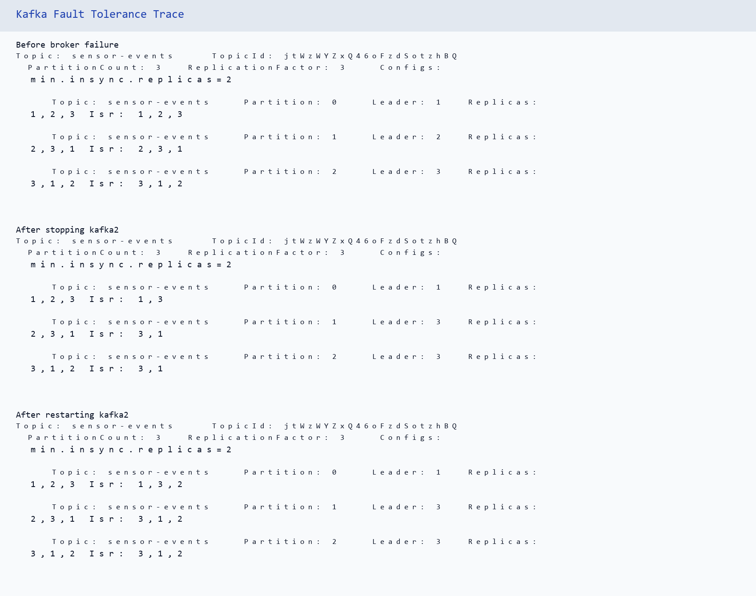
Figure 2 - Fault-tolerance trace before and after stopping kafka2.
When kafka2 was stopped, partition 1 moved from leader 2 to leader 3 while the ISR remained at two replicas. This confirms the expected leader re-election behavior with one broker unavailable.

4. Step 2 - Reliable Python Producer
The producer generates temperature, humidity and pressure readings using realistic ranges. It enforces at least 10% anomalies, uses the sensor type as Kafka key, and configures reliable delivery with acks=all, retries=5 and one in-flight request per connection.
python src/producer.py --count 300 --rate 60 --source site-A-rack-12
Produced 300 events to sensor-events; anomalies=36 (12.0%).
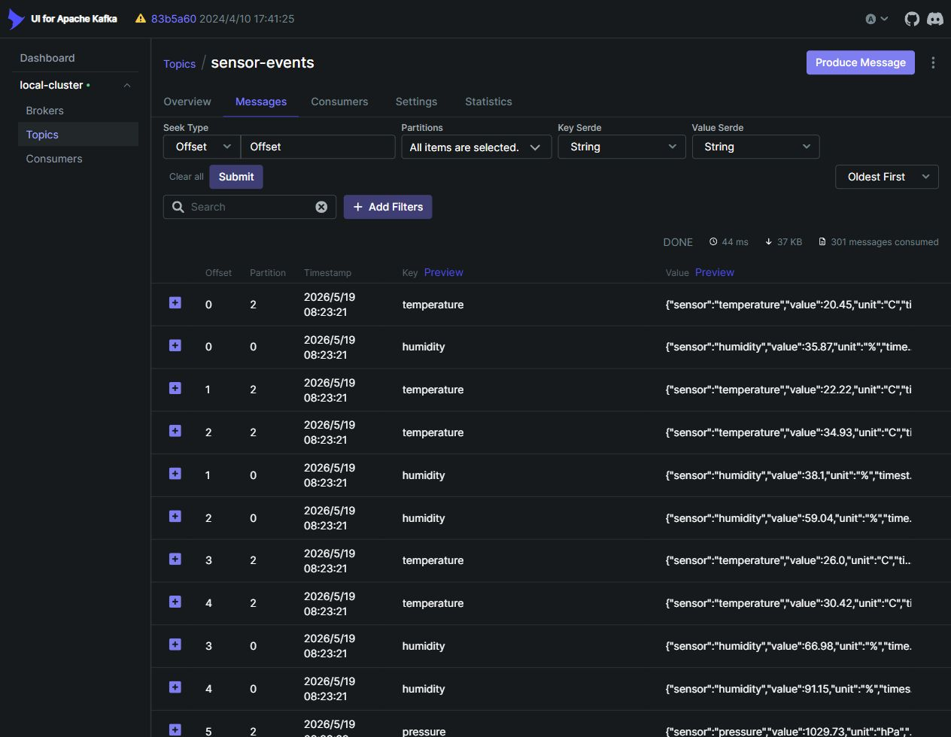
Figure 3 - Kafka UI Messages tab showing keyed sensor events in sensor-events.

5. Step 3 - Spark Structured Streaming Pipeline
The Spark job subscribes to Kafka in streaming mode, parses JSON with an explicit schema, validates plausible values, computes the independent is_anomaly flag, applies a two-minute watermark and writes three lake zones. The run used availableNow mode to process the current Kafka backlog and stop cleanly for assessment evidence.
spark-submit --packages org.apache.spark:spark-sql-kafka-0-10_2.12:3.5.3 src/spark_pipeline.py --once --datalake-root datalake --checkpoint-root checkpoints
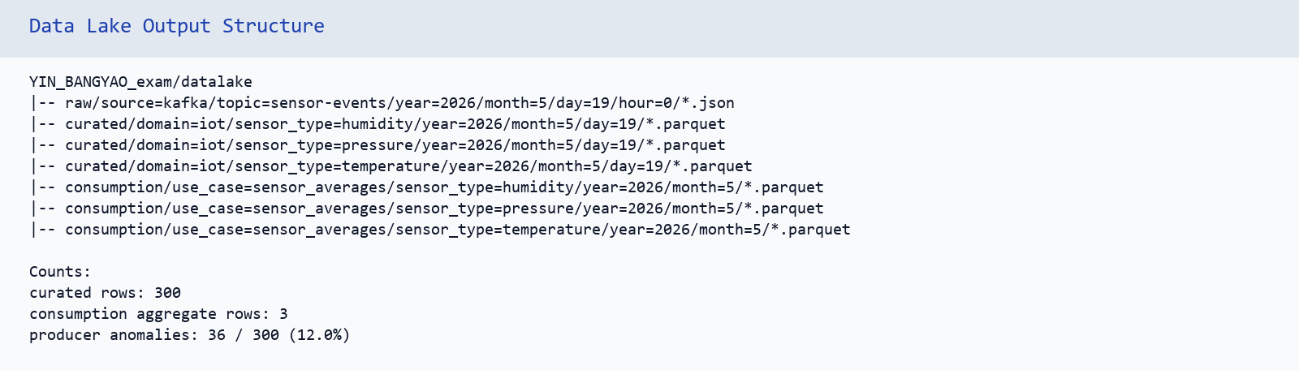
Figure 4 - Data lake output structure and row counts after the Spark pipeline.

6. Step 4 - Spark SQL Analytics
The analytics script reads the curated Parquet zone and executes the four required queries: top anomaly hours, statistics by sensor, temperature daily evolution and a partition pruning comparison. Results are printed and exported as CSV directories under outputs/analytics.
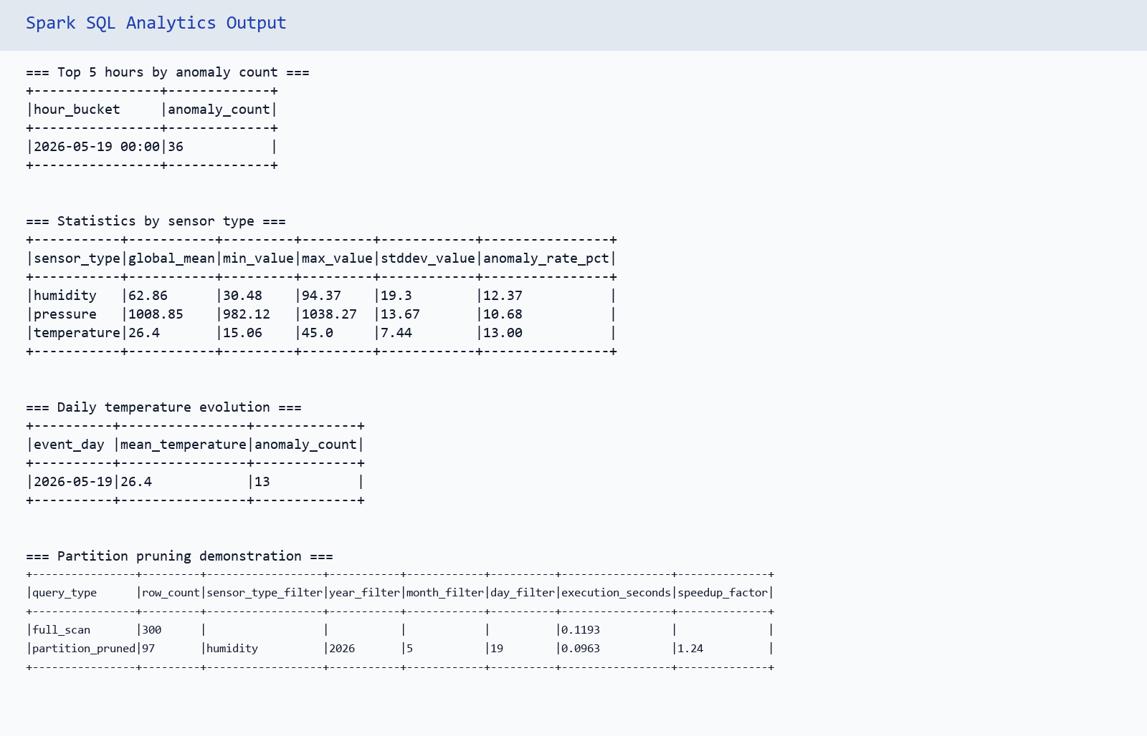
Figure 5 - Spark SQL analytics output and partition pruning timing.

7. Step 5 - REST API
The Flask API exposes health, sensor metadata, latest Kafka readings, Parquet-backed statistics, anomaly lists and POST ingestion. All success and error responses use a consistent JSON envelope. Input validation distinguishes malformed requests from semantic errors.
GET /api/v1/health
GET /api/v1/sensors
GET /api/v1/sensors/<type>/latest
GET /api/v1/sensors/<type>/stats?days=N
GET /api/v1/anomalies?sensor=<type>&limit=N
POST /api/v1/readings
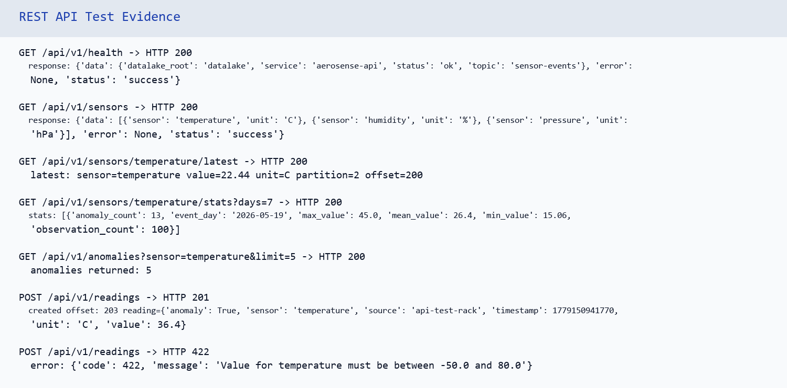
Figure 6 - REST API test evidence, including 200, 201 and 422 responses.

8. Technical Choices and Justification

Curated partitioning
The curated zone is partitioned by domain, sensor_type, year, month and day. Sensor type is a natural analytical filter and event-time dates preserve the real business day of the reading. I considered source-based partitions, but source can have higher cardinality and create many small files.

Spark output mode
Raw and curated records are append-only because every Kafka event becomes a lake record. The consumption aggregation uses update mode with foreachBatch so active five-minute windows can be refreshed while the watermark is open. A production version should use Delta Lake or Iceberg for idempotent upserts.

Replication factor and ISR
Replication factor 3 with min.insync.replicas 2 allows one broker failure while keeping acks=all writes durable across at least two replicas. Replication factor 1 would be faster but would not meet the fault-tolerance objective.

Event time versus ingestion time
Raw storage uses ingestion time because it is an operational landing zone. Curated and consumption zones use event time because analytics should represent when the sensor measured the value, even if ingestion is delayed.

Delivery semantics
The platform provides at-least-once semantics. Kafka producer reliability settings and Spark checkpoints reduce loss risk, but plain Parquet files do not provide cross-sink transactions. Topic, partition and offset columns are retained to support deduplication or recovery.

9. Limitations and Improvements
- The local Parquet lake does not provide ACID transactions; Delta Lake or Iceberg would be stronger for production.
- The REST API reads Parquet files directly with pandas, which is acceptable for this assessment dataset but not for high-volume serving.
- The latest Kafka endpoint scans a bounded recent offset range rather than maintaining a dedicated serving cache.
- Future improvements: Schema Registry, authentication, metrics, alerting, Dockerized Spark and a quarantine zone for invalid sensor records.

10. Submission Checklist
Deliverable | Location | Status
README | README.md | Completed
Docker Compose | docker-compose.yml | Completed
Producer | src/producer.py | Completed
Spark pipeline | src/spark_pipeline.py | Completed
Analytics | src/analytics.py and outputs/analytics | Completed
REST API | src/api/app.py | Completed
Fault tolerance notes | docs/fault_tolerance.md | Completed
Reflection answers | docs/reflection.md | Completed
Screenshots | outputs/screenshots | Completed

