**The Report of Introduction to Computer System Finale**

Team Members:

卓一 余连玮 2016302580095

卓一 任远 2016302580012

卓一 戴侃 2016302580013

**Lab Finale**

Part1:

Enter team member’s mysql:

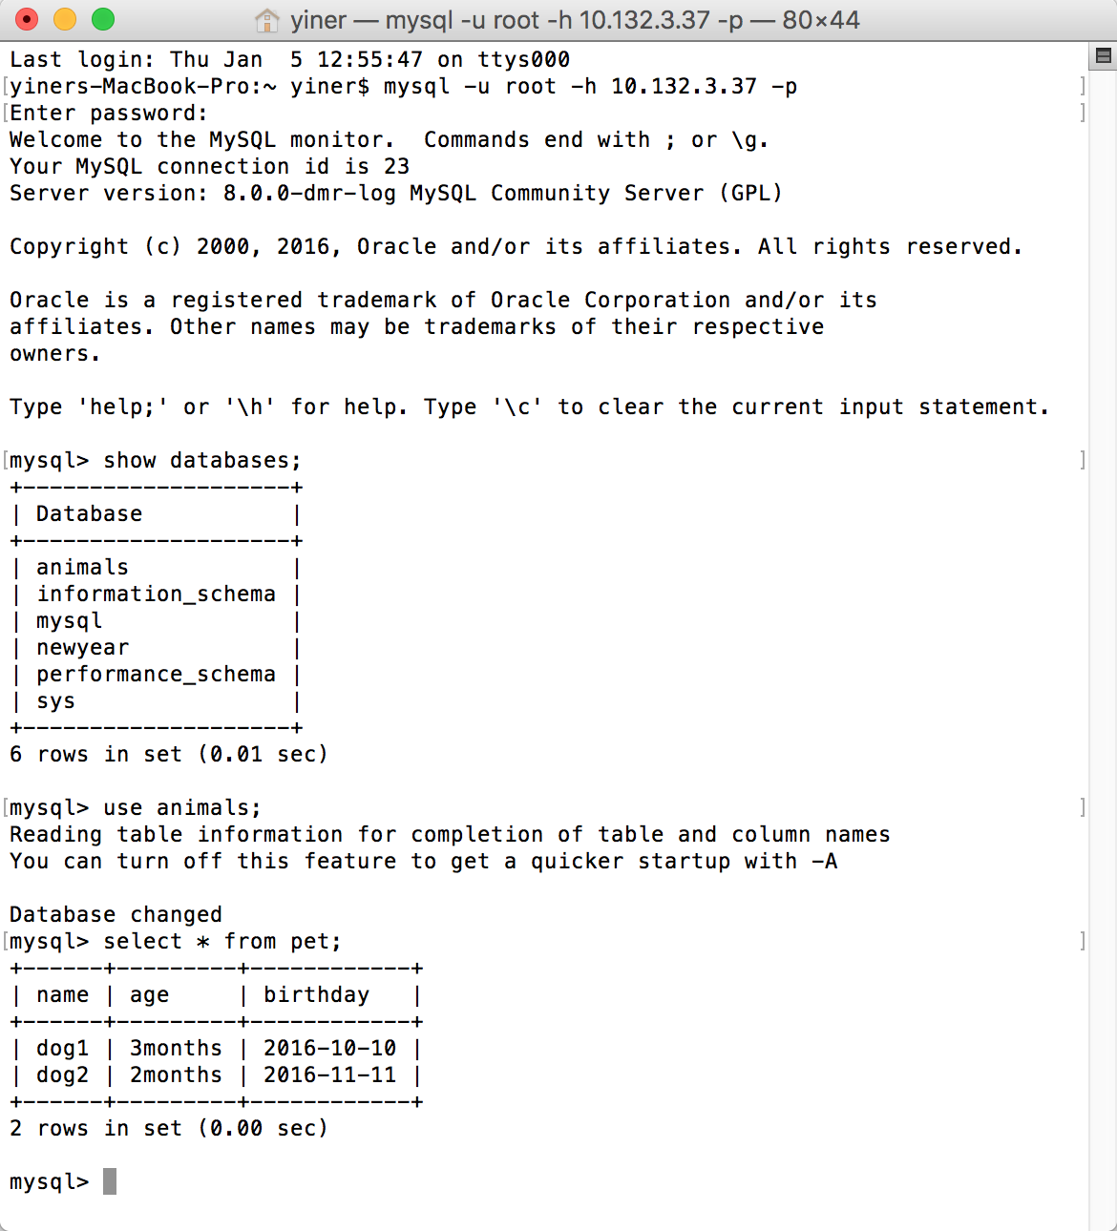

Part2:

Use web server as database client to access the database server, and send the results to browser in formatted HTML Pages.

1.

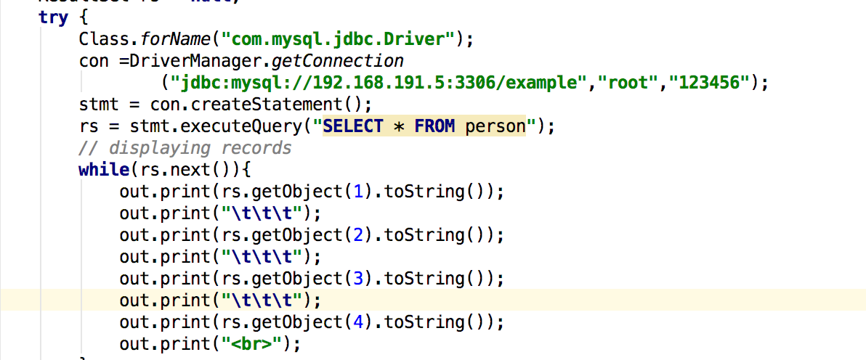

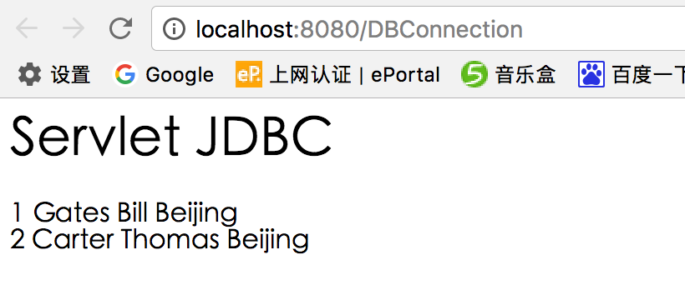

2.

