**IAQF Student Problem**

**A PROJECT REPORT FOR**

**FRE 6073 – Introduction to Derivatives**



**Submitted By (Quantinomics)**

**December 4, 2020**

|  |  |  |
| --- | --- | --- |
| **(Team Name)** | **Name** | **Email** |
| **Team Captain** | **Zhang, Yipei** | **yz4369@nyu.edu** |
| **Member 2** | **Fan, James** | **jf3296@nyu.edu** |
| **Member 3** | **Huang, Elaine** | **eh2039@nyu.edu** |
| **Member 4** | **Wu, Ruiyi** | **rw1988@nyu.edu** |
| **Member 5** | **Zhong, Zhi** | **zz3005@nyu.edu** |

**Stuctured Notes Solutions for Partisan Portfolios**

**Abstract**

Using the stock market and financial data from 2000 to 2020, this paper firstly examines the quantitative differences between the two stock portfolios. One is a Democratic portfolio, and another is a Republican portfolio. The authors also figure out the influence of the Election categorical factor and multiple presidential macroeconomic policy factors on the cumulative return of two portfolios. The analysis shows that the performance of Democratic and Republican Portfolios hardly have correlation with the presidential election. Given that the results of factor analysis, the authors construct several strategies (structured notes) from the portfolios to provide different payoffs depending on the influence of presidential election factors, which helps to generate some short-term profits.

**Keywords:** Election, Macroeconomic Policy,

**I. Introduction**

In the past few months, the U.S. stock market has been fluctuating because of the 2020 presidential election. The stock market was also greatly affected on the day of the vote result is released. This phenomenon is not uncommon. Many scholars believe that the US stock market is closely related to elections. This article analyzes the influence of the election on a Democratic portfolio and a Republican portfolio, each consists of 15 stocks. The results help construct several structure note for investors to choose to earn possible profit by hedging the results of the election.

The first part of this article analyzes the two portfolios by comparing their historical performnace using quantatitive factors to see whether two portofolios under different parties are different. Then we measure the effects of election factor with the Fama-French three factor model on the cumulative returns of each portfolio. Considered specific economic pocily proposed by the winer of the election, several Macroeconomic factors are also added to figure out the combined effect on portfolio’s return. Our ultimate goal is to formulate desired strategies for investors who want to participate into the stock market based on the US presidential election. By contructing bull note, bear note, and butterfly note, we provided investors different choices based on their opinion about the election. Whether consumers are bullish, bearish, or uncertain on stocks after considering election factors, they can find a strategy to satisfy their expectation.

**II. Data**

Before we use models to do any analysis, we normalized our data by (Xi-average)/ standard deviation. Data normalization helps for numerical issues in the data and makes it easier for interpretation. Because we have data based on different scales, so we must make them on one standard before we trying to use models to analyze them.

**A. Election Data**

We constructed two porfolios: Democratic and Republican, each consist of 15 equally weighted stocks. We collected the election data for each portfolio from year 2000 to year 2020 from Wikipedia and Infoplease website.

**B. Fama-French Data**

We collected SMB (Small Minus Big), HML (High Minus Low) and Mkt-RF(excess return on the market portfolio) from Data Library of University of Dartmouth. All factors are monthly basis and will be used in the Fama-French three factor model.

**C. Macroeconomics Data**

We collected NonFarmPayroll (non-farm employment in Private, Commodity production, and Manufacturing industry), Num_PTM (employment number in production, transportation and handling occupations) and Avg_Low_Income (low-income households with 20% of mean income of all household), in total three macroeconomics factors from Wind, which is a Financial Terminal that provides investment professionals with the data related to China's capital markets.

**D. Democratic Votes Data.**

We collected percentage of presidential election votes for Democrats from Wikipedia. This dataset will be used when we construct the multi-factor model in Part b.

**III. Analysis**

**A. Differences between two portfolios through Quantitative Methods**.

We collected the historical data of each stock in the Democratic portfolio (which we denoted as Portfolio A later on), and the Republican portfolio (Portfolio B) from the year 2000 till now. The reason we only include the data from the year 2000 is that some of the stock is not available before that year. So, by analyzing the dataset from the year 2000 to 2020, we can better figure out the performance of each stock since they have a comparable period. We focused on several indicators: cumulative return, volatility, Sharpe ratio, investment sectors, and the correlation among stocks within each portfolio to compare and contrast two portfolios

*1) Cumulative Return*

Firstly, we calculated the weighted average return of both Portfolio A and B, by assuming all the stocks in the portfolios are equally weighted. To directly compare the different performance between Portfolio A and B, we measured the cumulative return of each portfolio in each year and plotted them in a line graph. The cumulative return is the aggregate change of price in a period of time, so we used it to show how the stock prices changed in each portfolio, which gave us an overall performance of them.

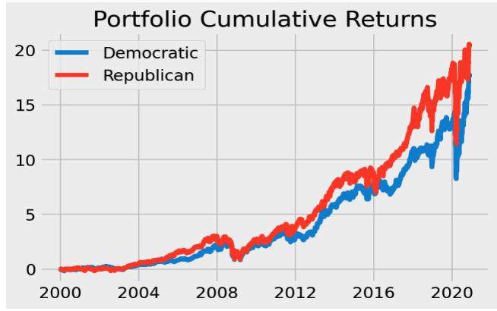

Figure 1: Cumulative Return of Two Portfolios

Figure 1 shows the growth trend of each portfolio. The red line represents the Democratic portfolio, which steadily increased from the year 2000, and had decreased cumulative return after the year 2008, which respond to the influence of recession in 2008. The Republican portfolio, which is represented by the blue line, had a similar growth trend as the Democratic portfolio.

However, we can clearly figure out that the cumulative return of the Republican portfolio is always greater than that of the Democratic portfolio. During the earliest period, both portfolios had approximately the same cumulative returns, and even the Democratic portfolio sometimes outperform the Republican portfolio. After the year 2004, the Republican portfolio performed better than the Democratic, and they then backed to similar results after the recession in 2008. After the year 2012, the difference between the cumulative returns of the two portfolios enlarged, the Republican portfolio had a much higher return than the Democratic one, and especially had the greatest difference around the year 2018.

*2) Volatility*

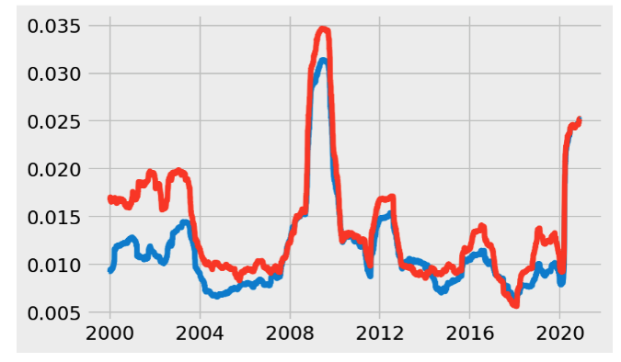 We also calculated the annually rolling volatility of each portfolio and plotted them in Figure 2. As a measure of the dispersion of return for the market index, it helped us define the risk of each portfolio. Since the higher the volatility, the risker the asset. The graph of volatility shows the risk performance of two portfolios. It shows that during almost all the period, the volatility of the Republican portfolio is greater than that of the Democratic portfolio. And in the period of the year 2016 to the year 2020, the Republican portfolio had a more volatile trend and performed much riskier than the Democratic ones.

Figure 2: Volatility of Two Portfolios

*3) Sharpe Ratio*

Sharpe ratio is the average return earned per unit of volatility. It helps investors understand the excess return of investments compared to risk. we calculate the annual Sharpe Ratio of each portfolio based on average risk-free rate in each year, annual portfolio returns and annual portfolio volatility.

​ Sharpe Ratio = (Rp​−Rf​)​/σp​ ​​ (1)

The democratic portfolio’s Sharpe ratio is more frequently higher than republican portfolio’s Sharpe ratio during the spread. Therefore, the average return per unit of Democratic portfolio is slight higher than that of Republican portfolio.

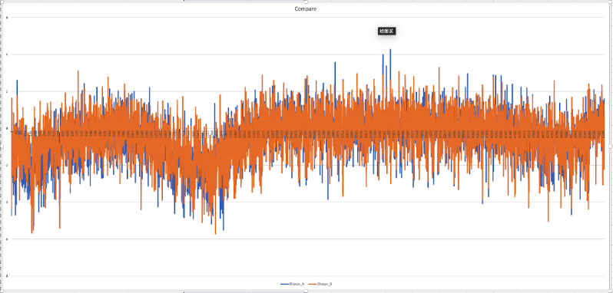

Figure 3: Sharpe Ratio of Two Portfolios

*4) Sectors*

We look up the sectors of each stock in different portfolios. Clearly, two portfolios are invested in different ways. The Democratic portfolio is majorly invested in consumer cyclical, consumer defensive and utility sectors. Whereas, Republican portfolio contains stock majorly from energy, financial service, communication service sectors.

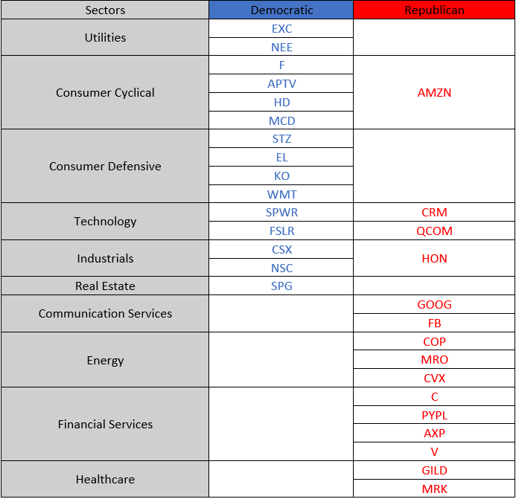

Figure 4: Sectors of each stock in Two Portfolios

*5) Correlation*

We visualize the correlation matrix of two portfolios using heat maps. We find that the correlation of stocks in Republican portfolio is stronger than that of stocks in Democratic portfolios. It implies that there may be more companies in the same sector or the sectors where republican stocks are in are more closely related to each other. To some extent, it also means that Democratic is more diversified than Republican portfolio.

Figure 5: Correlation matrix of each stock in the Democratic portfolio

Figure 6: Correlation matrix of each stock in the Republican portfolio

*6)Beta*

We also look at the Beta value of each stock in two portfolios. Beta is the measure of the systematic risk of portfolio compared to the entire market which is used in the capital asset pricing model (CAPM). The model describes the relationship between expected return for stocks and systematic risk. The detail analysis of beta is in Fama-French three factor model in section B.

**B. Portfolio Performance Consider Election Fac**

*1) Fama-French three factor model*

Although the CAPM is a simple and efficient model to calculate assets’ valuations, it does not explain sufficient systematic risk factors other than the beta. Better to measure the return of a portfolio of assets, the Democratic portfolio, and the Republican portfolio, we chose the Fama -French three-factor model. This model adds two more factors to the CAPM: the value risk factor High-Minus-Low (HML) and the size risk factor Small-Minus-Big (SMB).

E[Rit]​−Rft​ = αit ​+ β1​(RMt​−Rft​) + β2​SMBt​ + β3​HMLt​ + ϵit (2)

In formula above , E[Rit] represents the expected total return of a stock or portfolio i at time, Rft is risk free rate of return at time t, RMt is total market portfolio return at time t. We utilized this three-factor model to calculate the excess return on the Democratic and the Republican portfolio by thinking about the size and value premium of the stocks.

*2) Consider Election*

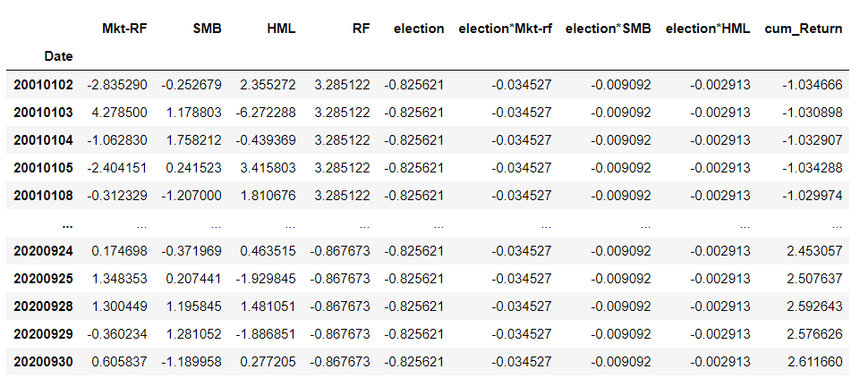The US presidential election each four years has a significant influence on the stock market. Some researchers verify the relationships between election and financial market value. Santa-Clara and Valkanov figured out the excess return of the stock market is lower under Republicans than the Democratic. Others analyzed that the average price changes of Dow Jones(DJI) before and after presidential elections and concluded the stock market did not perform very different when during Democratic or Republican administrations. (Niederhoffer etc., 1970). Investors will have expectations of the financial market in the future regarding who is the winner of election and how the future economic policy will be like, which result in a market uncertainty*.*

Figure 7: Democratic Regression table of Fama-French with Election and interaction terms.

Figure 8: Republican Regression table of Fama-French with Election and interaction terms.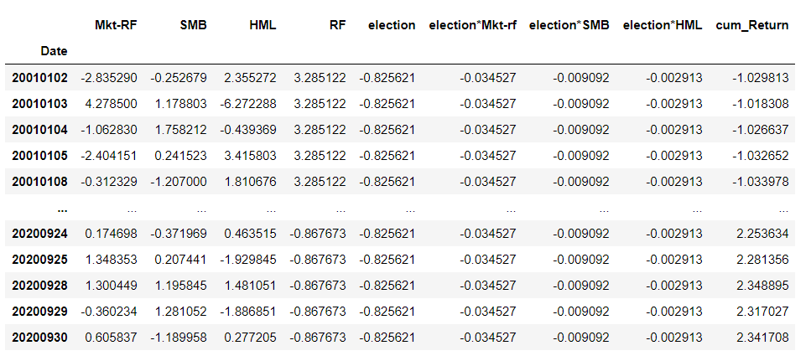

E[Rit]​−Rft​ = αit ​+ β1​(RMt​−Rft​) + β2​SMBt​ + β3​HMLt​ + β4θ(RMt​−Rft​) + β5θ​SMBt​ + β6​θHMLt  + β7θ + ϵit (3)

Based on the Fama-French three factor model, we tried to figure out if the Democratic candidate or Republican candidate won the election will bring a great difference to the stock market, which results in affecting Portfolio A and B. We added a dummy variable – election into our model, where 1represents Democratic and 0 represents Republican. In order to figure out relationships among three factors and election factor and avoid overlooking the significance of specific factor, we added three interaction terms, which are election*Mkt-rf, election*SMB, and election*HML shown in Figure 7 and 8 to look at the combined effect.

From the figure above, we can interpret the effect of three factors depends on the value of the categorical factor election. First, we look at the coefficient of the model which is the Beta value. We take the absolute value of the coefficients, the larger the value means more impact to the cumulative return of the stocks. Next, we look at the P-value of the model. P-value represent the statistically significance to the model. The closer to zero, the factor is more significant to the cumulative return.

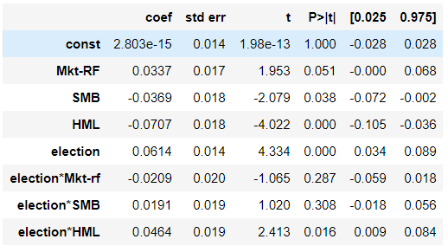

Figure 9: Statistical data of three factors, election, and interaction terms-Democratic

Figure 9 shows the Fama-French model summary from portfolio A. Coefficient values for all factors in portfolio A are below 0.1. We cannot see any obvious pattern from this. There is no factor that has more impact to the cumulative return than other factors. For P-values, Mkt-RF, SMB, HML, election, and election*HML have P-value close or less than 0.05 which means those factors are significant to the cumulative return. HML and election even have P-values less than 0.001. On the other side, election*Mkt-RF and election*SMB have high P-values of 0.287 and 0.308 which indicates those two factors are not significant to the stock prices.

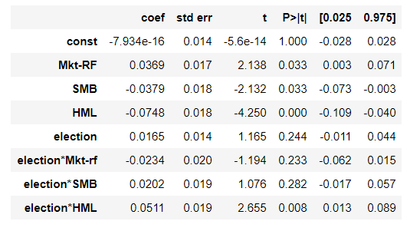

Figure 10: Statistical data of three factors, election, and interaction terms-Republican

Figure 10 shows the Fama-French model summary from portfolio B. Coefficient values for all factors in portfolio B are below 0.1. Similar to portfolio A, there is no factor that has more impact to the cumulative return than other factors. For P-values, we see similar pattern to portfolio A except election factor. Election have a P-value of 0.244 which indicates it’s not significant to the cumulative return. Election*Mkt-RF and election*SMB still are not significant to the cumulative return because they have high P-values. Mkt-RF, SMB, HML, and election*HML still have P-values less than 0.05 which indicates they are significant to the stock prices.

*3) Multi-factor model with Macro-economic influences*

In addition, to consider whether a specific party wins the election influenced by three factors and the cumulative return of two portfolios, we also consider whether the president who won the election will enact some policies which also have effects on the return of portfolios, on a macro level. Winning candidates for the election have direct effects on the business environment because the governing president will provide and enact policies that affect the ability of the financial market and the general economy world.

The growth of GDP and the unemployment rate of the country is associated with the change in stock price caused by the election and presidential policy. Thus, we thought about macroeconomic factors: new non-farm employment in Private, Commodity production, and Manufacturing industry; employment number in production, transportation and handling occupations; low-income households with 20% of mean income of all household. The reason we chose nonfarm payroll and employment number in PTM is because Democratic and Republicans may have different strategy or plans on how to improve the employment rate, therefore those factors may be influenced by which party is governing. The reason we chose the low-income households factor is that Democratic and Republicans have different thinking about class taxation. Republicans are more prone to collect tax on the middle and the low-level classes, whereas Democratic prefer to tax on rich people. Hence, which party governing will have a systematic difference to the wealth of low-income families.

We added these macro factors into previous Fama-French three-factor model with election and calculated the correlation between each term. Correlation represents the change in one factor are associated with changes in other factors. However, it doesn’t mean that change in one factor caused changes in other factors. We also considered percentage of democratic votes in president election, DemoVotes, as an election related factor.

(4)

In formula 4, xi is the i-th continuous variable, di is the i-th dummy variable, beta are the constant coefficient, y is the target variable which is the cumulative return, and ε is a normally distributed random variable with 0 mean and σ2.

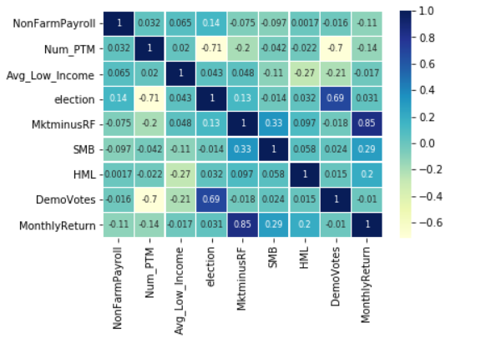

Figure 11: Correlation of all factors of Democratic Portfolio

Figure 11 shows the correlation of factors in portfolio A. We noticed Mkt-RF and the monthly return have a 0.85 correlation which is the highest in the table. We ignore the correlation between election and DemoVotes because they are dependent variables. Negative correlation means the one factor increases while the other one decreases. Election and Num_PTM have a high negative correlation of -0.71. DemoVotes and Num_PTM also have a high negative correlation of -0.7. Other correlations in the table are pretty low.

Figure 12 is the correlation table for portfolio B. We see some similar patterns in figure 9 and 10. Mkt-Rf and monthly return still is the highest correlation in the table which is 0.92. Election and Num_PTM with DemoVotes and Num_PTM have high negative correlations again. Other correlations in the table all have low numbers.

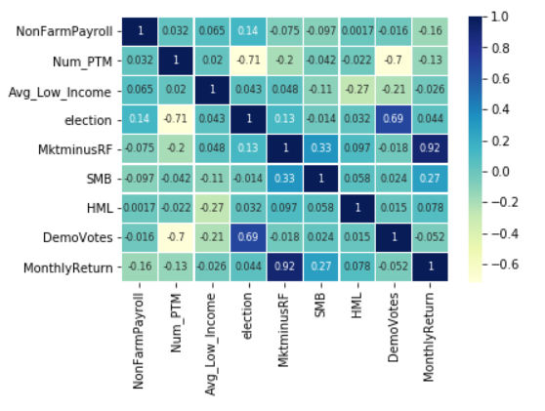

Figure 12: Correlation of all factors of Republican Portfolio

In Figure 13 we have the model summary for multi-factor model without interaction factors for Democratic. Election, NonFarmPayroll, Mkt-RF, HML, and DemoVotes have absolute coefficient values greater than 0.1. This indicates those factors have more impact to the cumulative return than other factors. Especially for Mkt-RF, its coefficient is 0.8592 which means Mkt-RF has the most impact to the target variable. For P-values, election, Mkt-RF, HML, and DemoVotes are significant since their P-values are less than 0.05.

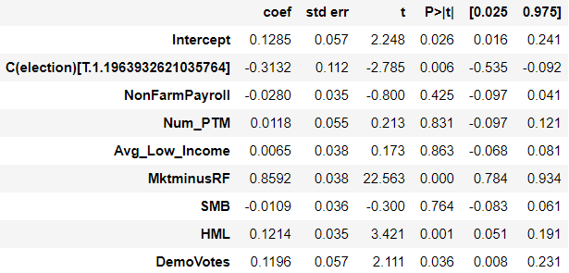

Figure 13 Multi-Factor Model without Interaction – Democratic

Figure 14 has the model summary for multi-factor model without interaction factors for Republican. We see different pattern in two portfolios. For coefficient values in portfolio B, Mkt-RF has a high value of 0.9439, other factors have absolute coefficients less than 0.1, so only Mkt-RF has impact to the cumulative return. For P-values, nonFarmPayroll, Avg_Low_Income, and Mkt-RF are significant to the cumulative return. Election and DemoVotes which are significant in portfolio A, but have high P-values in portfolio B.

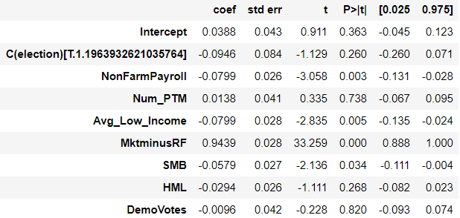

Figure 14 Multi-Factor Model without Interaction – Republican

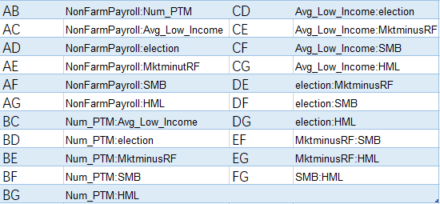

Figure 15 Interaction Factors

The figure below shows the model summary for multi-factor model with interaction factors for Democratic. For the standalone factors, all factors have high absolute coefficient values which indicates all standalone factors have high impact to cumulative return. Mkt-Rf, HML, and DemoVotes have P-values below 0.05 which means they are significant. For the interaction Variables, AB, BC, BE, BG, CD has high absolute coefficients, and DE, DF, DG, EF, EG, FG has very low absolute coefficient values. For P-values, only BE and BG are significant to cumulative return, other interaction factors

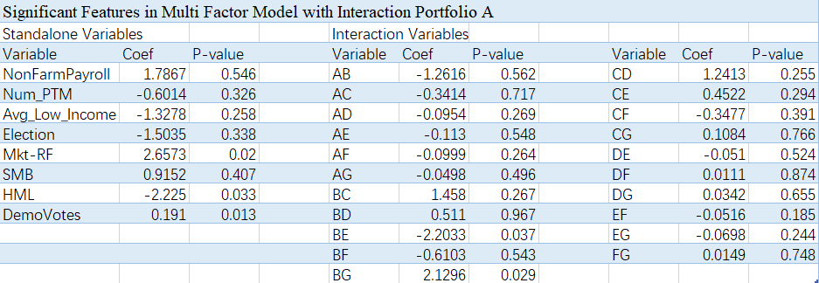are not significant since their high P-values.

Figure 16 Summary for multi-factor model with interaction factors -- Democratic

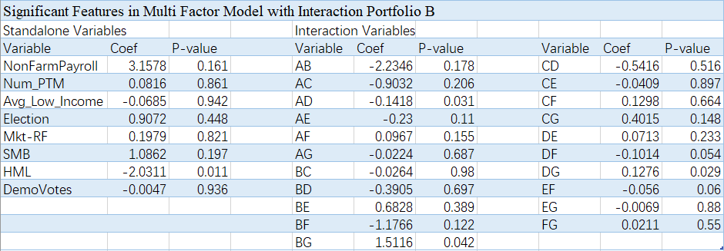The figure below shows the model summary for multi-factor model with interaction factors for Republican. For standalone factors, NonFarmPayroll, Avg_Low_Income, and HML have high impact to cumulative return because they have high absolute coefficient values. HML is the only standalone factor that has P-value less than 0.05, so it’s the only significant factor. For interaction factors, AB, BF, and BG have more impact to the cumulative return than other interaction factors. AD, BG, DF, DG, and EF have low P-values that indicates they are significant to cumulative return.

Figure 17 Summary for multi-factor model with interaction factors -- Republican

*4) Lasso*

Lasso is a regression analysis method that performs variable selection and regularization for linear models in order to improve the accuracy and interpretability of the model. Lasso would shrink the size of factors in the model by eliminate factors that have less impact to the target value.

By using Lasso, we get that the best factor combination in portfolio A and B. In portfolio A, the best factors combination is election, Mkt-RF, and HML. In portfolio B, the combination is election and Mkt-RF. Previously, the P-values from different models proved that election is not significant to the cumulative return of stocks in the 7 factors we chose. But it doesn’t mean that election itself is not significant to the stock prices, maybe in other factor combinations election would be more significant. By using Lasso, both portfolios have election in their best factor combinations.

**C. Structured Notes Construction**

Structured Notes consist of two components: a zero-coupon bond and a portfolio-linked option. The note is issued at par and redeemed at par plus option payoff. Par of our note is designed to be $1000 for one contract. Because of the COVID, the stock market is highly volatile and investors have different judgments on how the stock market will move. Therefore, we design three different option strategies, bull spread, butterfly and bear spread to meet different investor demands. Because the risk of the note is higher than risk of zero-coupon bonds and lower than risk of a pure derivative position, the return should be between these two as well. In this section, we are going to explain in detail how we design the note and evaluate our note performance.

*1) Zero Coupon Bond*

|  |  |
| --- | --- |
| Face Value | $1,000 |
| Risk-Free Rate | 3.00% |
| Credit Spread | 0.78% |
| Discount Rate | 3.78% |
| Value of ZCB | $963.58 |
| Principal Leftover | $36.42 |

Figure 18: Valuation of zero-coupon bond

Treasury rate today is extremely low because of the COVID and this will make the zero coupon bond high priced with little principal left to invest on option. Therefore, we adopt a hypothetical risk-free rate at 3%. The credit spread for Moody’s Aa company is 0.78%, so the discount rate is risk-free rate+ credit spread= 3.78%. With all the parameters settled, we calculate the present value of this zero coupon bond by using formula: face value/ (1+discount rate). The principal leftover is simply the face value- zero coupon’s present value, which means the money left we can use to invest in options.

*2) Options*

While most structured notes are linked to a market index such S&P 500, NSDAQ100, our note is linked to the underlying portfolio (Democratic Portfolio and Republican Portfolio).

1. Underlying assets

Since we are trying to construct specified option strategy for two customized equity, Democratic Portfolio and Republican Portfolio, the underlying assets would be these two portfolios. We will then try to utilize different option strategy to construct different options for investors with varied risk preference to choose to hedge the election outcome and market volatility. The portfolio parameters are as below (These data are before standardized).

|  |  |
| --- | --- |
| Risk Free Rate | 3.00% |
| Maturity | 1 |
| Start Price D | 126.24 |
| Start Price R | 440.40 |
| Volatility D | 42.34% |
| Volatility R | 42.59% |

Figure 19 Portfolio parameters

Here, the start prices of two portfolios are the weighted average price in the most latest date and volatility is the annul volatility of two portfolios in the latest year

b. Option Strategy

To make this note attractive, the participation rate should be high enough. Typically, the participation rate should not be lower than 50%. It forces us to seek alternative option combinations costing less to purchase and embed in the note. Here, we consider bull spread, butterflies and bear spread. These three options cost less than ATM options and will help us raise the participation rate.

**i) Bull Spread Call**

This strategy is designed for investors who expect the stock market will move upward in the following year. The option payment in this note can be calculated as principal*participation rate* option payoff/100, where participation rate is the percentage of par invested in options. Our option design is as below

|  |  |
| --- | --- |
| Bull Spread Call (Democratic Portfolio) | |
| Long a Democratic Portfolio Call with Strike Price | 126.24 |
| Short a Democratic Portfolio Call with Strike Price | 140 |
| Bull Spread Call (Republican Portfolio) | |
| Long a Rapublican Portfolio Call with Strike Price | 440.40 |
| Short a Republican Portfolio Call with Strike Price | 481 |

Figure 20 Bull spread call design

We choose these two strike price because they will make our participation rate high enough so that the return of our note would be attaractive to potential investors.

The equation we used for calculating Participation rate is

(100- ZCB Value)/ Option Value. (5)

Here, the ZCB value and option value are both standardized. We standardize the option value by setting the initial stock price to 100. We assume that the price of the portfolio follows a Geometric Brownian Motion. Therefore, we use Black-Scholes model to price our option. Pricing equation for call option is as below.

c(t,S) = SN(d2) – EXP{-r*(T-t)}KN(d1)

Where,

d1 = [ln(S/K) + (r-1/2*σ^2*(T-t))]/(σ*(T-t)^(1/2))

d2 = [ln(S/K) + (r+1/2*σ^2*(T-t))]/(σ*(T-t)^(1/2)) (6)

By using Black-Scholes formula, we get two bull spread calls’ value

|  |  |  |  |
| --- | --- | --- | --- |
| BS Model Value | | | |
| d1 | -0.08 | Option Value 1 | 14.65 |
| d2 | 0.26 |  |  |
| d3 | -0.39 | Option Value 2 | 10.34 |
| d4 | -0.05 |  |  |
| Bull Spread Value D | | | 4.31 |
|  |  |  |  |
| d3 | 0.26 | Option Value R1 | 5.46 |
| d4 | 0.36 |  |  |
| d5 | -0.65 | Option Value R2 | 1.67 |
| d6 | -0.55 |  |  |
| Bull Spread Value R |  |  | 3.78 |

Figure 21 Bull spread call valuation

By using participation rate formula, we get 88.32% and 99.41% for democratic and republican portfolio. The relationship between participation rate and strike price can be shown as below. The column stands for strike price 1 and row stands for strike price 2 (Prices are before standardized).

Figure 22 Bull spread call participation rate analysis -- Democratic

Figure 23 Bull spread call participation rate analysis -- Republican

Next, we are going to calculate the return. Because on the maturity date, the investor will receive principal for sure, then the return for the note is just the option payment/ principal. Option payment = principal*participation rate* option payoff/100. For a bull spread call, the option payoff is: 0, when ST< K1; ST – K1 when K1<ST<K2; K2 – K1 when ST>K2. The payoff can be shown in the below graph.

Figure 24 Bull spread call payoff – Democratic

Figure 25 Bull spread call payoff -- Republican

We do a return sensitivity analysis based on different stock price at maturity. The result can be shown as below

Figure 26 Note D (bull spread call) return sensitivity analysis -- Democratic

Figure 27 Note R (bull spread call) return sensitivity analysis -- Republican

As we can see, if the stock price goes up on maturity date, which means greater than 100, the return will be positive. The highest potential return will be around 10%. It is higher than the bond issued by Julius Baer. Therefore, it would be attractive to investors.

**ii) Bear Spread Call**

This strategy is designed for investors who expect the stock market will move dowanrd in the following year. The option payment in this note can be calculated as principal*(option payoff+bear spread call value)/100, Our option design is as below

|  |  |
| --- | --- |
| Bear Spread Call (Democratic Portfolio) | |
| Short a Democratic Portfolio Call with Strike Price | 126.24 |
| Long a Democratic Portfolio Call with Strike Price | 142 |
| Bear Spread Call (Republican Portfolio) | |
| Short a Rapublican Portfolio Call with Strike Price | 440.40 |
| Long a Republican Portfolio Call with Strike Price | 485 |

Figure 28 Bear spread call design

These two strike prices will make the return of our note high enough to attaract potential investors.

One thing different from Bull Spread Call is that we receive money when we invest in the Bear Spread Call. Therefore, the definition of participation rate will not be suitable for putting into the profit formula anymore. So when we were calculating the expected return for Bear Spread Call, we did not include participation rate. The expected return can be calculated as principal*(option payoff+bear spread call value)/100/principal. Therefore, it is just (option payoff+bear spread call value)/100.

Here, again, we assume that the price of the portfolio follows a Geometric Brownian Motion. Therefore, we use Black-Scholes model to price our option. Pricing equation for call option is as below.

By using Black-Scholes formula, we get two bear spread calls’ value

|  |  |  |  |
| --- | --- | --- | --- |
| BS Model Value | | | |
| d1 | -0.08 | Option Value 1 | 14.65 |
| d2 | 0.26 |  |  |
| d3 | -0.39 | Option Value 2 | 10.34 |
| d4 | -0.05 |  |  |
| Bear Spread Value D | | | 4.31 |
|  |  |  |  |
| d3 | 0.26 | Option Value R1 | 5.46 |
| d4 | 0.36 |  |  |
| d5 | -0.41 | Option Value R2 | 2.40 |
| d6 | -0.31 |  |  |
| Bear Spread Value R | | | 3.06 |

Figure 29 Bear spread call value

For a bear spread call, the option payoff is: 0, when ST< K1; -(ST – K1) when K1<ST<K2; -(K2 – K1) when ST>K2. The payoff can be shown in the below graph.

Figure 30 Bear spread call payoff – Democratic

Figure 31 Bear spread call payoff -- Republican

We do a return sensitivity analysis based on different stock price at maturity. The result can be shown as below.

Figure 32 Note D (bear spread call) return sensitivity analysis -- Democratic

Figure 33 Note D (bear spread call) return sensitivity analysis -- Republican

As we can see, if the stock price goes down on maturity date, which means smaller than 100, the return will be positive. The highest potential return will be around 4%. It is higher than the bond issued by Julius Baer. Therefore, it would be attractive to investors.

**iii) Butterfly Spread Call**

This strategy is designed for investors who do not know the future movement of the financial market for the next year. Butterfly Option is suitable for the stock market, or customed equity, which is very hard to predict the overall price movement. The long butterfly call spread is created by buying one in-the-money call option with a low strike price, writing two call options with a silghtly higher price, and buying one out-of-the-money call option with a higher strike price. Net debt is created when entering the trade. Our option design is as below

|  |  |
| --- | --- |
| Butterfly Spread Call (Republican Portfolio) | |
| Long a Rapublican Portfolio Call with Strike Price K1 | 100 |
| Short a Republican Portfolio Call with Strike Price K2 | 125 |
| Long a Democratic Portfolio Call with Strike Price K3 | 150 |
| Butterfly Spread Call (Republican Portfolio) | |
| Long a Rapublican Portfolio Call with Strike Price K4 | 400 |
| Short a Republican Portfolio Call with Strike Price K5 | 450 |
| Long a Democratic Portfolio Call with Strike Price K6 | 500 |

Figure 34 Butterfly spread call design

Again, these three strike prices will make our participation rate high enough so that the return of our note would be attaractive to potential investors.

The equation we used for calculating Participation rate is (100- ZCB Value)/ Option Value.

By using Black-Scholes formula, we get two butterfly spread calls’ value

|  |  |  |  |
| --- | --- | --- | --- |
| BS Model Value | | | |
| d1 | 0.62 | Option Value D1 | 26.73 |
| d2 | 0.95 |  |  |
| d3 | -0.05 | Option Value D2 | 15.10 |
| d4 | 0.29 |  |  |
| d5 | -0.59 | Option Value D3 | 7.94 |
| d6 | -0.26 |  |  |
| Butterfly Value D |  |  | 4.47 |
| d7 | 1.26 | Option Value R1 | 12.27 |
| d8 | 1.35 |  |  |
| d9 | 0.04 | Option Value R2 | 4.27 |
| d10 | 0.14 |  |  |
| d11 | -1.05 | Option Value R3 | 0.84 |
| d12 | -0.95 |  |  |
| Butterfly Value R |  |  | 4.56 |

Figure 35 Butterfly Spread Call

By using participation rate formula, we get 76.86% and 78.91% for democratic and republican portfolio. The relationship between participation rate and strike price can be shown as below. The column stands for strike price 1 and row stands for strike 2.



Figure 36 Butterfly spread call participation rate analysis -- Democratic

Figure 37 Butterfly spread call participation rate analysis -- Republican

Next, we are going to calculate the return. Return = option payment/ principal. The Option payment = principal*option payoff/100. For a butterfly spread call, the option payoff is: 0, when ST< K1; ST – K1 when K1<ST<K2; 2K2 – K1 – ST when K2<ST<K3; 0 when ST>K3. The payoff can be shown in the below graph The maximum profit for Buterfly spread call is earned when underlying asset’s price equals to the start price at maturity. The payoff can be shown in the below graph.

Figure 38 Butterfly spread call payoff – Democratic

Figure 39 Butterfly spread call payoff -- Republican

We do a return sensitivity analysis based on different stock price at maturity. The result can be shown as below.

Figure 40 Note D (butterfly spread call) return sensitivity analysis – Democratic

Figure 41 Note D (butterfly spread call) return sensitivity analysis -- Republican

As we can see, if the stock price goes up or goes down in a certain range on maturity date, the return will be positive. The highest potential return will be around 10%. It is higher than the bond issued by Julius Baer. Therefore, it would be attractive to investors.

*3) Structure Note*

The final term sheet is shown as below:

|  |  |
| --- | --- |
| Issuer: | Julius Baer Bank |
| Issue Date: | 1/29/2021 |
| Undrlying Assets | Democratic Portfolio |
| Principal: | $1,000 |
| Coupon: | zero |
| Issue Price: | $1,000 |
| Issue Size: | $40,000,000 |
| Redemption: | Principal + Democratic Portfolio Payment |
| Democratic Portfolio Payment: | Principal*Participation Rate*Democratic Bull Spread Call Payoff/100 |
| Maturity Date: | 1/29/2022 |

Figure 42 Structured note for Democratic portfolio (bull spread call)

|  |  |
| --- | --- |
| Issuer: | Julius Baer Bank |
| Issue Date: | 1/29/2021 |
| Undrlying Assets | Republican Portfolio |
| Principal: | $1,000 |
| Coupon: | zero |
| Issue Price: | $1,000 |
| Issue Size: | $40,000,000 |
| Redemption: | Principal + Republican Portfolio Payment |
| Democratic Portfolio Payment: | Principal*Participation Rate*Republican Bull Spread Call Payoff/100 |
| Maturity Date: | 1/29/2022 |

Figure 43 Structured note for Republican portfolio (bull spread call)

|  |  |
| --- | --- |
| Issuer: | Julius Baer Bank |
| Issue Date: | 1/29/2021 |
| Undrlying Assets | Democratic Portfolio |
| Principal: | $1,000 |
| Coupon: | zero |
| Issue Price: | $1,000 |
| Issue Size: | $40,000,000 |
| Redemption: | Principal + Democratic Portfolio Payment |
| Democratic Portfolio Payment: | Principal*Democratic Bear Spread Call Payoff/100 |
| Maturity Date: | 1/29/2022 |

Figure 44 Structured note for Democratic portfolio (bear spread call)

|  |  |
| --- | --- |
| Issuer: | Julius Baer Bank |
| Issue Date: | 1/29/2021 |
| Undrlying Assets | Republican Portfolio |
| Principal: | $1,000 |
| Coupon: | zero |
| Issue Price: | $1,000 |
| Issue Size: | $40,000,000 |
| Redemption: | Principal + Republican Portfolio Payment |
| Democratic Portfolio Payment: | Principal*Republican Bear Spread Call Payoff/100 |
| Maturity Date: | 1/29/2022 |

Figure 45 Structured note for Republican portfolio (bear spread call)

|  |  |
| --- | --- |
| Issuer: | Julius Baer Bank |
| Issue Date: | 1/29/2021 |
| Undrlying Assets | Democratic Portfolio |
| Principal: | $1,000 |
| Coupon: | zero |
| Issue Price: | $1,000 |
| Issue Size: | $40,000,000 |
| Redemption: | Principal + Democratic Portfolio Payment |
| Democratic Portfolio Payment: | Principal*Participation Rate*Democratic Butterfly Spread Call Payoff/100 |
| Maturity Date: | 1/29/2022 |

Figure 46 Structured note for Democratic portfolio (butterfly spread call)

|  |  |
| --- | --- |
| Issuer: | Julius Baer Bank |
| Issue Date: | 1/29/2021 |
| Undrlying Assets | Republican Portfolio |
| Principal: | $1,000 |
| Coupon: | zero |
| Issue Price: | $1,000 |
| Issue Size: | $40,000,000 |
| Redemption: | Principal + Republican Portfolio Payment |
| Democratic Portfolio Payment: | Principal*Participation Rate*Republican Butterfly Spread Call Payoff/100 |
| Maturity Date: | 1/29/2022 |

Figure 47 Structured note for Republican portfolio (butterfly spread call)

**IV. Conclusion**

Our daily frequency basis quantitative analysis shows that Democratic Portfolio have correlation with presidential election result, while Republican Portfolio is independent with presidential election. It means, when Democratic Party is selected to govern, the return of Democratic Portfolio will be slightly better than the Republican Party is selected. For further quantitative analysis, we add three macroeconomic factors which can be explained as proxies of election and the outcome shows that both portfolio’s performance are independent with presidentiao election outcome.

Further, based on what we found in quantitative analysis, after making several reasonabl assumptions, we construct three kinds of structured note for investors with different risk preference to hedge whether the market volatility or upcoming presidential election outcome. We can satisfy investors with various kinds of need on the market by setting different strike prices in our constructed note.

**V. References**

1. Chien, Wen-Wen, et al. “Stock Market, Economic Performance, And Presidential Elections.” Journal of Business &amp; Economics Research (JBER), vol. 12, no. 2, 2014, p. 159., doi:10.19030/jber.v12i2.8530.

2. Goodell, J. W., &amp; Vähämaa, S. (2013). US presidential elections and implied volatility: The role of political uncertainty. Journal of Banking &amp; Finance, 37(3), 1108-1117. doi:10.1016/j.jbankfin.2012.12.001

3. Niederhoffer, V., Gibbs, S., & Bullock, J. (1970). Presidential elections and the stock market. Financial Analysts Journal, 26, 111-113.

4. Santa-Clara, P., & Valkanov R. (2003). The presidential puzzle: Political cycles and the stock market. The Journal of Finance, 58, 1841-1872.

**VI. Appendix**

URL for data

<https://www.infoplease.com/us/government/elections/presidential-elections-1789-2020>

websitehttps://mba.tuck.dartmouth.edu/pages/faculty/ken.french/Data_Library/f-f_factors.html.

<https://en.wikipedia.org/wiki/List_of_United_States_presidential_elections_by_popular_vote_margin>.