1. 数据库的创建
2. 创建名为“Company”的数据库，要求数据库字符集为utf8，校对规则为utf8_general_ci。

Create database company default character set utf8 default collate utf8_general_ci;

1. 创建表1.1、1.2和1.3并为插入数据

Employees：员工信息表

Departments：部门信息表

Salary：员工薪水情况表

表实验1.1 Employees表结构

|  |  |  |  |  |
| --- | --- | --- | --- | --- |
| **列名** | **数据类型** | **长度** | **是否允许空值** | **说明** |
| Employees | char | 6 | 否 | 员工编号，主键 |
| name | char | 10 | 否 | 姓名 |
| education | char | 4 | 否 | 学历 |
| birthday | date | 16 | 否 | 出生日期 |
| sex | char | 2 | 否 | 性别 |
| workyear | tinyint | 1 | 是 | 工作时间 |
| phonenumber | char | 12 | 是 | 电话 |
| departmentID | char | 3 | 否 | 员工部门号，外键 |

表实验1.2 Departments表结构

|  |  |  |  |  |
| --- | --- | --- | --- | --- |
| **列名** | **数据类型** | **长度** | **是否允许空值** | **说明** |
| departmentID | char | 3 | 否 | 部门编号，主键 |
| departmentName | char | 20 | 否 | 部门名 |
| note | text | 16 | 是 | 备注 |

表实验1.3 Salary表结构

|  |  |  |  |  |
| --- | --- | --- | --- | --- |
| **列名** | **数据类型** | **长度** | **是否允许空值** | **说明** |
| employmeeID | char | 6 | 否 | 员工编号，主键 |
| Income | float | 8 | 否 | 收入 |
| Outcome | float | 8 | 否 | 支出 |

表实验1.1 Employees表数据样本

|  |  |  |  |  |  |  |  |
| --- | --- | --- | --- | --- | --- | --- | --- |
| **编号** | **姓名** | **学历** | **出生日期** | **性别** | **工作时间** | **电话** | **部门号** |
| 000001 | 张三 | 大专 | 1966-01-23 | 1 | 8 | 83355668 | 2 |
| 000002 | 李四 | 本科 | 1976-03-28 | 1 | 3 | 823211321 | 1 |
| 000003 | 王五 | 硕士 | 1982-12-09 | 1 | 2 | 83792361 | 3 |
| 000004 | 陈六 | 本科 | 1960-07-30 | 0 | 6 | 82413301 | 1 |

表实验1.2 Departments表数据样本

|  |  |  |
| --- | --- | --- |
| **部门号** | **部门名称** | **备注** |
| 1 | 财务部 | null |
| 2 | 人力资源部 | null |
| 3 | 经理办公室 | null |

表实验1.3 Salary表数据样本

|  |  |  |
| --- | --- | --- |
| **编号** | **收入** | **支出** |
| 000001 | 2100.8 | 123.09 |
| 000002 | 1582.62 | 88.03 |
| 000003 | 2569.88 | 185.65 |
| 000004 | 1987.01 | 79.58 |

2.

1. 删除“王五”员工的员工信息和薪水记录。

Delete from employees where employees.name=”王五”;

delete from salary where salary.employmeeid in (select employmeeid from employees where employees.name=”王五”);

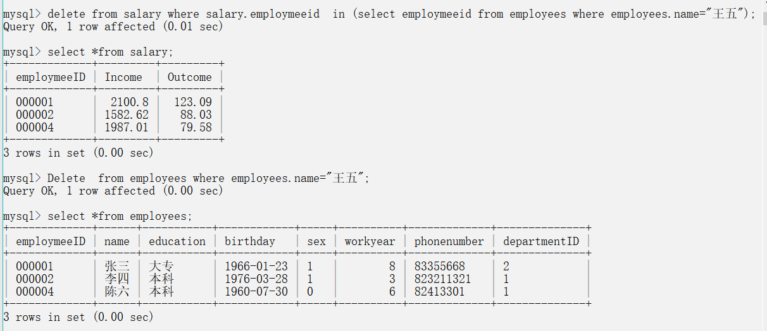

1. 把“张三”员工的收入增加“200.00”，支出改为“100.00”

Update salary set income=income+200.00,outcome=100.00 where employmeeid in (select employmeeid from employees where employees.name=”张三”);

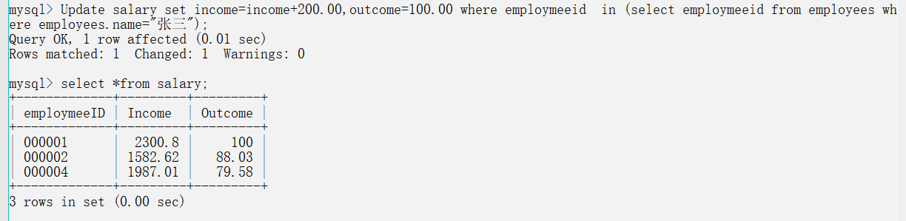

1. 把“收入”最低的员工收入增加“100”

Update salary set income=income+100.00 order by income limit 1;

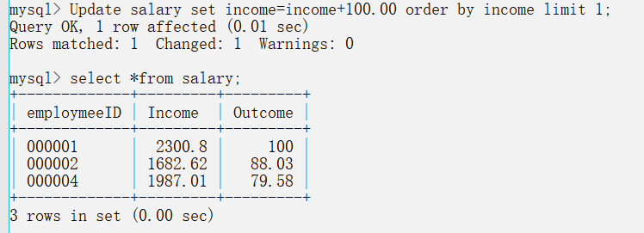

1. 查询“财务部”的员工“姓名”和”学历”

Select name,education from employees where departmentid in(select departmentid from departments where departmentname=”财务部”);

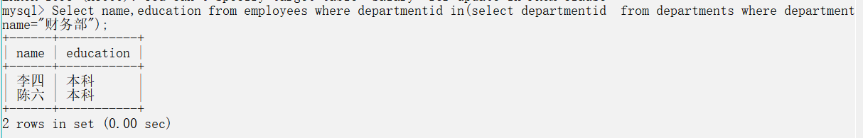

1. 查询“李四”的“学历”“性别”“部门名称”以及薪水（收入减支出）

Select education,sex,departmentname,income,outcome from departments right join employees on departments.departmentid=employees.departmentid left join salary on salary.employmeeid=employees.employmeeid where employees.name=”李四”;

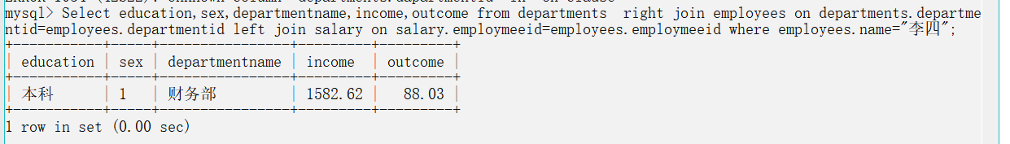

1. 查询“本科”中薪水最高的员工“姓名”、“工作时间”、“部门名称”

Select name,workyear,departmentname from departments right join employees on departments.departmentid=employees.departmentid left join salary on salary.employmeeid=employees.employmeeid where salary.income in (select max(salary.income)from salary);

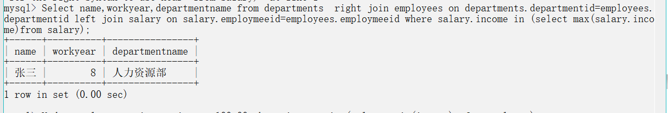

（7）查询手机尾号是“1”的员工“姓名”、“部门名称”，按照薪水降序排列

Select name,departmentname from departments right join employees on departments.departmentid=employees.departmentid left join salary on salary.employmeeid=employees.employmeeid where employees.phonenumber like”%1” order by salary.income desc;

