1. Significantion of Pre-slaughter Inspection
2. Find out diseased livestock in time, quarantine animal of normal and disease, and prevent disease infection.
3. Inspect indiscoverable disease in post-slaughter,such as tetanus(破伤风)、rabies(狂犬病)、listeriosis(李氏杆菌病)、cephalitis(脑炎)、echinococcosis(脑包虫病)、botulism(肉毒中毒症)and some toxicosis, which have distinctness clinic symptom before death and have not special pathological change after death.
4. Prevent to slaughter animals including protective wild animal, farm animal, breeder, pup and female animal of the right age.
5. Discover epidemic situation in time, trace to the source, report to organization of prevention and surveillance, control and eradicate epidemic situation.
6. Basic Principle of HACCP
7. Hazard analysis(危害分析)
8. Identify Critical Control Point (CCP) （确定关键控制点）
9. Establish Critical Limits, ensure the CCP is under control（确定关键限值）
10. Monitoring critical limits（确定监控CCP措施）
11. Corrective Action(纠偏措施)
12. Record Keeping（记录保持）
13. HACCP Verification（证明HACCP运行正常）
14. Inspection sites Setting of Post-slaughter
15. Checkpoint of head （头部检验点）
16. Checkpoint of skin （皮肤检验点）
17. Checkpoint of “white offal”(白下水)
18. Checkpoint of “red offal”(红下水)
19. Checkpoint of trichina(旋毛虫)
20. Checkpoint of carcass（胴体检验点）
21. Checkpoint of masseter (咬肌) （咬肌检验点）
22. Final checkpoint（终末检验点）
23. Basic Principle to choose inspected lymph nodes
24. Firstly focusing on the main flow direction of lymph and exporting lymph vessel(淋巴液和输出淋巴管的主要流向).
25. Selecting the lymph node which have a wide scope of collecting lymph and whose position can easily be invaded by pathogens, foreign bodies then cause diseases.(收集淋巴液范围较广)
26. Selecting the superficial lymph node which can easily implement the anatomising and inspecting.(位于浅表的、容易施行剖检的淋巴结)
27. Not destroying the integrity of carcass and effecting the commodities’ appearance.(不破坏胴体的完整性和不影响商品外观)
28. Inspected lymph nodes in pigs’ head, front body, back body

Lower half of head(头下半部)：

1. lymph nodes mandibularis (颌下淋巴结)
2. lymph nodes mandibularis accessorii(颌下副淋巴结)

Upper half of head (头上半部)：

1. lymph nodes parotideus (腮淋巴结)
2. lymph nodes retropharyngeus lateralis (咽后外侧淋巴结)
3. lymph nodes retropharyngeal medialis(咽后内侧淋巴结)

front body

1. LN cervicalis superficialis dorsal (颈浅背侧淋巴结)
2. LN cervicalis caudales (颈后淋巴结)

back body

1. lymph node inguinalis superficialis (腹股沟浅淋巴结)
2. lymph node popliteus(腘淋巴结)
3. lymph node subiliacus(髂下淋巴结)
4. lymph node inguinalis profundus(腹股沟深淋巴结)
5. lymph node iliaci medialis (髂内淋巴结): Most important lymph nodes of hysterosoma in swine
6. Program, Essential and Basic method in Pigs’ Post-slaughter Inspection

Program

Basic methods of post-slaughter inspection

1. Watching inspection(视检)
2. Touching inspection(触检)
3. Anatomising inspection(剖检)
4. Smelling inspection(嗅检)

Essential

1. Head inspection(头部检验)
2. Skin inspection（皮肤检验）
3. Viscera inspection（内脏检查）
4. Inspection of carcass（胴体检验）
5. Trichina inspection(旋毛虫检验)
6. Handing when finding disease animal in preslaughter(宰前检验发现病畜时的处理)
7. Slaughter forbidden(禁宰)
8. Emergency slaughter(急宰)
9. Suspend slaughter(缓宰)
10. Epidemic situation report(疫情报告)
11. Disposal in Post-slaughter Inspection
12. Suitable for eating(适于食用)
13. Eating conditionally(有条件的食用)
14. Bio-safety disposal methods of conditional edible meat:
15. High temperature treatment（高温处理）
16. Freezing disposal(冷冻处理)
17. Acid-forming disposal(产酸处理)
18. Salination disposal(盐腌处理)
19. Refining edible oil(炼食用油)
20. Rendering(化制)——refining industrial oil
21. Destroy(销毁)
22. Incineration(焚烧)
23. Deep buried(深埋)
24. Changes of meat: Rigor-Ripening-Autolysis-Spoilage
25. Meat rigor(肉的僵直)

After animals slaughtered, carcass (body) turns hard. This process is meat rigor.

1. Meat ripening(肉的成熟)

After rigor, meat becomes tender and flexible, with moisture enriching on its cross-section, easy to cook and chew. It has nice aroma and flavor.

1. Meat autolysis and acid fermentation(肉的自溶和酸性发酵)

Nigrescence with autolysis(自溶性变黑)

Acid fermentation of meat(酸性酵解)

1. Meat spoilage(肉的腐败)

Meat spoilage is the process in which something unwanted for human body created under the contribution of microbe.(肉在微生物的作用下，产生人体不需要的物质，称为肉的腐败)

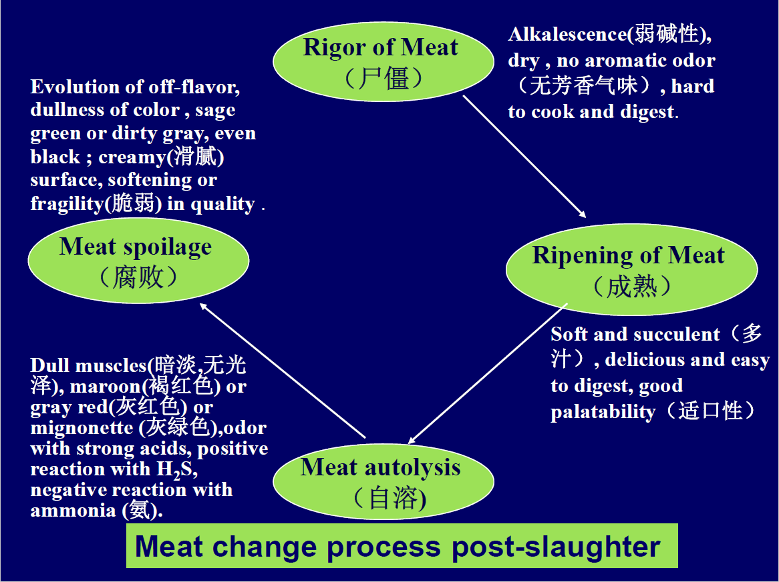

1. Meaty Acidic Ultimate pH(肉的酸性极限pH值)

When glycogen is exhausted or residue cannot be decomposed on account of passivation(钝化作用) of glycolysis(糖酵解), pH of the meat will not descend(下降), that is acidic ultimate pH.(当糖原耗尽或糖酵解的钝化作用,肉的pH值不会下降,这个pH称为肉的酸性极限pH值)

1. Inspection of meat freshness: sensory inspection and laboratory examination(total volatile basic-nitrogen, H2S test, Determine the total number of bacteria, most probable number of coliform)

见课件

1. Storage methods: freezing, increase osmotic pressure; high pressure; desiccation;
2. low temperature preservation--- refrigeration（冷冻）
3. high temperature sterilization (杀菌)
4. preservation---can（罐头）
5. high osmotic pressure preservation--cured meat product （腌腊制品）
6. desiccation preservation--charqui(肉松、肉干)
7. Chilling meat: -2℃- 0℃-one month
8. The chilling(冷却) means that make the temperature of fresh meat fall into feasible nonicing temperature：
9. Temperature requirement: refrigeratory temperature should keep -2℃before fresh meat warehousing, then keep 0℃.
10. Chilling time: pig 24 h; sheep 12 h.
11. Fresh meat was kept distance about 3-5 cm.
12. Storeroom: keep dark to reduce fat oxidation.
13. Preservation time: 1 month.
14. Freezing meat: -18 to -23 ℃

The freezing means that make the temperature of meat decreased down to freezing point (冰冻点).

Two steps freezing method:

◆ keep fresh meat at the temperature 0℃ for 24 h

◆ keep chilling meat at the temperature -23℃ for 24 h, and the internal temperature of meat keep -15℃

One step freezing method:

◆ After 4 h forced air cooling, keep fresh meat at the temperature -23℃ for 24 h

(The critical temperature(临界温度) of prevented bacteria growth is -12℃, but activity of enzymes

have not been effectively inhibited, so frozen meat should keep -18℃)

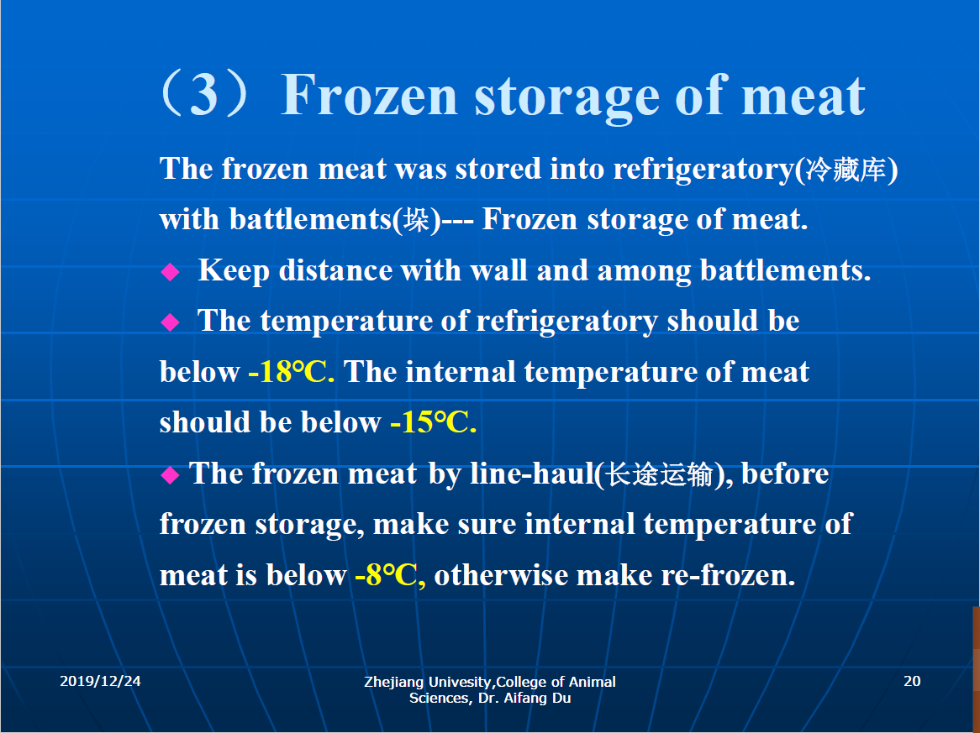

1. Abnormal changes in frozen storage: Pastiness(发粘); Peculiar smell(异味); Fat oxidation(脂肪氧化); Go moldy(发霉); Deep-seated decay(深层腐败); Dry rot(干枯); Irradiance(发光); Off colour(变色)

见课件

1. Nitrite detection; NaCl detection

Determinating of nitrite with Griess colorimetry(Griess氏试剂比色法)

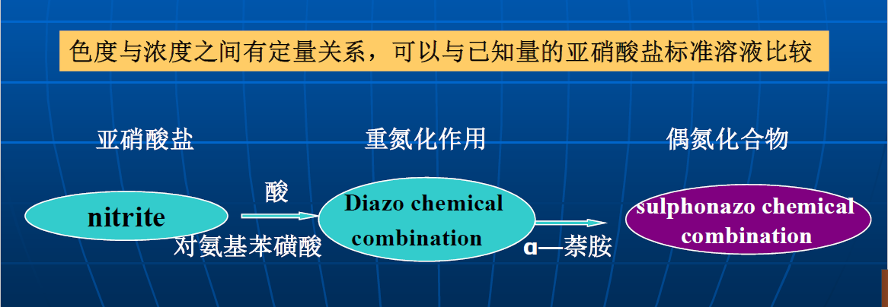

Measurement of NaCl: silver titration method (银滴定法)

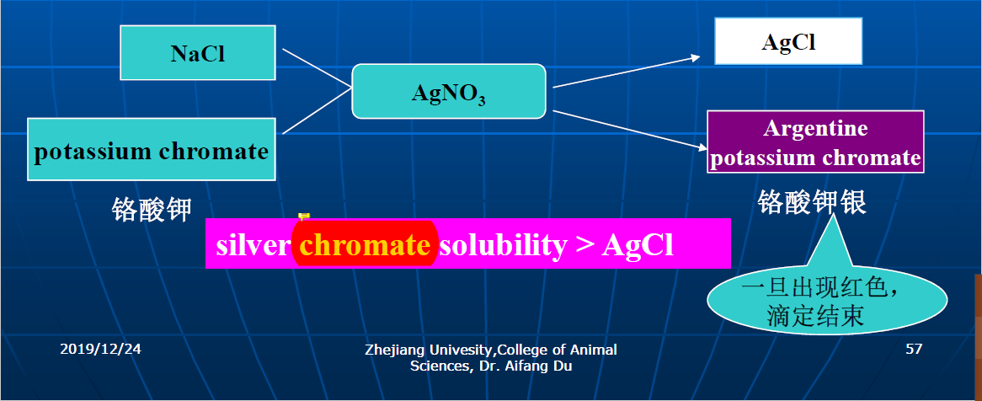

1. Action of saltpeter(硝石): Coloration; Flavour development function; Bacteriostasis
2. Coloration

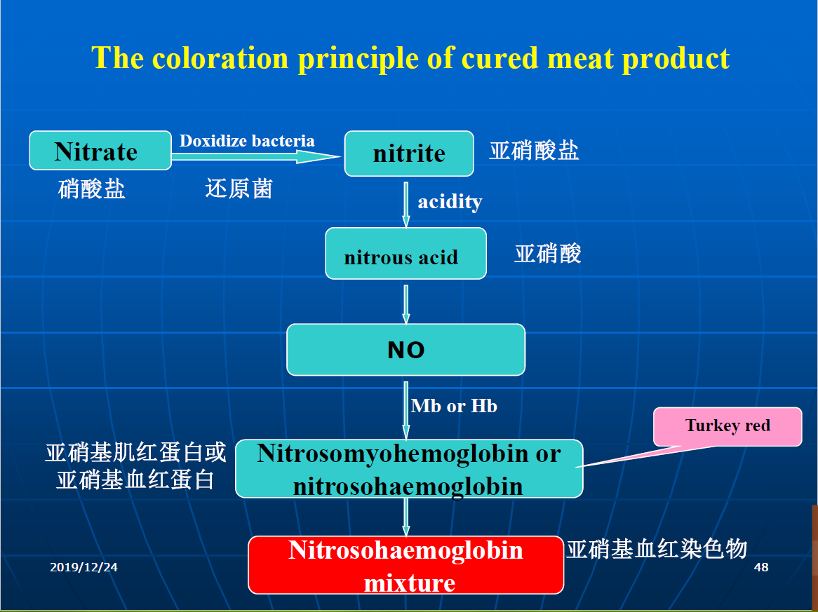

1. Bacteriostasis (制菌作用)

G+oxyphobe bacteria(厌氧性G+菌)

Closridium botulinum (肉毒梭菌)—producting paralysis exotoxin（外毒素）、endotoxin(内毒素)

1. Flavour development function(呈味作用): special aromatic odor
2. Inspection of can: Appearance check; Content check ; Microorganism detection
3. Appearance check
4. Label paper（商标）
5. Expandation（膨胀）
6. Rust（绣斑）
7. Crack and dilapidation（裂缝和破损）
8. Clarity（玻璃罐罐身是否清洁透明）
9. Air bubble（玻璃罐内有无气泡）
10. Content check
11. Tissue morphological identification(组织和形态鉴定): unfrozen morphological check(将肉罐头加热至汤汁溶化)--eyewinker(异物) such as grass, blood, hair etc.
12. Color and lustre identification(色泽鉴定): observe whether the solid content and cooking liquor(汤汁) is clear.
13. Savor and flavor identification(滋味和香味鉴定): degustation identification
14. Can wall check(检查容器内壁): rust or iron sulfide macula
15. Microorganism detection

