**Lecture1**

**DNA structure(overall structure of the DNA molecule. )**

1.DNA is composed of 2 chains of nucleotides that form a double helix双螺旋 shape.

2.The two strands are antiparallel反向平行

3.The backbone of the DNA molecule is composed of alternating交替的 phosphate groups磷酸基 and sugars

4.The complimentary nitrogenous bases含氮碱基 form hydrogen bonds氢键 between the strands

5. A is complementary to T and G is complementary to C

**DNA functions**

1. Storage of genetic information

2. Self-duplication & inheritance

3. Expression of the genetic message

DNA’s major function is to code编码 for proteins. Information is encoded in the order of the nitrogenous bases.

**Biological roles of RNA**

1. RNA is the genetic proaterial of some viruses

2. RNA functions as the protein-synthesizing machinery

3.RNA functions as an asaptor(tRNA) between the codons密码子 in the mRNA and amino acids氨基酸

4. RNA serves as a regulatory molecule, which through equence complementarity binds to, and interferes with the translation of certain mRNAs.

5. Some RNAs are enzymes that catalyze催化 essential reactions in the cell

**Summarize the relationship between genes and DNA.**

**Lecture2**

1.During prophase of mitosis有丝分裂, chromatin染色质 fibers become coiled into chromosomes with each chromosome having two chromatids染色单体 joined at a centromere着丝点.

2.A centromere is a region of DNA typically found near the middle of a chromosome where two identical sister chromatids come in contact. It is involved in cell division as the point of mitotic spindle纺锤体.

1. A telomere端粒 is a region of repetitive DNA（重复DNA） at the end of a chromosome, which protects the end of the chromosome from deterioration解体
2. **Difference about chromosome in Prokaryotic原核 and Eukaryotic真核?**

**Prokaryotic:** circular, very small, 1chromosome per cell, some enzymes and proteins are associated with the DNA, not housed in a nucleus

**Eukaryotic:** linear, fairly long, several chromosomes per cell, histone 组蛋白proteins spools缠绕 same in all eukaryotes, housed in a nucleus,2 loops of DNA wrapped around 8 histone proteins in nucleosome核小体, unity theme

**Functions of chromatin**

The functions of chromatin are to package DNA into a smaller volume to fit in the cell, to strengthen the DNA to allow mitosis and meiosis减数分裂, and to serve as a mechanism to control expression and DNA replication(DNA复制和表达).

**Difference about Heterochromatin异染色体 and euchromatin常染色体?**

**Lecture3**

1.parental strand = template

2.Single strand Binding Proteins (SSB) keep the two strands from re-annealing (coming back together).

3.Primase引物酶 is an RNA polymerase（RNA聚合酶） that synthesize the RNA primer引物.

4. Exonuclease外切酶 removes mismatches 3'to 5', degrades退化 double stranded DNA 3'to 5'

5. Polymerase聚合酶 catalyzes催化 chain growth 5' to 3'

6. Prokaryotes have a single origin of replication while eukaryotes have multiple origin of replication

7. Replication happens in the S phase of Interphase分裂间期

**What DNA replication require**

1. H bonds between bases must be broken

2. chain separation/unwinding

3. available pools of 4 dNTPs: A = T, C ≡ G

4. Enzymes

**Describe how replication works and the significant**

Enzymes unzip DNA and complementary互补的 nucleotides join each original strand. Both new cells will have the correct DNA through replication.

**Nature of the Genetic Material**

①it must contain, in a stable form, information encoding the organism’s生物体 structure, function, development and reproduction繁殖

②it must replicate accuratelyso progeny cells子细胞 have the same genetic make up

③it must be capable of some variation (mutation) to permit evolution

**Enzymes required in DNA replication：**

1. a DNA helicase解旋酶 must unwind the parental template
2. a primase must synthesize short oligoribonucleotides寡核糖核苷酸 that serve as primer for synthesis of the Okazaki fragments冈崎片段 on the lagging strand后随链, a single-stranded DNA-binding protein that coats the single-stranded lagging-strand template and interacts with other replication proteins
3. a DNA polymerase must synthesize the nascent leading and lagging strands.

**Semiconservative replication：**

**Semiconservative replication** describes the method by which [DNA](http://cn.bing.com/reference/semhtml/DNA) is replicated in all known cells. This method of replication was one of three proposed models[[1]](http://cn.bing.com/reference/semhtml/Semiconservative_replication#cite_note-Griffiths-0) [[2]](http://cn.bing.com/reference/semhtml/Semiconservative_replication#cite_note-1) of[DNA replication](http://cn.bing.com/reference/semhtml/DNA_replication):

* Semiconservative replication would produce two copies that each contained one of the original strands and one new strand.
* Conservative replication would leave the two original template [DNA](http://cn.bing.com/reference/semhtml/DNA) strands together in a double helix and would produce a copy composed of two new strands containing all of the new DNA base pairs.
* Dispersive replication would produce two copies of the [DNA](http://cn.bing.com/reference/semhtml/DNA), both containing distinct regions of DNA composed of either both original strands or both new strands

**Lecture4**

**Mechanism of DNA replication？？？**

**General concepts：**

RNA is a polymer composed of alternating units of ribonucleotides connected through a 3’-5’phosphodiesterbond.

**rRNA** -Ribosome -contains enzymes and keeps everything together，the RNA structural component of the ribosome

**tRNA** -Transfer RNA carries amino acid and read codonson m-RNA through its own anticodons.assists in decoding the information contained within mRNA duringtranslation by recruiting the correct amino acid to the growing peptide chain

**mRNA** the RNA that transfers genetic information stored in DNA into a

form useable for protein synthesis

**General mechanism of RNA synthesis**

①elongation by addition of ribonucleotides to the 3’-OH end

②3’-OH acts as a nucleophile, attacking the a-phosphate of the incoming ribonucleoside triphosphate and releasing pyrophosphate

③mechanism is the same as that used for elongation of a DNA strand

**Function of 5´cap**

• Protection from degradation

• Increased translational efficiency

• Transport to cytoplasm

• Splicing of first intron

**Function of poly(A) tail**

• Increased mRNA stability

• Increased translational efficiency

• Splicing of last intron

**1. Why is transcription necessary?**

Transcription makes messenger RNA (mRNA) to carry the code for proteins out of the nucleus to the ribosomesin the cytoplasm.

**2. Describe transcription.**

RNA polymerase binds to DNA, separates the strands, then uses one strand as a template to assemble mRNA.

**5. What are the main differences between DNA and RNA.**

DNA has deoxyribose, RNA has ribose; DNA has 2 strands, RNA has one strand; DNA has thymine, RNA has uracil.

**What is different between the DNA replication and RNA transcription ?**

Transcription is very similar to DNA replication but there are some important differences:

1.RNA is made of ribonucleotides

2.RNA polymerase catalyzes the reaction

3. The synthesized RNA does not remain base-paired to the template DNA strand

4. Less accurate (error rate: 10-4)

5.Transcription selectively copies only certain parts of the genome and makes one to several hundred, or even thousand, copies of any given section of the genome.

**Lecture5**

**Genes are expressed in a 2 step process:**

First, an RNA copy of a single gene is made (transcription).

Then, the nucleotide sequence of the RNA copy (messenger RNA) is translated into the amino acid sequence of the polypeptide.

**Main challenge of translation**

• The genetic information in mRNA cannot be recognized by amino acids.

• The genetic code has to be recognized by an adaptor molecular (translator),

and this adaptor has to accurately recruit the corresponding amino acid.

**The structure and function of four components of the translation**

**Machinery.???**

**functions of RNA**

tRNA are adaptors between codons and amino acids

tRNAs share a common secondary structure that resemble a cloverleaf which shows the base pairing of various regions to form four stems (arms) and three loops.

Aminoacyl tRNA synthetases :Amino acids should attach to tRNA first before adding to polypeptide chain.

**mRNA**

The protein-coding region of the mRNA consists of an ordered series of 3-nt-long units called codons that specify the order of amino acids.

1 Prokaryotic mRNAs have a ribosome binding site that recruits the translational machinery

2 Eukaryotic mRNA are modified at their 5’and 3’ends to facilitate translation.

**the ribosome is composed of a large and a small subunit**

• The large subunit contains the peptidyltransferase center, which is responsible for the formation of peptide bonds.

• The small subunit interacting with mRNA contains the decoding center,in which charged tRNAs read or “decode”the codon units of the mRNA.

**Translation initiation, elongation and termination???**

Translation initiation factors hold eukaryotic mRNAs in circles

**How do prokaryotes and eukaryotes find the translation start sites ?**

Eukaryotic mRNA uses a methylated cap to recruitthe ribosome. Once bound, the ribosome scans themRNA in a 5’-3’direction to find the AUG start codon.

**Prokaryotes???**

**Lecture6**

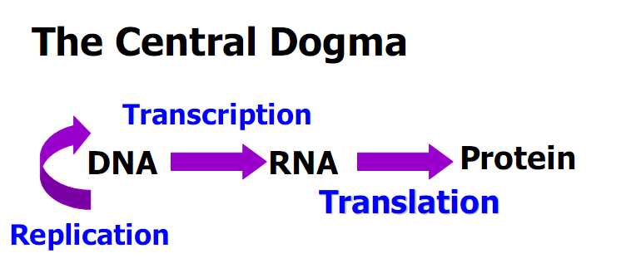

中心法则

**“The genetic code is degenerate”What does it mean? What’s the benefits?**

it means that many amino acids are speafied by more than one codon

Code degeneracy explains how therecan be great variation in the AT/GC ratios in the DNA of various organisms without large changes in the proportion of amino acids in their proteins.

The benefit:

1.The genetic code evolved in such a way as to minimize the deleterious effects of mutations.

2.Code degeneracy may serve as asafety mechanism to minimize errors in the reading of codons.

**What’s about the anticodonrecognition? How the code was discovered?**

**What are the three rules governing the genetic code? What are the mutations altering genetic code?**

Some tRNA could recognize several different codons

Inosine【次黄(嘌呤核)苷】 is present in the anticodonloop as a fifth base

**Wobble Concept**

the 5’end of the anticodonis not as spatially confined as the other two, allowing it to form hydrogen bonds with more than onebases located at the 3’end of a

codon.

**Why wobble is allowed at the 5’anticodon**

• The 3-D structure of tRNA shows that the stacking interactions between the

flat surfaces of the 3 anticodonbases + 2 followed bases position the first (5’)

anticodonbase at the end of the stack, thus less restricted in its movements.

• The 3’base appears in the middle of the stack, resulting in the restriction of its

movements.

Three codons, UAA, UAG, and UGA signify chain termination.

**THREE RULES GOVERN THE GENETIC CODE**

1 Codonsare read in a 5’to 3’ direction.

2 Codonsare nonoverlapping and the message contains no gaps.

3 The message is translated in a fixed reading frame which is set by the initiation codon.

**Three Kinds of Point Mutations Alter the Genetic Code**

1. Missense（错义） mutation: An alternation that changes a codonspecific for one amino acid to a codonspecific for another amino acid.

2. Nonsense无（意）义or stop mutation: An alternation causing a change to a chain-termination codon.

3. Frameshift(移码) mutation:Insertions or deletions of one or a small number of base pairs that alter the reading frame.

**Reverse the harmful mutations by a second genetic change**

①Reverse (back) mutations: change an altered nucleotide sequence back to its

original arrangement.

②Suppressor mutations: suppress the change due to mutation at site A by

producing an additional genetic change at site B.

(1) Intragenic基因内的suppression

(2) Intergenic基因间的suppression

**Benefits of the universal codes**

(1)Allow us to directly compare the protein coding sequences among all

organisms.

(2) Make it possible to express cloned copies of genes encoding useful protein in different host organism. Example: Human insulin expression in bacteria

**What are the benefits of the code universality? What’s about the**

**mitochondrial codes and tRNAs?**

the genetic code is slightly different from the standard code.

Mitochondrial tRNAs are unusual in the way that they decode mitochondrial messages.

Only 22 tRNAs are present in mammalian mitochondria. The U in the 5’ wobble position of a tRNA is capable of recognizing all four bases in the 3’ of the codon.

**Lecture7**

1、**Housekeeping genes**(持家基因):

expressed constitutively, essential for basic processes involving in cell

replication and growth

1. **Inducible genes**: （诱导基因）

expressed only when they are activated by inducers or cellular factors.

1. **Operon**: （操纵子）/ Lactose operon（乳糖操纵子）

a unit of prokaryotic gene expression and regulation ...有问题？

4、lacZ半乳糖苷酶、lacY(半乳糖苷渗透酶)、lacA(硫代半乳糖苷转乙酰酶)

**Topic1 看**

**Principles of Transcription Regulation**

Gene Expression is Controlled by Regulatory Proteins

Positive regulators or activators increase the transcription

Negative regulators or repressors decrease or ELIMINATE the transcription

Transcription process：

Targeting promoter binding by activators or repressors → Promoter “melting” → Initial transcription → Elongation and termination

**Topic2 看**

**Regulation of Transcription Initiation**

Operon includes：Structural genes、Control elements、 Regulator gene(s).

Lac operon

Lactose operon: a regulatory gene and 3 stuctural genes, and 2 control elements

Structure genes：lacZ半乳糖苷酶、lacY(半乳糖苷渗透酶)、lacA(硫代半乳糖苷转乙酰酶)

The enzymes required for the use of lactose as a carbon source are only

synthesized when lactose is available as the sole carbon source.

①Absence of inducer：

repressor binds to operantor region and prevents the RNA polymerase from transcribing the operon

②presence of inducer:

**Inducer binds repressors,(**inducer bind repressor or represser mRNA**). →** inactive repressot ,operon transcription → lac mRNA

An activator and a repressor together control the lac genes

CAP and lac repressor have opposing effects on RNA polymerase binding to the lac

promoter.

The lac operator overlaps promoter, and so repressor bound to the operator physically prevents RNA polymerase from binding to the promoter.

CAP has separate activating and DNA-binding surface;CAP and lac repressor bind

DNA using a common structural motif (DNA binding by a helix-turn-helix motif )

The activity of Lac repressor and CAP are controlled allosterically by their

Signals

Lack of inducer: the lac repressor block all but a very low level of transcription of lacZYA .

Key points of this chapter

1.Operon

2.Operator

3.Polycistronicmessage

4.Cis-acting elements

5.Activator/represor

7.Regulatory gene/structural gene

8.Regulation of transcription initiation in bacteria: the lacoperonmodel

Catabolite repression （分解代谢物阻遏又被称为葡萄糖效应）

**Lecture8**

**Similarity of regulation between eukaryotes and prokaryote**

1、Principles are the same: signals, activators and repressors, recruitment and allostery（变构）, cooperative binding

2、Expression of a gene can be regulated at the similar steps, and the initiation of transcription is the most pervasively regulated step.

**Difference in regulation between eukaryotes and prokaryote**

1. Pre-mRNA splicing adds an important stepfor regulation.

2. The eukaryotic transcriptional machineryis more elaborate than its bacterial counterpart.

3. Nucleosomesand their modifiers influenceaccess to genes.

4. Many eukaryotic genes have more regulatory binding sites and are controlled by more regulatory proteins than are bacterial genes.

**cis-regulatory element**

A cis-regulatory element or cis-element is aregion of DNA or RNA that regulates the

expression of Genes located on that same strand. This term is constructed from the

Latin word cis, which means "on the same side as". These cis-regulatory elements are

often binding sites of one or more trans-acting factors. A cis-element may be located in the promoter region 5' to the gene it controls, in an intron, or in the 3'untranslated region.

**Trans-regulatory elements**

Trans-regulatory elements are species which may modify the expression of genes distant

from the gene that was originally transcribedto create them. To demonstrate the concept

(this is not a specific example), a transcription factor which regulates a gene

on chromosome 6 might itself have been transcribed from a gene on chromosome 11.

This term is constructed from the Latin root -trans, which means "across from".

**Expound the general mechanism of control of gene expression of Eukaryotes???**

**Lecture9**

**The Sanger sequencing reaction.**

Single stranded DNA is amplified in the presence of fluorescently labelled ddNTPsthat

serve to terminate the reaction and label all the fragments of DNA

produced. The fragments of DNA are then separated via polyacrylamidegel

electrophoresis and the sequence read using a laser beam and computer.

**Two strategies for large-scale sequencing**

1 Clone by Clone

2 Whole Genome Shot-gun

**Lecture10**

**Techniques of Molecular Biology**

1.Electrophoresis

2.Restriction digestion

3.Hybridization

4.PCR

5.Genome sequence & analysis

6.DNA Cloning and gene expression

Gel electrophoresis separates DNA and RNA molecules according to size shape and topological properties

**To separate DNA of different size ranges**

Narrow size range of DNA: use polyacrylamide

Wide size range of DNA: use agarosegel

Very large DNA(>30-50kb): use pulsed-field gel electrophoresis

**Southern/Northern/Western Blotting, those techniques for what’s purpose ?**

**Southern Blotting** detects the target gene in genome

**Northern Blotting** detects the RNA（usually mRNA）and expression level

**Western Blotting** to detect specific protein

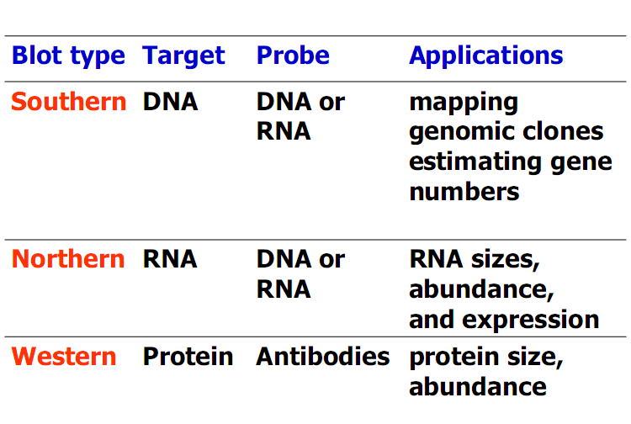

**PCR cycle principles**

①Denaturation: The target DNA (template) is separated into two stands by heating to

95℃

②Primer annealing: The temperature is reduced to around 55℃ to allow the primers to anneal.

③Polymerization (elongation, extension):The temperature is increased to 72℃ for

optimal polymerization step which uses up dNTPsand required Mg++.

**The requirement of PCR cycle**

①Template ：PCR can only be applied ifsome sequence information is known so that

primers can be designed.

②Primers：PCR primers need to be about 18 to 30 nt long and have similar G+C contents so that they anneal to their complementary sequences at similar temperatures.They are designed to anneal on opposite strands of the target sequence.

**Way to PCR optimization**

We can change the annealing temperature and the Mg++ concentration or carry out nested PCR to optimize PCR.

**Two ways for sequencing:**

1. DNA molecules (radioactivellabeled at 5’termini) are subjected to 4 regiments to be

broken preferentially at Gs, CsTs, As, separately.

2. chain-termination method