Electrophoresis: gel electrophoresis separates DNA and RNA molecules according to size, shape and topological properties

1. Gel matrix is an inserted, jello-like porous material that support material that supports and allows macromolecules to move through

two different gel matrices:

1. Agarose: wide size range of DNA
2. Polyacrylamide: narrow size range of DNA

Pulsed field gel electrophoresis: very large DNA

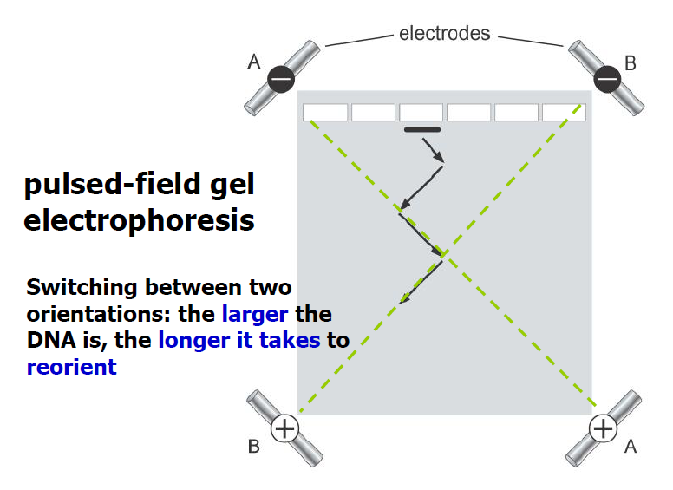

1. DNA and RNA molecules are negatively charger, thus move in the gel matrix toward the positive pole (+)
2. Linear DNA molecules are separated according to size. The mobility of circular DNA molecules is affected by their topological structures. The mobility of the same molecular weight DNA molecule with different shapes is : supercoiled＞linear＞nicked or relaxed

Restriction digestion: restriction endonucleases cleave DNA molecules at particular sites

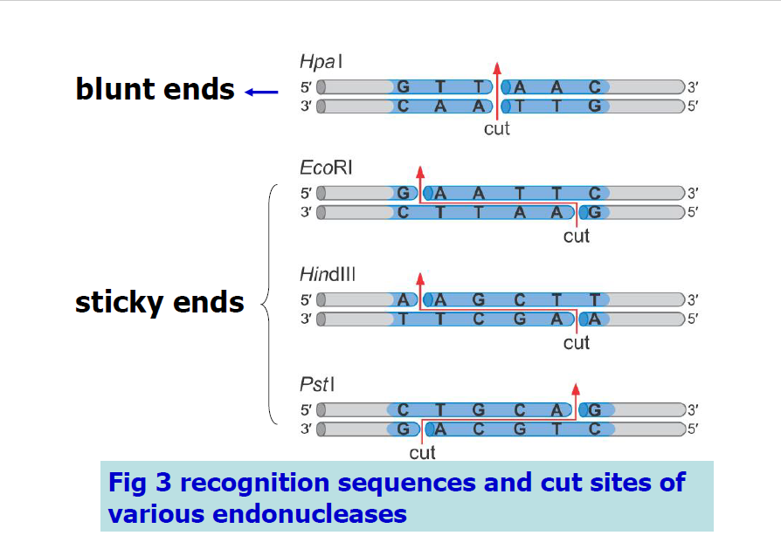

The 5’ protruding ends of are said to be sticky because they readily anneal through base-pairing to DNA molecules cut with the same enzyme

DNA/RNA hybridization: the process of base-pairing between complementary ssDNA or RNA from two different sources

DNA hybridization can be used to identify specific DNA molecules

Probe: a labeled, defined sequence used to search mixtures of nucleic acids for molecules containing a complementary sequence

Labeling of DNA or RNA probes

1. Radioactive labeling: display and/or magnify the signals by radioactivity
2. Non-radioactive labeling: display and/or magnify the signals by antigen labeling/antibody binding/enzyme binding/substrate

* End labeling: put the labels at the ends__single stranded DNA/RNA
* 5’-end labeling: polynucleotide kinase(PNK)
* 3’-end labeling: terminal transferase
* Uniform labeling: put the labels internally
* Nick translation: DNaseⅠto introduce random nicks→DNA polⅠto remove dNMPs from 3’ to 5’ and add new dNMP including labeled nucleotide at the 3’ ends
* Hexanucleotide primered labeling: denature DNA→add random hexanucleotide primers and DNA pol→synthesis of new strand incorporating labeled nucleotide

1. Southern blotting: a method routinely used in molecular biology for detection of a specific DNA sequence in DNA samples
2. Northern blotting: a technique used in molecular biology research to study gene expression by detection of RNA (or isolated mRNA) in a sample
3. Western blotting: an analytical technique used to detect specific proteins in a given sample of tissue homogenate or extract
4. Resolve protein samples on native page
5. Electrophoretically transfer fractionated proteins from gel onto PVDF membrane
6. Block the membrane with neutral protein (BSA or milk casein)
7. Incubate the membrane with HRP-labeled antibody specific to prey protein
8. Incubate the blot with chemiluminescent HRP substrate and expose to film

Enzyme-linked immunosorbent assay(ELISA)

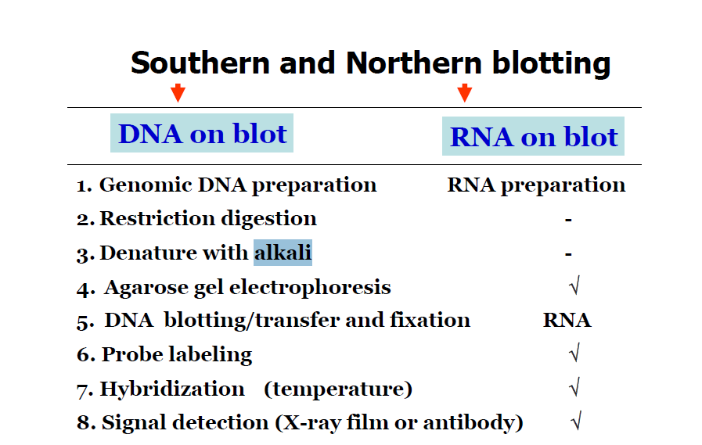

|  |  |  |  |
| --- | --- | --- | --- |
| Blot type | target | probe | application |
| Southern | DNA | DNA or RNA | Mapping  Genomic clones  Estimating gene numbers |
| northern | RNA | DNA or RNA | RNA sizes  expression  abundance |
| western | protein | antibody | Protein size  abundance |

PCR (polymerase chain reaction): amplify a sequence of DNA using a pair of primers each complementary to one end of the DNA target sequence

The PCR cycle

1. Denaturation: the target DNA (template) is separated into two stands by heating to 95℃
2. Primer annealing: the temperature is reduced to around 55℃to allow the primers to anneal
3. Polymerization (elongation, extension): the temperature is increase to 72℃for optimal polymerization step which uses up dNTPs and required Mg2+

Template: any source of DNA whose sequence information is known so that primers can be design

Primers: an oligo pool derived from protein sequence, about 18 to 30 nt long and have similar G+C contents so that they anneal to their complementary sequences at similar temperature

▲Tm=2(A+T)+4(G+C): determine annealing temperature. If the primer is 18-30 nt, annealing temperature can be Tm±5℃

Enzymes: the most common is Taq polymerase which has (no???) 3’ to 5’ proofreading exonuclease activity

PCR optimization: we can change the annealing temperature and the Mg2+ concentration or carry out nested PCR to optimize PCR

Two way of DNA sequencing

DNA molecules are subjected to 4 regiments to be broken preferentially at Gs, Cs, Ts, As, separately

Chain-termination method

ddNTP are chain-terminating nucleotides: the synthesis of a DNA strand stops when a ddNTP is added to the 3’ end. The absence of 3’-hydroxyl lead to the inefficiency of the nucleophilic attack on the next incoming substrate molecule

DNA cloning by recombinant DNA methods and gene expression

A fragment of DNA to be cloned is first inserted into a plasmid vector containing an ampicilin-resistance gene. Only the few cells transformed by incorporation of a plasmid molecule will survive on ampicilin-containing medium. In transformed cells, the plasmid DNA replicates and segregates into daughter cells, resulting in formation of an ampicilin-resistant colony

▲Blue/white colony screening, its principle?

Cells transformed with vectous containing recombinant DNA will produce white colonies, cells transformed with non-recombinant plasmids grow into blue colonies

αcomplementation of the β-galactosidase gene. The function of an inactive mutant β-galactosidase with deleted sequence was rescued by a fragment of β-galactosidase in which that same sequence. The mutant non-function β-galactosidase was lacking in part of its N-terminus with its residues 11-41 deleted, but it may be complemented by a peptide formed of residues 3-90 of β-galactosidase. The α-complementation via the use of a vector was demonstrated by the formation of blue plaques when cells containing the inactive protein were infected by the phage and then grow in plates containing X-gal

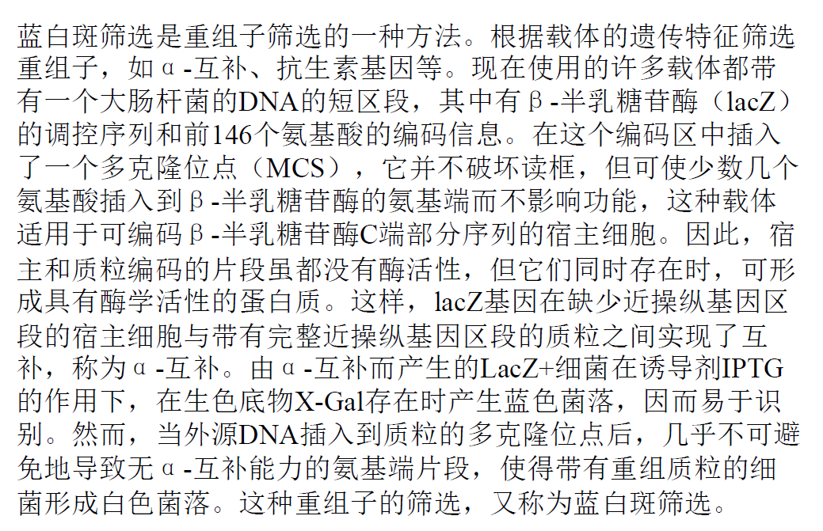

#T4 DNA ligase

Plasmid: a small DNA molecule that is physically separate from, and can replicate independently of, chromosomal DNA within a cell

Vector: plasmids used in genetic engineering are called vectors

Mechanism of induction by IPTG

In the absence of lactose, the lac repressor binds to the operator sequence on DNA and this prevents T7 RNA polymerase to bind the promoter site and thus prevents leaky transcription of gene before induction. When lactose binds to LacI it induces a conformational change in the protein structure that renders it incapable of binding to the operator DNA sequence. IPTG is a structural mimic of lactose (it resembles the galactose sugar) that also binds to the lac repressor and induces a similar conformational change that greatly reduces its affinity for DNA. Unlike lactose, IPTG is not part of any metabolic pathways and so will not be broken down or used by the cell. This ensures that the concentration of IPTG added remains constant, making it a more useful inducer of the lac operon than lactose itself.

在乳糖缺失的情况下，Lac阻遏物与DNA上的操作者序列结合，从而阻止T7 rNAPOR酶进入启动子位点，从而防止诱导前的基因的漏泄转录。当乳糖结合到LacI时，它诱导蛋白质结构的构象改变。这使得它不能与操作者的DNA序列结合。IPTG是一种结构类似于乳糖（类似于半乳糖）的结构类似物，它与Lac阻遏物结合并诱导类似的构象变化，从而大大降低其对DNA的亲和力。与乳糖不同，IPTG不是任何代谢途径的一部分，因此不会被细胞分解或使用。这使IPTG的浓度保持恒定，使其成为乳糖操纵子比乳糖本身更有用的诱导剂。

Restriction endonucleases

Southern/Northern/Western Blotting,

those techniques for what’s purpose ?

PCR and its working principle ? Its application ?

DNA sequencing principle

DNA recombination

blue/white colony screening principle

induction expression principle