Gene expression

An RNA copy of a single gene is made (transcription)

The nucleotide sequence of the RNA copy (mRNA) is translate into the amino acid sequence of the polypeptide

Allele: the same gene in the same chromosomal location, but with minor nucleotide changes that yield slightly proteins

Diploid: having 2 copies of each gene and each chromosome

Codons: an ordered series of 3-nt-long units of the mRNA that specify the order of amino acids

Opening reading frame (ORF): a continuous, non-overlapping string of codons that makes up the protein coding region of each mRNA

Polycistronic mRNA: mRNA containing more than one ORF

Prokaryotic mRNAs have a ribosome binding site(RBS/SD-sequence) that recruits the translational machinery

Eukaryotic mRNA are modified at their 5’ and 3’ ends to facilitate translation

Ribosome binding site(RBS) or SD-sequence in prokaryotic mRNA, complementary with the sequence at the 3’ end of 16s rRNA

Enkaryotic mRNA uses a methylated cap to recruit the ribosome. Once bound, the ribosome scans the mRNA in a 5’ to 3’ direction to find the AUG start codon

Kozak sequence increases the translation efficiency

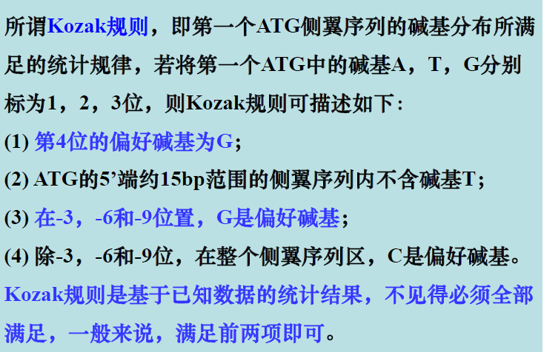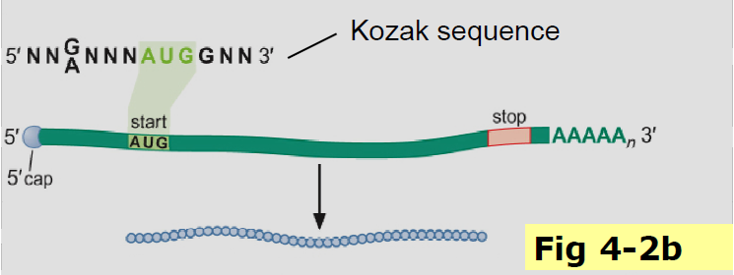

（无0位）

Poly-A in the 3’ end promotes the efficient recycling of ribosomes

All tRNAs end with the sequence CCA-3’ at the 3’ end, where the aminoacyl-tRNA-synthetase adds the amino acid

Aminoacyl tRNA syntherases charge tRNA

1. Adenylylation of amino acids: the aminoacyl-tRNA synthetase attaches AMP to the -COOH group of the amino acid utilizing ATP to create an aminoacyl adenylate intermediate
2. The appropriate tRNA displaces the AMP

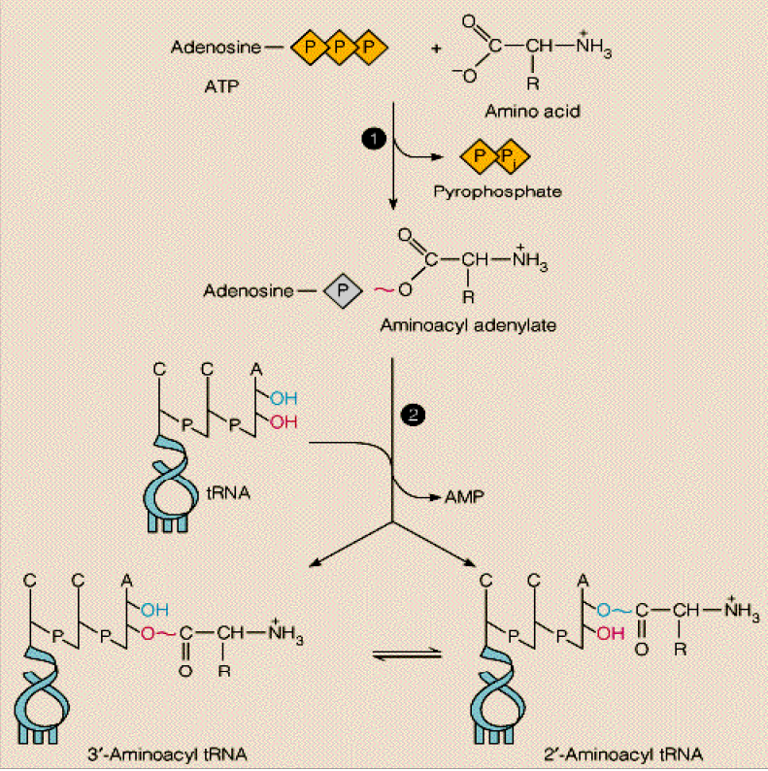

Ribosome cycles: in cells, the small and large ribosome subunits associate with each other and the mRNA, translate it, and the dissociate after each round of translation

Polysome/polyribosome: an mRNA bearing multiple ribosomes

Try to explain how the mRNA poly-A tail contributes to the translation efficiency?

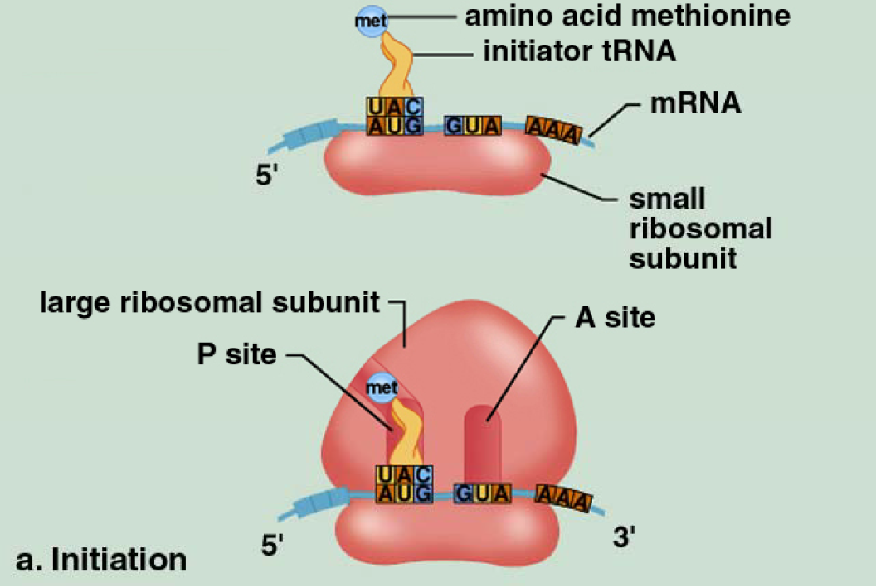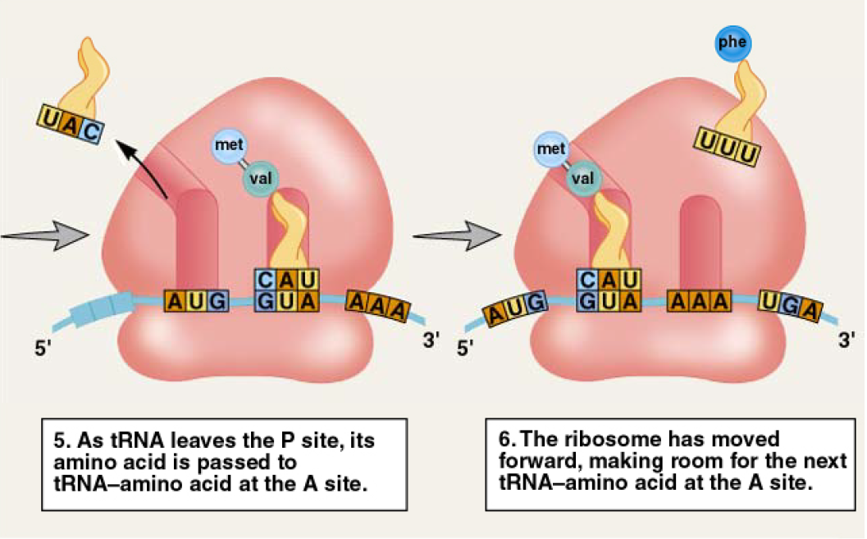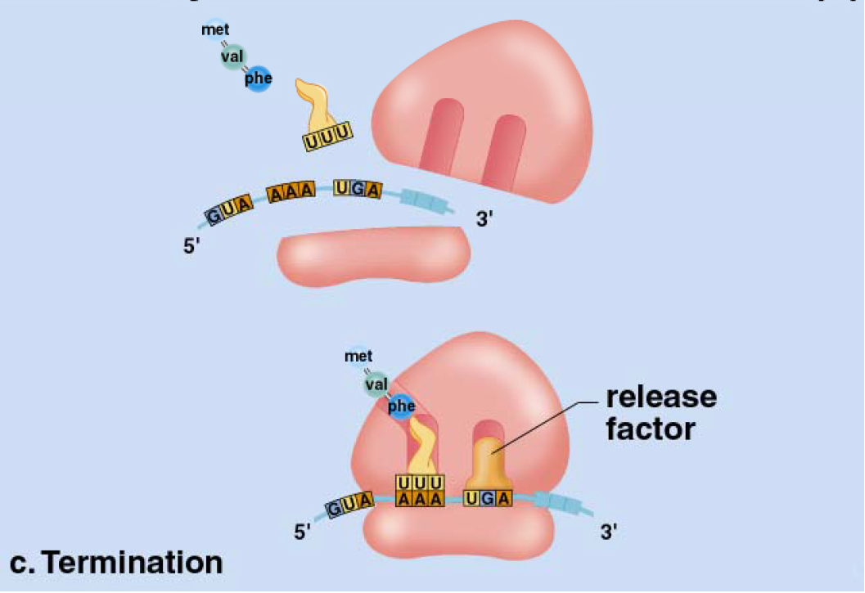

1. The main challenge of translation and the solution

2. The structure and function of four components of the translation machinery.

3. Translation initiation, elongation and termination

4. How do prokaryotes and eukaryotes find the translation start sites

mRNA、tRNA、rRNA

ORF

polycistronic mRNAs

Kozak sequence

SD sequence

ribosome/ribosome cycle

polysome

translation