Synonyms: codons specifying the same amino acid are called synonyms

Transition in the third position of a codon specifies a same amino acid

Transversion in this position changes the amino acid about half the time

Code degeneracy minimizes the deleterious effects of mutations and serves as a safety mechanism to minimize errors in the reading of codons

The second position of a codon:

Pyrimidines(U、C)-hydrophobic amino acids

Purines(A、G)-hydrophilic amino acids

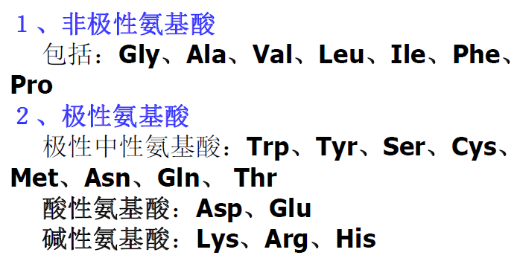

If the first two positions are both occupied by G or C, each of the four nucleotides in the third position specifies the same amino acid

Some tRNA could recognize several different codons

The wobble rules:一个tRNA通过与密码子第三个碱基非寻常配对(不是GC， AT)而识别不止一个密码子

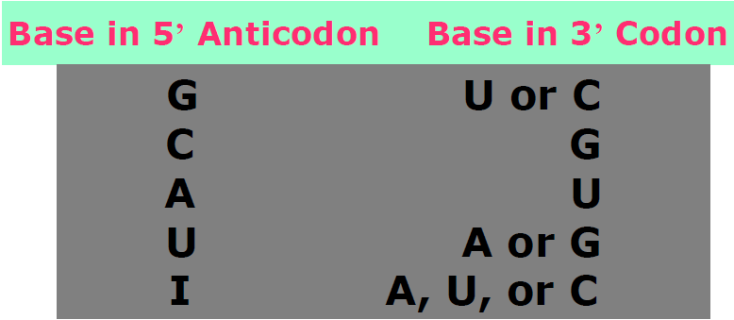

#In mammalian mitochondria, the U in the 5’ wobble position of a tRNA is capable of recognizing all four bases in the 3’ of the codon

Three codons, UAA, UAG, UGA signify chain termination. They are not read by tRNAs but by proteins called release factors(RF1 and RF2 in bacteria and eRF1 in eukaryotes)

Three rules govern the genetic code

1. Codons are read in a 5’ to 3’ direction
2. Codons are nonoverlapping and the message contains no gaps
3. The message is translated in a fixed reading frame which is set by the initiation codon

Three kinds of point mutations alter the genetic code

1. Missense mutation: an alternation that changes a codon specific for one amino acid to a codon specific for another amino acid
2. Nonsense or stop mutation: an alternation causing a change to a chain-termination codon
3. Frameshift mutation: insertions or deletions of one or a small number of base pairs that alter the reading frame

Genetic proof that the code is read in units of three

A classic experiment involving bacteriophage T4. Because the gene could tolerate three insertions but not one or two, the genetic code must be read in units of three.

Reverse the harmful mutations by a second genetic change

Reverse mutation: change an altered nucleotide sequence back to its original ariginal arrangement

Suppressor mutations: suppress the change due to mutation at site A by producing an additional genetic change at site B( intragenic suppression & intergenic suppression)

Genetic codon

Stop codon

codon-degeneracy

Transition/Transversion

Wobble Rules

Three Rules

Missensemutation, Nonsense or stop mutation, Frameshift mutation

universality of the genetic code

“The genetic code is degenerate” What does it mean? What’s the benefits? What’s about the anticodon recognition? How the code was discovered?

What are the three rules governing the genetic code? What are the mutations altering genetic code?

What are the benefits of the code universality? What’s about the mitochondrial codes and tRNAs?