Housekeeping genes: expressed constitutively, essential for basic processes involving cell replication and growth

Inducible genes: expressed only when they are activated pr de-repressed by cellular factors

Why are proteins not made where/when they are not needed?

1. Conserve cellular resources and energy
2. Bestow cell types specificity

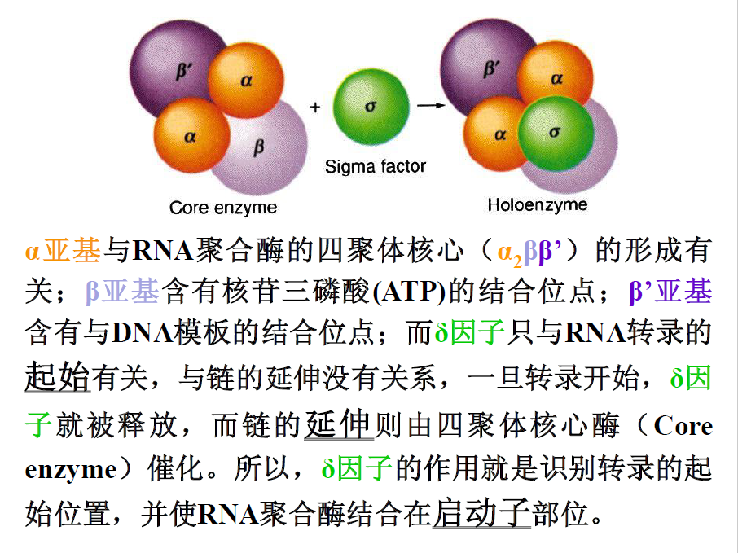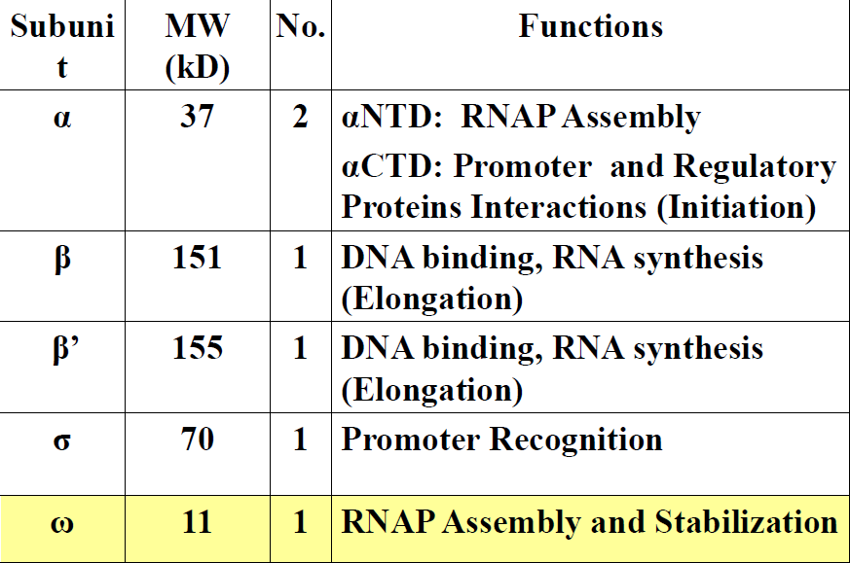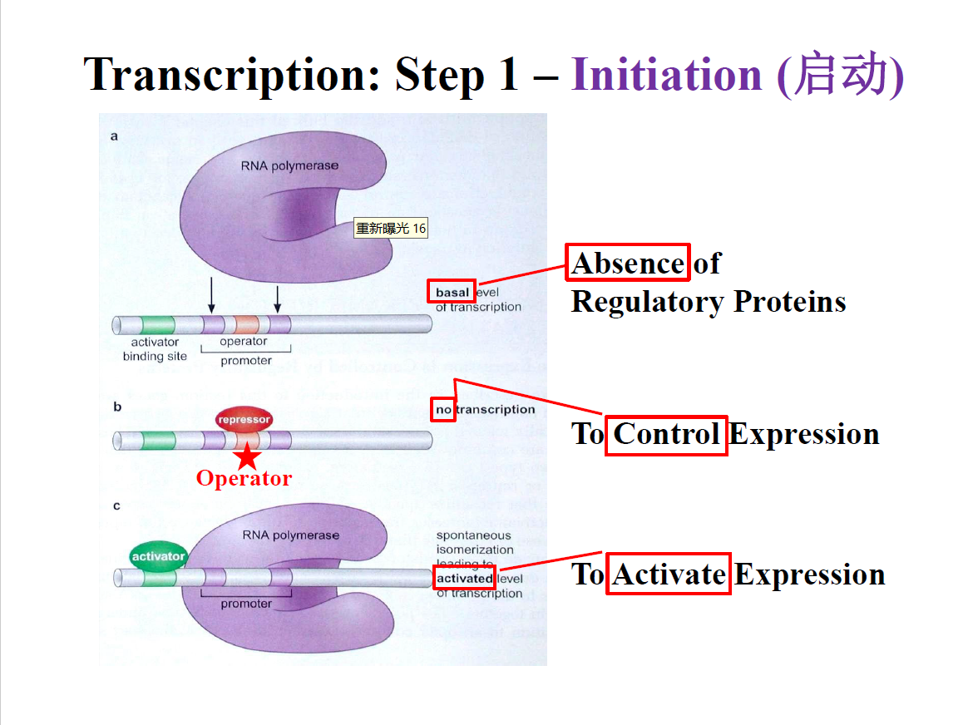

Regulation of transcription initiation(examples from E.coli)

Operon: a unit of prokaryotic gene expression and regulation which typically includes structural genes, control elements and regulator genes.

1. Structural genes, encodes for enzymes in a specific biosynthetic pathway whose expressions are coordinately controlled
2. Control element, such as operator sequence
3. Regulator genes, whose products recognize the control elements

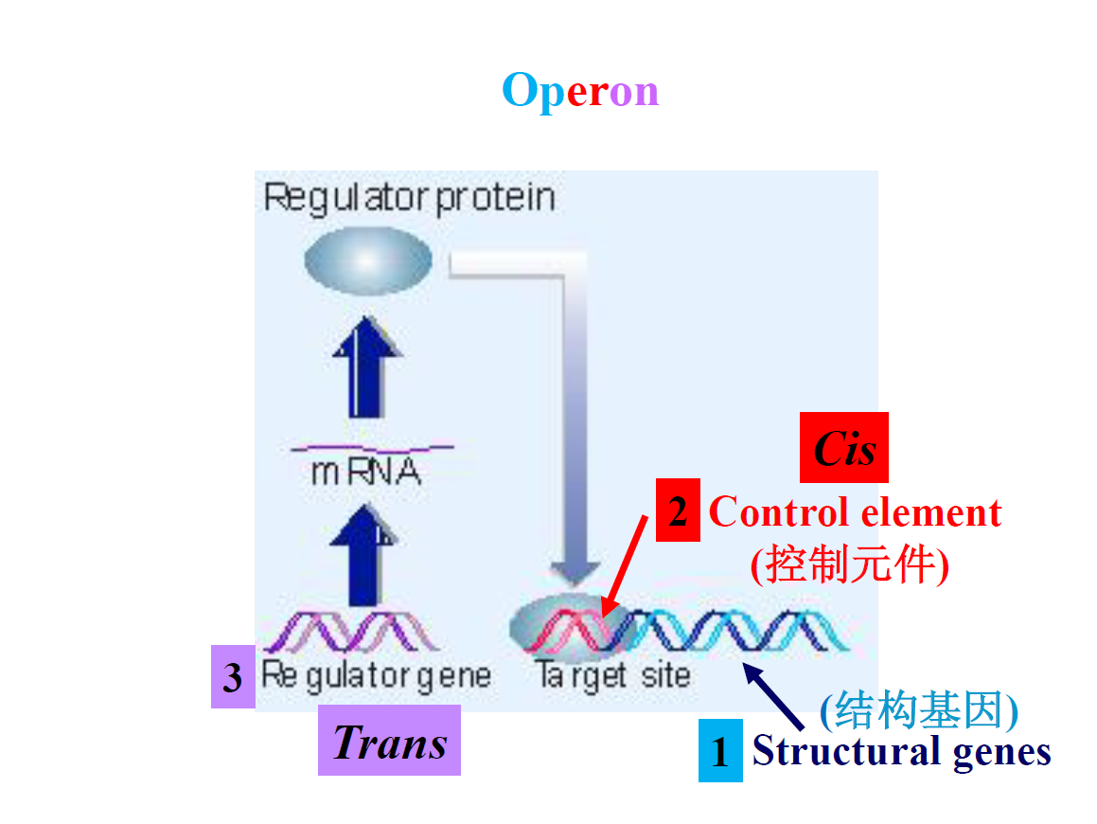

顺式作用元件cis-acting element：与结构基因串联并影响基因表达的特定DNA序列

包括启动子、增强子、调控序列和可诱导元元件等。其本身不编码任何蛋白质，仅仅提供一个作用位点，与反式作用因子相互作用而起作用

反式作用因子（转录因子）trans-acting factor：是直接或间接地识别或结合在各类顺式作用元件核心序列上参与调控靶基因转录效率的蛋白质

包括两个功能结构区（domain）：DNA结合结构域（DNA-binding domain——DBD），转录活化结构域（TAD）

Regulation of transcription initiation——the lac operon

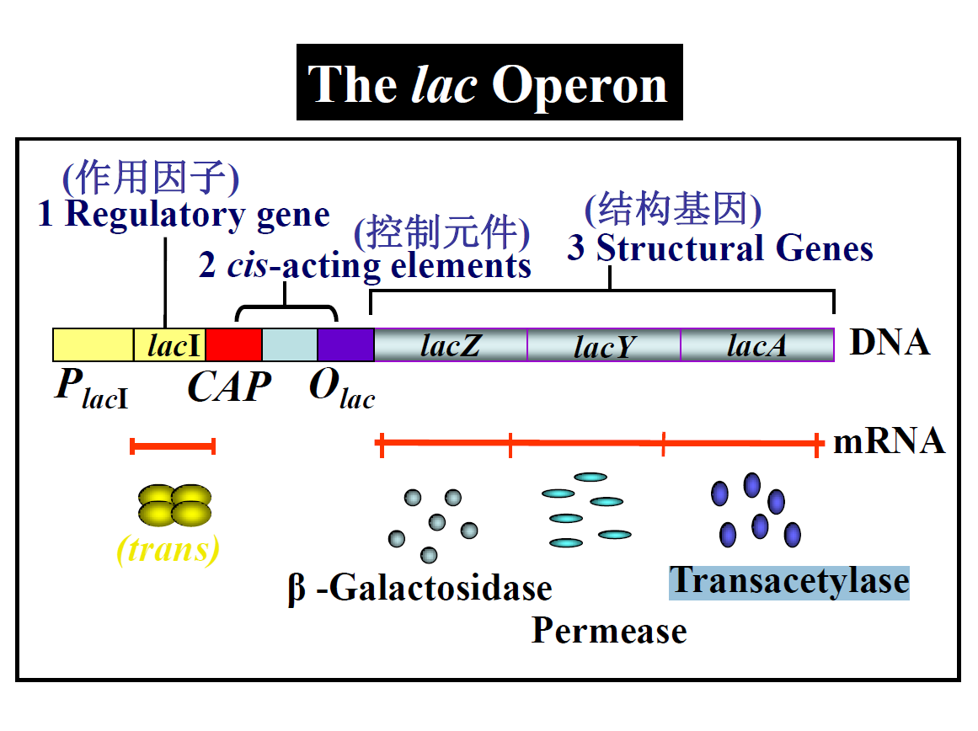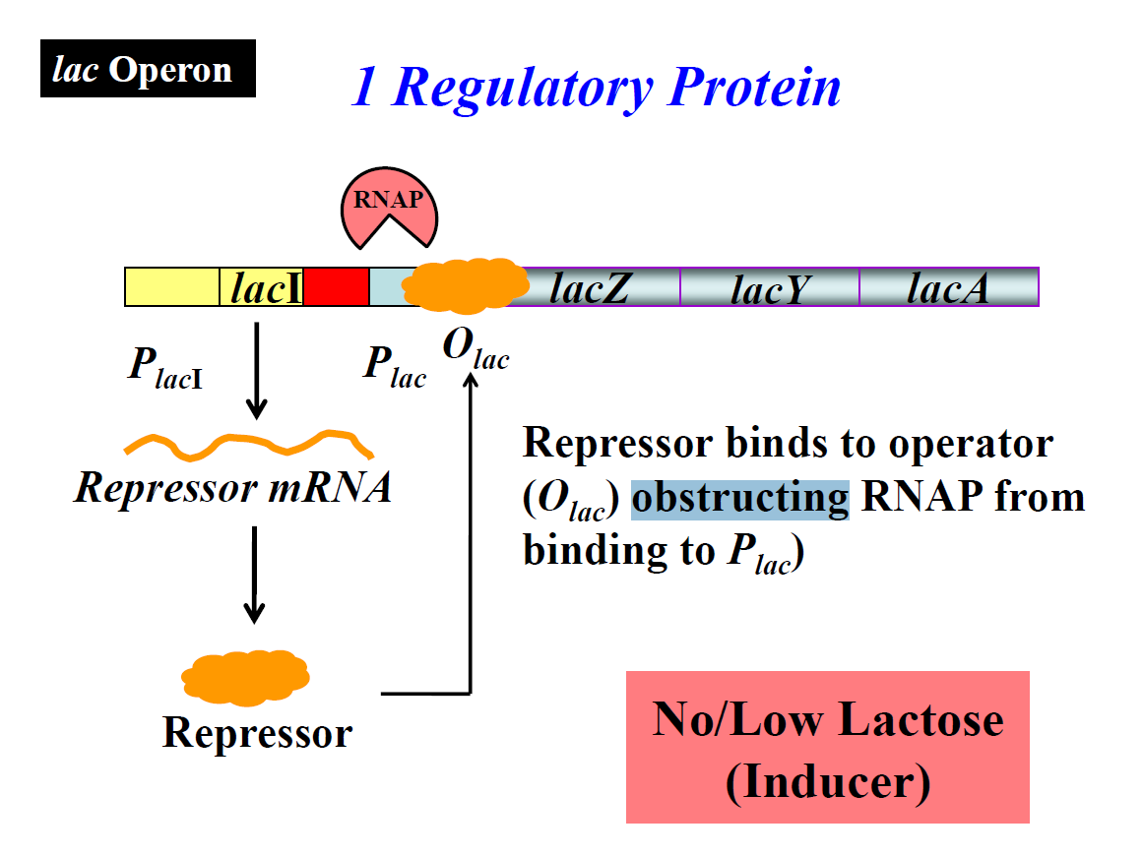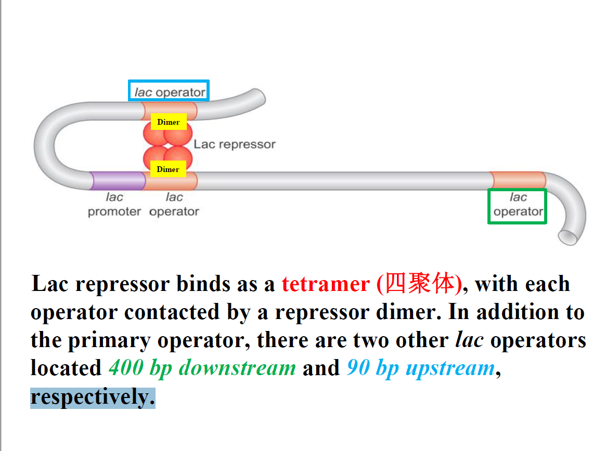

lacZ: codes for β-galactosisidase — lactose hydrolysis=glucose + galactose

lacY: codes for a cell membrane protein—lactose permease: transport lactose across cell membrane

lacA: codes for thiogalactoside transacetylase — to get rid of toxic thiogalacosides

Polycistronic message: a singke mRNA molecule codes for more than one protein — characteristic of prokaryotes

*CAP*: catabolite gene activator protein binding site

分解代谢物基因激活蛋白（CAP）结合位点

cAMP + CAP binding to CAP

CAP has separate activating and DNA-binding surfaces ——

N: ligand binding domain (dimerization & cAMP binding)

C: DNA binding domain

CAP consensus binding site: TGTGA-N6-TCACA

葡萄糖+→CAP不结合→操纵子关闭

葡萄糖-，乳糖-→CAP结合，操纵子关闭

葡萄糖-，乳糖+→CAP结合，操纵子打开