Transcriptional regulation:

cis-elements: promoter, enhancer, silencer

Trans-factors: DNA binding domains, helix-turn-helix, zine finger, basic leucine zipper, baisic helix-loop-helix, activation domains, the preinitiation complex(PIC)

Differential expression allow:

1. Cells to respond to environmental constant changes
2. Cells to specialize in multi-cellular organisms
3. Organisms to develop over time

Prokaryotic & eukaryotic genomic structures

|  |  |
| --- | --- |
| Small genomes (many carries plasmids) | Large genome |
| Naked nucleoid | nuclear envelop |
| Few non-coding and repeated sequence | Non-coding sequences far exceed coding sequences, rich in repeated sequences |
| exons | Exons and introns |
| Many genes with related functions are close together in operons | Longer space between genes |
| Polycistronic mRNA | Monocistronic mRNA |
| Localized control elements | Long range control elements |

Eukaryotes: control of gene expression

1. Without operons
2. Genes are controlled individually where each gene has specific control sequences
3. There are additional ways in which expression can be controlled in eukaryotes

Difference of regulation between eukaryotic and prokaryotic gene expressions

1. Pre-mRNA splicing adds an important step for regulation
2. Transcriptional machinery is more elaborate than its bacterial counterpart
3. Nucleosomes and their modifiers influence gene access
4. Many eukaryotic genes have more regulatory binding sites and are controlled by more regulatory proteins than bacterial genes

Control points

1. DNA packaging
2. Transcription
3. RNA processing
4. mRNA export
5. mRNA modification
6. mRNA degradation
7. Translation
8. Protein modification
9. Protein transport
10. Protein degradation

Nucleosome = DNA + core histones

1. Cis-regulatory element: a region of DNA that regulates the expression of genes located on the same strand

Concluding: promoter, enhancer, silencer

1. Trans-regulatory factor(transcription factors=TF): are species which may modify the expression of genes distant from the gene that it is transcribed from

Including: TFIID(TATA), CTF(SP1),CTF(CAAT)

Promoter: a regulatory region of DNA generally located at the 5’ region of the antisense strand of a gene that promotes transcription

Concluding: TATA box, GC box, CAAT box

#模板链（非编码链）=反义链=antisense strand，编码链=正义链=sense strand

Preinitiation complex(PIC): a large, universal complex of proteins that is necessary for the transcription of protein-coding genes in eukaryotes

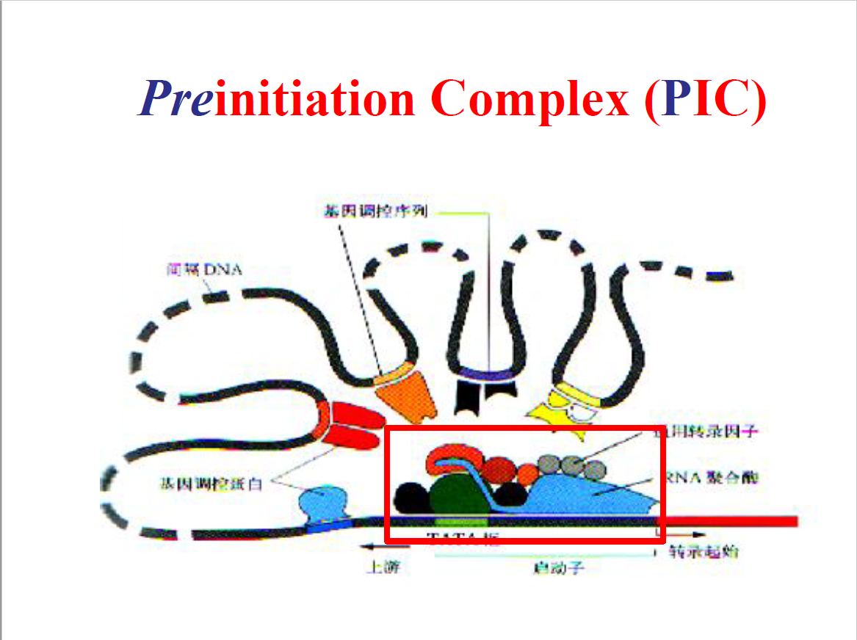

Enhancer: 能使与它连锁的基因转录频率明显增加的DNA序列

1. 增强效应十分明显
2. 增强效应与其位置和取向（5→3，3→5）无关
3. 大多为重复序列。常含核心序列：（G）TGGA/TA/TA/T（G）
4. 增强效应有严密的组织和细胞特异性，说明增强子只有与特定的蛋白质（转录因子）相互作用才能发挥其功能
5. 无基因专一性
6. 许多增强子受外部信号的调控

How does an enhancer work?

1. Enhancer-banding protein: DNA-binding site and sites that bind to transcription factors assemble at the promoter of the gene

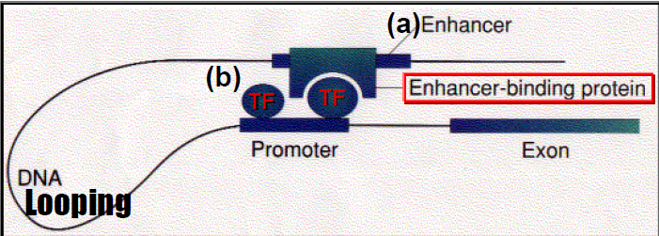

1. Coactivators: protein that bring enhancer binding proteins and proximal promoter binding factors together

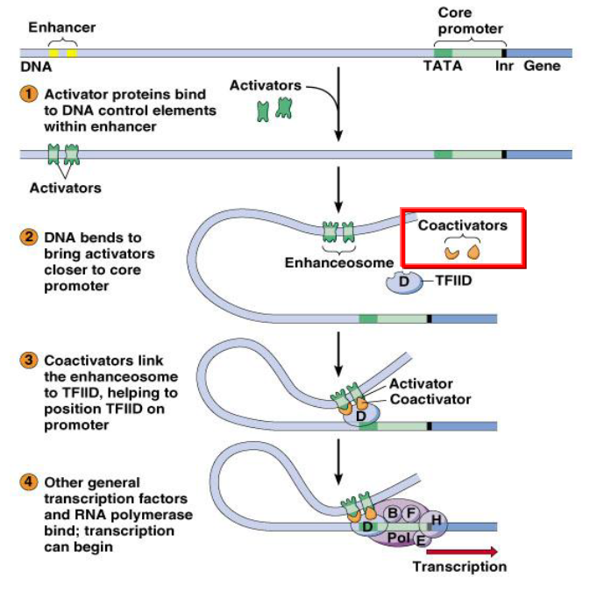

Insulator: stretches of DNA located between enhancer(s) and promoter or silencer(s) and promoter of adjacent genes or clusters of adjacent genes

Their function is to prevent a gene from being non-specifically influenced by the activation (or repression) of its neighbors

Silencer: control region of DNA that may be located thousands of base pairs away from the gene they control. However, upon bound by TFs, they repress gene expression

Trans-acting element(response elements)

1. DNA binding domain (DBD):
2. Helix-turn-helix=H-T-H（螺旋-转折-螺旋）: two α helices joined by a short strand of amino acids

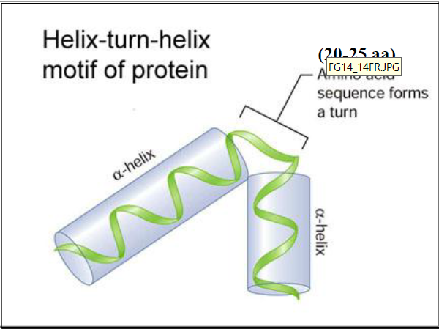

1. Zinc finger（锌指结构）:30 amino+Zn+4Cys(/2 Cys+2 His)——SP1, TFIII

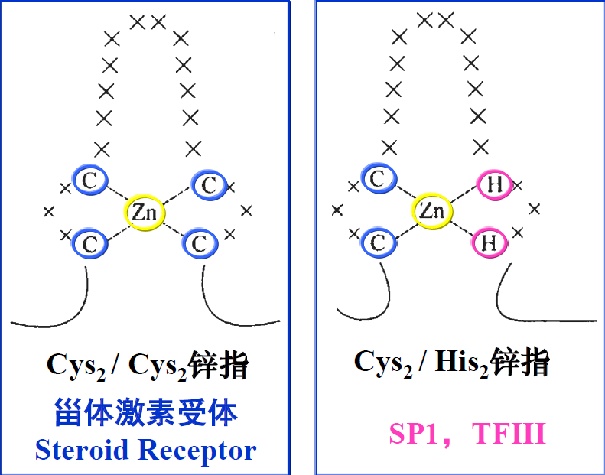

1. Basic leucine zipper（碱性-亮氨酸拉链）

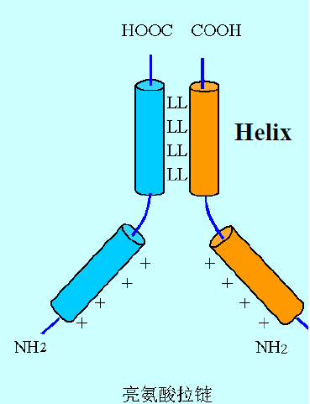

1. Basic-helix/loop/helix=bHLH（碱性-螺旋-环-螺旋）

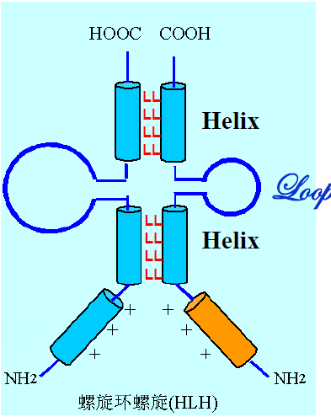

1. Transactivation domain (TAD):able to activate/enhance transcription by recruiting RNAP, directly or indirectly

Eukaryotic gene expression is controlled by transcription factors and response elements.

Binding of specific transcription factors to response elements determines which genes will be expressed in certain cell type under certain cell type under certain set of conditions

1. Eukaryotes vs Prokaryotes: Genomic Structures
2. Eukaryotes vs Prokaryotes: Gene Expression Control
3. Multiple levels of Control
4. Nucleosome
5. Transcriptional Initiation
6. cis-Acting Elements
7. Promoter, Enhancer, Silencer
8. trans-Acting Factors
9. DNA Binding Domain & Activation Domain